M,u s6 PC06
C(>NG HOA XA HQI CHU NGHiA VltT NAM
D<)c lip - T\f do - H;mh phiic

PHUONGAN
CHUA CHAY, cuu N4N, cuu HQ CUA ca so

Ten cO' sfr: CONG TY TNHH TM THJNH VU'QNG HU'NG
Dja chi: S6 240 ip Long Th&i A, xa Long H6, tinh Viuh Long
S6 di�n tho�i lien hf: .0766.243.234

Long H6, ngay 11 thang 11 nam 2025

\��o .::: � ,/2///
-·---- -� •· --- ··---·--,
S0D0Ms\TBANGT◊NGTHE
_J

B

T+D �

Chu thich:
�- . binh bo. t

qlJ•>
N • o,<JRcf;.
I !Jq
'IJ.f-t C,
��q0v,--.
.z
� I 11</J
,{ � olJR
I Cu

I

l'J(u-o
�Q�
-lo� ltos
04d
&: binh khi
-: hu&ng t�n cong
===:>: hu6ng chay Ian
� : dam chay

F : nO'i xu�t phat chay

/\;l/<1_'

))<1.�

<'\to
'-11)'
�)'-Ru;>,
- Oc I
4
"- I
I .,
900
o-lo
- S.3
- - >-- : 16i thoat n�n
l�:=:�}��l b€ nu6c
� : hu6·ng gi6 th6i "' ,

·� �y/J>
, � '1,y

�00

<'\to

/\;l/<1_'

b,{y
lftro.,.,
- '✓R cfI;· r..
-✓1-,.i V,·
1/JJ;
')rel/)
- -< t ► - -
.• tru.
nua, c no". 1

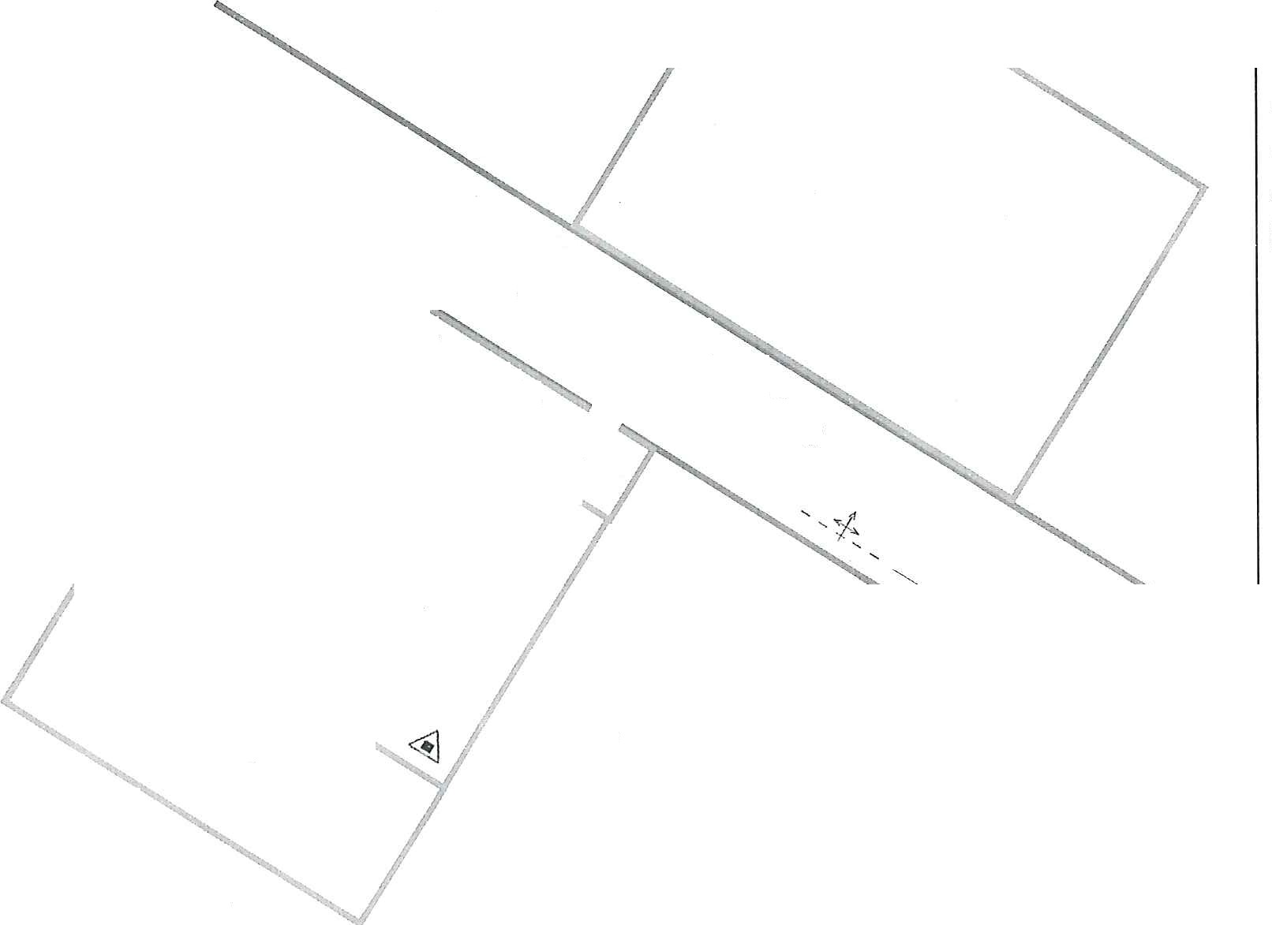
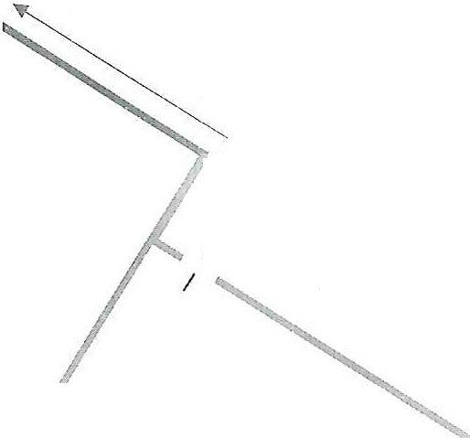
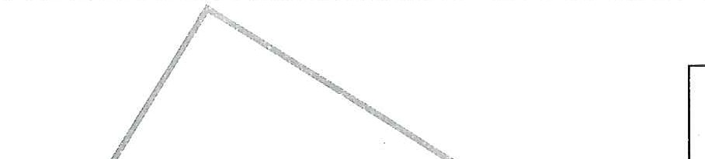
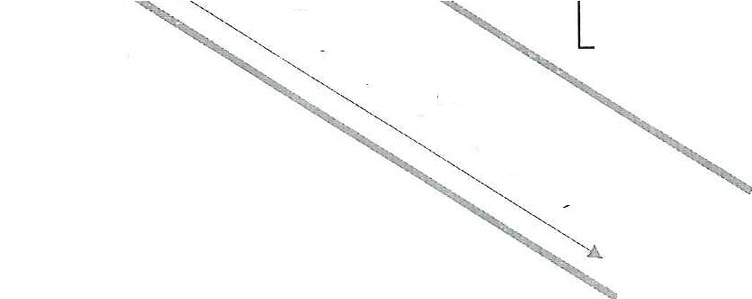
h ,·
�1' fJ? <
0/\;G

- THONG TIN CO SO
  - Ten co s6: CONG TY TNHH TM THJNH VU'()NG HUNG
  - Dia chi: S6 240 �p Long Th6'i A, xa Long H6, tinh Vinh Long
  - HQ va ten nguc>'i dfrng dllu CO' s6: TRAN VAN XEP;
S6 di?n tho�i: 0766.243.234
  - T6 chfrc h,rc luqng t�i ch6CI):
    - :09i phong chay, chfra chay va CU'U n�m, Cll'U h9 CO' s6/chuyen nganh:
      - T6ng s6 d<)i vien: nguai;
      - H9 va ten d9i tnro·ng: TRA.N VAN XEP;
S6 di?n tho�i: 0766.243.234
    - T6ng s6 04 nguai duqc phan cong nhi?m vv phong chay, chfra chay va ct'.m n�n, cfru h9.
    - Lvc lu(Jllg c6 thS huy d<)ng:
      - Trong gia lam vi?c: 04 nguo'i;
      - Ngoai gia lam vi?c: 04 nguai.
  - Bang th6ng ke h? th6ng phong chay, chfra chay, phuong ti?n chfra chay, ct'.ru n�m, ct'.ru he) cu.a co s6:
    - Bang th6ng ke phuong ti?n chfra chay, cuu n�m, ct'.:ru he)

STT | Lo�i phtrO'ng ti�n chfra chay, CU'U n�n, ctru hQ | Don vi tinh | ,  So  llfQ'ng | Vi tri b6 tri | Ghi chu
1 | Binh b<)t chfra chay | Binh | 01 | T�i hanh lang
1 | Binh khi chfra chay | Binh | 01 | T�i hanh Jang
    - Bang th6ng ke h? th6ng phong chay, chfra chay (nSu c6)

rn
NG
HI-\

�UQt
�-,

STT | H� th6ng  phong chay, chfra chay | DO'n vj tinh | SB  lu'Q'ng | Vj tri b6 tri | Ghi chu
1 | H? th6ng bao chay t\l·d<)ng
1.1 | Tu bao chay trung tam
1.2 | :0:lu bao chay....
1.3 | Nut §.n bao chay
... | ......
2 | H� th6ng chfra chay tµ d9ng (nu6c, khi, sol khi, b9t, b9t...)
2.1 | Tu diSu khiSn... |  |  |  | ·-

  - Ngu6n mr6'c phvc V\1 chfra chay<²):
2.2 | Dllu phun chfra chay
2.3 | Tr�m barn chfra chay
... | .....
3 | H� th6ng chfra chay b�ng mr6c
3.1 | Tu h9ng nu6'c chfra chay
3.2 | Tr�m born chifa chay
3.3 | H9ng tiSp nu6'c
3.4 | H9ng hut nu6-c
.... | ......

TT | Ten nguo;\ n nu,o·c | Vi tri | Trfr lm;rng (m3)  ho�c hru  lm}'ng  (1/s) | Ghi ch{1
1 | Beg tJ."oQg_
1.1 | Nu6c sinh ho�t | Phia trong  CO' SO | Khong dang k� | Dung cho may born  chfra chay nhCtng dam chay nho
2 | Ben ngoai
2.1 | Trv nu6c | Cach CO' so 100m-200m  (tren Qu6c  16 53) _ | 141/s | TruySn nu6'c cho xe chil'a chay
  - Danh sach s6 di�n tho�i:
    - S6 di�n tho�i bao chay' bao tinh hu6ng CU'U n�n, CU'U h9: 114
    - S6 di�n tho�i cac co quan, don vi lien quan clln lien h�:
-,-.I

T
G

�
:��

-·-
STT | Ten CO' quan, do·n vi | S6 di�n tho�i | Ghi  ch{1
1 | Uy ban nhan dan xa Long H6 | 02703.850.250
2 | Canh sat PCCC va CNCH | 114  02703.822.333
3 | Cong an xa Long H6 | 02703.851.852

4 | Dan vi di?n ll}'c Long H6 | 02702.483.222
5 | Dan vi c§.p nu6c Long H6 | 0703.822.583
6 | Ca quan y tS xa Long H6 | 02703.851.672

- TINH CHAT, D!C DIEM NGUY HIEM VE CHAY, TAI N�N, Sl/ CO TRONG CO SO
  - Danh gia tinh ch§.t, d�c di Sm c6 lien quan dSn chay' tai n�m, S\f c6 cua cong trinh, h<:tng lTI\lC cong trinh theo cong nang SU' d\mg
- Cong nang sfr d\lng dS san xu§.t, kinh doanh
- Quy mo, d�c diSm kiSn true, xay dvng: (s6 tcing, di¢n tich m¢,t b6.ng, kit cdu be tong c6t thep ho¢,c khung thep mid ton )
  - D�c diSm kiSn true xay dvng: T6ng di?n tich: 125ni; Di?n tich xay dvng 125m²; di?n tich san: 125m²
  - Nai bay ban: rc)ng khoang 80m2, xay dvng kiSu nha c§.p 4, c6 0 I cfra ra
vao, I6i di tu c6ng chinh vao rc)ng 2m, v�t li?u xay dvng bing be tong c6t thep mai tol.
- D�c diSm nguy hiSm chay, n6 cua cac nguyen li?u, nhien li?u, v�t tu, hang hoa dS chay chu ySu: (vi tri b6 tri, s!ip xip, s6 liu;mg, kh6i lu9ng trong titng khu v�cc, hc;mg 7n1:[C cong trinh; il(l,c aidm chay, y§u t6 il{Jc hgi khi chay, kha nang chay Zan ra khu v�rc xung quanh).
- Ch§.t chay chu ySu: Gifty, bao bi, nhva, thiSt bi tieu th\l di?n, h� th6ng di�n, d6 dung gia dinh.
- Ngu6n nhi�t gay chay: Sa su§.t trong vi�c ban hang ho�c do thiSt bi di?n,...
- YSu t6 d(k h�i khi chay: Kh6i d(>c, khi dc)c
Tinh chfit nguy hi�m chay n6 d<)c: Khi xay ra chay kha nang chay Ian rftt nhanh, nhi�t de) dam chay tang cao, kh6i thoat ra d?m d�t, nSu chay trong m◊t thai gian dai se lam cho V?t li�u xay dl}'ng m§.t kha nang chiu Ive, do bj tac d9ng cua nhi?t d9, buc x� nhi�t gay chay Ian toan be) ca s&, chay Ian qua nha dan lam svp d6 cong trinh, gay nguy hiSm dSn tinh ITI<:tng con nguai, cong tac chfra chay se g�p kh6 khan, phuc t�p.
- Cong nang SU d\lng de o·
- Quy mo, d�c diSm kiSn true, xay dvng: (s6 tcing, di¢n tich 111¢,t b6.ng, kit cdu be tong c6t thep ho(tc khung thep mai ton )
- D�c diSm nguy hiSm chay, n6 cua thiSt bi, d6 d(mg sinh hrn;1t: ( vf tri b6 tr£, s!ip xdp, s6 ltt'9ng; age aidm chay, ydu t6 a{Jc hc;ii /chi chay, kha nang chay Zan ra khu V1/'C xung quanh)
ThiSt bi, d6 dung sinh ho�t trong nha la cac dl)ng Cl), may m6c dung cho rn1u nu6ng, su6i Am, chiSu sang, giai tri, gi�t giu, 1am Gyp, v.v. Ch(mg c6 thS tr& thanh ngu6n gay chay, n6 khi:
- Lam vi?c o·nhi?t d9 cao,

C·

11
.� I
!UNG
/ 1
�

- Su dvng di?n, gas, hO?C nhien li?u,
- Bi hu hong, qua tai, ro ri, ho?C
- Su d1,1ng sai quy each.
- DS phat nhi?t, ch�p di?n, tia lua khi day di?n ha, qua tai ho?c fim. - B1,1i, long, vai bam trong thiSt bi gay qua nhi?t, chay cu<)n day. - S.;ic pin, di�n tho.;ii, laptop d.m lau gay qua nhi?t ho?C n6 pin lithium.
- Rori gas ho?c d&u t.;io h6n hqp hoi -khong khi dS n6. - Khi b�t bSp, lfra c6 thS bit vao hoi gas tich tv � n6. - Binh gas mini n6 khi dS g&n ngu6n nhi?t ho?c dung nhiSu l&n.
- Y�u t6 d(k h.;ii khi chay: Kh6i d<)c, khi d<)c
Tinh chfit nguy hi�m chay n6 d<)c: Khi xay ra chay kha nang chay lan nit nhanh, nhi�t d9 dam chay tang cao, kh6i thoat ra d�m d?,t, nSu chay trong m9t thai gian dai se lam cho v�t li�u xay dvng m:lt kha nang chiu lvc, do bi tac d9ng cua nhi?t d<), bt'rc x.;i nhi?t gay chay lan toan 69 CO' SO', chay lan qua nha dan lam svp d6 cong trinh, gay nguy hiSm dSn tinh m.;i,ng con nguai, cong tac chfra chay se g?p kh6 khan, phuc t.;ip.
- Nhfrng v:in dS c&n luu y dS bao dam an toan cho nguai, phuong ti?n khi t6 chuc chfra chay, CU'U n.;in, CU'U h9 d6i v6i ch:lt, hang hoa nguy hiSm vs chay, n6 duqc bao quan, SU' d1,1ng trong co so·
  - Ch:lt, hang hoa trong co so· kY. nu6c:
Ch:lt hO?C hang hoa k:v. nu6'c la nhfrng v�t li?u phan t'.rng m�nh hO?C bi hu h.;ii khi tiSp xuc v6'i nu6'c ho?c hoi fim.
- M<)t s6 ch:lt phan (mg h6a h9c v6'i nu6'c, sinh ra nhi�t, khi d& chay (hydro)
-+ c6 thS b6c chay hoi.ic n6.
- M<)t s6 l<hac m:it tinh ch:lt ho?c bi hong khi fim (vi dv: b9t, mu6i khan, thu6c n6 l<ho, san ph�m hut fim... )
Yeu c&u bao quan chung d6i v6'i ch:lt, hang h6a kY. nu6'c.
- Phai la kho kin, l<ho rao, thong thoang, khong ro d9t, nSn cao rao.
- Khong d?t g&n khu vµc fim u6't, duang 6ng nu6'c, ho?c noi c6 thS bi ng�p.
- C6 mai che t6t, tranh mua t.;it, hoi fim tll' ngoai.
- Nhi?t d9 6n dinh, tranh thay d6i d9t ng9t gay ngung t�1 hoi nu6'c
  - Khu vµc chua ch:lt, hang hoa l<hi chay dS sinh ra kh6i khi d9c:
Hang hoa khi chay d� sinh ra kh6i d(k la nhfrng v�t li?u ho?c san phfim ma trong qua trinh chay, phan huy nhi?t sinh ra cac l<hi ho?c hoi d9c (CO, HCI, HCN, NOx, S02, aldehyde...).
- Cac l<hi nay gay ng:;tt, bong duang ho h:lp, r6i lo.;in thfin kinh va giam tfim nhin, can tr& thoat n.;in & chfra chay.

�
'?',

�

Yeu d.u bao quan d6i v&i hang hoa sinh kh6i c19c khi chay:
- Phai thong thoang, c6 h� th6ng thong gi6 ho�c hllt kh6i tv d9ng.
- Khong b6 tri trong ting him ho�c nai kh6 thoat hiSm.
- C6 tuong, trin, sanch6ng chay va each ly khu dan cu, khu lam vi?c.
- Trang bi h? th6ng bao kh6i, bao chay tl.)' d9ng va sprinkler.

- C§.m lua, c§.m hut thu6c, treo biSn canh bao ro rang.

)
  - Khu Vl.)'C c6 nguoi lam vi?c ma kh6 tiSp C?n khi c(ru nc;m, CU'U h9:
Khu Vl,l'C c6 ngucYi lam vi�c ma kh6 ti@p C?n khi cuu rn;m, CU'U h9 la nhfrng vi tri trong cong trlnh, nha xubng, him, tau, hoi;ic thiSt bi san xu§.t ma khi xay ra sv c6 (chay, n6, ngc;tt khi, S?P d6 ... ) h,rc lu9·ng CNCH kh6 tiSp c�n c1S cfru nguoi do:
- Khong gian hyp, kin ho�c sau,
- Duc'Jng di phuc tc;tp, hc;tn chS t§.m nhin,
- Khoang each xa, nhi@u v�t can,
- I-Io�c nguy ca chay n6, s�p, khi c19c cao.
Bi;ic diSm nguy hiSm chung cua cac khu V\JC nay
- Kh6 xac djnh vi tri nc;tn nhan do kh6i, bong t6i, ti§ng 6n.
0 L6i ti@p c�n hyp, chi du cho 1 nguoi ho�c phai bo, truon.
- Khi d9c, nhi?t cao, thiSu oxy, d@ gay ngc;tt cho ca n�m nhan va cuu he'>,
- Nguy ca S?P, n6, di?n gi?t r§.t cao.
- ThiSu thong tin, dinh hu6ng, dS bi lc;tc trong moi truong khep kin. Bi�n phap phong ngfra va chu§.n bi CU'U rn;m CU'U h9
- Bi?n phap phong ngira tc;ti khu V\fC lam vi?c
  - Danh gia rui ro CNCH trong thiSt k@, v�n hanh cong trinh.
  - B6 tri it nh§.t hai 16i thoat hiSm cho m6i khu vvc lam vi?c.
  - Cung c§.p thong gi6 va chiSu sang kh§_n c§.p cho l<l16ng gian l�fn ho�c him.
  - Giln biSn canh bao ro rang: ! "Khong gian kin - Chi vao khi c6 nguai giam sat"
  - Lip h? th6ng bao chay, bao khi d9c, camera gi.am sat. - 2. Bi?n phap h6
trq cuu n:;m, cuu h9
  - Cung c§,p ban ve, so d616i di, vj tri nguoi lam vi?c cho lvc luqng CNCH.
  - Trang bi phuong ti�n chuyen d\mg:
  - Binh duong khi, m�t nc;t the\ day CU'U h9, cang mSm.
0 Den chi@u sang ch6ng chay n6, may do nguo·i, may do khf.
  - Hu&n luy?n djnh ky cho nguoi lao d9ng v@:

  - Cach thoat n�m trong khong gian hyp.
  - Cach SU' dt_mg day thoat hiSm, m�t nc;t ch6ng kh6i.
- Khu V\l'C c6 nguy ca hinh thanh moi trucmg nguy hiSm n6:
Khu V\JC c6 nguy ca hinh thanh moi truang nguy hiSm n6 la khu V\fC ma trong diSu ki?n binh thuang ho�c bit thuong c6 thS xuit hi?n h6n hqp khi, hai, b\li dS chay v6i khong khi, dc;tt t6i n6ng d9 chay n6 gi6i hc;tn (LEL - UEL).

d9i.
Khi c6 ngu6n lfra ho?,c tia lfra, h6n hqp nay c6 thS phat n6 ho�c b6c chay dfr

Bi�n phap phong ngua va bao v?
- ThiSt kS va b6 tri an toan
  - Tach rieng khu V\JC nguy hiSm n6 khoi khu Vl,l'C lam vi?c thong thuang.
  - C6 thong gi6 tt.r nhien ho�c cuang hue, tranh tich t\l khi/hoi/b1,-1i.
  - Cfra thoat n6, tuong nhy hu6ng ra ngoai dS giam ap khi n6 xay ra.
  - NSn va tuong ch6ng tTnh di?n, c6 n6i dit an toan cho thiSt bi.
- KiSm soat ngu6n phat tia lfra
  - Cim lfra, dim h(1t thu6c, treo biSn canh bao ro rang.
  - Khong dung thiSt bi di?n thong thucmg, phai dung thiSt bi ch6ng n6 (Ex)
�,�-

Jr
),,I
�!

dc;tt chu�n.
    - Hc;tn chS ma sat co khi, tia lua di?n, ph6ng tTnh di?n.
- GIA DJNH TINH HUONG CHA.Y, TAI N�N, SV CO
  - Tinh hu6ng chay
    - Tinh hu6ng I
- Gia dinh tinh hu6ng chay<³)
- Vao h6i 15 gia 00 phut ngay..../....1.... xay ra chay t�i khu V\fC bay ban phia tru6c; ho�c vao h6i 15 gia 10 phut. Phat hi?n chay do nguc>'i phat hi�n chay ho�c h� th6ng bao chay tv d9ng ldch hoc;tt:
- Nguyen nhan do khach dSn mua hang v6 tinh vut tan thu6c lam chay thung rac dvng giiy va bao bi;
- Chit chay chu ySu la: Giiy, bao bi, nhl,l'a, thiSt bi di�n, h� th6ng di�n;
- Dam chay c6 nguy ca chay lan sang cac khu Vl,l'C, h�mg mvc xung quanh:
V6i nhi?t d9 cao, kh6i khi d9c toa ra d�rn d�c cua dam chay, kha nang ti�p c�n chfra chay bi h,;1n chS do kh6i, nhi�t d9 cao, nSu chay trong m9t thoi gian dai se lam S\lp d6 cong trlnh, gay kh6 khan cho cong tac t6 chuc d�p t�t dam chay.;
- Di?n tich dam chay khoang 03m²;

- T?i thoi diSm xay chay, c6 02 nguai dang c6 m�t trong khu \f\l'C xay chay.
- Nhi?m V\J cua Ive luqng phong chay, chu-a chay va cuu n?n, CU'U h9 CO" so,
C\J thS nhu sau:
- Nhi?m V\J cua nguoi chi huy chfra chay t?i ca so:
+ Phan cong cac lgc luqng thgc hi?n nhi?m V\J thong tin lien l?c, hu6ng d§n thoat n?n va triSn ldiai chu-a chay, CU'U n�m, c(ru h9;
+ Bao dam cac di�u ki�n cfin thiSt cho chfra chay, CU'U n�m, CllU h9;
+ T6 chuc bao v? hi�n truo·ng, khrtc phvc h�u qua.
- Nhi?m V\J thong tin lien l?c, gf>m 01 nguc)'i:
+ Nhanh ch6ng bao d9ng, df>ng thai bao ngay cho nguai dung dfiu co so va 09i truong 09i phong chay, chfra chay va CU'U n?n, ci.'.ru h9 CO' so (ho�c chuyen nganh) biSt c6 SIJ c6 chay xay ra;
+ Di?n tho?i cho Ive luqng Canh sat phong chay, chu-a chay va ct'.ru n�m, CU"U
h9 theo s6 114;
+ Di�n tho?i cho ca quan Y tS theo s6 115;
+ Di�n tho?i bao chay cho Cong an d.p xa, chinh quy�n dia phuong va cac
ca quan c6 lien quan khac;
+ Crtt di�n t�i khu V\J"C chay; t6 chfrc trinh sat xac dinh vi tri, s6 luvng nguo·i bi n�n, nguy ca chay lan dS bao cao cho nguoi chi huy chfra chay cua cu so;
+ Sfr dvng h� th6ng loa phat thanh, h? th6ng thong tin trong n9i b9 cLia co SO" dS thong bao cho m9i nguo·i biSt hi?n t�i c6 tinh hu6ng S\l' c6 xay ra va yeu cfiu so tan theo hu6ng d�n dS thoat ra ben ngoai dSn vi trf t�p k�t an toan da duqc quy dinh.
- Nhi?m V\J cuu n�m va hu6ng dftn thoat n�n, g6m 02 nguo·i:
+ T6 chuc di tan nguoi, CU'U nguo"i bi n�n, SO' cuu cac n�n nhan;
+ T6 chuc hu6ng d§n nguoi thoat n�n ra vi tri t�p kSt;
+ T6 chuc kiSm dSm, xac dinh s6 luqng nguoi con m�c kyt (nSu c6).
- Nhi�m V\J di chuySn, bao v? tai san, gf>m 02 nguai:
+ Di chuySn tai san va cac lo?i chAt chay nguy hiSm ra khoi ldiu V\J"C chay dS t�o ldioang each ch6ng chay Ian sang ldiu V\J"C xung quanh;
+ 06n va hu6ng d§n cac Ive luqng tham gia chfra chay dSn ldiu V\J'C chay; thvc hi�n cac nhi�m vv ldiac theo yeu c�u cua nguoi chi huy chfra chay.
- Nhi�m V\J chfra chay, gf>m 02 nguai:
+ Sfr dvng binh chfra chay xach tay, xe d&y dS chfra chay;
+ TriSn ldiai Hing phun tu h9ng nu6c chfra chay d@ chfra chay, lam mat ch6ng chay Ian cho nguai, phuang ti�n tham gia chfra chay, ci.'.ru nc:m, cuu h9.

:.---1
C
�I
T
.\NH
)-...

�

+ Tham gia bao v? hi?n tnrang, khic ph\lc h�u qua.
so 06 TiNH HUONG xAY RA 0AM cHAY

0221

;NJ
lH�
vUQ
Y₋E.

71;"1��� Yi\,
� -��::..........,.......::,. ic:=...�-==r =====��--�.���-��oo;:,:.�,...-:----,---��.��•�•

L_ ·-_ S0B0TiNHHU6NG�YTH1JNHAT_ ... j

B
+
T+B

l',"

/;;l/-o-,
'-Q
'Rct-;
'./ /:
'lqlJ
'R

�

f,:y

)>/((;;'
�ol;
�o-1r. 4os

Chu thich:
£: binh b9t
&: binh khi
-: hu6ng tftn cong
�: hu6'ng chay Ian

<'Vff-1· b-1:V
I

.,. ,,
. �,JJ
,,�z
I �01)
. Cv 'R
:.-</ )', •
� "'- ku-Oc I

Arai .(/.N,
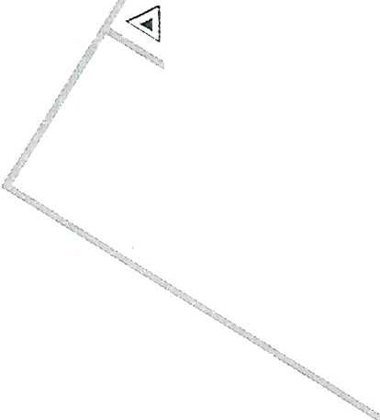
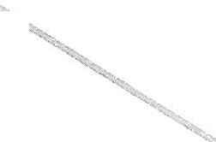
!}:.-</,
y!},
�.;\t

Qo. ,<
00.1.,0
  - S-3
o ./:rd

li-q,,
o�cJ;- ,
-,��

�:damchay
F:nai xu!t phat chay
- - >-- : 16i thoat n1;tn
[:=:��===l b� mr6'c
� : hu6ng gi6 th6i
- - +.,. - - : tr1=1 n,uo·c n0;_1.

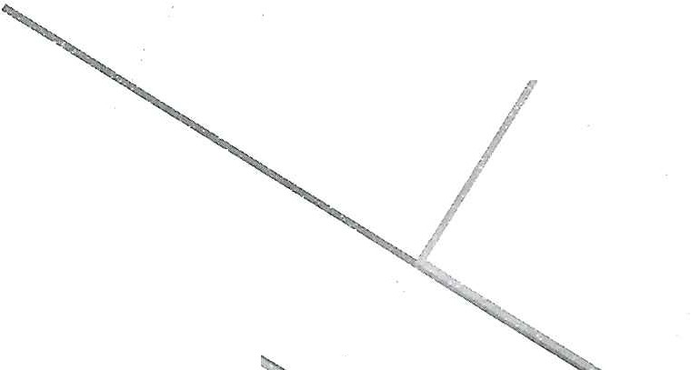
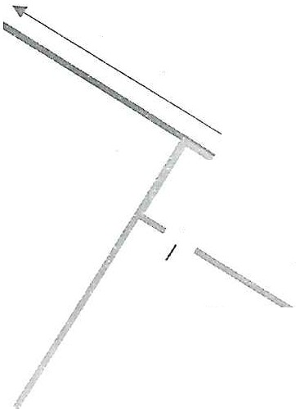
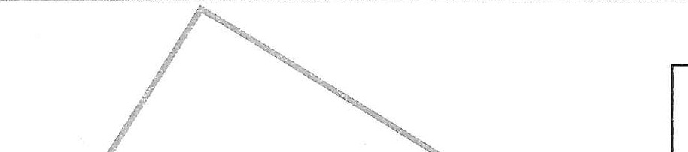
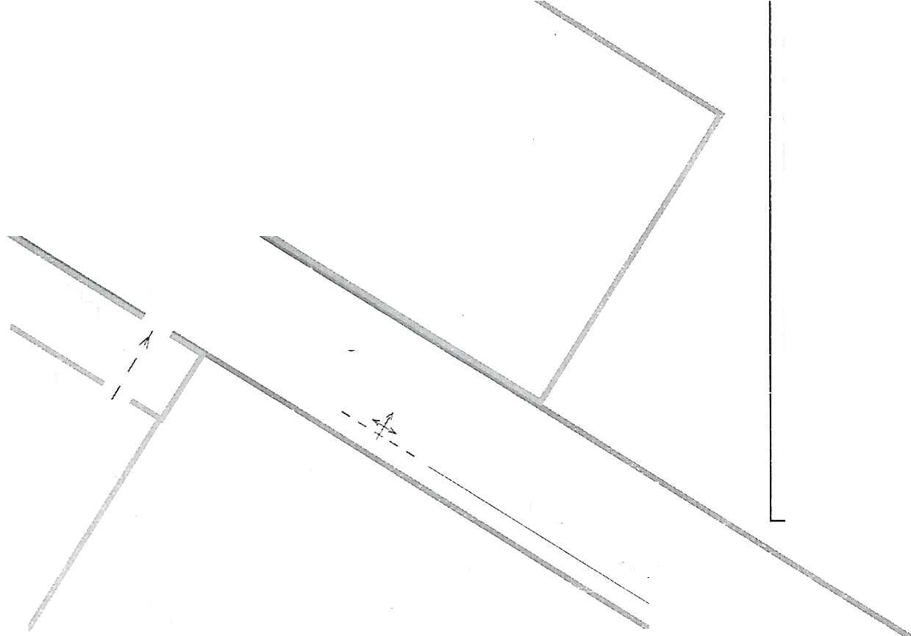
¼oq,,
��G �.
h . J
<'1}' fl( <
O,,yG
<V.11-1·
b-1\,
I);.'
cl V.·
�rctt)
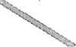

    - Tinh hu6ng 2
      - Vao h6i 08 gio 00 phut ngay....1.... / xay ra chay t?i kho dS hang phia sau;
ho�c vao h6i 08 gio 10 phut. Phat hi?n chay do nguo'i phat hi?n chay ho�c h? th6ng bao chay tv d<)ng kich ho?t:
      - Nguyen nhan do: ch�p di?n d�n d@n kho hang;
      - Chtt chay chu y@u la: Giiy, bao bi, hang h6a, thi@t bi di�n;
      - Barn chay c6 nguy ca chay Ian sang cac khu VlJC, lwng 111\)C xung quanh: V6i nhi?t cl<) cao, kh6i khi d<)c toa ra d�m d�c cua dam chay, kha nang ti@p c�n chila chay bi h?n ch@ do kh6i, nhi?t de) cao, nSu chay trong m<)t thoi gian dai se lam svp d6 cong trinh, gay kh6 khan cho cong tac t6 cht'.rc d�p t�t dam chay.;
      - Di?n tich dam chay khoang 04m²;
      - Ti;ii thoi diSm xay chay, c6 02 nguoi dang c6 m�t trong khu V\l'C xay chay.
b) Nhi?m Vl) cua Ive Iuqng phong chay, chfra chay va CU'U ni;in, ct'.ru he) CO' so·, cv thS nhu sau:
      - Nhi?m vv cua nguoi chi huy chfra chay tc;1i ca so·:
+ Phan cong cac lvc luqng thvc hi?n nhi?m V\l thong tin lien I?c, hu6ng d�n thoat n?n va triSn I<liai chil'a chay, cuu ni;in, cl'.ru he);
+ Bao dam cac di�u ki?n cin thi@t cho chil'a chay; cuu ni;in, cl'.ru h9;
+ T6 chtrc bao v? hi?n truong, l<liic phvc h�u qua.
      - Nhi�m vv thong tin lien ll;l.C, g6m O1 nguoi:
+ Nhanh ch6ng bao d<)ng, d6ng thoi bao ngay cho nguo·i dung ctiu cu so· va 09i trucmg B<)i phong chay, chfra chay va cuu n�m, cuu h9 cu so· (ho�c chuyen nganh) biSt c6 S\f c6 chay xay ra;
+ Di?n thoc;1i cho lµc luqng Canh sat phong chay' chfra chay va CU'll l1l;ln, CU'U he) theo s6 114;
+ Di?n tho?i cho cu quan Y tS theo s6 115;
+ Oi?n thoc;li bao chay cho Cong an cip xa, chinh quy�n dia phuung va cac
CO' quan c6 lien quan khac;
+ Cit di?n tl;li khu V\IC chay; t6 chuc trinh sat xac djnh vi tri, s6 ]uqng nguoi bi n?n, nguy ca chay Ian dS bao cao cho nguo·i chi huy chil'a chay cua ca s6';
+ Sfr dvng h? th6ng loa phat thanh, h? th6ng thong tin trong n9i b9 cua cu SO' dS thong bao cho m9i nguoi bi@t hi?n ti;ii c6 tinh hu6ng Sl)' c6 xay ra va yeu ciu so tan theo hu6ng d�n dS thoat ra ben ngoai d@n vi tri t�p k�t an toan da duqc quy dinh.
      - Nhi�m Vl) CllU nl;ln va hu6ng d�n thoat Dl;ln, g6m 02 nguoi:
+ T6 chuc di tan nguo·i, CU'U nguoi bi ne;m, so cl'.ru cac llc;lll nhan;
+ T6 chfrc lm6ng d1n nguoi thoat nc;ln ra vi tri t�p k@t;

·,
I
J
,l
ii.IN

1
.�:i?"

+ T6 chuc kiSm dSm, xac dinh s6 Iuqng ngu<Ji con mite kyt (nSu c6).
- Nhi�m V\l di chuySn, bao v� tai san, g6m 02 nguai:
+ Di chuySn tai san va cac lo?i ch:lt chay nguy hiSm ra khoi khu V\JC chay dS t?0 khoang each chfJng chay Ian sang khu V\l'C xung quanh;
+ D6n va hu6ng d§n cac Ive luqng tham gia chfra chay d@n khu vvc chay; thvc hi�n cac nhi�m V\l khac theo yeu d.u cua nguo·i chi huy chfra chay.
- Nhi�m V\l chfra chay, g6m 02 nguai:
+ Su d\lllg binh chfra chay xach tay, xe d�y dS chfra chay;
+ TriSn khai Hing phun tu hc,mg nu6c chfra chay dS chfra chay, lam mat chfJng chay Ian cho nguoi, phuang ti�n tham gia chfra chay, cuu n?n, cuu he\
+ Tham gia bao v� hi�n truang, kh�c ph\lc h�u qua..
Sd DO TiNH HUONG xAY RA DAM CHAY

�
vl
11

?Ii

� �---··-;--- :y��I �-]

[ -SOD6TiNHHUONGCHA

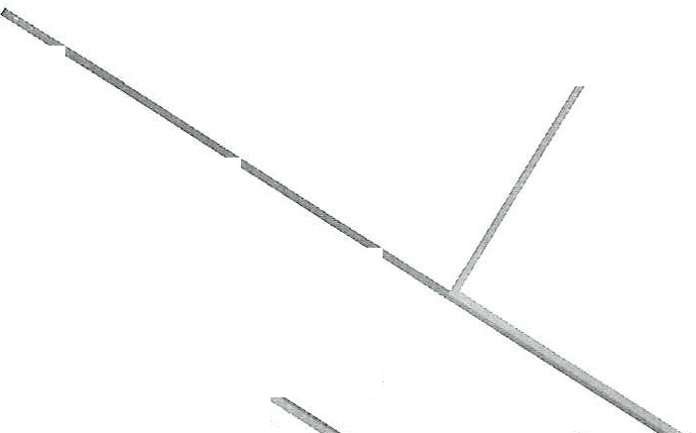
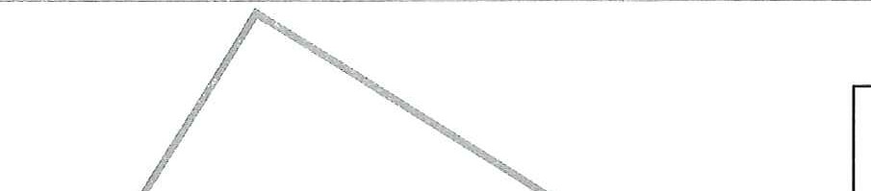
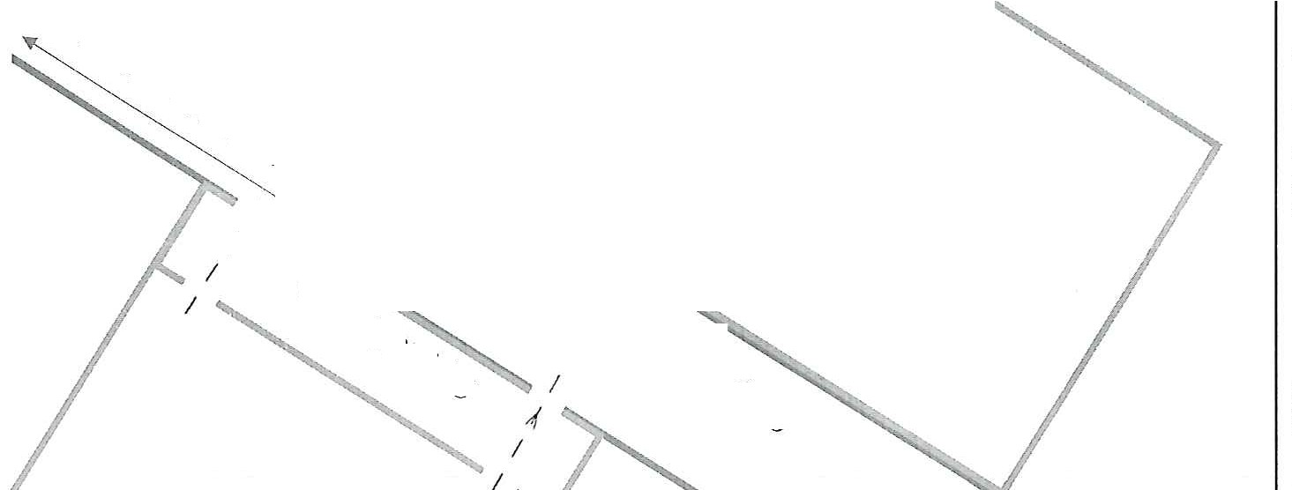
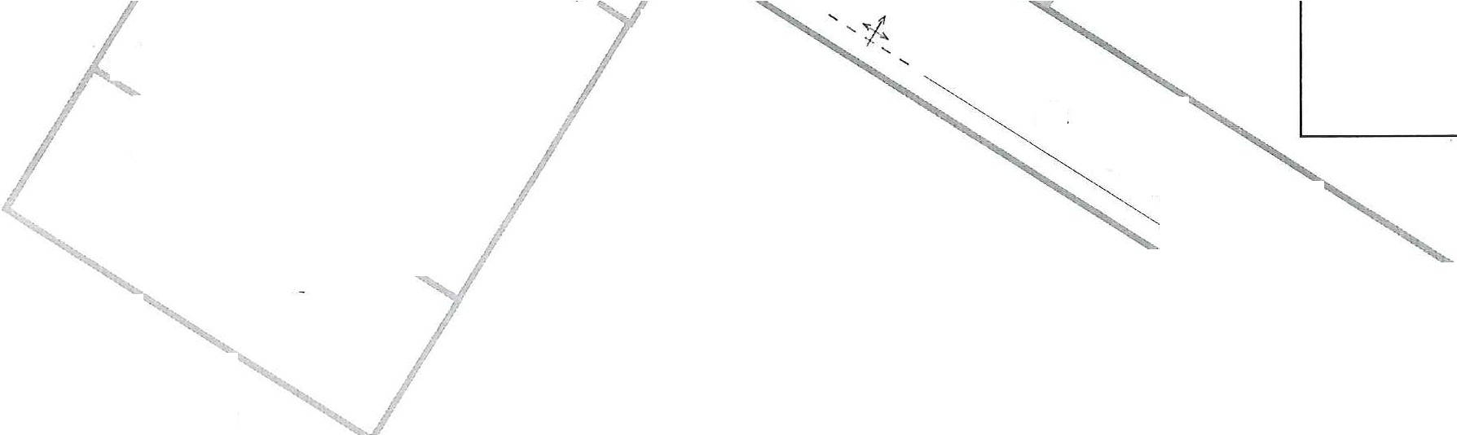
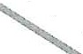
B

T+E

N

.ltt;0;0,:;>

�

cf/Ir.
Q�t.:,
- ct/1)

:,,l(u,d
�Q�
�O,t.

.qOs

Chu thich:
£: binh b9t
&: binh khi
-: hu&ng t.in cong
'.>: hu&ng chay lan

�//'
b,1�
01J4.
,fl�¼�

0&
�/',
�&o-
0

9&o
o�o
  - S'.3

o/td
� : dam chay
F:nai xu§.t phat chay
- - =- - • 16i thoat n�n
lf:=:�[1b� mr&c

4'-oj-0 t
�IL_ ,
��- : hu6'ng gi6 thoi

'� '1)>-0 >
'14--
�-> ' ;(.
•• '.'II

�

Arlj-/J·

l:tt;, >
•00: (fi·
I 'h
�If}

- ·
- - -i·- - : trµ nuac no1

��' ....41
:D'

b-1:V
' '1J4
-------"-. (cl}!
'�

"1]'1'1r <
OA;-G

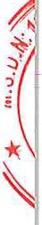
- Tinh hu6ng tai n�m, sv c6
  - Tinh hu6ng c6 nguai du6i nu6c
- Gia dinh tinh hu6ng
- Vao h6i 16 gio· 30 phut ....ngay....1..../ .... xay ra tai n�m, S\l' c6 c6 02 nguai
bi du6i nu6c;
- Nguyen nhan do: 02 chau nh6 vo tinh roi xu6ng song khi choi g�n d6
- T6 chl'.rc cfru n<:m
- Khi phat hi�n tai n�m, sv c6 c6 nguai bi du6i nu6c, nguai phat hi�n cfrn th1,rc hi�n theo cac bu6c sau:
+ Nhanh ch6ng bao d9ng, d6ng thai bao ngay cho nguo·i dung dfru co s6' va f)9i tru6·ng f)9i phong chay, chua chay va CU'U ll<;lll, cuu h9 CO' so· ho�c chuyen nganh biSt c6 tai n<;1n, S\1' c6 xay ra;
+ f)i�n tho<;1i cho Ive luqng Canh sat phong chay' chua chay va CU'U n<;1n, cuu h9 theo s6 114;
+ f)i�n tho<;1i cho co· quan Y tS theo s6 115;
+ Di�n tho<;1i cho Cong an d.p xa, chinh quy@n dia phuong va cac co· quan c6 lien quan khac.
- Danh gia tinh hinh va quan sat s6 luqng, vi tri nguai bi du6i nu6c, di@u ki�n moi trucmg nu6c (dong chay, song, dia hinh, d9 sau) dS quySt dinh phuang phap cuu nguo'i trvc tiSp ho�c gian tiSp, C\l tht
+ Cuu nguai gian tiSp: quang day, phao CU'U sinh, van n6i, can nhva, thtmg x6p, ao phao dS n<;1n nhan barn vao; su d\,lng thuy@n, xu6ng ho�c v�t n6i 16n dS tiSp c�n va cuu ll<;lll nhan;
+ Cuu nguai trvc tiSp: nguai trvc tiSp ra cuu m�c ao phao, bu<)c m9t d§.u day c6 dinh vao vi tri an toan (ho�c c6 nguai giu day), dfru con l<;1i bu9c vao nguai trvc tiSp ra cuu, bai ra tiSp c�n n<;1n nhan tu phia sau dS dua n<;1n nhan vao vi tri an toan (dung ky thu�t boi diu n<;1n nhan ngfra len m�t nu6c, giG' dfru n<;1n nhan n6i tren m�t nu6c; nSu c6 nhiSu n<;1n nhan, hay uu tien nguo·i v§n con phan t'.mg nhung ki�t sue tru6c).
- Bi�n phap so ct'.ru ngay khi dua n<;1n nhan dSn vi tri an toan:
+ D�t n<;1n nhan 6· tu thS n&m ngfra tren m�t phiing ct'.mg, kiSm tra phan t'.rng, nhip tim va nhip tho;
+ NSu n<;1n nhan khong tho, tiSn hanh ho hAp nhan t<;10 va ep tim ngoai l6ng ngvc ngay l?p tl'.rc;
+ Khong d6c nguqc nguai n�m nhan dS ep nu6c ra vi c6 thS lam rnAt tho·i gian vang d@ cuu s6ng n�m nhan;
+ Giei' frm cho n<;111 nhan nSu trai l<;1nh va cha d<)i y tS dSn.

- H6 trq h,rc luqng Canh sat phong chay, chfra chay va CU'U n�m, Cll'U h9 khi dSn hi?n truang, cv th§: cung d.p thong tin vS s6 lu9·ng n�m nhan, tinh tr<;1ng hi?n t<;ti va cac bi?n phap da thvc hi?n.
  - Tinh hu6ng S?P d6 nha, cong trlnh, cay c6i
- Gia dinh tinh hu6ng
- Vao h6i 08 gio 45 phut ngay..../..../.... xay ra tai n<;tn, S\l' c6 S?P d6 nha, cong trinh, cay c6i lam O1 nguai bi mite b�t t<;ti nha g1n co· so·;
- Nguyen nhan do mua 16n kem theo giong 16c lam cay c6i nga ct6.
- T6 chfrc cfru n�m
- Khi phat hi?n tai n<;tn, S\l' c6 S?P d6 nha, cong trinh, cay c6i e6 nguoi bi mite kyt, nguoi phat hi?n e§n thvc hi?n theo eac bu6'c sau:
+ Nhanh ch6ng bao d9ng, ct6ng thoi bao ngay cho nguo·i d1mg ctiu co so· va D9i truang D9i phong chay, ehfra chay va CU'U n<;tn, CU'U h9 co SO' ho�e chuyen nganh biSt e6 tai n;;m, S\l' e6 xay ra;
+ Di?n tho<;ti eho lve luqng Canh sat phong ehay, chfra chay va Cll'LI n<;tn, ClYU
h9 theo s6 114;
+ Di�n tho<;ti eho co quan Y t� theo s6 115;
+ Di?n thoc;1i eho Cong an c&p xa, chinh quySn dia phuong va eae co quan c6 lien quan khac.
- Danh gia nhanh ttnh hinh, khoanh vung hi?n truang va quan sat s6 luqng, vi tri nguai bi mite kvt, diSu ki?n moi truong dS quy@t dinh phuong phap, bi?n phap efru nguai, e\l thS:
+ Quan sat ml.'.rc d9 S?P d6, xae dinh cac nguy ca ti@p di�n;
+ Cong trinh c6 th� tiSp tvc S?P d6 thfr e&p;
+ Kha nang ehay, ro rI khi gas, eh?p di?n;
+ Dung ngay eac ho<;1t d9ng e6 thS gay nguy hiSm them;
+ Khoanh vung hi?n truong, ngan nguoi khong e6 nhi?m V\l vao khu vvc nguy' hiSm.
- TiSn hanh CU'U n<;tn, etru h9:
+ T6 chfre ngk\t di�n, dong van gas nSu c6 ro ri; quan sat xem cong trinh, cay e6i e6 nguy co s�ip d6 thfr cip khong dS e6 bi?n phap ch6ng, chen phu hqp;
+ Cuu nguoi bi thuong llily ho�e mite kvt ngoai d6ng d6 nat: dung clvng C\l cuu h9 s�il c6 nhu xa beng, bua, kim c9ng l\rc d@ m6 duong thoat; hu&ng d�n n�m nhan tv di chuySn ra ngoai n@u c6 thS;
+ Tim ki@m va tiSp c�n nguo·i bi n<;tn trong d6ng d6 nat: g9i 16'n, l�ng nghe ti@ng keu euu; khong di chuySn d6ng d6 nat tuy ti�n, tranh gay S?P d6 ti@p; SLT

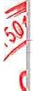
>->.n
�
d

d\mg c6 thiSt bi h6 trq nhu camera do thn, cam biSn (nSu c6) dS xac djnh vi trf nc;m nhan; tc;10 16i thoat an toan cho nc;1n nhan bing each d9n dyp nhy nhang;
+ Giai CU'U nguai bi mic kyt nzing: nSu nc;m nhan bi kyt trong be tong, d6ng g6 16n,... c�n cha Ive lu(Jng Canh sat phong chay, chfra chay va CU'U nc;1n, CU'U h9;
+ Duy tri sv s6ng bing each: n6i chuy�n trftn an, cung c§.p nu6c hozic oxy (nSu c6); danh d§.u vi tri nc;1n nhan dS hu6ng din l\l'C luqng Canh sat phong chay, chfra chay va cfru nc;1n, CU1J h9.
- So cuu nguai bi thuong:
+ Ki�m tra y thfrc, nhip thO";
+ Ho h§.p nhan tc;10 nSu nc;1n nhan ngung tho;
+ C�m mau, c6 dinh xuang gay bing nyp hozic v�t d\mg thay thS;
+ �hong di chuySn nc;1n nhan bi chftn thuong c9t s6ng, trfr khi c6 nguy co tfr vong neu 6 nguyen vi tri;
+ Gifr ftm, trftn an nc;1n nhan.
- H6 trq Ive Iuqng Canh sat phong chay, chfra chay va cfru nc;1n, cu·u h9 khi dSn hi�n truang, c1,1 th@: cung cftp thong tin vS s6 Iuqng nc;1n nhan, tinh trc;1ng hi�n tc;1i va cac bi�n phap da thµc hi�n; hu6ng din Ive Iuqng Canh sat phong chay, chfra chay va CU'U nc;1n, CU'U h9 vao hi?n truang theo l6i an toan nhftt; tiSp t1,1c h6 trq di chuySn nc;1n nhan ra khu V\}'C an toan.
Luu y: khong vao hi�n truang m<)t each tuy ti�n, luon bao dam an toan cho nguai Cll'U nc;1n tru6c; khong dung sue nguai dS di chuy@n v�t nzing, tranh gay s�p d6 thfr cftp; ph6i hqp v6i l1,1·c Iuqng Canh sat phong chay, chfra chay va cuu nc;1n, CU'U h9 dS bao dam hi?u qua cuu nc;1n.
  - Tinh hu6ng tai nc;1n, sv c6 do phuang ti?n, thiSt bi gay ra
- Gia dinh tinh hu6ng
- Vao h6i 14 gia 20 phut ngay..../..../.... xay ra tai nc;1n, S\l' c6 do phuong ti�n, thiSt bi hu hong gay ra lam OI nguo·i bi mic kyt;
- Nguyen nhan do b§.t din khi SU dl,lng may m6c
- T6 chfrc cuu nc;1n
- Khi phat hi?n tai nc;1n, sµ c6 do phuang ti�n, thiSt bi gay ra c6 nguo'i bi mic kyt, nguai phat hi?n c�n th\l'C hi�n theo cac bu6c sau:
+ Nhanh ch6ng bao d<)ng, d6ng thai bao ngay cho nguo·i dfrng d�u co so va D<)i tnrong D<)i phong chay, chfra chay va CU'U nc;1n, cl'.ru h9 CO' so· hozic chuyen nganh biSt c6 tai nc;1n, S\l' c6 xay ra;
+ f)i�n thoc;1i cho Ive IuQ'Ilg Canh sat phong chay, chfra chay va CU'U nc;m, CU'U h9 theo s6 114;

;
fNt
�
,{tt�·

�'1-f;�

+ Di?n tho:;ii cho co quan y tS theo s6 115;
+ Di?n tho:;ii cho Cong an cip xa, chfnh quySn dia phuong va cac co· quan c6 lien quan khac.
- Danh gia nhanh tinh hinh, khoanh vung hi?n truang va quan sat s6 luqng, vi tri nguai bi mic kyt, diSu ki?n moi trucmg dS quySt dinh phuong phap, bi?n phap cl'.ru nguai, C\l thS:
+ Quan sat muc d9 mile kyt cua Il<;lll nhan d@ xac dinh phuong phap, bi?n phap cl'.ru n:;in;
+ Khoanh vung hi?n truang, ngan khong cho ngucYi khong c6 nhi?m V\l vao khu V\fC nguy hiSm;
+ KiSm tra nguy ca thu cip nhu: ro ri nhien li?u, khi gas, h6a chit d9c h:;ii; nguy CO' chay, ch�p di?n tu phuang ti?n, thiSt bi; kha nang thiSt bi c6 thS s�p d6 ho�c tiSp t\lc gay chin thuang; ngilt ngu6n di?n, d9ng co, nhien li?u cua phuong ti?n ho�c thiSt bi (nSu c6 thS).
- TiSn hanh cl'.ru n:;in, cuu h9: giai cuu nguai mile kyt trong thiSt bi may m6c: ngilt ngu6n di�n, kh6a h� th6ng diSu khiSn cua may m6c tnr6'c khi tiSp c�n n:;in nhan; dung d\lng C\l CU'U h9 (xa beng, kim c9ng Ive, may cilt) dS ma phfm mic kyt; gifr nguyen tu thS n:;in nhan, tranh keo m:;mh c6 thS gay t6n thuong them; n@u c6 ro ri h6a chit, khi d9c, cAn deo m�t n:;i phong d9c va SO' tan n<;m nhan ngay khi c6 tht
- Sa cfru nguo'i bi n:;in:
+ KiSm tray thfrc, nhip tho cua Dl;lll nhan;
+ NSu ngung tho, ngung tim, tiSn hanh ho hip nhan t:;io va ep tim ngoai l6ng ngvc ngay l�p tfrc;
+ C§.m mau, c6 dinh xuang gay, d�c bi?t v6i n:;in nhan bi kyt lau c6 nguy
ca ho:;i.i tu;_
+ Gilr im va trfin an n:;in nhan trong khi cha 11,l'.c lu9·ng Canh sat phong chay, chfra chay va cuu n�m, ct'.ru h9 dSn h6 trq.
- H6 trq lvc luqng Canh sat phong chay, chfra chay va ctru n:;in, ct'.ru h9 khi dSn hi�n truang, C\l thS: bao cao nhanh s6 lu'Q'ng n:;in nhan, tinh tr:;ing hi�n t:;ii, cac bi�n phap da thvc hi�n; h6 trq di chuySn n:;in nhan len xe c§p cuu.
Luu y: khong tv y di chuySn n:;in nhan bi kyt n�ng, trfr khi c6 nguy ca tfr vong nSu o nguyen vi tri; luon mang theo trang ph\lc bao h9, tranh bi thuong trong qua trinh giai cl'.ru; khong SU di.mg cac cong C\J cilt, c:;iy nSu c6 nguy CO' gay t6n thuang them cho n:;in nhan; luon uu tien sv an toan cua h,.rc luqng CU'U n:;in tnr6c khi thvc hi�n giai ctru.
  - Tinh hu6ng tai n:;in giao thong
- Gia dinh tinh hu6ng
- Vao h6i 14 gia 20 phut ngay....1..../. ... xay ra tai n:;in, S\J' c6 do tai ll?D giao

�

.\j�
�'it,l\l

thong gay ra lam 01 nguai bi thuang tc;Li qu6c 19 53
- Nguyen nhan xay ra tai Ilc;lll la do qua 19 thiSu quan sat
- T6 chl'.rc cuu nc;Ln
- Khi phat hi?n tai Ilc;lll, sv c6 tai Ilc;lll giao thong c6 nguai bi mic kyt, nguai phat hi?n c�n thvc hi?n theo cac bu6'c sau:
+ Nhanh ch6ng bao d9ng, d6ng thai bao ngay cho ngucYi dtmg d�u ca so· va D9i truo·ng D(>i phong chay, chfra chay va cuu n�m, cuu he) ca s& ho?c chuyen nganh biSt c6 tai n9-n, S\l' c6 xay ra;
+ Di?n thoc;Li cho Ive lm;mg Canh sat phong chay, chfra chay va CU'U n�m, CU'U
h9 theo s6 114;
+ Di?n thoc;Li cho ca quan Y tS theo s6 115;
+ Di?n tho;;ii cho Cong an c§.p xa, chinh quySn dia phuang va cac ca quan c6 lien quan khac;
+ Cung c§p thong tin chi tiSt: vi tri xay ra tai nc;Ln giao thong, s6 nguai mic kyt (nSu c6 thS xac dinh), tinh trc;Lng cua phuang ti?n ho?c nguai bi nc;Ln tren phuang ti?n.
* D&i vo"i tinh hu6ng tai n�m giao thong drrO"ng b(>
- Danh gia nhanh tinh hinh, khoanh vung hi?n truong va quan sat s6 luvng, vi tri nguai bi mic kyt, diSu ki?n moi truang dS quySt dinh phuang phap, bi?n phap cuu nguai, C\l thS:
+ Khoanh vung hi?n truang, d�t biSn canh bao ho�c vl\it can dS canh bao cho cac phuong ti?n giao thong khac;
+ K.iSm tra nguy CO' thu c§p: ro ri xang, d�u, chl\ip di�n c6 th� gay chay 116; xe c6 thS bi ll\it tiSp, troi xu6ng vvc ho?c xu6ng nu6'c; cit di?n phuong ti�n ( nSu c6 th@) dS tranh chl\ip chay.
- TiSn hanh cuu n�n, cuu h9 d6i v6·i nguai bi mic kyt trong xe:
+ KiSm tra muc d9 mic kyt: nSu cfra c6 thS m&, h6 trq nc;Ln nhan thoat ra; nSu cfra kyt, dung xa beng, kim c9ng Ive, bua pha kinh d� tc;Lo 16i thoat; pha kinh xe: dl\ip kinh hong ho�c ldnh sau, tranh gay thuang tich cho nc;Ln nhan;
+ Gifr an toan c9t s6ng nSu nc;Ln nhan bi thuang n�ng.
- TiSn hanh cuu nc;Ln, CU'U h9 d6i v6'i nguo·i bi vang ra ngoai:
+ Khong di chuySn nc;Ln nhan ngay nSu nghi ch§n thuang c9t s6ng, trfr khi nguy hiSm dSn tinh mc;Lng nguai bi nc;Ln;
+ NSu ngung th&, ngung tim, tiSn hanh ho h§.p nhan tc;LO va ep tim ngoai 16ng ngµc ngay ll\ip tuc;
+ C�m mau, c6 dinh gay xuang, tranh iam t6n thuang them;
+ Gifr §.m va tr§.n an n<:m nhan trong khi cho· Ive luqng y tS dSn.
- H6 trg Ive luqng Carlh sat phong chay, chfra chay va Cll'U n�n, CU'U he) khi dSn hi?n truang, C\l th�: bao cao nhanh s6 nguoi bi ll<;ll1, tinh trc;Lng, bi�n phap da

?.
rv
fM
3HU

�

thv·c hi?n; h6 trg di chuySn n?n nhan len xe cuu thuang; giup diSu tiSt giao thong, tranh un tic gay can tra cuu h<).
* D6i v6'i tinh huBng tai n�n giao thong durrng thuy
- Danh gia tinh hu6ng va dam bao an toan
+ Quan sat tinh tr?ng tau, thuySn: c6 bi chim khong?; c6 nguy ca va ch?m them khong?; c6 ro ri nhien li�u, ch�p di�n khong?;
+ Khoanh, vung hi�n truang, d�t phao ho�c canh bao tau khac khu vvc xay ra tai n?n, sv c6.
- TiSn hanh cuu n�m, cuu h<) d6i v6i nguoi rai xu6ng nu6c:
+ Nern phao cuu sinh, day thung, can nhva dS n?n nhan bam vao;
+ N�u phai xu6ng nu6c, chi cuu khi c6 ky nang bai cuu h<), tiSp c�n tu phia �
Ji
sau da tranh bi n?n nhan keo chim;
+ NSu n�m nhan bit tinh, gifr d§.u h9 n6i tren m�t nu6c va dua vao bo nhanh nhit c6 thS.
- TiSn hanh cuu n?n, cuu h<) d6i v6i mic h;t trong tau, thuy�n: �
+ NSu tau chua chim hin, h6 tr9· n?n nhan thoat kh6i khoang tau, thuy�n;
+ NSu c6 kh6i, chay, hu6ng d�n n?n nhan ra kh6i khu vvc nguy hi�m;
+ N@u tau dang chim, hu6ng d�n 1wn nhan barn vao v�t n6i (van g6, thung phuy, phao).
- Sa cuu nguai bi n?n:
+ Ki8m tra y thuc, nhip tho cua n?n nhan;
+ NSu ngung tho·, ti@n hanh ho hip nhan t?O ngay tren tau ho�c bo;
+ U irn cho n?n nhan nSu bi l?nh ho�c ng?t nu6c;
+ C& dinh gay xuang, bang b6 vSt thuang nSu c6.
- H6 trg lvc luqng Canh sat phong chay, chua chay va cuu n?n, CU'U h<) khi dSn hi?n truang, cv thS: cung cip thong tin vS sf> ngucJi bi n?n, tinh tr?ng sue kh6e; h6 trg di chuySn n�m nhan len bo ho�c len tau c{ru h<).
- Luu y: khong nhay xu6ng nu6c cfru n?n nSu kh6ng c6 ky nang, hay h6 trg
tir xa b&ng phao, day thfrng; khong di chuy�n n?n nhan chin thuang c<)t s&ng, trfr khi c6 nguy ca tu vong nSu a nguyen vi trf; luon uu tien an toan cho lvc lugng
cuu Il?Il tru6c khi thvc hi?n giai cuu.

V. C�P Nll4T, BO SUNG, CHiNH LY PHUONG AN
TT | Ngay,  thang, nam | Nqi dung  c�p nh�t, b& sung, chinh Iy | Ngll'O'i  d(mg d�u CO' so·ky  xac nh�n
1 | 2 | 3 | 4

)
�
)i

VI. THEO DOI THVC T� PHUONG AN

)
TT

1
Ngay, thang, nam
2
Tinh hu6ng th'!c t�p

3
Ngufri
dfrng diu CO' SO' ky xac nhan
4
.
-

Long
110, ngay ..... t ang ..... nam ..........
D�I DitN CO SO
u:: , h, �

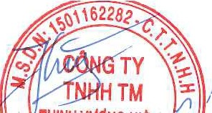
(Ky, ghi ro h9 ten, cl11'cc VF·,· dong ddu ndu c6)

��H/NH'@NGH!� 0))/

I �
� Ji,

