## Polarity measurement of piezo transducer

Many methods are found in www, most common is to poke the transducer cone and measure excitation signal with scope. Standard 10:1 scope probe is ok for that.

The signal looks like that

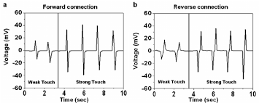

It is easy explained. If positive going pulse is first followed by negative pulse it means that scope probe is at the positive terminal. You can easy back check by just revert polarity oft he scope probe.

The Amplitude may differ according to piezo, applied force and measurement equipment – will be lower if 1:1 probe is used.

With 10:1 it may go up some 100mV up to some volts.

Well this method is quite OK, but may damage the transducer if to much force is applied.

The polarity is measured as it is not reliable that marking is correct. In the vdatp it is crucial to have correct polarity on all of the transducers.

Picture – bottom side of the transducers used with + marking on the positive terminal.

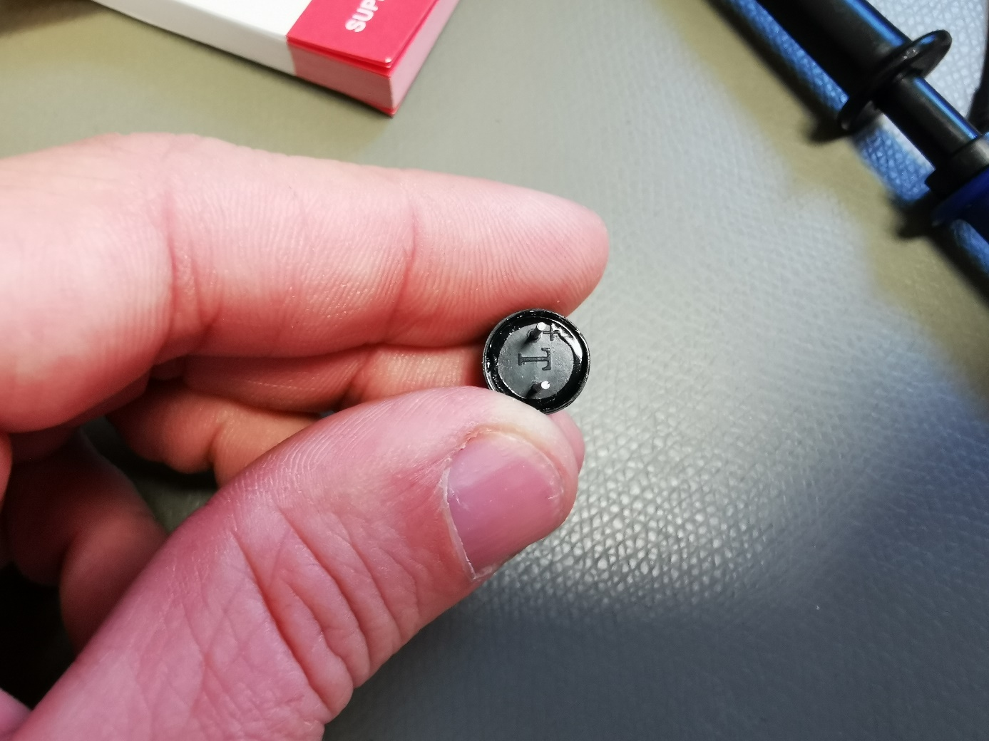

## Alternate polarity measurement of piezo transducer

Well we can do some different kind of setup to measure polarity, using transmitter/receiver method.

One transducer is put into transmitter mode, and the other is used as receiver. (speaker / microphone setup)

We transmit acoustic wave that will cause an excitation on the receiver transducer.

On the scope we have to measure the orignal excitation signal and the received signal.

Simplified test setup:

(speaker and microphone piktogram represent the transducer in the way it is operating)

**NF generator**

* Set to transducer resonantfrequency
* Max amplitude
* Sinus excitation



Scope

10:1 probe on DUT

CH1 (gen out) CH2

Based on the physical distance between TX and RX there is a natural propogation time that is based on the speed of sound in air (approx 343m/sec) – that will show up on the scope as a phase shift between CH1 and CH2. Variation of distance between RX and TX within the wavelength will give a full 360° phase-shift. Please note there is minimum distance for that behaviour.

If you keep this distance a constant value and revert polarity on one transducer then the phase shift will have additional 180°.

In this example with 44kHz it will be 0.78cm.

Use the resonant frequency to have good efficincy on the transmitter and therefore get higer amplitude on the receiver side.

**Real Measurement:**

NF Generator Setup:

* frequency = 44kHz
* amplitude = +-10V (symmetrical)
* waveform: sinus-excitation

**Scope Setup:**

* Timebase: 10µsec / div
* Trigger: CH1 – edge triggered (generator signal)
* CH1: 10V / div
* CH2: 500mV / div

2 transducers RX/TX are marked with (+) on the side. Polarity was tested with first method described.

On the left side is transmitter, on the right side is receiver transducer.

The easiest way to have constant distance is to just hold them together.

In the pictures the yellow signal (upper) is the received signal.

Result with identical polarity on rx and tx transducer

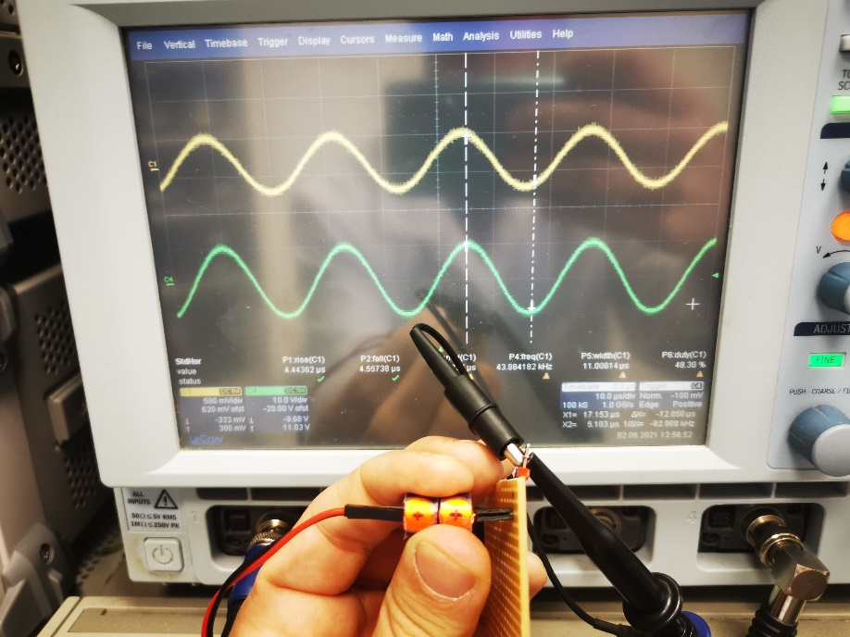

Result with reverted polarity on receiver transducer (180° phase-shift on yellow signal)

