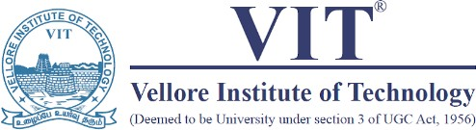

School of Computer Science Engineering and Information Systems

Fall Semester 2025-2026

Department of Information Technology

BITE 487J Project – I

Review -1

Date: 10.9.2025

PREPMATE: AN INTERVIEW PREPARATION PLATFORM

22BIT0248 | KOTHURU SIVA HARSHITHA REDDY
22BIT0197 | THODEM VENKATA DINESH REDDY
22BIT0288 | HEMAKESH SURAPAREDDY

Under the Guidance of
RANICHANDRA C
Associate Professor Grade 2
SCORE

Guide Signature with date
RANICHANDRA
DECLARATION

I hereby declare that the BITE497J – Project I thesis entitled “Prepmate-An Interview preparation platform” submitted by me, for the award of the degree of Bachelor of Technology in Information Technology, School of Computer Science Engineering and Information Systems to VIT is a record of bonafide work carried out by me under the supervision Ranichandra C, Associate Professor Grade 2, SCORE, VIT, Vellore.
I further declare that the work reported in this thesis has not been submitted and will not be submitted, either in part or in full, for the award of any other degree or diploma in this institute or any other institute or university.

Place: Vellore
Date:31-10-2025

Signature of the Candidate

CERTIFICATE
This is to certify that the BITE497J – Project I thesis entitled “Prepmate-An Interview preparation platform " submitted by THODEM VENKATA DINESH REDDY & 22BIT0197, SCORE, VIT, for the award of the degree of Bachelor of Technology in Information Technology, School of Computer Science Engineering and Information Systems, is a record of bonafide work carried out by him / her under my supervision during the period, 21. 07. 2025 to 30.11.2025, as per the VIT code of academic and research ethics.
The contents of this report have not been submitted and will not be submitted either in part or in full, for the award of any other degree or diploma in this institute or any other institute or university. The thesis fulfills the requirements and regulations of the University and in my opinion meets the necessary standards for submission.

Place: Vellore
Date:31-10-25

Signature of the Guide

Internal Examiner External Examiner

Head of the Department
Department of Information Technology

ACKNOWLEDGEMENT

It is my pleasure to express with a deep sense of gratitude to my BITE497 - Project I guide Ranichandra C, Associate Professor Grade 2, School of Computer Science Engineering and Information Systems, Vellore Institute of Technology, Vellore for her constant guidance, continual encouragement, in my endeavor. My association with her is not confined to academics only, but it is a great opportunity on my part to work with an intellectual and an expert in the field of Full stack and AI/ML.

I would like to express my heartfelt gratitude to Honorable Chancellor Dr. G Viswanathan; respected Vice Presidents Mr. Sankar Viswanathan, Dr. Sekar Viswanathan, Vice Chancellor Dr. V. S. Kanchana Bhaaskaran; Pro-Vice Chancellor Dr. Partha Sharathi Mallick; and Registrar Dr. Jayabarathi T.

My whole-hearted thanks to Dean Dr. Daphne Lopez, School of Computer Science Engineering and Information Systems, Head, Department of Information Technology, Dr. Arivuselvan K, Information Technology Project Coordinator Dr. Suganya P, SCORE School Project Coordinator Dr. Thandeeswaran R, all faculty, staff and members working as limbs of our university for their continuous guidance throughout my course of study in unlimited ways

It is indeed a pleasure to thank my parents and friends who persuaded and encouraged me to take up and complete my project successfully. Last, but not least, I express my gratitude and appreciation to all those who have helped me directly or indirectly towards the successful completion of the project.

Place: Vellore
Date: THODEM VENKATA DIENSH REDDY

Executive Summary
PrepMate: An AI-Driven Interview Preparation Platform
The growing competitiveness of the job market demands that students and fresh graduates develop strong interview skills, yet traditional preparation methods remain subjective, inconsistent, and often ineffective. Peer-based practice lacks objectivity, while existing digital tools frequently fail to simulate realistic interview dynamics or provide meaningful, actionable feedback. This gap leaves candidates unable to identify and address specific weaknesses in content clarity, verbal delivery, and confidence.
PrepMate addresses this challenge through an innovative, AI-driven web platform that serves as a personal interview coach. The system leverages advanced AI models and real-time speech processing to conduct dynamic mock interviews, deliver immediate feedback on accuracy, clarity, and confidence, and track performance trends over time. By combining voice-enabled interviews with an adaptive quiz system that targets identified weaknesses, PrepMate creates a closed-loop learning experience that accelerates interview readiness.
The platform integrates three core modules: an AI Interview Module that generates contextually relevant questions, a Real-Time Feedback Engine that evaluates responses against professional standards, and an Analytics Dashboard that visualizes progress and motivates continued practice.
Key innovations include voice-first interaction design, rubric-aligned automated scoring, and seamless interview-to-quiz feedback loops that personalize remediation. The platform has been developed through agile methodology, with modular architecture enabling independent component testing and easier maintenance. Security and accessibility have been prioritized throughout, ensuring compliance with data privacy standards and WCAG guidelines.
Expected outcomes include measurable performance improvements, reduced interview anxiety through realistic practice, and increased success rates in actual job interviews. The scalable architecture enables campus-wide deployment and future integration with career portals and placement systems. Pilot testing with student cohorts will validate performance metrics and gather feedback for iterative enhancement.
PrepMate represents a transformative tool for democratizing interview preparation, combining the personalization of human coaching with the scalability and consistency of AI systems. Recommended next steps include beta deployment with measurable metrics, integration of user feedback, and expansion to include video interviews and advanced emotion detection capabilities.

ABSTRACT

PrepMate AI, an AI-driven interview preparation platform designed to enhance users readiness through personalized, voice-based coaching. Utilizing advanced AI models such as LLMA and APIs, the platform conducts realistic mock interviews, delivers immediate feedback, and offers adaptive learning suggestions. Core features comprise voice-enabled interview sessions, comprehensive response evaluation, a structured question bank, progress tracking, and curated learning materials. Built as a scalable, web application, the system supports multiple concurrent users with attention to performance, security, and accessibility. The SRS defines key functional requirements including user management, voice interaction, feedback generation, and administration, along with non-functional requirements addressing low latency, privacy compliance, and reliability. Risk analysis identifies challenges related to real-time voice processing and third-party service dependencies. This review underscores the SRS’s thorough approach in developing an effective, user-centric interview coaching tool.

- INTRODUCTION:
In today’s competitive job market, students and fresh graduates face increasing challenges in demonstrating career readiness. Traditional interview preparation methods such as peer practice, workshops, or generic online resources often lack personalization, objectivity, and measurable outcomes. This results in persistent issues like unclear feedback, limited exposure to realistic interview dynamics, and difficulty bridging the gap between academic learning and professional expectations. As industries evolve with higher demands for communication clarity, confidence, and technical articulation, there is a growing need for intelligent systems that provide structured, consistent, and adaptive training.
Artificial Intelligence has emerged as a transformative enabler in this domain, offering capabilities like voice analytics, natural language processing, resume parsing, and real-time feedback generation. Numerous AI-driven mock interview platforms and career tools have been proposed, each contributing valuable features such as automated scoring, sentiment analysis, or resume-to-interview integration. However, these systems are often fragmented, with limited scalability, weak integration across preparation stages, and insufficient empirical validation. Reviewing existing literature in this field is therefore essential to identify current strengths, recognize recurring limitations, and establish the foundation for designing holistic, user-centric platforms like PrepMate.

- PROBLEM STATEMENT
Many of the students and job seekers struggle to adequately prepare for interviews due to
lack of access to realistic practice environments and personalized, objective feedback.
Traditional methods like practicing with peers are often subjective and inconvenient,
while existing digital tools frequently lack the conversational realism and in-depth
analysis needed to drive meaningful improvement. This gap results in candidates being
unable to effectively identify and rectify weaknesses in their interviewing skills, such as
response structure clarity, and confidence. Therefore, there is a need for an intelligent,
accessible, and data-driven platform that can simulate realistic interviews and provide
immediate, actionable feedback to help users build the confidence and skills necessary to
succeed.

[3.] OBJECTIVES
The primary objectives of the PrepMate project are as follows:
- To Develop a Secure and Personalized Platform: Create a web application with secure user registration and profile management to provide a tailored user experience.
- To Provide Instant, AI-Driven Feedback: Design and implement a system that evaluates user responses on key metrics like content accuracy, verbal clarity, and confidence, delivering immediate and constructive feedback.
- To Enable Performance Tracking: Build a user-friendly dashboard that visualizes a user's progress over time, highlighting strengths and areas for improvement to keep them motivated.
To Ensure System Scalability and Reliability: Engineer the platform as a scalable, cloud- based application capable of handling multiple concurrent users while maintaining low latency, data privacy, and high reliability.

[4.] SCOPE OF THE PROJECT:
The scope of this project is to develop a comprehensive, user-centric interview coaching
tool
- Core Features: The system will include voice-enabled interview sessions, a structured question bank, comprehensive response evaluation, progress tracking analytics, and access to curated learning materials.
- Functional Requirements: Key functionalities to be developed are secure user management, voice interaction capabilities , AI-powered feedback generation.
- Non-Functional Requirements: The project will focus on delivering high performance with low latency during voice processing, ensuring data privacy and security compliance, and maintaining system reliability and accessibility.
- Risk Management: The scope also includes identifying and planning for potential challenges, such as the complexities of real-time voice processing and managing dependencies on third-party services like OpenAI.

[5.] PROPOSED SYSTEM:
The proposed system, PrepMate, is an innovative, AI-driven web platform designed to function as a personal interview coach. Its primary goal is to enhance the interview readiness of students through personalized, voice-based mock interviews that simulate real-world conditions. The system is architected as a scalable, focusing on performance, security, and accessibility to support multiple concurrent users.
Core Modules and Functionality
The platform is comprised of several integrated modules that work together to deliver a comprehensive coaching experience:
- AI Interview Module: This is the heart of the system. It uses LLMA to dynamically generate relevant and realistic interview questions. For user interaction, it employs the API for real-time, accurate speech-to-text transcription of the user's spoken answers.
- Real-Time Feedback Engine: After a user responds, the system provides immediate and comprehensive feedback. It is designed to evaluate responses on key metrics such as accuracy, clarity, and confidence, providing a detailed score to guide improvement.
- Analytics and Progress Tracking Dashboard: A key feature is the visual dashboard that enables students to track their performance trends over time. This powerful tool allows them to identify specific areas for growth and monitor their measurable progress, which helps in staying motivated.
USER WORKFLOW:
A typical user interaction with the PrepMate system would follow these steps:
- Registration and Setup: A new user signs up and creates an individual profile.
- Initiate Session: The user starts a mock interview session tailored to their profile. The system presents the first question generated by LLMA
- Voice Response: The user answers the question by speaking. Their voice is captured and transcribed in real-time .
- Receive Feedback: Immediately after the response is processed, the user receives detailed, actionable feedback and a performance score.
- Track Progress: The session results are saved, and the user's progress is visually updated on their personal dashboard.

[6.] LITERATURE REVIEW:

S.NO | TITLE | MERITS | DEMERITS
1 | AI‑PrepMate: AI‑Assisted Mock Interview and Feedback System (2025) | Real‑time mock interviews with rubric‑aligned feedback and dashboards; feasible, scalable web deployment. | Limited reporting on bias/ethics and ATS integration; latency/scalability benchmarks not rigorous.
2 | AI Powered Mock Interview System with Real‑Time Voice and Emotion Analysis (2024–25) | Prosody/emotion cues improve delivery coaching; enables instant feedback for student practice. | Accuracy sensitive to audio quality and accents; cross‑demographic robustness not verified.
3 | AI Based Mock Interview System (2025) | Evaluates verbal and non‑verbal cues with structured performance reports; supports detailed coaching. | Multimodal compute/privacy overhead; minimal dataset and metric disclosure.
4 | MOCKMATE AI: Personalized Interview Assistant (2025) | Feature mapping and personalization strategies useful for requirement scoping and differentiation. | Narrative focus; no head‑to‑head empirical metrics.
5 | AI‑Based Mock Interview Evaluator (2025) | Emotion/sentiment models with precision/recall support objective delivery scoring. | Potential over‑weighting of emotion signals; unclear data diversity.
6 | AI‑Based Mock Interview Simulation for Job Readiness (2025) | Student‑centric design with behavioral feedback and generative prompts shows confidence gains. | No resume/ATS linkage; small pilots limit generalization.
7 | NexInterview: AI‑Driven Mock Interview Preparation Platform (2025) | Speech/NLP pipelines and personalization inform architecture and item‑bank design. | Limited quantitative results; cross‑module data flows unspecified.
8 | AI‑Driven Mock Interviews: A New Era in Candidate Preparation (2024–25) | Synthesizes automation, cost, and standardization benefits for risk/impact analysis. | Broad survey; few specifics on latency/storage/reproducibility.
9 | AI Mock Interview Platform: Implementation Notes (2025) | Instant feedback, automated scoring, scenario variety support real‑time coaching. | Non‑standard datasets; sparse reproducibility details.
10 | Free vs. Paid AI Mock Interview Tools: Comparison (2025) | Clarifies expected features and feedback speed for KPI targets. | Non‑academic comparison; lacks controlled methodology.
11 | AI Interview Tools for Students and Colleges (2025) | Highlights campus deployment needs and constraints for pilots. | Marketing‑style overview; minimal technical validation.
12 | AI Interview Platforms: Features and Comparison (2025) | Feature matrices helpful for MVP scoping and differentiators. | Secondary synthesis; lacks controlled benchmarking.
13 | Online Mock Interview Platforms Overview (2025) | Curates common capabilities (recordings, instant tips) shaping user expectations. | Listicle format; can be outdated and lacks rigor.
14 | Automated Resume Parsing: Techniques and Challenges (2025) | Ontology mapping, normalization, failure modes guide robust parsing. | Parsing‑only; no downstream interview integration.
15 | AI‑Driven Virtual Interviewer (2025) | Resume scan to personalized Q&A with instant feedback supports resume→interview loop. | Limited evidence of long‑term learning outcomes.
16 | Real‑Time Interview Simulation with Voice & Facial Analysis (2024) | Validates multimodal (audio+video) delivery coaching as a roadmap item. | Privacy/compute overhead; potential fairness concerns.
17 | Emotion‑Aware Mock Interviews with Real‑Time Guidance (2025) | Feasibility of emotion‑stage feedback and targeted coaching rules. | Preprint‑level validation; reproducibility not independently confirmed.
18 | Resume Parsing Software Guides and Benchmarks (2024–25) | Practical expectations for field coverage, export formats, ATS integration. | Vendor bias; lack of open evaluation datasets.
19 | PARIKSHAN.IO: AI‑Driven Mock Interview Platform (2025) | End‑to‑end flow from resume parsing to dynamic questions mirrors module boundaries. | Limited analytics continuity; unclear quiz/remediation link.
20 | AI‑Driven Mock Technical Interviews on Students: Formative Study (2025) | Perceived realism and low latency—useful KPI references for pilots. | Domain‑specific scope; may not generalize to non‑technical roles.

[6.1] FINDINGS IN LITERATURE SURVEY:
- Realistic practice boosts confidence and readiness when interviews are simulated with live follow-ups and timed responses.
- Instant voice analytics (pace, pauses, fillers, tone) enable actionable delivery coaching beyond generic tips.
- Rubric-based, automated scoring improves consistency across sessions versus ad-hoc human feedback.
- Resume/JD parsing lets systems personalize questions and drills to a candidate’s actual gaps.
- Saving transcripts and scores across sessions enables visible progress tracking and targeted remediation.
- Gaps remain: small study sizes, mixed metrics, accent robustness, and fragmented tools that don’t unify resume→interview→quiz loops.

[7. ] METHEDOLOGY:
The development of PrepMate followed a user-centric, modular, and interconnected approach to ensure a robust, scalable, and reliable platform. This methodology was guided by a core philosophy of agile development and practical implementation, addressing the real-world challenges faced by students and recent graduates.
System Architecture and Design:
- Modular Approach: The system was built with independently developed and tested components, which allows for faster iterations, flexibility, and easier maintenance. This design ensures that new features can be seamlessly integrated without disrupting existing functionalities.
- Data Flow: A seamless and efficient information exchange was prioritized to create a cohesive and responsive user experience across all modules.
- Core Principles: The design was guided by principles of user-centricity, ensuring all features directly address student needs. It also emphasizes scalability to support future growth and a strong commitment to privacy and ethical, unbiased AI assessments.
Technical Implementation:
The platform leverages a modern technology stack to deliver a high-quality product:
- Frontend: Built with React.js for a responsive and intuitive user interface.
- Backend: Utilizes Python for its powerful capabilities in advanced AI and Machine Learning processing.
- Database: MongoDB is used for secure and efficient storage of user profiles, interview data, and quiz results.
Specialized Libraries: State-of-the-art Natural Language Processing (NLP) libraries were integrated to intelligently analyze and structure data from diverse resume formats.
[8.] SOFTWARE REQUIREMENTS:
Functional requirements :
- User Management:
  - The system must provide a secure user registration and login process
  - Users must be able to create and manage their individual profiles to enable tailored practice sessions.
- Voice-Based Interaction:
  - The platform must allow users to provide answers using voice input.
  - It must perform real-time transcription of user speech into text
- AI-Powered Interview Module:
  - The system shall conduct realistic mock interviews by dynamically generating questions using the llma model.
  - A structured question bank must be available to guide the interview sessions.
- Feedback and Evaluation:
  - The platform must deliver immediate feedback after an interview session.
  - It will evaluate user responses based on multiple criteria, including accuracy, clarity, and confidence, and provide a detailed score.
- Performance Analytics:
  - The system will feature visual dashboards for progress tracking.
  - Users must be able to monitor their performance trends over time to identify areas for growth.
- Learning Resources:
  - The platform must provide users with access to curated learning materials to aid their preparation
Non-Functional Requirements:
Non-functional requirements define how the system is supposed to be and specify its quality attributes.
- Performance:
  - The system must ensure low latency, especially during real-time voice processing, to provide a smooth user experience.
  - It must be designed to support multiple concurrent users without degradation in performance.
- Scalability:
  - The application must be built as a scalable, to accommodate a growing user base.
- Security and Privacy:
  - The system must ensure robust security for user data.
  - It must adhere to data privacy and security compliance standards to protect user information.
- Reliability:
  - The platform is required to be highly reliable and consistently available to users.
  - The system must manage dependencies on third-party services effectively to minimize downtime.
- Accessibility:
The user interface should be designed with accessibility in mind, ensuring it can be used by a wide range of individuals

[9.] SYSTEM ARCHITECTURE:
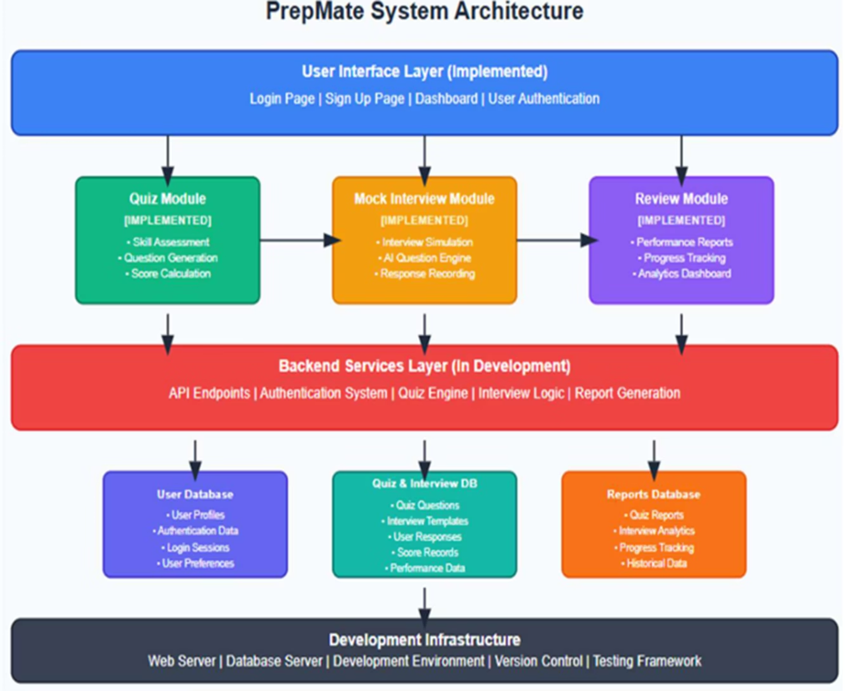 System Architecture

[10]. UML DIAGRAMS:

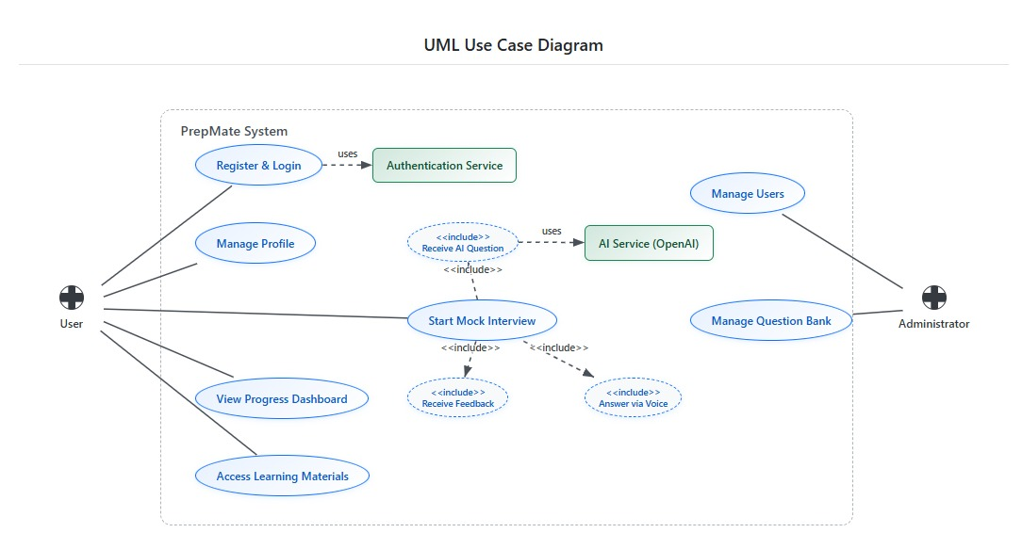

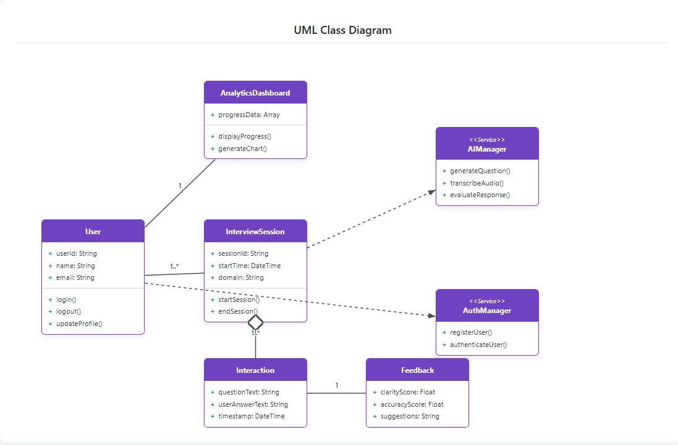

[11]SUMMARY:

PrepMate is a focused, voice-first practice platform that pairs live AI mock interviews with tightly targeted, adaptive quizzes to accelerate interview readiness for final-year students and fresh graduates. Each interview captures speech in real time, transcribes it, and scores answers against a compact rubric covering content quality (structure, relevance, correctness) and delivery (pace, clarity, fillers), then immediately guides a re-answer flow with actionable tips. The goal is to deliver fast, useful feedback that learners can act on within the same session, minimizing latency between practice and improvement and building confidence through repeated, rubric-aligned attempts.
What makes PrepMate distinct is the closed loop between interviews and quizzes: every miss or weak dimension in the interview instantly seeds short, role-agnostic micro-quizzes that target exactly those knowledge or communication gaps, provide concise explanations, and feed the next interview plan. Dashboards track longitudinal trends such as rubric attainment by criterion, words-per-minute/clarity bands, and reductions in repeat weak topics, enabling learners and mentors to see tangible progress over sessions. Pilot objectives emphasize responsiveness and learning impact, aiming for median end-to-end latency around a few seconds, user-rated usefulness above four out of five, roughly 20% quiz-score lift within four sessions, and a 30% drop in recurring weak areas as the interview–quiz loop adapts to each learner’s trajectory.

REFERENCES:
- S. Dunbale, S. Patil, B. Vakare, and K. Shinde, “AI Based Mock Interview System,” International Journal of Research Publication and Reviews, vol. 6, no. 5, pp. 4887–4893, May 2025.
- S. Khapekar, S. Bothara, T. Babar, and R. Kine, “AI Powered Mock Interview System with Real-Time Voice and Emotion Analysis,” International Journal of Novel Research and Development, 2024.
- “A REVIEW: MOCK INTERVIEW SYSTEM USING AI,” International Research Journal of Modernization in Engineering Technology and Science, Oct. 2024.
- J. Passmore and E. Velez, “A systematic literature review of artificial intelligence (AI) in coaching,” Journal of Work-Applied Management, 2025.
- S. Khapekar, S. Bothara, T. Babar, and R. Kine, “AI Powered Mock Interview System with Real-Time Voice and Emotion Analysis,” International Journal of Novel Research and Development, Feb. 2024.
- “A Survey on Voice-Based 2D AI-Powered Mock Interview Assistant,” International Journal of Advanced Research in Computer and Communication Engineering, June 2025.
- M. N. Hossain and A. A. Nisa, “AI Powered Mock Interview Platform,” International Journal of Innovative Research in Multidisciplinary Physical and Social Sciences, 2023.
- B. Nofal, “AI-enhanced interview simulation in the metaverse,” AI Open Research, 2025.
- R. Patil, S. Kale, and A. Deshmukh, “PARIKSHAN.IO: AI-Driven Mock Interview Platform,” International Research Journal of Modernization in Engineering, Technology and Science, vol. 5, no. 4, Apr. 2025.
- P. Sharma, K. Gupta, and M. Verma, “AI-Based Mock Interview Simulation System for Job Readiness,” Journal of Emerging Technologies and Innovative Research, vol. 12, no. 5, 2025.
- S. Raj, A. Jain, and P. Rao, “AI-Virtual Interviewer,” International Journal of Research Publication and Reviews, vol. 6, no. 5, 2025.
- H. Singh and R. Mehta, “AI-Driven Mock Technical Interviews on Student Cohorts: A Formative Study,” preprint, 2025.
- V. Kulkarni, P. Nair, and S. Kamat, “Resume Analysis Using NLP and ATS Algorithm,” International Journal of Latest Technology in Engineering, Management & Applied Science, vol. 14, no. 5, 2025.
- S. A. Khan and T. Reddy, “Automated Resume Parsing: Techniques, Challenges, and Opportunities,” Multidisciplinary Global Education Journal, vol. 2, no. 2, 2025.
- Iyer and P. Joshi, “AI-Driven Virtual Interviewer: Personalized Q&A and Instant Feedback,” Multidisciplinary Global Education Journal, vol. 2, no. 1, 2025.
- R. Srinivasan, N. Banerjee, and K. Rao, “AI-Driven Real-Time Interview Simulation with Voice Recognition and Facial Analysis,” Indian Journal of Science and Technology, vol. 17, no. 8, 2024.
- M. Desai and A. Patel, “AI-Based Mock Interview with Emotion Detection and Real-Time Feedback,” preprint, Sept. 2025.
- S. Nigam, “AI-Powered Mock Interview Platform,” International Journal of Innovative Research in Multidisciplinary Physical and Social Sciences, vol. 13, no. 1, 2025.
- Kulal and R. Rao, “AI-Based Interview Mocker System,” International Journal of All Research in Applied Science and Computer Technology, vol. 11, no. 2, 2024.
- P. Shah and V. Goyal, “Survey on Different Mock Interview Platforms,” International Journal of Scientific Research in Computer Science, Engineering and Information Technology, vol. 10, no. 6, 2024.

