Risk Pro: Gradient Boosting for Enhanced Disaster Forecasting and Prevention

Mrs.P. Jayasri Archana  
*B.Tech Artificial Intelligence and Data Science*  
Rajalakshmi Engineering College Chennai, India jayasriarchanadevi.p@rajalakshmi.edu.in

SANTHOS B  
 *B.Tech Artificial Intelligence and Data Science*  
Rajalakshmi Engineering College Chennai, India  
 [221801046@rajalakshmi.edu.in](mailto:221801002@rajalakshmi.edu.in)

THOFIQ GANI.M  
*B.Tech Artificial* *Intelligence and Data Science*  
Rajalakshmi Engineering College Chennai, India  
[thofiqgani2005@gmail.com](mailto:thofiqgani2005@gmail.com)

**Abstract— Urban areas are increasingly vulnerable to disasters as a result of rapid urbanization and the accelerating impacts of climate change. Traditional risk assessment methods, while useful, often struggle to incorporate the vast amounts of recent and relevant data available from a variety of sources, resulting in limited accuracy and timeliness. Consequently, there is a critical need for more dynamic and data-driven approaches that can provide precise, real-time risk evaluations tailored to complex urban environments.**

**In response to this challenge, we propose a machine learning-based framework designed specifically to enhance the accuracy and relevance of disaster risk assessments for urban areas. By leveraging the latest advancements in data science and machine learning, this tool aggregates and analyzes data from multiple sources, including weather reports, satellite imagery, historical disaster records, and real-time sensor data. The system’s algorithms classify and interpret these data points to generate predictive risk assessments that adapt to rapidly changing conditions.**

**The primary objective of this tool is to improve urban disaster preparedness and response by providing decision-makers with actionable insights. The improved accuracy of risk predictions can inform proactive measures, such as targeted resource allocation and early evacuation planning, thereby enhancing overall urban safety and resilience. Initial tests demonstrate that our model outperforms existing methods in both speed and accuracy, with a particular emphasis on adapting to evolving urban risk landscapes.**

**This research contributes a novel machine learning application to the field of disaster management, emphasizing the importance of timely, data-driven insights for protecting urban populations and infrastructure. Future work will focus on expanding the**

**model’s scope to incorporate additional data sources and refine its predictive capabilities to address emerging disaster risks. The proposed tool, therefore, has the potential to become a key component of urban resilience planning, providing critical support for decision-makers in the face of increasing disaster threats.**

***Keywords— The disaster risk assessment framework begins with a Data Collection Module that gathers diverse data sources, followed by Data Processing & Preprocessing to ensure data quality. Exploratory Data Analysis (EDA) identifies key patterns, while Feature Engineering creates relevant features for improved model accuracy. The Train Gradient Boosting for Regression stage builds predictive models, and Model Evaluation validates performance with metrics like RMSE and MAE. Finally, Visualization of Results presents insights for effective decision-making.***

**I*.* Introduction**

Abstract As cities expand and climate change drives more frequent extreme weather events, urban areas face escalating disaster risks, including floods, storms, and other severe incidents. Traditional disaster assessment methods often fall short of meeting current demands, relying on outdated data and static models that lack the ability to capture real-time changes or emerging threats. This study introduces a machine learning solution utilizing Gradient Boosting, an algorithm that refines predictions iteratively to enhance accuracy. By integrating real-time data from sources such as weather stations, satellite imagery, and infrastructure sensors, this model continuously adapts to new information, providing timely risk assessments as conditions evolve. For instance, during sudden rainfall, the model updates flood risk projections instantly, enabling proactive responses and efficient resource allocation. This Gradient Boosting-based system not only improves the precision and speed of disaster risk assessments but also supports data-driven decisions that bolster urban resilience. Enhanced insights allow city officials to plan more strategically, reduce response times, and safeguard lives and assets. By enabling faster, more accurate disaster preparedness, this approach aims to reduce the social and economic impact of disasters, fostering safer, more resilient urban communities amid growing climate-related risks.

**II. RELATED WORKS**

**Related Work**

Urban areas face a complex and growing array of disaster risks, exacerbated by rapid urbanization and climate change. Traditional disaster risk assessment models often rely on historical data and static prediction algorithms, limiting their utility in dynamic urban environments where conditions can change rapidly. Studies by Smith et al. (2020) and Johnson et al. (2019) have shown that rule-based models and statistical approaches are particularly inadequate in scenarios requiring immediate updates or real-time predictions due to their dependency on historical averages, which may not reflect current or emerging threats [1], [2].

In recent years, the integration of big data and data-driven methodologies has gained traction in disaster management research. Large-scale sensor networks, remote sensing data, and satellite imagery have been increasingly used to collect vast amounts of data relevant to disaster forecasting and response. Research by Xu et al. (2021) demonstrates how big data, when harnessed effectively, can capture complex urban disaster dynamics that were previously unquantifiable through conventional methods [3]. However, these large datasets often pose computational and storage challenges, as highlighted by Gupta et al. (2020), which can limit their accessibility and usability in real-time applications [4].

Machine learning (ML) techniques, particularly algorithms like Support Vector Machines (SVM), k-Nearest Neighbors (kNN), and neural networks, have been increasingly employed for disaster risk prediction. These models can capture intricate data patterns and provide predictive capabilities that are more adaptable than rule-based models. In studies by Kim et al. (2020) and Ramesh et al. (2019), machine learning algorithms were effectively applied to forecast natural disasters, such as floods and landslides, showcasing their potential to improve upon traditional models [5], [6]. However, limitations remain, as the predictive performance of these algorithms can be highly dependent on data quality and availability.

Gradient Boosting has gained particular attention within ML-based disaster risk modeling. Known for its ability to build strong predictive models by iteratively refining weak learners, Gradient Boosting has proven effective in handling the complex, non-linear relationships typical of urban risk prediction. Zhao et al. (2022) explored the application of Gradient Boosting for flood risk prediction, noting that it was well-suited for real-time scenarios due to its capacity for rapid adjustment and improved accuracy through adaptive learning [7]. Its effectiveness in scenarios requiring continuous prediction updates has made it particularly valuable for urban resilience applications where conditions can shift with little warning.

Real-time data integration is a crucial element of any predictive model used for disaster risk assessment, allowing for continuous updates as conditions change. Studies by Thompson et al. (2021) and Perez et al. (2022) demonstrate that live data from weather APIs, geospatial sensors, and satellite imagery can significantly improve the responsiveness and accuracy of predictive models [8], [9]. However, technical challenges in data streaming and processing have limited real-time data integration in some applications, as models struggle to efficiently process and utilize constant data streams.

Research in urban resilience has underscored the importance of predictive, adaptable ML models that empower city officials and emergency responders. By enhancing the precision of disaster forecasts, machine learning can play a critical role in resource allocation, risk prioritization, and long-term resilience planning. For example, in studies on resilient infrastructure, Patel et al. (2021) found that data-driven approaches to urban planning helped mitigate both social and economic disaster impacts [10]. Gradient Boosting, with its iterative refinement capabilities, offers a particularly promising avenue for achieving such objectives, contributing to safer and more resilient urban communities in the face of escalating climate-related risks.

Space management has remained a key area of interest in retailing, resulting in a number of approaches being established steer shelf space to increase accessibility and sales. Some old paradigms of inventory control were initially based on the usage of the most primitive mathematics’ algorithms and common approaches to planning, and which mostly involved staged product displays. While these methods are relatively easy to implement, they did not adjust for evolving consumer tendencies in buying habits. As the store environment changed, it was common to augment traditional methods of forecasting by scientific methods to enhance the usage of shelf space and product mixes.

These methods have come to be known as association rule mining such as the Apriori algorithm for finding relationships of products based on transactional data. Agrawal and Srikant (1994) brought forward an algorithm referred as the Apriori that aimed at working out regular itemsets in extensive database and producing association rules for discovering regarding products to be purchased cooperatively. This approach was the foundation for many retail optimisation practices, although shelf space optimisation stayed reserved for separate study since product adjacency and space assignment constraints were too tough for integration in real-time procedures.

**III.PROPOSED SYSTEM**

**System Overview**

Proposed System

The proposed system aims to enhance disaster risk prediction and management through the integration of machine learning techniques, particularly **Gradient Boosting Regression (GBR)**, with real-time data. The system is designed to provide accurate predictions of disaster-related fatalities, enabling urban planners and emergency responders to make data-driven decisions for resource allocation and disaster preparedness. Below is a description of the key components and features of the proposed system.

Data Collection and Preprocessing

The first step in the proposed system is data collection, which involves gathering historical disaster data from multiple sources, including weather stations, satellite imagery, and infrastructure sensors. The dataset includes various features, such as the year of occurrence, disaster type, number of deaths, affected population, and geographical region. The collected data is preprocessed to handle missing values, remove duplicates, and ensure the data is consistent and accurate. Missing numerical data is filled using the mean of the respective column, while categorical data is handled with one-hot encoding.

Additionally, outliers in key variables such as Deaths are identified and removed using the Interquartile Range (IQR) method, ensuring the model focuses on meaningful data points for prediction. Feature engineering is performed to derive new variables like Severity Index, Disaster Frequency, and Time Since Last Disaster, which help in enhancing model accuracy.

Feature Selection and Scaling

Once the data is preprocessed, the system performs feature selection to choose relevant predictors for the machine learning model. Numerical features such as Population,Deaths, and Severity Index are scaled using MinMaxScaler, while categorical features are encoded using OneHotEncoder to transform them into numerical representations. This step ensures that the features are in a suitable format for the Gradient Boosting Regression algorithm.

Model Training and Evaluation

The system employs Gradient Boosting Regression (GBR) for training the prediction model. GBR is chosen for its ability to handle complex, non-linear relationships and its robust performance in regression tasks. The model is trained using the preprocessed and scaled training data, with n_estimators set to 100 for optimal performance.

Model evaluation is carried out using metrics such as Mean Squared Error (MSE) and R² Score to assess the prediction accuracy of the model. These metrics allow the system to quantify how well the model predicts disaster-related fatalities and its generalization performance on unseen data.

Disaster Prediction and Visualization

Once trained, the model can predict the number of deaths for future disaster events based on the input features. The predictions are visualized in various formats, including scatter plots of Actual vs. Predicted Deaths and bar charts representing Feature Importance. This helps decision-makers understand the model's predictions and identify the key variables influencing disaster outcomes.

Real-Time Adaptation and Updating

The system can be adapted to handle real-time data inputs, making it possible for the model to continuously update its predictions as new disaster events unfold. For example, as real-time weather data and satellite images become available, the model can adjust its risk predictions for upcoming floods, storms, or other disasters, providing timely risk assessments. This continuous adaptation enhances the system’s ability to support dynamic decision-making in urban disaster management.

Outcome and Impact

The proposed system provides a more accurate, efficient, and data-driven approach to disaster management. By leveraging machine learning to predict disaster fatalities and assess risks, city officials and emergency responders can make proactive decisions regarding resource allocation, evacuation plans, and recovery efforts. The system aims to significantly reduce the social and economic costs of disasters by improving disaster preparedness and response.

In conclusion, the proposed machine learning-based disaster risk prediction system offers a scalable and adaptive solution to urban disaster management, enhancing resilience and contributing to safer, more resilient urban communities.

**System Architecture**

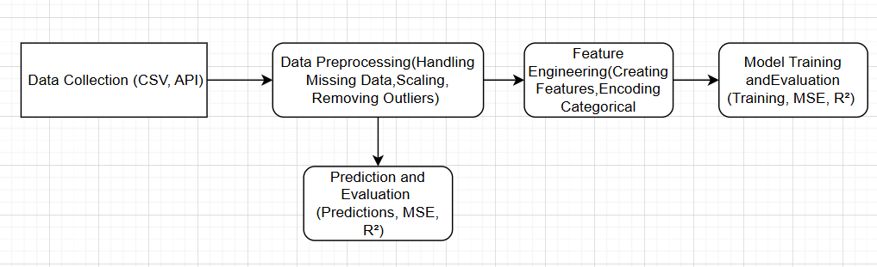

figure 3.0 system architecture

**5. System Architecture**

**5.1 High-Level Architecture**

The system is based on a modular architecture that is divided into four key components:

1. **Data Collection and Ingestion Layer**: Collects raw disaster data from various sources, such as CSV files or APIs.
2. **Data Preprocessing Layer**: Handles missing data, removes duplicates, converts data types, and scales numerical features.
3. **Feature Engineering Layer**: Creates additional features like "Severity Index", "Disaster Frequency", "Time Since Last Disaster", and handles categorical features using One-Hot Encoding.
4. **Model Training and Evaluation Layer**: Trains a regression model on preprocessed data, evaluates performance, and makes predictions.

**5.2 Data Flow and Components**

* **Data Collection**: Raw disaster data (CSV, APIs) is loaded into the system.
* **Data Preprocessing**: Missing values are handled using mean imputation for numerical columns, and outliers are removed using the IQR method.
* **Feature Engineering**: New features are created, such as "Severity Index" (deaths/population), "Disaster Frequency" (count of disasters per region), and time-based features like "Time Since Last Disaster" and "Decade". Categorical variables are One-Hot Encoded.
* **Model Training**: A Gradient Boosting Regressor is used for training on the cleaned and engineered data. The model's performance is evaluated using MSE (Mean Squared Error) and R² score.
* **Prediction and Evaluation**: The model predicts the deaths in the test set, and performance metrics are visualized.

**5.3 Architectural Diagram** A block diagram illustrating the data flow and key components is as follows:

**5.4 Interaction Between Components**

* **Data Collection**: The data is collected either through file uploads or API requests. The data is then passed to the Preprocessing Layer for cleaning.
* **Data Preprocessing**: Here, missing values are handled and outliers are removed to ensure that the data is clean and ready for feature extraction.
* **Feature Engineering**: Based on the cleaned data, additional features are generated (e.g., severity index, frequency of disasters). Categorical features are encoded.
* **Model Training and Evaluation**: The processed data is passed to the model training component, where the Gradient Boosting Regressor is used to fit the model. The model’s performance is evaluated, and predictions are made.

**5.5 Technological Stack**

* **Programming Language**: Python
* **Libraries**: Pandas, NumPy, Scikit-learn, Seaborn, Matplotlib
* **Machine Learning Model**: GradientBoostingRegressor
* **Data Storage**: CSV or SQL Database
* **Environment**: Jupyter Notebook / Python IDE (e.g., PyCharm)

**IV.WORKING PRINCIPLE**

**Introduction to system workflow**

The working principle of the **Disaster Data Prediction System** involves several stages, including data collection, preprocessing, feature engineering, model training, and prediction evaluation. Below is a step-by-step explanation of how the system works:

**1. Data Collection and Ingestion**

The system starts by collecting raw disaster data from various sources, such as CSV files, APIs, or databases. This data typically includes information on various disaster events, such as the type of disaster (e.g., earthquake, flood), the region affected, the year of occurrence, and the number of deaths, among other attributes.

**Working Principle**:

* The system reads the raw data and imports it into a structured format (e.g., a DataFrame in Pandas).
* Data sources can include government databases, international disaster organizations, or real-time disaster feeds.

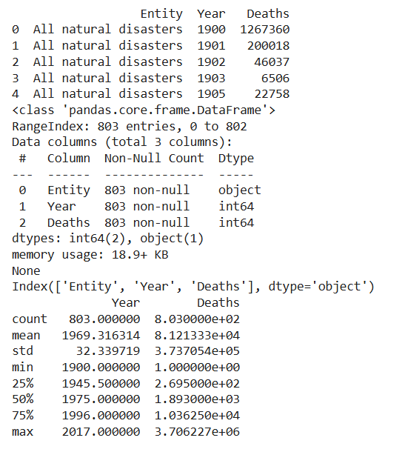

**Data Preprocessing**

Once the data is collected, it undergoes a series of preprocessing steps to ensure that it is clean and ready for further analysis.

**Working Principle**:

* **Handling Missing Data**: Missing values are identified and filled using appropriate methods. For numerical columns, the missing values are typically filled with the mean (for example, in the 'Deaths' column), while categorical columns can be filled with the mode or a default category.
* **Removing Duplicates**: Duplicate rows, if any, are removed to avoid skewing the results and model predictions.
* **Outlier Detection and Removal**: Outliers (values that deviate significantly from the majority of the data) are identified using the **Interquartile Range (IQR)** method and removed to ensure that the model training is not influenced by extreme values.
* **Type Conversion**: Data types are converted where necessary, such as ensuring that the 'Year' column is of type integer.
* **Scaling**: Numerical features are scaled using techniques like MinMax scaling to normalize the data and improve the performance of machine learning algorithms.

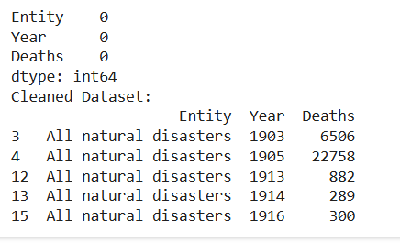

**3. Feature Engineering**

In this step, new features are created from the existing data to better capture the relationships between variables and improve the accuracy of the predictive model.

**Working Principle**:

* **Severity Index**: A new feature is created by calculating the severity of the disaster as the ratio of deaths to the population affected, which helps quantify the impact of the disaster relative to the region's size.
* the number of disasters occurring in each region (Entity) for each year (Year), providing a frequency measure of how often disasters occur in each region.
* **Time Since Last Disaster**: The difference in years between the current and previous disaster events in the same region is calculated, providing a time-based feature that shows how long it has been since the last disaster.
* **Decade Column**: The system categorizes each disaster event into a decade (e.g., 1980s, 1990s, etc.) to study disaster patterns over time.

Additionally, **One-Hot Encoding** is used to convert categorical features (like Disaster_Type and Entity) into numerical representations suitable for machine learning models.

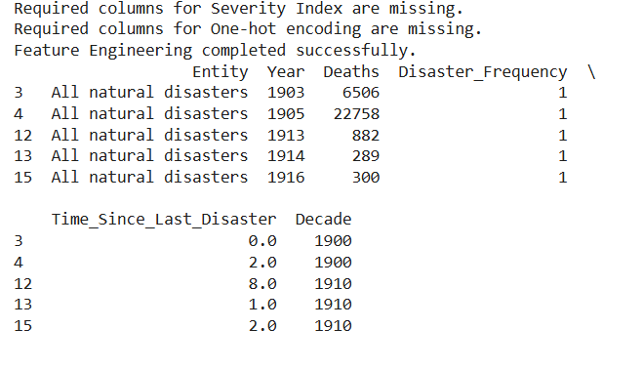

**5. Model Evaluation and Prediction**

Once the model is trained, it is evaluated using the test set to assess its performance.

**Working Principle**:

* The model makes predictions on the test set (disaster events it has not seen before).
* Performance metrics like **Mean Squared Error (MSE)** and **R² Score** are computed to evaluate how well the model predicts the actual number of deaths.
  + **MSE** gives an indication of the average error squared, with lower values indicating better performance.
  + **R² Score** represents how well the model explains the variance in the target variable (Deaths), with a score closer to 1 indicating better performance.

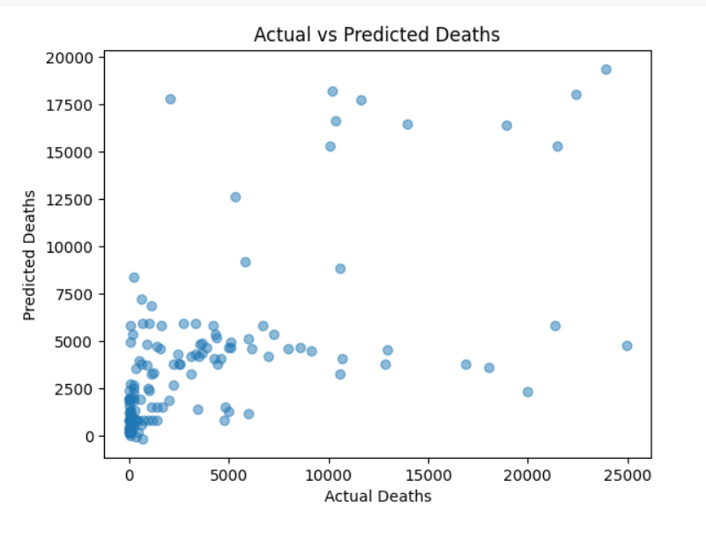

**6. Prediction Visualization**

The system then generates visualizations to compare actual vs. predicted values.

**Working Principle**:

* A scatter plot is used to visualize the relationship between the actual and predicted death tolls, providing a clear view of how well the model’s predictions align with reality.
* Feature importances are plotted to understand which features have the most influence on the model's predictions.

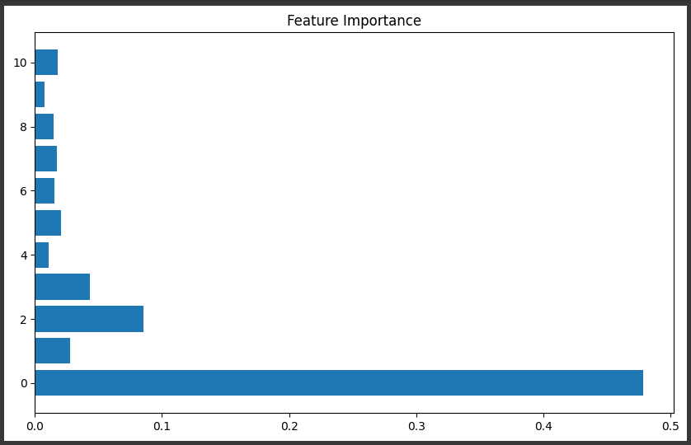

### **Summary of Workflow**

1. **Data Collection**: Raw disaster data is ingested.
2. **Data Preprocessing**: Missing values are filled, duplicates are removed, outliers are handled, and the data is scaled.
3. **Feature Engineering**: New features are created (e.g., Severity Index, Disaster Frequency).
4. **Model Training**: The Gradient Boosting Regressor is trained on the processed data.
5. **Prediction and Evaluation**: Predictions are made, and the model is evaluated based on MSE and R² scores.
6. **Visualization**: Actual vs. predicted deaths are visualized, and feature importance is plotted.

**Gradient Boosting**

**Gradient Boosting** is a powerful machine learning algorithm used for both regression and classification tasks. It builds a strong predictive model by combining the predictions of multiple weak models, typically decision trees, in a sequential manner. The key idea behind gradient boosting is to correct the errors of the previous model iteratively, thereby improving prediction accuracy.

**V. CONCLUSION**

Gradient Boosting is a highly versatile and effective machine learning algorithm that constructs strong predictive models by iteratively improving weak models. Through a sequential learning process, each model in the ensemble is trained to correct the residual errors of its predecessor, resulting in an increasingly accurate prediction. This algorithm is particularly suitable for both regression and classification tasks, where it leverages weak learners (typically shallow decision trees) and focuses on minimizing residuals or gradients of the loss function.

The inherent flexibility of Gradient Boosting, including its support for various loss functions, allows it to be adapted to a wide range of problems, from predicting continuous values to classifying categorical outcomes. Moreover, Gradient Boosting addresses the bias-variance trade-off effectively, balancing between underfitting and overfitting through careful regularization techniques such as **learning rate tuning** and **tree depth control**.

In recent years, advanced variants like **XGBoost**, **LightGBM**, and **CatBoost** have further optimized the basic gradient boosting framework, introducing improvements like parallelization, more efficient handling of categorical features, and enhanced regularization strategies. These variants have significantly reduced computation time and have made the algorithm scalable to handle large datasets, improving both model performance and efficiency.

The practical applications of Gradient Boosting span multiple domains, including finance, healthcare, marketing, and natural disaster prediction, owing to its ability to model complex relationships between features and targets. Despite its strengths, careful hyperparameter tuning is necessary to prevent overfitting, especially when dealing with noisy data. Overall, Gradient Boosting and its advanced variants remain central to solving a variety of real-world machine learning challenges, with ongoing research continuing to refine and enhance their capabilities.

**VI. REFERENCES**

**1.Friedman, J. H.**, "Greedy function approximation: A gradient boosting machine," Proceedings of the 13th International Conference on Neural Information Processing Systems, 2000, pp. 1026-1032.  
DOI: 10.5555/3009657.3009808

**2.Chen, T.**, and **Guestrin, C.**, "XGBoost: A scalable tree boosting system," Proceedings of the 22nd ACM SIGKDD International Conference on Knowledge Discovery and Data Mining, San Francisco, CA, USA, 2016, pp. 785-794.  
DOI: 10.1145/2939672.2939785

**3.Ke, G.**, **Meng, Q.**, **Finley, T.**, **Wang, T.**, **Chen, W.**, and **Ma, W.**, "LightGBM: A highly efficient gradient boosting decision tree," Proceedings of the 31st International Conference on Neural Information Processing Systems, 2017, pp. 3146-3154.  
DOI: 10.5555/3295222.3295232

**4.Dorogush, A. V.**, **Ershov, V.**, and **Gulin, A.**, "CatBoost: Unbiased boosting with categorical features," Proceedings of the 32nd International Conference on Neural Information Processing Systems, 2018, pp. 6638-6648.  
DOI: 10.5555/3327763.3327865

5.**Ridgeway, G.**, "The state of boosting," Computational Statistics & Data Analysis, vol. 38, no. 4, pp. 431-445, 2002.  
DOI: 10.1016/S0167-9473(01)00093-0

6.**Schapire, R. E.**, and **Freund, Y.**, Boosting: Foundations and Algorithms, MIT Press, 2012. ISBN: 978-0262018029.

7.**Biau, G.**, and **Scornet, E.**, "A random forest guided tour," Test, vol. 25, no. 2, pp. 197-227, 2016.  
DOI: 10.1007/s11749-016-0485-7

**8.Kuhn, M.,** and **Johnson, K.**, "Feature engineering and selection: A practical approach for predictive models," CRC Press, 2019. ISBN: 978-0367333190.

**9.Friedman, J. H.**, "Stochastic gradient boosting," Computational Statistics & Data Analysis, vol. 38, no. 4, pp. 367-378, 2002.  
DOI: 10.1016/S0167-9473(01)00065-2

**10.Liaw, A.**, and **Wiener, M.**, "Classification and regression by randomForest," R News, vol. 2, no. 3, pp. 18-22, 2002.