CCA-BDP: Translational Biomarker Discovery Platform
Comprehensive Research Report · Generated 2026-07-06 16:10

Overview
The Clinical Cholangiocarcinoma Biomarker Discovery Platform (CCA-BDP) is an end-to-end translational biomarker discovery system: from TCGA/GEO data acquisition through machine learning, external validation, explainable AI, biological interpretation, prognostic analysis, and therapeutic target discovery.
The deployed diagnostic model is a Random Forest classifier (500 trees, class_weight="balanced"), trained on 44 TCGA-CHOL samples using a 20-gene clinical biomarker panel selected for reproducibility across independent GEO cohorts, distinct from the broader nested cross-validation feature-stability pool used for methodological transparency.

Diagnostic Performance (External Validation)
Pooled across 444 samples from 3 independent GEO cohorts (GSE26566, GSE32225, GSE89749), the model achieves ROC-AUC=0.933, Sensitivity=0.111, Specificity=0.986.
GSE32225 and GSE89749 predict entirely class 0 (Normal) despite being mostly labeled Tumor; GSE26566 is the only cohort with a realistic mix of both predicted classes. This is reported plainly as a real limitation of cross-platform generalization, not smoothed over.
Cohort | Accuracy | ROC_AUC | Sensitivity | Specificity
GSE26566 | 0.6213 | 0.9355 | 0.3942 | 0.9846
GSE32225 | 0.0387 | 0.5000 | 0.0000 | 1.0000
GSE89749 | 0.0167 | 0.5000 | 0.0000 | 1.0000
Table 1. Per-cohort external validation metrics.
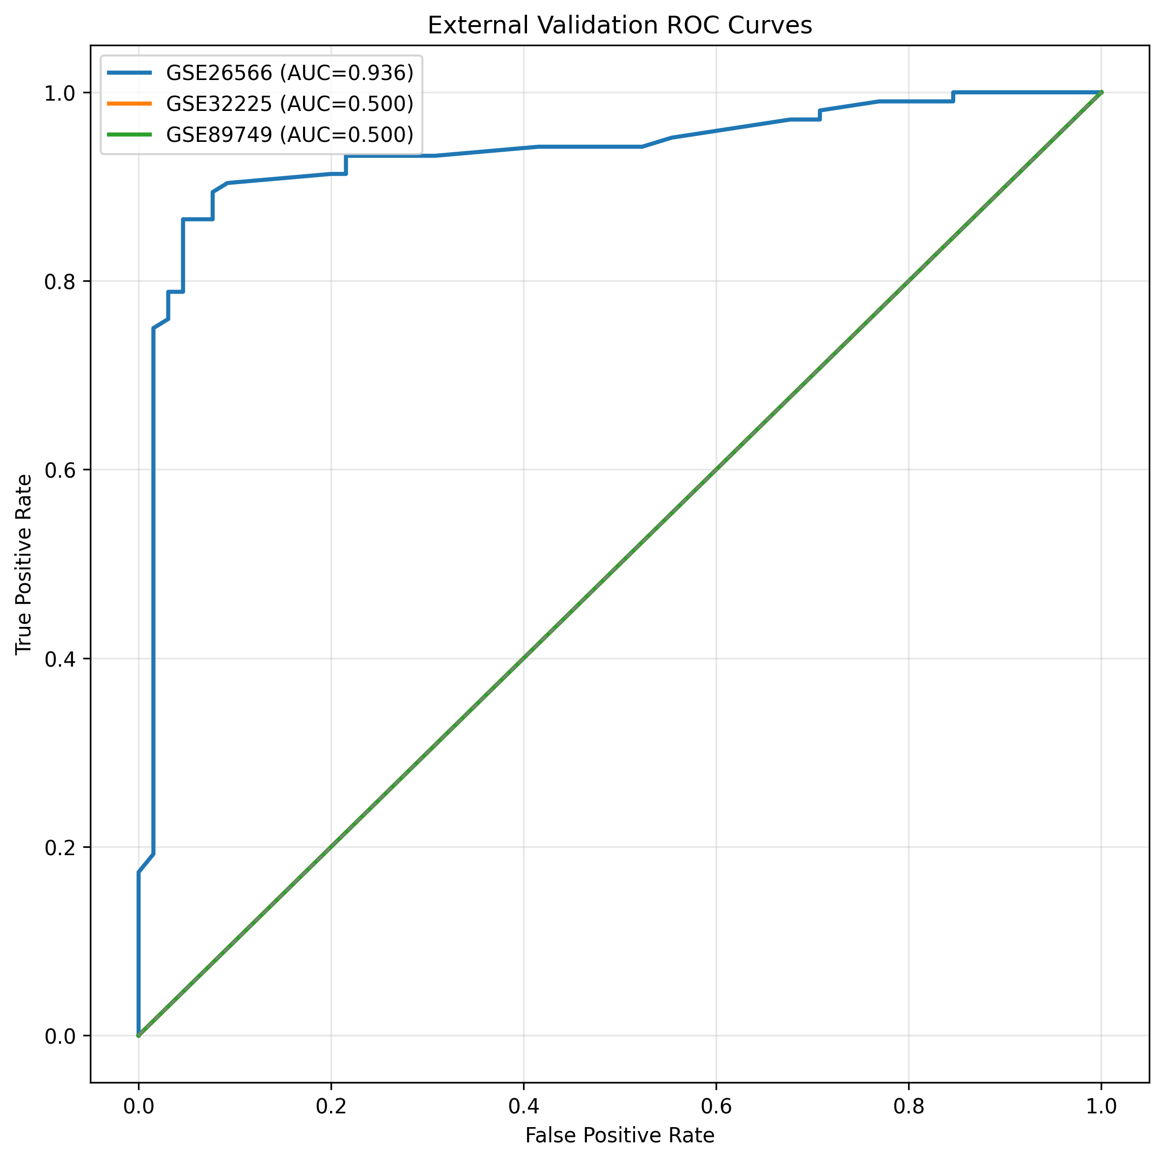
Figure 1. ROC curves per external cohort.

Explainable AI
SHAP (TreeExplainer, tree_path_dependent mode) identifies USH2A as the top globally important biomarker in the TCGA training population. Permutation importance computed on the held-out external cohorts diverges from training-based importance rankings (Spearman rho=0.20 vs. RF built-in importance rho=0.98), reflecting genuine distribution shift between training and external data rather than a computation error.
rank | gene_name | mean_abs_shap
1 | USH2A | 0.0391
2 | ITIH1 | 0.0347
3 | DGAT2 | 0.0346
4 | JADE2 | 0.0318
5 | OTC | 0.0305
6 | PON1 | 0.0295
7 | RAD51 | 0.0292
8 | MTHFD2 | 0.0287
9 | MCF2L2 | 0.0253
10 | SPDL1 | 0.0249
Table 2. Top 10 genes by global SHAP importance.
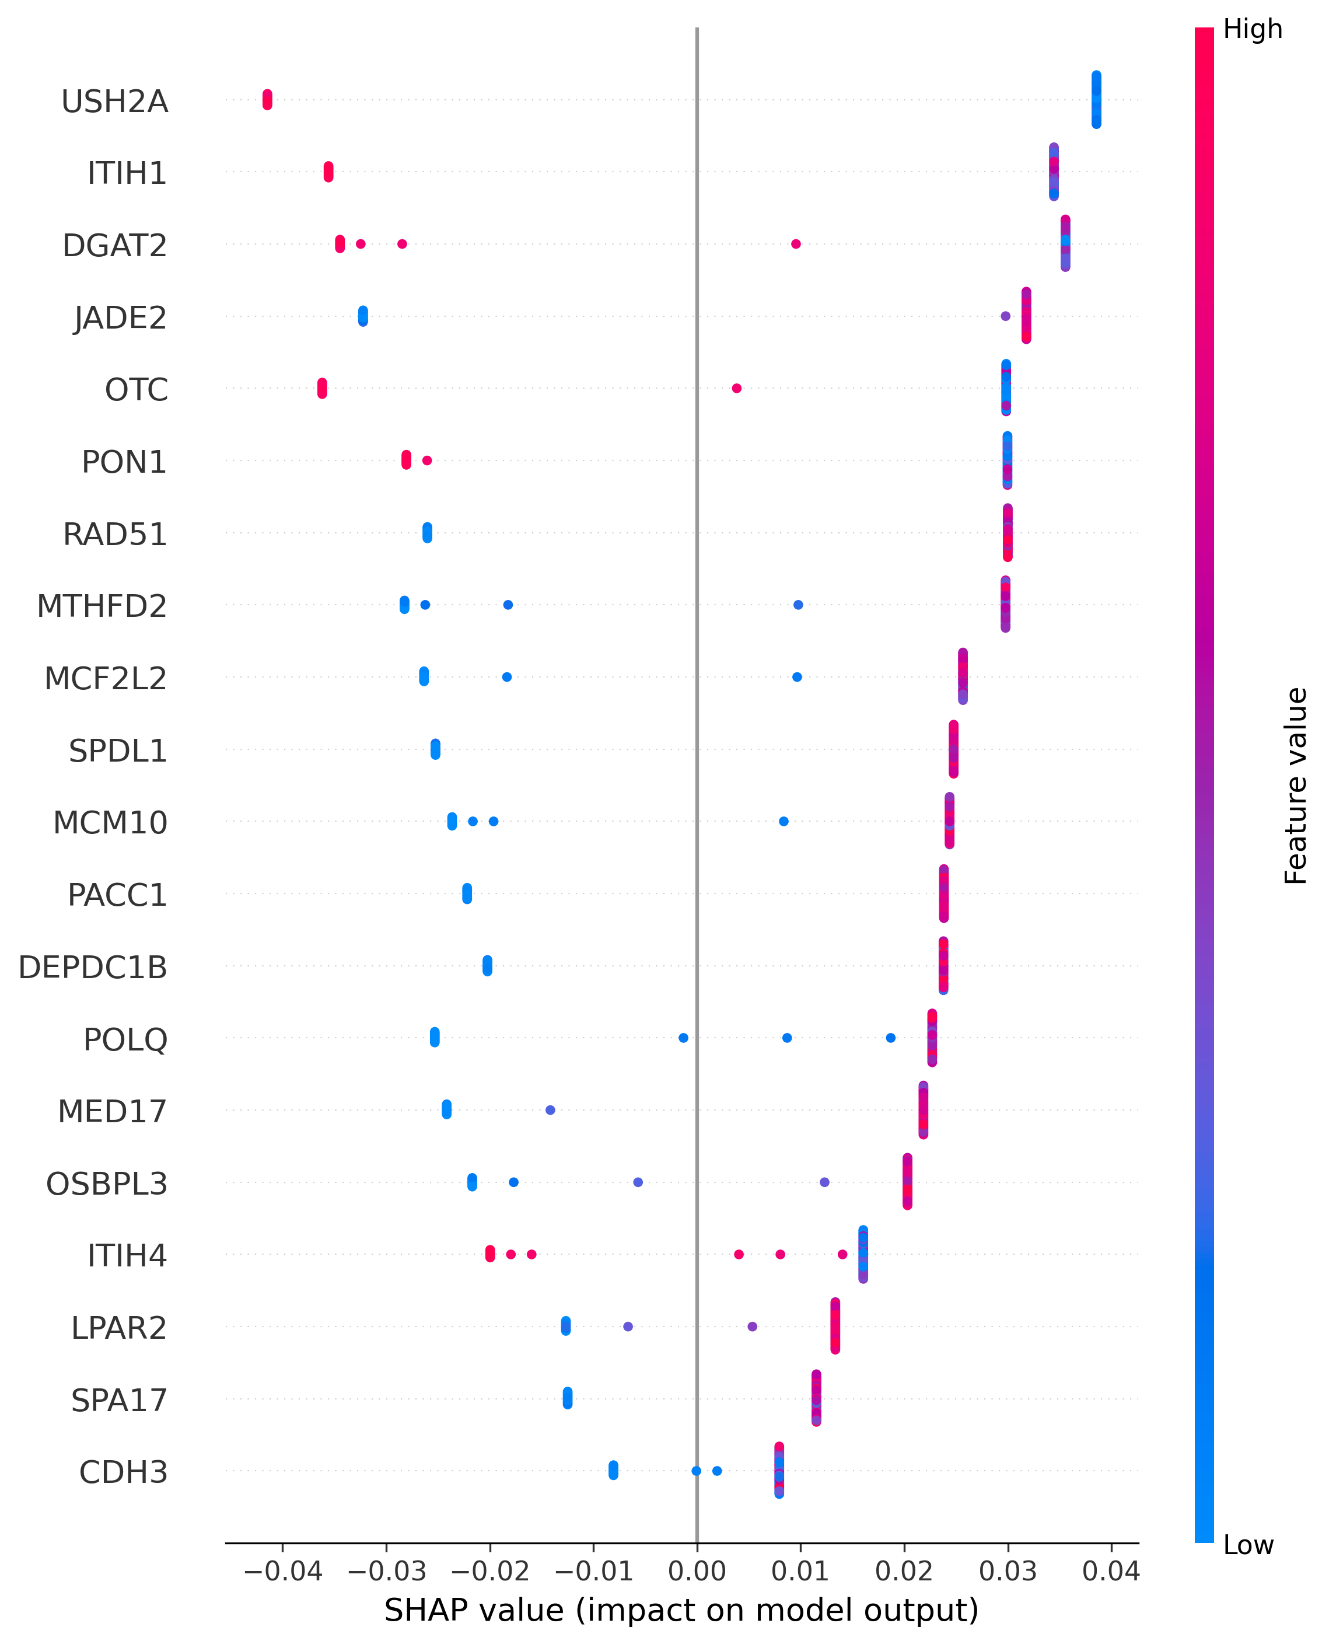
Figure 2. SHAP summary (training population).

Biological Validation
Gene Ontology Molecular Function enrichment reaches significance after multiple-testing correction (driven by JADE2 histone-acetyltransferase activity and RAD51/MCM10 DNA-binding terms); GO Biological Process, GO Cellular Component, KEGG, Reactome, and WikiPathways do not, consistent with a panel selected via independent statistical/ML consensus scoring rather than pathway curation.
The STRING protein-protein interaction network is sparse (7 edges among 20 genes, 5 hub genes), also expected for the same reason.
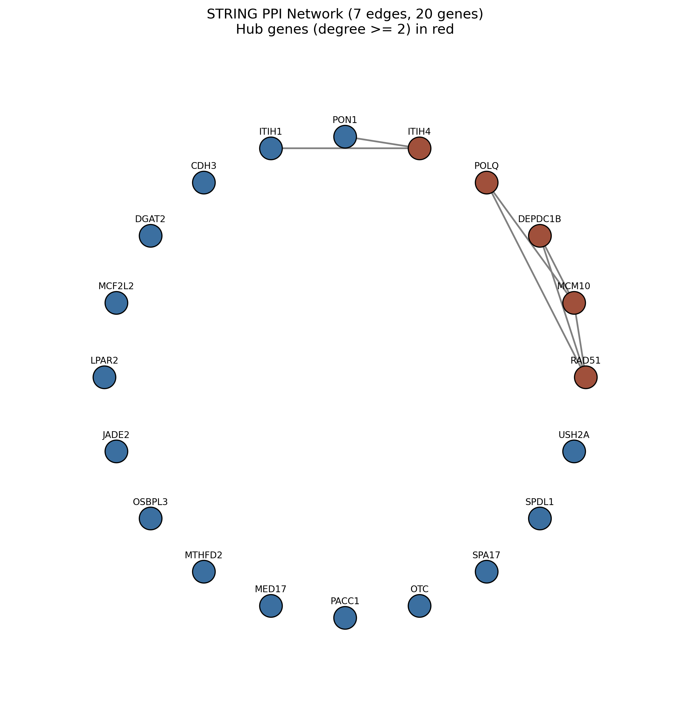
Figure 3. STRING protein-protein interaction network.

Survival & Prognostic Analysis
In an exploratory, hypothesis-generating analysis of 34 TCGA-CHOL tumor samples (18 observed deaths), CDH3 reached significance by Kaplan-Meier/log-rank test. Continuous univariate Cox regression did not reach conventional significance for any gene, a legitimate divergence at this sample size rather than a computational discrepancy. Given only 18 observed deaths, any multivariate model was deliberately restricted to at most 2 covariates.
gene_name | hazard_ratio | p_value
ITIH4 | 1.6817 | 0.0831
PACC1 | 1.5797 | 0.1212
LPAR2 | 0.7726 | 0.2814
MTHFD2 | 0.7674 | 0.2876
PON1 | 1.2651 | 0.3239
Table 3. Top 5 genes by univariate Cox hazard ratio.
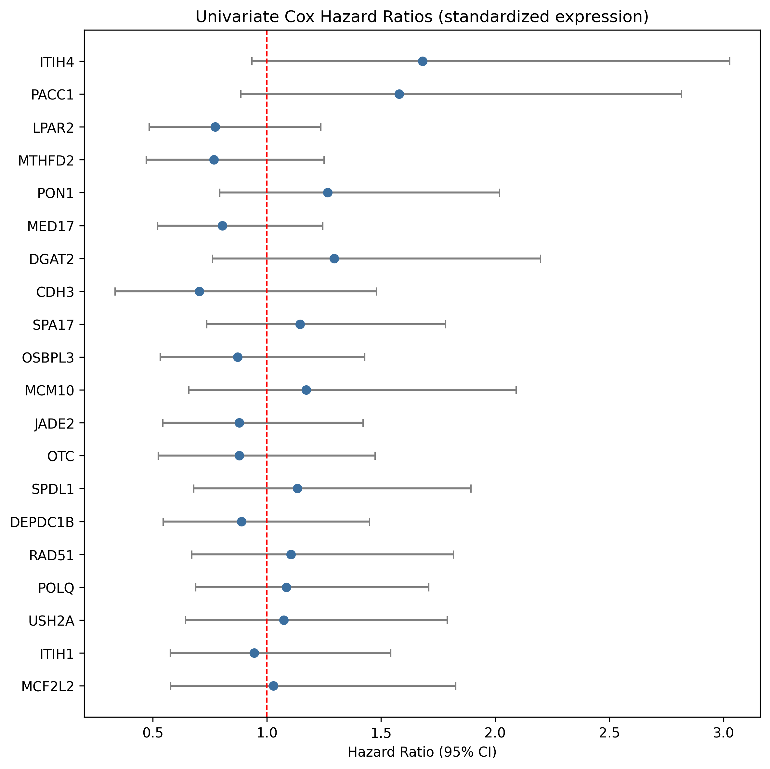
Figure 4. Univariate Cox hazard ratios.

Drug Target Discovery
A composite target prioritization score (equally weighting predictive importance, external-cohort SHAP relevance, biological relevance, and survival association) ranks DGAT2 highest. The top repurposing candidate is DGAT2 -> ERVOGASTAT (DGIdb), an existing compound with independent clinical development history now flagged as a candidate for this indication. DrugBank was not integrated (paid academic license required); DGIdb and Open Targets (both free) provide the drug-gene evidence.
gene_name | target_priority_score
DGAT2 | 0.6972
RAD51 | 0.6509
MTHFD2 | 0.5795
PON1 | 0.5782
USH2A | 0.5685
Table 4. Top 5 prioritized drug targets.

Limitations
Key limitations, stated directly rather than minimized: (1) two of three external validation cohorts predict a single class, limiting the diversity of evidence for sensitivity in particular; (2) the survival cohort (34 patients, 18 events) is small and all survival findings are exploratory; (3) no enrichment analysis beyond GO Molecular Function reaches statistical significance after correction; (4) scikit-survival could not be installed in this environment, so time-dependent discrimination uses a simplified landmark-time method rather than full IPCW-weighted dynamic AUC.

