From Simulation to Learning: Advancing SCRES Modeling with Deep Learning Algorithms

Targeted journal: IEEE Transactions on Artificial Intelligence (Q1, h-index 31), Journal of Simulation (Q2, h-index 34)

Abstract
Naksk skksjsj sninxl

Keywords
Naksk skksjsj sninxl

1. Introduction
Hook
Over the past decade, supply chain resilience (SCRES) has transitioned from a conceptual aspiration to a modeling imperative.
While simulation techniques—particularly discrete-event simulation or DES—have enabled researchers to examine disruption propagation and recovery dynamics, most SCRES models remain structurally reactive.
They simulate responses to disruptions, yet they do not learn from them.
As a result, resilience is frequently operationalized as a static performance outcome rather than as a dynamic capability that evolves over repeated exposure to shocks.
Recent work by Garrido et al. (2024) takes an important step forward by proposing the integration of artificial intelligence (AI) algorithms into simulation-based SCRES models.
Their exploratory analysis highlights a fundamental methodological gap: traditional simulation frameworks lack endogenous learning mechanisms capable of capturing adaptation across successive disruption events.
By suggesting the incorporation of neural algorithms, the authors open a promising avenue for transforming resilience modeling from rule-based experimentation to adaptive system learning.
Building upon this foundation, the present study argues that the true advancement of SCRES lies not merely in embedding AI within simulation, but in reconceptualizing resilience itself as a learning-dependent system property.
If supply chains (SC) accumulate experience across disruptions, then resilience performance should improve endogenously over time.
The critical question is therefore no longer how systems recover from a single shock, but how they learn to recover more effectively from the next one.

Research question:
How can the integration of neural network–based learning mechanisms into simulation models enhance the dynamic operationalization and predictive accuracy of Supply Chain Resilience (SCRES) under recurring and heterogeneous disruption scenarios?

Research objective:
To develop and empirically test a hybrid simulation–neural modeling framework that endogenizes learning mechanisms within SCRES models under repeated disruption scenarios.

2. Background and related works
XXX et al. (2025) developed a theoretical analysis to evaluate the incorporation of additive manufacturing on supply chain resilience.

Research gaps
This research makes five primary contributions to the theoretical development of SCRES.
First, design a discrete-event simulation (DES) model representing supply chain disruption and recovery dynamics.
Second, embed neural learning algorithms (e.g., ANN, RNN, or Reinforcement Learning, guys, we have to figure it out!) to enable adaptive decision-making across disruption cycles.
Third, compare resilience performance between:
- Static (non-learning) simulation models
- Learning-enabled hybrid models
Fourth, evaluate improvements in key resilience metrics:
- Time to recovery
- Service level stability
- Cost volatility
- Adaptation speed
Lastly, theorize SCRES as a path-dependent learning capability rather than a static recovery attribute.
Thus, the main contribution of this research work is:

Formal Dynamic Representation
Resilience performance over time can be represented as:
$$R_{t}=f(S_{t},D_{t},L_{t-1})$$
where,
$R_{t}$ = Resilience performance at time t
$S_{t}$ = System state
$D_{t}$ = Disruption shock
$L_{t-1}$ = Learned knowledge accumulated until t − 1

Traditional simulation assumes:
$$R_{t}=f(S_{t},D_{t})$$
Thus, the main contribution of this research is introducing Lₜ₋₁ as an endogenous state variable.

3. Research Methodology
3.1 Core Hypotheses
H₁ – Learning Effect Hypothesis
Hybrid simulation–neural models achieve significantly shorter recovery times compared to static simulation models.
H₂ – Adaptation Hypothesis
Neural-enabled SCRES models demonstrate improved performance under successive disruptions (learning curve effect).
H₃ – Volatility Reduction Hypothesis
Learning-enabled models reduce performance variance across heterogeneous disruption intensities.
H₄ – Path Dependency Hypothesis
The resilience performance at time t is positively influenced by accumulated learning from prior disruptions.

3.2 Discrete Event Simulation
The discrete-event simulation (DES) layer reconstructs the 13-operation military food supply chain (MFSC) presented in Garrido-Rios (2017, Ch. 6). The model was rebuilt in Python with SimPy 4 as a process-based network in which material flows, transport lags, inventories, and disruption events are represented explicitly rather than through aggregate equations. To preserve fidelity and reproducibility, the full parameter set was transcribed from the thesis source tables (Tables 6.4, 6.10, 6.12, 6.16, 6.20, and 6.25), making the simulation configuration directly traceable to the original MFSC study.
The system is organized into four functional echelons: procurement (Op1-Op2), warehousing and inbound logistics (Op3-Op4), ration manufacturing (Op5-Op8), and forward distribution to the theatre of operations (Op9-Op13). Operations interact through continuous material buffers, which is appropriate for bulk ration flows and raw-material streams. Each operation is defined by its processing time (PT), order quantity (Q), and reorder point (ROP), while the overall supply chain configuration remains consistent with the SCUA shown in Figure 1.
A key modelling decision is the use of hourly granularity in the assembly subsystem (Op5-Op7). Under a single-shift configuration (S=1), the assembly line operates at lambda = 320.5 rations per hour, whereas downstream dispatch follows daily cycles of 2,400 to 2,600 rations. This hourly representation prevents sub-day disruptions from being masked by daily aggregation, which is especially important for workstation breakdowns (R11) whose repair time is on the order of only a few hours.

The stochastic layer reproduces the three thesis risk categories: operational risks (R11-R14), known-unknown risks (R21-R24), and the black-swan event R3. These events affect processing capacity, transport links, product quality, and demand surges according to the probability distributions summarized in Tables 1-3. The DES therefore captures not only annual throughput, but also inventory dynamics, fill rate, backorders, and operation-level downtime under current and increased disruption settings.
The simulation horizon spans 20 years (161,280 hours under the thesis basis of 8,064 hours per year). Following the original validation logic, the warm-up period ends when the first batch of 5,000 rations reaches Op9, which occurs at approximately 838.8 hours under deterministic conditions; only after that point are steady-state observations interpreted. In this way, the DES provides a standalone resilience model and, at the same time, the operational backbone for the hybrid learning architecture introduced in the next subsection.

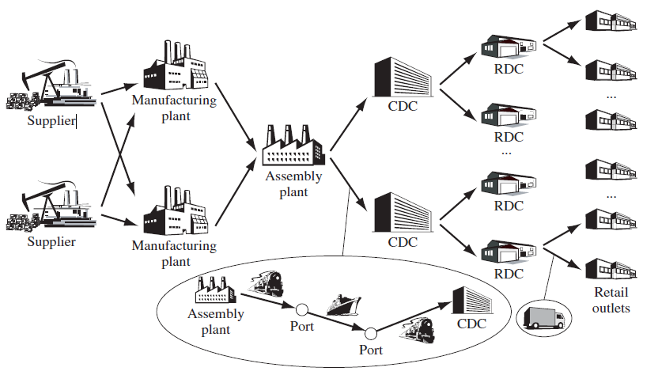

Fig. 1. Initial configuration of the supply chain under analysis (SCUA)

Table 1. Probability distributions and assumptions for modelling R_{1r} at the SCUA
Type of risk | Probability distribution | Distributional parameters | Modelling assumptions
R₁₁ | Uniform-discrete, U(x: occurrence of a breakdown at the workstation in an interval of 168 hours; a: the lower bound of the interval of time in hours; b: the upper bound of the interval of time in hours).  Exponential, exp(x: time in hours before the machine is repaired, β: average time in hours before the machine is repaired). The average time in hours before the machine or workstation is repaired is equal to two hours. | U(x ∈ Z⁺, a: 1, b: 168) for a ≤ X ≤ b;  exp(x ∈ R⁺, β: 2) for β > 0 | (1) The negative effects of breakdowns at Op₅ and Op₆ are all equivalent, (2) the probability of occurrence of any workstation’s breakdown is identical along of the interval of time, and (3) the average time in hours before the machine/workstation is repaired is independent for each event.
R₁₂ | Binomial, B(x: number of contracts delayed in n contracting processes; n: number of contracting processes, p: likelihood that one contract is delayed). | B(x ∈ Z⁺, n: 12, p: 1/11) for n ≥ 1 and 0 ≤ p ≤ 1 | (1) The likelihood of delays in Op₁ remains constant for each of n contracting processes (p = 1/11), (2) which are considered independent of each other, and (3) if one of the contracting processes is delayed, one week (168 hours) is added to MLA processing time.
R₁₃ | Binomial, B(x: number of delayed deliveries in n planned deliveries; n: number of planned deliveries; p: likelihood that one delivery is delayed). | B(x ∈ Z⁺; n: 12, p: 1/10) for n ≥ 1 and 0 ≤ p ≤ 1 | (1) The likelihood of delays in Op₂ remains constant for each of n deliveries (p: 1/10), (2) which are considered independent of each other, and (3) if one delivery is delayed, one day (24 hours) is added to each supplier’s processing time.
R₁₄ | Binomial, B(x: number of non-conforming products, n: number of units produced per shift; p: probability that one non-conforming product is produced). | B(x ∈ Z⁺, n: 2,564, p: 3/100) for n ≥ 1 and 0 ≤ p ≤ 1 | (1) The likelihood of non-conforming products in Op₇ remains constant for each shift (p: 3/100), (2) the number of units produced is independent of each other, and (3) if any defective product is detected, the item is returned to the previous operation for re-processing.

Table 2. Probability distributions and assumptions for modelling R_{2r} at the SCUA
Type of risk | Probability distribution | Distributional parameters | Modelling assumptions
R₂₁ | Uniform-discrete, U(X: occurrence of a natural disaster in an interval of 16,128 hours; a: the lower bound of the interval of time in hours; b: the upper bound of the interval of time in hours).  Exponential exp(x: time in hours before the assembly line returns to operation, β: average time in hours before the plant returns to operation). The average re-entry time in operation is equal to 120 hours (5 days). | U(x ∈ Z⁺, a: 1, b: 16,128) for a ≤ X ≤ b;  exp(x ∈ R⁺, β: 120) for β > 0. | (1) The likelihood of occurrence of natural disasters is identical along the simulation horizon; (2) when a natural disaster happens Op₃, Op₅, Op₆, Op₇ and Op₉ are simultaneously affected; and (3) the average re-entry time in operation is independent for each operation.
R₂₂ | Uniform-discrete, U(x: destruction of one line-of-communication in a interval of 4,032 hours; a: the lower bound of the interval of time in hours, b: the upper bound of the interval of time in hours).  Exponential, exp(x: time in hours before the affected line-of-communication is rehabilitated, β: average time in hours before the line-of-communication is rehabilitated). The average time of rehabilitation is equal to 24 hours (1 day). | U(x ∈ Z⁺, a: 1, b: 4,032) for a ≤ x ≤ b;  exp(x ∈ R⁺, β = 24) for β > 0 | (1) The likelihood that Op₄, Op₈, Op₁₀ and Op₁₂ are destroyed is identical along the period considered, and (2) rehabilitation times for each line-of-communication are independent of one another.
R₂₃ | Uniform-discrete, U(x: destruction of the forward logistics support unit in an interval of 8,064 hours, a: the lower bound of the interval of time in hours, b: the upper bound of the interval of time in hours).  Exponential, exp(x: time in hours before the affected forward logistics support unit is re-activated, β: average time in hours before the forward logistics support unit is re-activated). The average time of re-activation is equal to 120 hours (5 days). | U(x ∈ Z+, a: 1, b: 8,064) for a ≤ x ≤ b;  exp(x ∈ R⁺, β: 120) for β > 0; | (1) The likelihood that Op₁₁ is destroyed is identical for any week along the simulation horizon, (2) the mean duration of re-activating an affected forward logistics support unit is independent for each case, and (3) the likelihood that a single re-entry occurs in non-overlapping intervals is independent of the number of re-entries that occur in any other disjointed time interval.
R₂₄ | Uniform-discrete 1, U₁(x: time of a sudden increase in demand in an interval of 672 hours, a: the lower bound of the interval of time in hours, b: the upper bound of the interval of time in hours).  Uniform-discrete 2, U₂(D^{cn}: size of a sudden increase in demand between 2,400 to 2,600 rations/672 hours; c: the lower bound of the contingent demand in rations, d: the upper bound of the contingent demand in rations). | U1(x ∈ Z⁺, a: 1, b: 672) and U2(D^{cn} ∈ Z⁺, c: 2,400, d: 2,600) for a ≤ x ≤ b and c ≤ D^{cn} ≤ d | (1) The likelihood of occurrence of an increase in the demand (Op₁₃) is identical for any week along the simulation horizon, and (2) the likelihood associated with the size of the demand is the same for the indicated range.

Table 3. Probability distributions and assumptions for modelling R₃ at the SCUA
Notation  (R_{cat_risk}) | Probability distribution | Distributional parameters | Modelling assumptions
R₃ | Uniform-discrete, U(x: time of occurrence of a black-swan event in a interval of 161,280 hours, a: the lower bound of the interval of time in hours, b: the upper bound of the interval of time in hours). | U(x ∈ Z⁺, a = 1, b = 161,280) for a ≤ x ≤ b | (1) The probability of occurrence of a black-swan event is the same along the simulation horizon; (2) when a black-swan event occurs, Op₅, Op₆, Op₇ and Op₉ are simultaneously taken out of operation during 672 consecutive hours; and (3) operations affected return to normality after this time.

3.3 The discrete-event simulation model
3.3.1 Model genealogy and Baseline 0
The starting point is the military food supply-chain (MFSC) simulation reported by Garrido-Rios (2017).
The original model represents procurement, production, transport, storage, and theatre delivery as thirteen linked operations.
The original model evaluates fixed inventory-buffer and manufacturing-capacity scenarios under a long-run stationary design.
It does not make weekly decisions from the current system state.
This original configuration is Baseline 0 in our comparison ladder.
Baseline 0 uses discretionary ex-ante policies and is therefore a conceptual anchor rather than a matched adaptive comparator.
We reconstruct the specification as a Python discrete-event simulation.
The reconstruction preserves the operation topology, the decision tables, the risk parameter tables, and the operational ReT formula.
It also repairs causal links that were absent from early code versions, such as conservation-respecting procurement.
The reconstruction is a high-fidelity transcription of the static specification; complete endogenous replication of every thesis experiment is not claimed.
3.3.2 The thirteen-operation system
The simulation advances by scheduled events rather than by a fixed time step.
Each operation can release material, receive material, queue, process, and trigger transport.
Production follows an assemble-to-stock logic from contracting (Op1) to the supply battalion (Op9).
Distribution follows an assemble-to-order logic from the supply battalion to the theatre (Op13).
The promised downstream order lead time is forty-eight hours.
Figure M1 summarizes the thirteen operations with their processing times, order quantities, reorder cadences, and the Garrido-native risks attached to each operation.
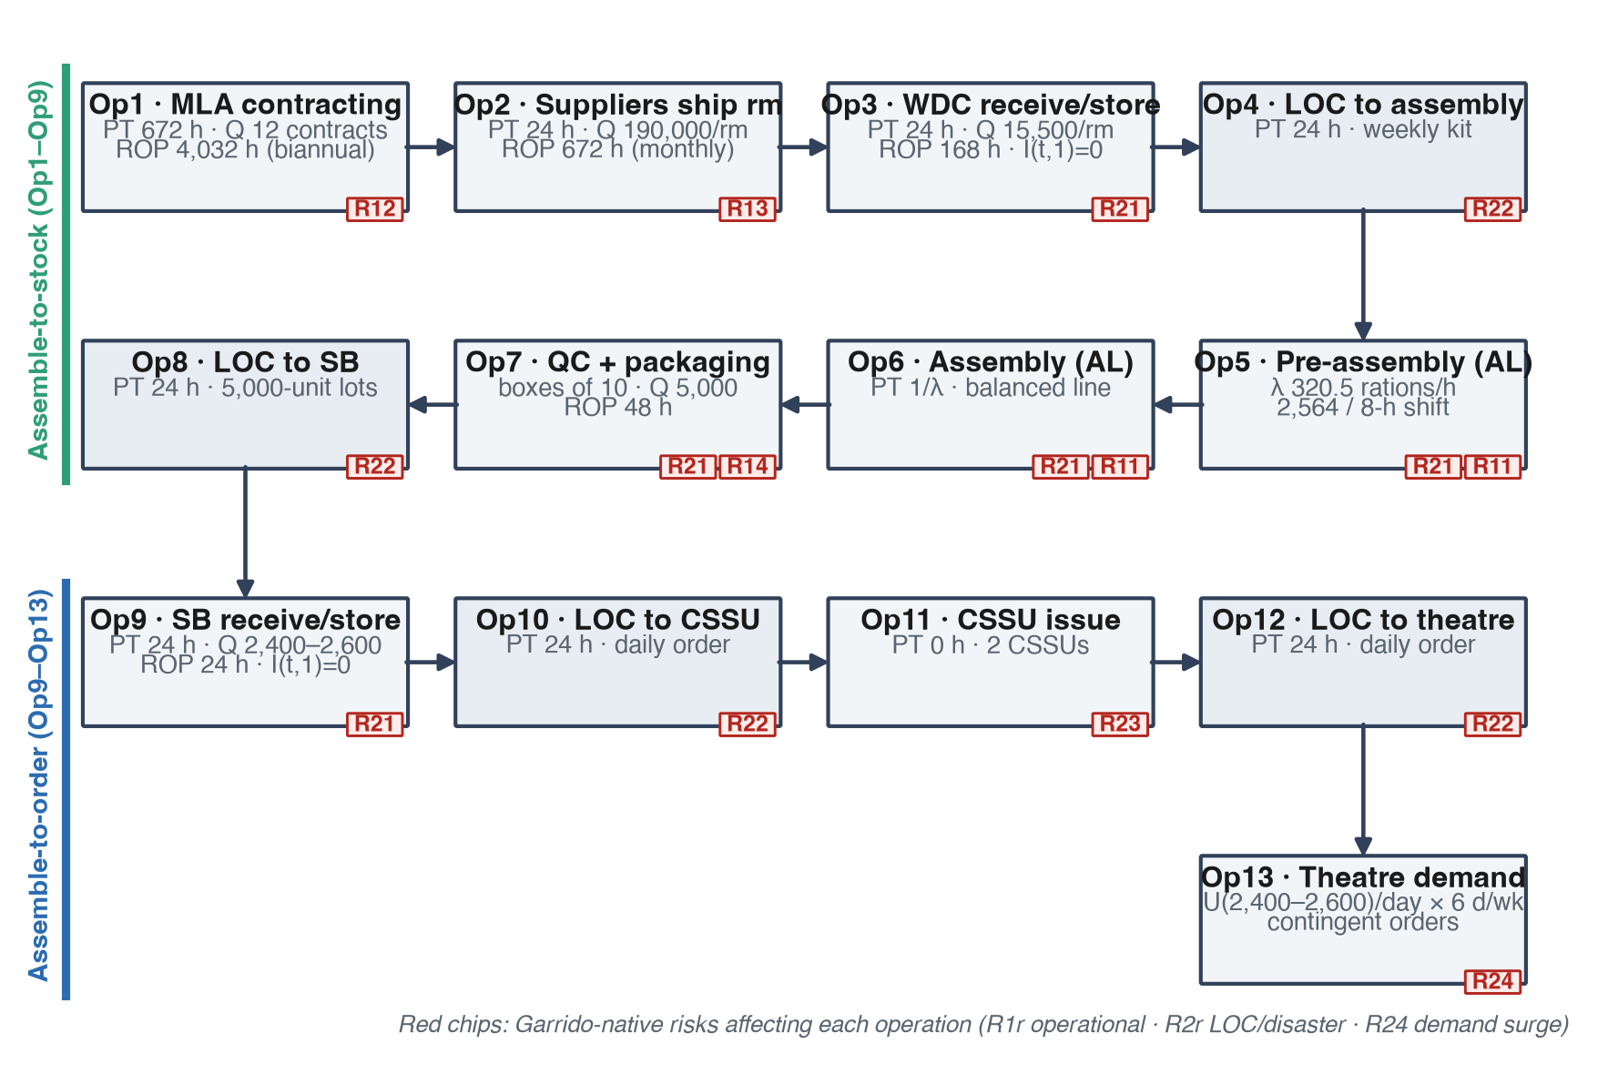
Figure M1. Thirteen-operation flow of the MFSC (after Garrido-Rios, Figure 6.2). Red chips mark the risks affecting each operation.
3.3.3 Material flow and conservation
A finished lot cannot be created unless the required upstream material and production rights exist.
Each finished lot contains 5,000 ration units.
The two-product extension assigns a product label (P_C or P_H) before the lot enters the controlled production sequence.
The label cannot be overwritten after a twenty-four-hour activation delay, which prevents retroactive renaming of inventory.
Op9 inventory is stored separately per product, and cross-product substitution is disabled.
The order queue is work-conserving and product-feasible: an unavailable product cannot block a feasible order for the other product.
Late orders remain in the ledger as backorders, and the pending-order list is capped at sixty orders, following the source model.
Every experimental arm receives the same scheduled production and transport entitlement.
Mass and product-partition checks verify that units are neither created nor destroyed by the controller.
3.3.4 Time, warm-up, and episode boundaries
The thesis reports a deterministic warm-up of 838.8 hours; the reconstruction triggers warm-up on physical readiness instead, because stochastic events can shift the calendar.
The two-product experiment uses a stricter product-balanced warm-up: one real 5,000-unit lot of each product must traverse Op1 through Op9 and coexist at Op9.
No finished inventory is ever injected directly.
The treatment episode lasts eight decision weeks of 168 hours each.
Six demand orders arrive per week at offsets of 30, 54, 78, 102, 126, and 150 hours.
No production or demand rights are created after the eighth decision.
A common 1,344-hour clearance tail lets material and open orders propagate, and every policy is scored at the same final time.
Figure M2 shows the episode structure.
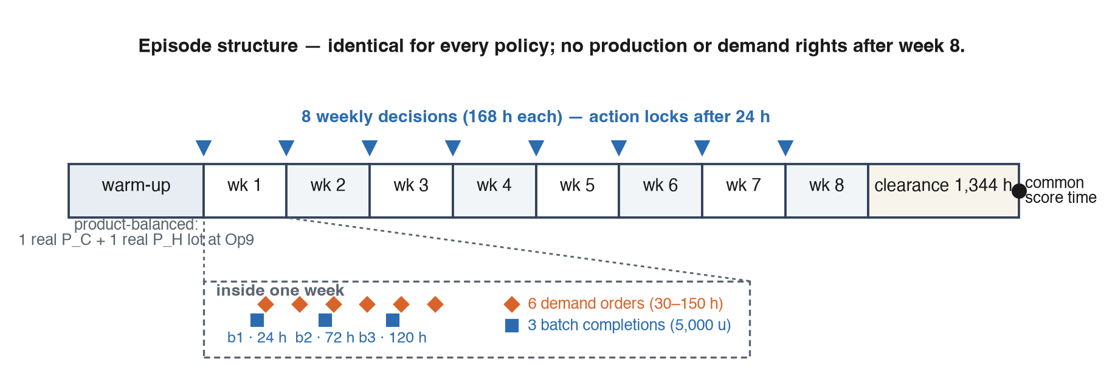
Figure M2. Episode structure: product-balanced warm-up, eight weekly decisions with three 5,000-unit batch completions each, clearance tail, and common score time.
3.3.5 Demand process and partial observability
Each episode contains forty-eight demand orders with integer quantities drawn from 2,400 to 2,600 rations, exactly the thesis demand range.
The requested product follows a two-state latent Markov regime: one regime makes P_C dominant, the other makes P_H dominant.
The regime persists between demand events with probability rho, and the dominant product is requested with probability s.
The evaluated cells are (rho=0.75, s=0.90), (rho=0.90, s=0.75), and (rho=0.90, s=0.90).
The controller never observes the latent regime and never receives the true rho or s of the evaluation cell.
A fixed hidden-Markov belief filter supplies a deployable estimate with the same fixed parameters in every cell, so no policy receives privileged knowledge of the sensitivity condition.
Demand tapes are generated independently of policy actions, which enables exact paired comparisons.
Future demand, random seeds, tape identifiers, oracle calendars, and terminal outcomes are forbidden observations.
3.3.6 Decision and observation contracts
The controller does not choose production volume, shift count, vehicle count, or demand quantity.
It chooses only how the next three fixed 5,000-unit batch targets are divided between P_C and P_H, one action per week from the set {0, 1, 2, 3} equal to the number of P_C batches.
Batch positions are centered (for example, action 1 is P_H, P_C, P_H) to remove intra-week timing advantages.
Actions activate after twenty-four hours, with batch completions at 24, 72, and 120 hours within the week.
Every eight-week calendar therefore commits exactly twenty-four batch slots and 120,000 units of controlled production rights.
The policy observes a normalized twenty-one-dimensional vector at each decision: per-product inventory, locked pipeline, backlog quantity and count, maximum backlog age, in-flight quantity, the fixed HMM belief and predicted share, the previous action (one-hot), and the episode phase.
The learning context is therefore a partially observed weekly allocation problem: the network must infer the demand regime from operational history.
Figure M3 summarizes the experimental architecture and the three controllers evaluated under identical resources.
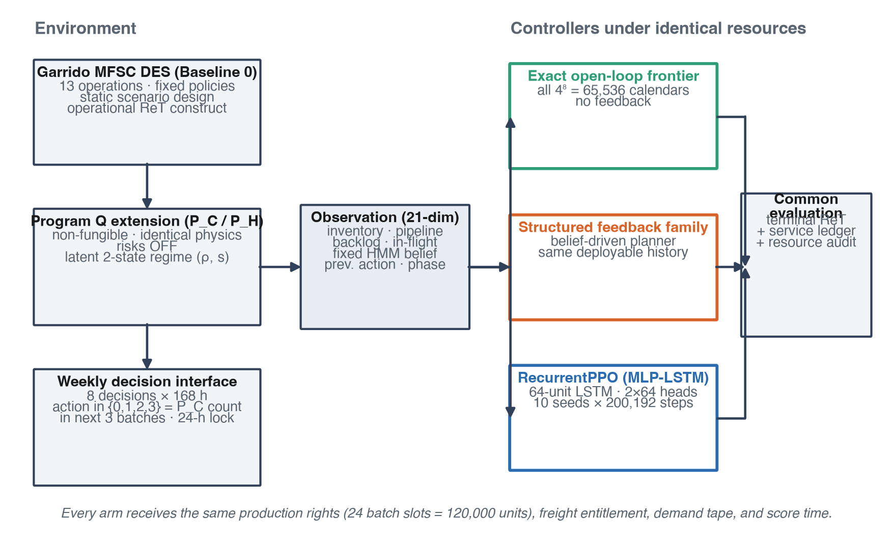
Figure M3. Experimental framework: the DES backbone and two-product extension feed a 21-dimensional observation to three controllers -- the exact 65,536-calendar open-loop frontier, the strongest tested structured feedback family, and RecurrentPPO -- all scored by the same terminal ReT and service ledger.
3.3.7 Resilience metric and reward
The primary outcome is the operational ReT formula from Garrido's raw Excel workbooks, reproduced without clipping, normalization, or replacement.
Each order j is scored at its request-time snapshot according to the following piecewise definition:
$$Re_{j}=\left\{\begin{matrix}\frac{AP_{j}}{LT} & \text{if risk active and }AP_{j}>0 \\ \frac{0.5}{RP_{j}} & \text{if risk active, }AP_{j}=0, RP_{j}>0 \\ 0 & \text{if risk active, no recovery} \\ 1−\frac{B_{t,j}+U_{t,j}}{j} & \text{if no risk active}\end{matrix}\right.$$
Here AP is the autotomy period, LT the promised forty-eight-hour lead time, RP the recovery period, and B and U the backorders and unattended orders accumulated at the request time.
The formula was recomputed on 47,546 source-workbook rows with zero mismatches.
The two-product primary experiment runs risk-off, so the no-risk branch is operative, and risk-adaptation claims are explicitly out of scope.
The reward is zero at intermediate decisions and equals the official terminal ReT at the common score time, avoiding any unvalidated shaping of the construct.
Because the visible ReT population contains completed non-lost orders, unresolved demand, lost demand, per-product fill, terminal inventory, and resource use are mandatory companion outcomes.
Figure M4 shows the scoring branches.
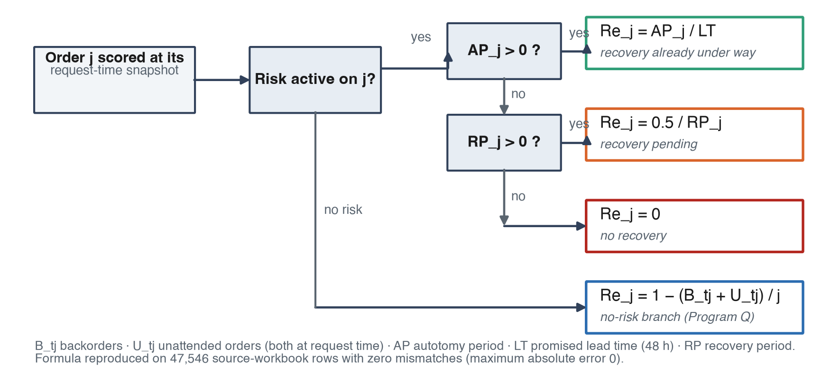
Figure M4. Order-level ReT scoring branches, reproduced exactly from the source workbooks (47,546 rows, zero mismatches). Program Q operates on the no-risk branch.
3.3.8 Sensitive assumptions
The most sensitive modeling decisions are those that determine what information is available, when actions become physical, and which orders enter the metric.
Equal-time events follow a strictly half-open rule: a lot arriving exactly at a release timestamp is not eligible for that release, and an order completion at a request time is processed before the request snapshot.
These conventions prevent the policy and the metric from seeing zero-time information that would not be operationally available.
The product classes are synthetic and share identical physics, so the experiment isolates allocation under demand uncertainty rather than product-specific manufacturing complexity.
Storage is unlimited, vehicle capacity is a fixed entitlement, and substitution is disabled.
A finite horizon could invite end-of-episode inventory hoarding; the fixed production entitlement, the clearance tail, and the terminal product ledger expose and bound this behavior, and no reward is assigned to ending inventory.
Distributional Kolmogorov Arnold Model
The distributional Kolmogorov-Arnold model or DKA is a machine learning based framework that, when operationalized through reinforcement learning, enables episodic learning within the DCA simulation environment.
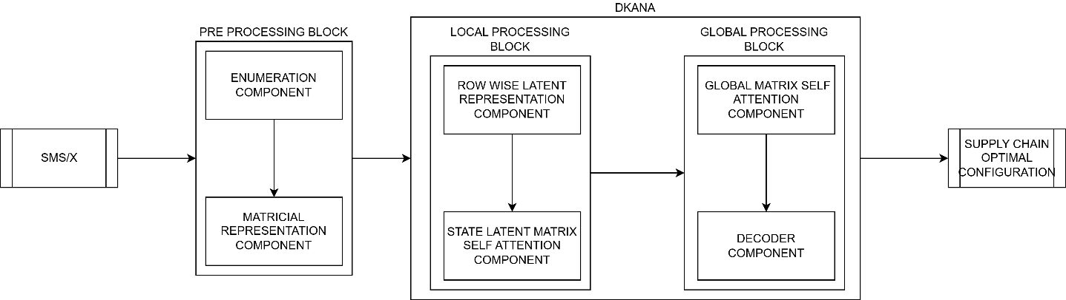
DKA is composed of two primary modules: a pre-processing block and a distributional Kolmogorov Arnold with attention block (DKANA).
The Pre processing block contains the Enumeration component (EC), and the matricial representation component or MRC.
EC, receives two external inputs: a sequence of states drawn from the DCA environment SMS, defined as $SMS=[S_{k+1},S_{k+2},...S_{k+n}]$, and a sequence of decision variables X, defined as $X=[x_{1},x_{2},...x_{j}]$, where each $x_{i}$ represents a decision variable of the supply chain implemented within DCA.
Using X and SMS, the Enumeration component derives a set of biyective indexing functions F, with $F=\{{IDX}_{X},{IDX}_{Ξ}\}$.
The mapping ${IDX}_{X}$, assigns each $x_{i}$ to a unique natural number ${IDX}_{X}(x_{i})$, and behaves as an identity for every real number, on the other hand, ${IDX}_{Ξ}$ defines a correspondence $\{=,<,>\} ↦ N,$where = , <, and > denote the equality, less-than, and greater-than relations respectively.
Both The set F and the state sequence SMS are then provided to MRC, which transforms each state $S_{i}=(\left[\begin{matrix}x_{di} & \begin{matrix}⨀_{di} & y_{di}\end{matrix} \\ \begin{matrix}⋮ \\ x_{ri}\end{matrix} & \begin{matrix}\begin{matrix}⋮ \\ ⨀_{ri}\end{matrix} & \begin{matrix}⋮ \\ y_{ri}\end{matrix}\end{matrix}\end{matrix}\right],θ_{{SC}_{i-1}})$ into its indexed representation $C(S_{i})$ defined as $C(S_{i})=(Concat(\left[\begin{matrix}{{IDX}_{X}(x}_{di}) & \begin{matrix}{{IDX}_{Ξ}(⨀}_{di}) & {{IDX}_{X}(y}_{di})\end{matrix} \\ \begin{matrix}⋮ \\ {{IDX}_{X}(x}_{ri})\end{matrix} & \begin{matrix}\begin{matrix}⋮ \\ {{IDX}_{Ξ}(⨀}_{ri})\end{matrix} & \begin{matrix}⋮ \\ {IDX}_{X}(y_{ri})\end{matrix}\end{matrix}\end{matrix}\right],,θ_{{SC}_{i-1}})$ .
Inside C(S_i), MAX#R(SMS) denotes the maximum number of rows among SMS states formula matrixes, #R(\operatorname{S}_i)\ describes the number of rows in the formula matrix of \operatorname{S}_i , 0_{(MAX#R(SMS)-#R(\operatorname{S}_i))\ x\ 3\ },\ is the zero for the matricial space with shape (MAX#R(SMS)-#R(\operatorname{S}_i))\ x\ 3 and ConcatR, is a binary operator that performs row wise concatenation for an arbitrary tuple of matrixes (\operatorname{E}_{L\ x\ Q},\operatorname{F}_{M\ x\ Q}).
Further on, within the DKANA block, the Row Wise Latent Representation Component or RWLRC, employs two multi layer perceptron (MLP), which are defined as the functions ${RWLMLP1}_{θ}:M_{1 x 3 }⟼M_{1 x R}$and ${RWLMLP2}_{θ}:M_{1 x |X| }⟼M_{1x R}$ respectively, to proyect each row of the $C(S_{i})$ matrix and the configuration $θ_{{SC}_{i-1}}$, into a common vectorial space of dimension R.
This results in the representation ${PMLP}_{i}$, which is the row wise concatenation of $C(S_{i})$ matrix and $θ_{{SC}_{i-1}}$ projection.
SLMSAC performs a multi head attention mechanism on each ${PMLP}_{i}$ matrix, as originally described by [CITATION](aiayn). In The resulting attention matrix AT(${PMLP}_{i}$), each row ${AT({PMLP}_{i})}_{j}$ encodes information exclusively from the preceding rows ${{\{{PMLP}_{i}}_{q}\}}_{q=0}^{q=j}$, allowing for causal context sharing among the components of ${PMLP}_{i}$.
Consequently, Each $AT({PMLP}_{i})$ is fed into the global matrix self attention component (GMSAC) which applies a multihead attention algorithm in the derived matrix GCL whose elements are defined as ${GCL}_{ij}={AT({PMLP}_{i})}_{R(AT({PMLP}_{i}))j}$, where R is a function that maps every matrix to its total number of rows.
The output of the multi head attention mechanism executed on GCL, AT(GCL), stores in its f-th row a compressed representation of the sequence of vectors ${\{AT({PMLP}_{1})}_{R(AT({PMLP}_{1})),},{AT({PMLP}_{2})}_{R(AT({PMLP}_{i}))}...{AT({PMLP}_{f})}_{R(AT({PMLP}_{f}))}\}$. Because each ${AT({PMLP}_{i})}_{R(AT({PMLP}_{i})),}$, serves as an encoding of the state $S_{i}$, the, rows of AT(GCL) consequently encode global information of the entire state batch fed to the DKA model.

4. Analysis of the Results
4.1 Results from Discrete Event Simulation
The DES model was first validated against the deterministic baseline Cf0 (single shift, S=1) reported in Garrido-Rios (2017, Table 6.10). Table 4 summarizes the official thesis-basis comparison together with a secondary gregorian annualization check used only as a diagnostic reference.
Table 4. Cf0 validation: simulated throughput vs. thesis reference (ECS)
Comparison basis | Hours/year | Our model | Thesis ECS | Relative gap
Thesis basis (official) | 8,064 | 733,621 | 767,592 | -4.43%
Gregorian basis (diagnostic) | 8,760 | 796,940 | 767,592 | +3.82%

Using the official thesis basis of 8,064 hours per year (48 operational weeks), the model delivers 733,621 rations per year on average, compared with the thesis ECS reference of 767,592 rations, which yields a relative gap of -4.43%. This result is comfortably within the accepted +/-15% validation threshold and therefore supports the structural fidelity of the rebuilt DES model.

Under deterministic Cf0 conditions with risks disabled, the simulation produces 734,458 rations per year on average and delivers 733,621 rations per year, with a fill rate of 99.3% and only 41 backorders accumulated over the 20-year horizon. These results indicate that the baseline network is well configured for nominal demand. At the same time, the weekly demand of roughly 17,500 rations against a single-shift production capacity of approximately 17,948 rations shows that the assembly line already operates near saturation.

To characterize the DES behavior under disruption, two stochastic risk configurations were evaluated over the 20-year simulation horizon. Table 5 summarizes the results.
Table 5. DES performance under stochastic risk configurations
Configuration | Avg. annual delivery | Fill rate | Total backorders | Disruptive events
Deterministic (Cf0, S=1) | 733,621 | 99.3% | 41 | 0
Current risk | 677,750 | 68.3% | 1,825 | 8,247
Increased risk | 549,250 | 45.6% | 3,132 | 13,705

When stochastic risks are enabled at the current level, average annual delivery falls to 677,750 rations (-7.6% relative to the deterministic baseline), the fill rate drops from 99.3% to 68.3%, and total backorders rise from 41 to 1,825. Across the 20-year horizon, the model registers 8,247 disruptive events, mainly driven by internal workstation breakdowns (R11, 1,868 events), defective products (R14, 5,591 events), and recurrent demand surges (R24, 478 events), together with one black-swan interruption lasting 672 consecutive hours.
A stronger stress configuration with increased risks confirms the same structural tendency. Under that setting, average annual delivery decreases to 549,250 rations, the fill rate falls to 45.6%, total backorders increase to 3,132, and the number of disruptive events rises to 13,705. The DES therefore shows a clear transition from a well-calibrated nominal system to a highly fragile network once disruption intensity escalates.
Taken together, these findings show that the reconstructed DES is both empirically credible and analytically informative: it reproduces the thesis baseline with acceptable error, while making visible how disruption propagation erodes service performance under stochastic risk. This establishes the DES as the reference environment on top of which adaptive learning mechanisms can be evaluated in the hybrid model.

4.2 Results from Hybrid Simulation Neural Model
4.3 Findings

Fig. 1. Klalnlado lnkaln

5. Conclusions, limitations, theoretical contribution and future research
5.2 Limitations
5.3 Theoretical Contribution
Reconceptualize SCRES as an adaptive learning trajectory.
Move resilience from “recovery metric” to “evolving capability”.
Integrate DES simulation with AI learning frameworks.
Offer computational grounding for dynamic capabilities theory.

6. Bibliography
Garrido, A., Pongutá, F., Adarme, W. (2024). Enhancing the Operationalization of SCRES-Based Simulation Models with AI Algorithms: A Preliminary Exploratory Analysis. In: International Conference in Computational Logistics (Garrido A, Paternina-Arboleda C, Voß S, Eds.). Lecture Notes in Computer Science, vol. 15168. Springer, Cham.
https://doi.org/10.1007/978-3-031-71993-6_6

7. Annexes

