Research
The solution which GLH wishes to develop is a web application designed to facilitate online ordering of locally produced goods. The primary goal of this is to increase awareness of the cooperative, expand the customer base and increase revenue for producers. As such, the web application must also be accessible on a large scale across a range of devices, including desktop computers and mobile devices, ensuring a seamless user experience for all customers.

Target audience:
Current customers: want easier access to products and information
Potential new customers: attracted by the convenience of online ordering
Local producers: need an effective system for product management and stock control

User needs:
Customers require:
Online product browsing
Ordering with collection or delivery options and delivery updates
Access to relevant information about products and the cooperative

Producers require:
A dashboard to manage stock and monitor sales
An easy-to-use system for updating product listings

System requirements:
Ordering system: allows users to purchase products and choose between collection or delivery. Users can also track orders and receive updates
Information access: provides product details and information about stock and producers as well as the cooperative
Producer dashboard: includes sales tracking, stock management and product update features
Multi-device accessibility: functionality across desktops, tablets and smartphones

Digital presence helps expand reach and improve convenience for customers. Dashboards and stock control help producers efficiently manage their products, supporting the cooperative’s operation.

Objectives:
GLH intends to develop a digital solution to enable online ordering of local goods. This will:
Increase awareness of the cooperative
Attract new customers and retain current existing customers
Boost revenue

To achieve this, a set of objectives can clearly define what the project must accomplish and guide the design process and proposal:
- Provide user-friendly online ordering for customers
- Ensure widespread accessibility
- Allow producers to manage products, monitor sales and control stock
- Offer a dashboard and reporting tools for producers
- Support collection and delivery options
- Enhance visibility and reach of the organisation

User research:
Users order food and goods online frequently:
UK research shows that people regularly use online platforms to order food and drink. Over half of survey respondents had ordered food from delivery sites and around a quarter used online marketplaces for general food shopping. This would imply that many customers are comfortable with virtual ordering systems.
https://www.food.gov.uk/research/wave-5-chapter-5-online-platforms
This would support the need for a simple local online ordering system.

Multi platform accessibility is needed:
Research emphasises that users expect good mobile experiences from e-commerce websites. Simple navigation, mobile friendly design and streamlined checkout processes greatly improve conversion rates.
https://www.bigcommerce.co.uk/blog/ecommerce-usability/
The solution must therefore be greatly responsive and mobile optimised so users can browse and order on phones and tablets without struggle.

Navigation, search and filtering are important to user satisfaction:
Best practices for online marketplaces highlight the importance of: clear navigation, search and filters and consistent intuitive layouts.

Product presentation:
Users often depend on high quality visuals and detailed descriptions to decide which products to buy. Clear information increases confidence and conversion rates for sales. Therefore clear and plentiful use of images, good descriptions and good prices will help users make informed decisions.

Usability is strongly linked to trust and accessibility:
Research suggests usability factors such as readability, trustworthiness and clarity affect user intent when browsing e-commerce sites. This includes accommodating for visually impaired users.
https://www.mdpi.com/2227-7390/11/1/25
This would suggest that accessibility increases usability for all users and therefore that the solution must be designed with accessibility best practices in mind.

Existing solutions:
In order to get the most out of case studies, I have chosen a diverse pick of existing solutions. Namely, these are Tesco online shopping, Shopify seller dashboard, farm shop and etsy product management. Each of these choices covers some aspects of the client’s requested solution, however falls short in other areas. As such, ideas can be taken from each example to properly form an idea for the proposal of an ideal solution.

Tesco online shopping:
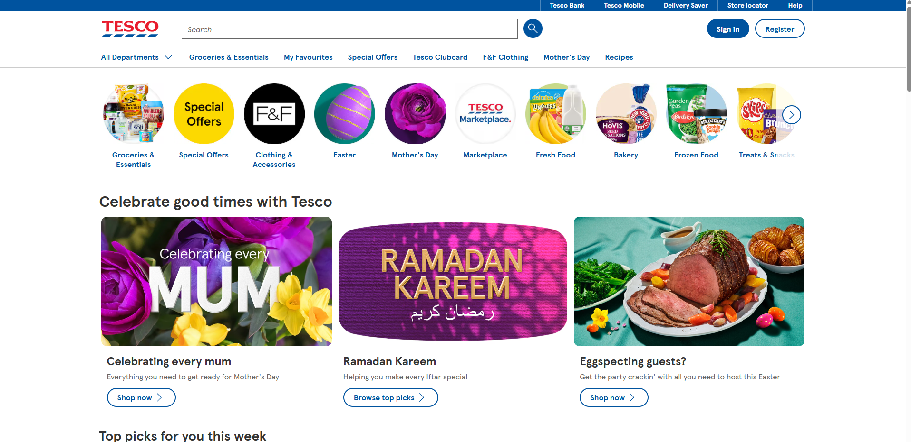
Being a large supermarket brand, tesco do not share many commonalities with GLH in terms of locality and customer base. As well as this, their website is not specifically tailored to producers and does not have a ‘dashboard’. The similarities and pros of this website however come in the shared feature of selling food and produce to an online market. In this department, the tesco online shopping website excels, providing clear and useful navigation options and showing a range of relevant options on the homescreen. The Tesco website features dedicated sections for Ramadan, as well as for specific dietary needs, including allergies and foods compliant with Islamic and kosher guidelines. This idea was a strong pro and would be a useful feature to include on the GLH website as these facilitations would grant a wider potential user base.
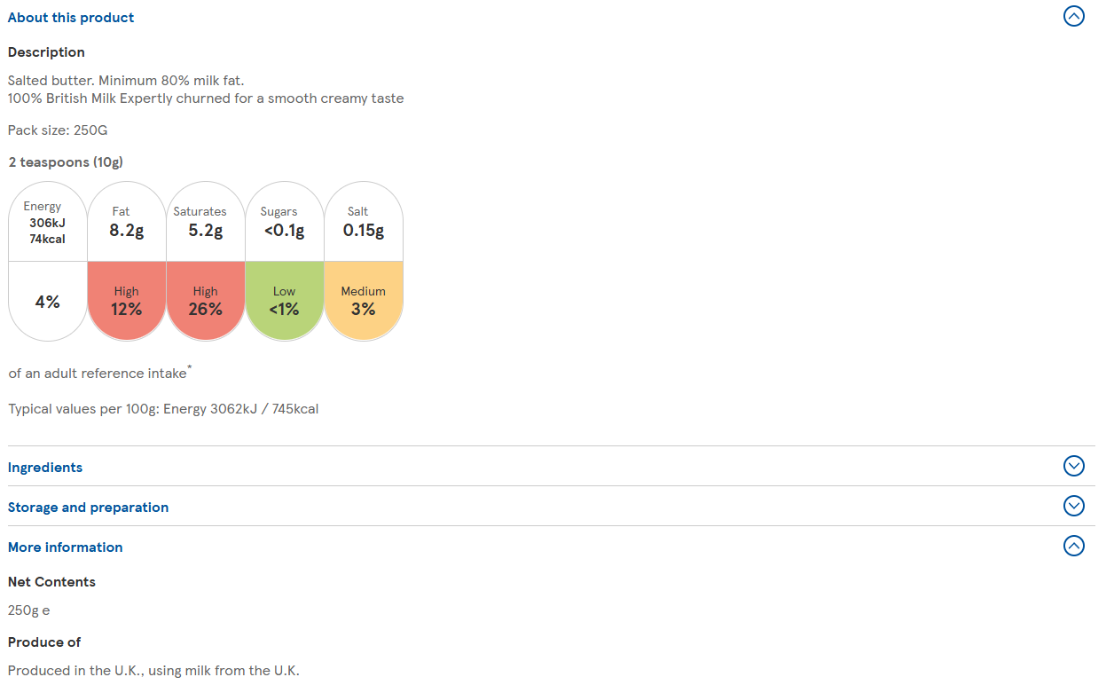
One improvement which the GLH solution would make over the tesco website is a greater availability of information as to the production of food. While the specific food purchased from a supermarket such as tesco may not be traceable to a batch, the information on where food has been produced is also missing. GLH’s website would improve upon this by offering a far clearer farm-to-fork transparency.

Shopify seller dashboard:
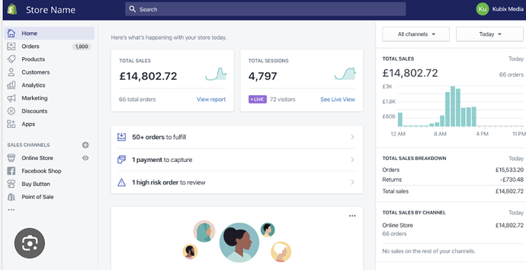The shopify seller dashboard shares aspects with the clients requests through being a seller focussed dashboard. The layout of the dashboard provides clear information about trends and growth / decline in the seller’s shop. This dashboard does an effective job at displaying successes, revenue and current orders; all of which are useful features in the case of GLH’s potential solution. Where shopify falls short is the lack of on-site shopping. Whereas for GLH shopping would be featured on site, shopify allows users to create their own websites for e-commerce. On a large scale this is very beneficial, however for GLH, the ambition is to have a single site where local producers can sell their goods and view sales patterns, trends and incoming orders. Overall, shopify has many strengths in the layout and utility of the seller dashboard, however it is designed for independent sellers running separate stores, whereas GLH requires a unified platform where multiple producers can operate within a single shared space.

To do:
Rest of case studies
Personas
User journeys
Legal considerations
Technical research

