C:\Users\Owner\Desktop\tril0515v2\FullStack-Lesson-Plans\01-Class-Content\01-html-git-css\01-Activities\07-RelativePaths-Activity\Solved\RelativePaths_1\html-bio.html:
9 <!-- Fill in the href to the CSS such that this HTML file can access the CSS -->
10 <!-- Don't move the HTML or CSS file. Use Relative Linking -->
11: <link rel="stylesheet" type="text/css" href="style.css">
12 </head>
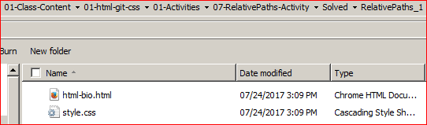
13

C:\Users\Owner\Desktop\tril0515v2\FullStack-Lesson-Plans\01-Class-Content\01-html-git-css\01-Activities\07-RelativePaths-Activity\Solved\RelativePaths_2\html-bio.html:
9 <!-- Fill in the href to the CSS such that this HTML file can access the CSS -->
10 <!-- Don't move the HTML or CSS file. Use Relative Linking -->
11: <link rel="stylesheet" type="text/css" href="assets/style.css">
12 </head>
13
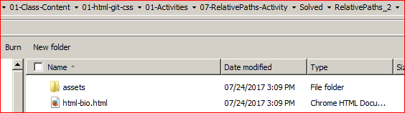

C:\Users\Owner\Desktop\tril0515v2\FullStack-Lesson-Plans\01-Class-Content\01-html-git-css\01-Activities\07-RelativePaths-Activity\Solved\RelativePaths_3\html-bio.html:
9 <!-- Fill in the href to the CSS such that this HTML file can access the CSS -->
10 <!-- Don't move the HTML or CSS file. Use Relative Linking -->
11: <link rel="stylesheet" type="text/css" href="assets/style/style.css">
12 </head>
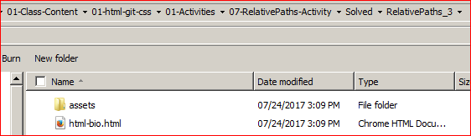
13

C:\Users\Owner\Desktop\tril0515v2\FullStack-Lesson-Plans\01-Class-Content\01-html-git-css\01-Activities\07-RelativePaths-Activity\Solved\RelativePaths_4\HTML\html-bio.html:
9 <!-- Fill in the href to the CSS such that this HTML file can access the CSS -->
10 <!-- Don't move the HTML or CSS file. Use Relative Linking -->
11: <link rel="stylesheet" type="text/css" href="../style.css">
12 </head>
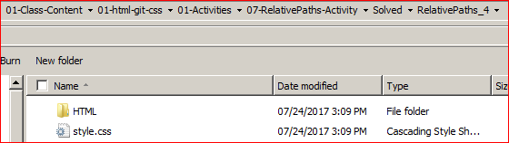
13

C:\Users\Owner\Desktop\tril0515v2\FullStack-Lesson-Plans\01-Class-Content\01-html-git-css\01-Activities\07-RelativePaths-Activity\Solved\RelativePaths_WorkingExample\html-bio-with-css.html:
9 <!-- This line is money! It points your HTML to the CSS file. -->
10: <link rel="stylesheet" type="text/css" href="assets/style.css">
- <!-- Notice the "relative" pathway? It matches a file inside our current directory's "assets" folder.
