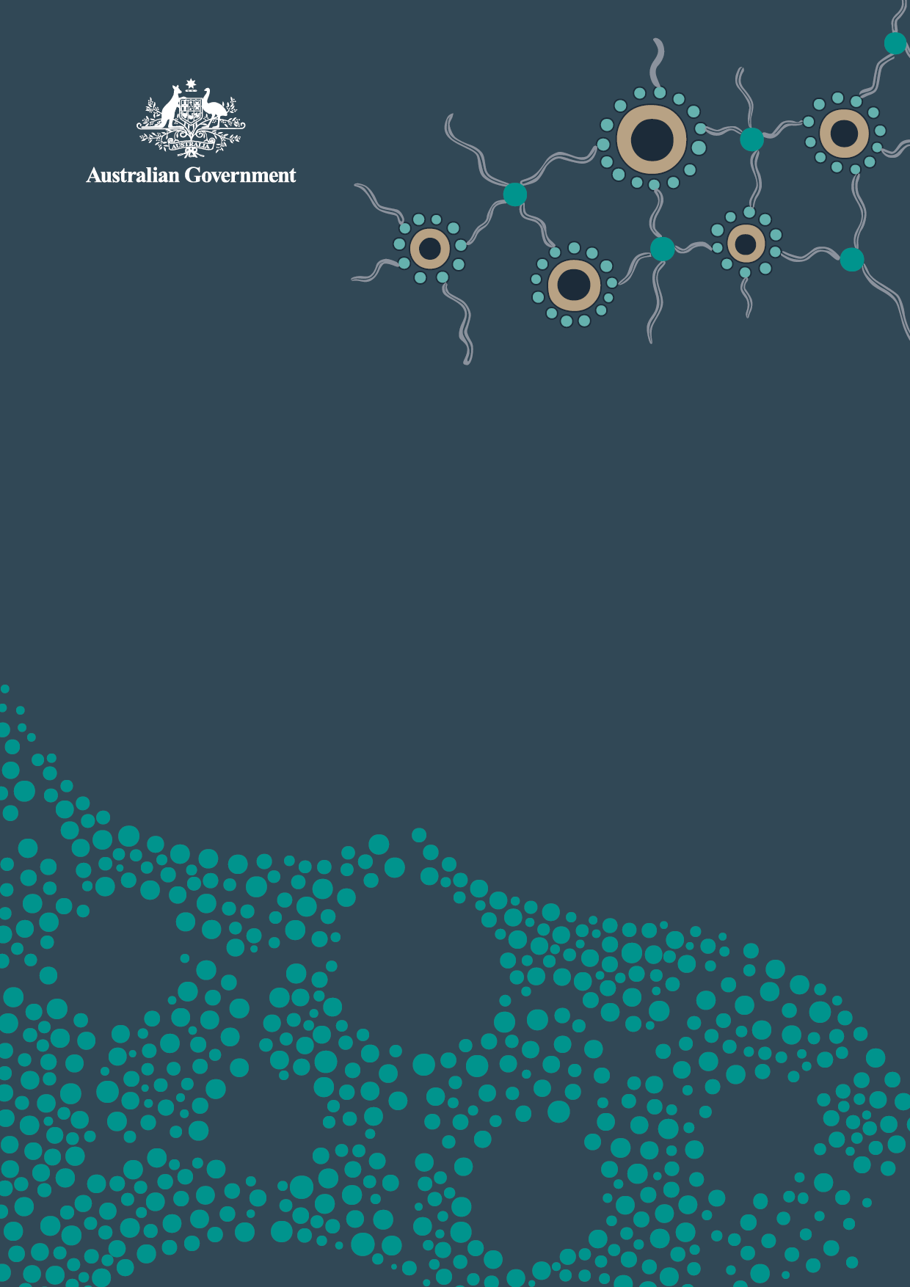

Framework
for Governance
of Indigenous Data
  - Practical guidance for the Australian Public Service

Acknowledgement of Country

The National Indigenous Australians Agency (NIAA) acknowledges the Traditional Owners and Custodians of Country throughout Australia and acknowledges their continuing connection to land, waters and community. We pay our respects to the people, the cultures and the Elders past, present.
© Commonwealth of Australia 2024
ISBN - 978-1-925365-46-7 Framework for Governance of Indigenous Data (digital)
Version: 1.0
First published: May 2024
Copyright Notice
With the exception of the Commonwealth Coat of Arms, this work is licensed under a Creative Commons Attribution 4.0 International license (CC BY 4.0) (https://creativecommons.org/licenses/by/4.0/).
Third party copyright
Wherever a third party holds copyright in this material, the copyright remains with that party.
Their permission may be required to use the material. Please contact them directly.

Attribution
This publication should be attributed as follows:
© Commonwealth of Australia, Framework for Governance of Indigenous Data.
The Framework for Governance of Indigenous Data was co-designed by Australian Public Service (APS) agencies, and Aboriginal and Torres Strait Islander and non-government partners. Co-design partners are listed in Appendix A.

Use of the Coat of Arms
The terms under which the Coat of Arms can be used are detailed
on the following website: https://pmc.gov.au/cca.

Other uses
Enquiries regarding this document are welcome at: gid@niaa.gov.au.
Contents
Acknowledgement of Country 2
Foreword 4
1. Summary of Framework Guidelines 6
2. Introduction 7
3. Monitoring and accountability 10
4. Guidelines for Australian Government Agencies 11
Guideline 1: Partner with Aboriginal and Torres Strait Islander people 12
Guideline 2: Build data-related capabilities 15
Guideline 3: Provide knowledge of data assets 18
Guideline 4: Build an inclusive data system 20
5. Appendices 24
Appendix A: Development of the Governance of Indigenous Data Framework 24
Appendix B: Related and Previous Work 28
Appendix C: Data Lifecycle 29
Appendix D: Case Studies 33
Key concepts 36
Key Terms 37
Resources 40

Foreword
Aboriginal and Torres Strait Islander people have been successfully governing Indigenous data (including information and knowledge in any format or medium) since time immemorial. This has been a critical factor ensuring the ongoing survival of Aboriginal and Torres Strait Islander cultures.
Recognising the importance of data for self-determination, this Framework for Governance of Indigenous Data (the Framework) provides a stepping stone towards greater awareness and acceptance by Australian Government agencies of the principles of Indigenous Data Sovereignty. The Framework aims to provide Aboriginal and Torres Strait Islander people greater agency over how their data are governed within the Australian Public Service (APS) so government-held data better reflects their priorities and aspirations.
The Framework puts Aboriginal and Torres Strait Islander peoples at its centre. It recognises better outcomes are achieved if Aboriginal and Torres Strait Islander people have a genuine say in matters affecting them, including use of data to inform policy-making in government.
The Framework has been developed with the intention of providing Aboriginal and Torres Strait Islander people meaningful access to relevant government-held data. Without access to these data, Aboriginal and Torres Strait Islander peoples will continue to be at a disadvantage in realising their right to self-determination. The Framework also calls for data-related capability building, both within the APS, and amongst Aboriginal and Torres Strait Islander people, communities and organisations. Data capability is essential for Aboriginal and Torres Strait Islander peoples’ self-determination in our digital age.
The Framework provides guidance to the APS in improving governance practices for data related to Aboriginal and Torres Strait Islander people. It seeks to move the APS beyond traditional methods of consultation, to ensure Aboriginal and Torres Strait Islander people have an equal position at the decision-making table on matters affecting them. Implementation of the Framework will support efforts to implement the National Agreement on Closing the Gap, in particular Priority Reform Three (Transforming Government Organisations) and Priority Reform Four (Shared Access to Data and Information at a Regional Level).
However, change to data governance practices alone will not be sufficient to shift the dial on governance of Indigenous data. Legislative and policy changes to current ways of managing data assets within government (including in relation to local and regional data) are also required. These changes are also necessary to help close the gap in outcomes. Through the partnerships formed to develop this Framework, there were calls for a one-stop-shop for Aboriginal and Torres Strait Islander people’s access to government-held data; the appointment of an Indigenous Data Commissioner; and the inclusion of Aboriginal Community Controlled Organisations as potential accredited users under the Data Availability and Transparency Act 2022. The APS will work in partnership with Aboriginal and Torres Strait Islander people to investigate these matters as a priority.
Though the Framework as it currently stands only applies to APS agencies, it is also relevant to Indigenous data held by States, Territories, and Local Government. Members of the partnership formed to develop this Framework emphasised that data held by States, Territories, and Local Governments are of particular relevance to Indigenous communities. Application of the Framework to other levels of government should leverage off the mechanisms of monitoring and accountability grounded in the National Agreement on Closing the Gap. As parties to the National Agreement embed the Priority Reforms they will need to work together to improve the governance of Indigenous data. The success of this Framework will depend on APS agencies implementing all actions relevant to them in full. In this respect, actions in the Framework should not be treated as optional. Full implementation is essential if the Framework is to avoid becoming just another document that sits on a shelf and gathers dust.
The Framework is a stepping stone towards better governance of Indigenous data. It will need to evolve over time as agencies continue to work in partnership with Aboriginal and Torres Strait Islander people. Genuinely listening and responding to the needs and aspirations of Aboriginal and Torres Strait Islander people is an ongoing process. Every journey begins with a step.

Signed:



Summary of Framework Guidelines
This Framework guides the Australian Public Service (APS) on how to build strong governance over Indigenous data holdings held by the Commonwealth.

Guideline 1: Partner with Aboriginal and Torres Strait Islander people
- Partner with Aboriginal and Torres Strait Islander people at all stages of the data lifecycle (see Appendix C) to ensure their priorities are reflected in data about their communities.

Guideline 2: Build data-related capabilities
- Improve the capabilities of APS staff and Aboriginal and Torres Strait Islander partners relating to Indigenous data across the data lifecycle.

Guideline 3: Provide knowledge of data assets
- Develop straightforward methods for Aboriginal and Torres Strait Islander people to know what data are held relating to their interests, its use, and how it can be accessed.

Guideline 4: Build an inclusive data system
- Build towards organisational and cultural change within the APS to support the inclusion of Aboriginal and Torres Strait Islander people in data governance.

Introduction
Aboriginal and Torres Strait Islander people have long sought the realisation of the right to self-determination. Data are critical to self-determination, enabling advocacy for the priorities and aspirations of Aboriginal and Torres Strait Islander people in government decision-making. It underpins decision-making at a community level, enables Aboriginal and Torres Strait Islander people to tell their own stories about who they are, and plan for their future needs.
The Australian Government holds substantial data assets about the Australian population, including data related to Aboriginal and Torres Strait Islander people. It collects and holds these data for a variety of purposes such as performance data to manage the expenditure of public funds; personal information to operate government services; and data to monitor a wide variety of health, social, and economic outcomes to inform policy development to better support Australians.

The Indigenous Data Sovereignty movement
The Indigenous Data Sovereignty Principles are outlined by the Maiam nayri Wingara Indigenous Data Sovereignty Collective and advocate for major changes to how data about, or that may affect, Aboriginal and Torres Strait Islander people are promoted, accessed and handled. The central tenet of these principles is that Aboriginal and Torres Strait Islander people have the right to exercise ownership and control over Indigenous data across all phases of the data lifecycle, including creation, collection, access, analysis, interpretation, management, dissemination, and reuse. Maiam nayri Wingara define Indigenous data as “information or knowledge, in any format or medium, which is about and may affect Indigenous peoples both collectively and individually”. This Framework accepts this definition while asking agencies to work closely with Aboriginal and Torres Strait Islander partners to determine what this means in relation to Indigenous data held by the agency, Indigenous data priorities, and the practical actions that can be implemented to improve governance.

Alignment to the National Agreement
on Closing the Gap
The Framework is also an important step towards delivering on commitments made through the National Agreement on Closing the Gap (the National Agreement), to mobilise all available opportunities to overcome the entrenched inter-generational inequality faced by too many Aboriginal and Torres Strait Islander people so their life outcomes are equal to all Australians. The Framework will help governments implement data governance policies to work more effectively with Aboriginal and Torres Strait Islander people and support greater access to data and information at a regional level. This will enable Australian Government policies, programs and services to be accessed by, and be of benefit to, Aboriginal and Torres Strait Islander people.

Working in partnership
The APS recognises that partnership with Aboriginal and Torres Strait Islander stakeholders is essential for respecting the right to self-determination. The Framework has been developed in partnership with Aboriginal and Torres Strait Islander people who have expertise in data governance, experience working with the government, and using data within their organisations. It acknowledges the best outcomes occur when the government and Aboriginal and Torres Strait Islander people work in partnership to inform, design and deliver better ways of achieving outcomes.
To ensure the inclusion of a range of input, APS, non-APS and Aboriginal and Torres Strait Islander representatives involved in drafting the Framework engaged with colleagues across their organisations and networks. Over the development of the Framework, representatives were able to share a draft to seek feedback. This process was important to gather broader views on the clarity, practicality and comprehensiveness of the guidelines and actions contained in the Framework. The engagement identified a need to clarify what types of Indigenous data are within scope for Framework actions; raised the importance of leveraging existing structures and initiatives to implement the actions; and highlighted where agencies would need additional support and resources to enable implementation. Further information on the Framework’s development can be found in Appendix A.
There has been significant and valuable work already undertaken to advance the importance of
including Aboriginal and Torres Strait Islander people in all phases of the lifecycle for data related to
them. Along with Maiam nayri Wingara, and several other key information sources, the development
of the Framework has been informed by the OCCAAARS Framework for First Nations Data Sovereignty (Kowa Collaboration) and the Indigenous Data Sovereignty Readiness Assessment and Evaluation
Toolkit (Lowitja Institute). Further detail on previous work and other relevant sources can be found
in Appendix B.

Aim of this Framework
This Framework is not appropriating the term Indigenous Data Sovereignty nor is it redefining it for a public sector audience. It is guiding Australian Government agencies on how to practically implement and embed those areas of data governance where the objectives of the Indigenous Data Sovereignty movement and the Australian Government align.
The Framework has been developed to change current data governance practices at all stages of the ‘Data Lifecycle’ (Appendix C), from conceptualisation (before data are collected) to dissemination and reuse. A key tenet of several actions in the Framework is the need to build capability to engage with and use data, both within the Australian Government and among Aboriginal and Torres Strait Islander communities. Better use of data can then support shared decision making at all points in the data lifecycle. Several case studies (Appendix D) were explored to understand the different stages of the data lifecycle and inform the actions in the Framework.
This Framework is based on the principles of respect for cultural heritage, informed consent, privacy, and trust. It is informed by FAIR (Findable, Accessible, Interoperable, and Reusable) guiding principles on data management and CARE (Collective Benefit, Authority to Control, Responsibility, Ethics) principles which reflect the crucial role of data in self-determination. Each guideline in this Framework will illustrate which aspects of these principles have been employed.

Implementation
The Framework has considered relevant legislation such as the Privacy Act 1988 (Cth) and the Data Availability and Transparency Act 2022 (Cth). Actions must be implemented in line with the rights and protections contained in those and other relevant legislation. Australian Government agencies are responsible for implementing the actions where reasonably practical within their legislative obligations, and for identifying areas where it is not practical, and why (for example, due to national security, privacy, or compliance-related limitations).
Agencies are expected to identify existing organisational resources necessary to implement this Framework, and to seek additional resourcing where required. Although legislative change is typically a last resort, where legislative barriers are preventing this Framework from being fully implemented, Australian Government agencies must consider what amendments might be possible, or what other avenues might exist for achieving necessary changes to current government practice.
It is not solely the role of Indigenous-specific programs to improve life outcomes of Aboriginal and Torres Strait Islander people. Through the National Agreement on Closing the Gap, all agencies must work toward this goal. That is why this Framework is also not limited to Australian Government agencies with Indigenous-specific data collections, but all datasets. While Aboriginal and Torres Strait Islander people may not be the focus of a dataset, the contents and outcomes may be relevant and the dataset therefore contains Indigenous data.
Australian Government agencies are required to prepare implementation plans responding to the actions contained within this Framework and a timeframe for implementation. The National Indigenous Australians Agency (NIAA) will collaborate with agencies and key stakeholders to influence and support the development of implementation plans to achieve the objectives of the Framework.
Once implemented, it is expected this Framework will:
- Increase and enhance engagement and partnership between Aboriginal and Torres Strait Islander people and organisations, and government concerning data;
- Increase the capability of both the Australian Government agencies and Aboriginal and Torres Strait Islander stakeholders to engage in the governance of Indigenous data;
- Ensure Aboriginal and Torres Strait Islander people’s priorities are influencing data collection, use, and dissemination; and
- Ensure Aboriginal and Torres Strait Islander people have information on what data the government holds and how they can access it.
This Framework is the first step toward a process of continual improvement in the governance of Australian Government-held data. It will need to evolve as new knowledge, technologies, and best practices emerge. It should be reviewed and updated to ensure it remains relevant and effective in addressing the complex and dynamic issues surrounding the governance of Indigenous data.

Monitoring and accountability
The long-term success of this Framework fundamentally depends on its implementation. As such, putting in place monitoring and accountability mechanisms is essential. Key components of monitoring and accountability for the Framework will include:
- Regular internal monitoring mechanisms within each agency, including reporting to Aboriginal and Torres Strait Islander stakeholders;
- Public reporting on actions through existing or emerging mechanisms; and
- Senior executive oversight of progress.
Wherever possible, monitoring of Framework implementation by agencies should be embedded into existing reporting requirements to ensure that implementation of Framework is included in the everyday business of agencies and the APS.

Internal monitoring
Australian Government agencies will prepare implementation plans responding to relevant actions contained within this Framework and a timeframe for implementation. Regular monitoring of progress against the actions should be established within each agency. Agencies and Aboriginal and Torres Strait Islander partners should work together to identify appropriate internal monitoring processes. This should include reporting to internal governance committees and other groups that include Aboriginal and Torres Strait Islander representatives, specific to each agency.

Public reporting
Public reporting on actions is an important way to build trust with, and accountability to, Aboriginal and Torres Strait Islander communities. Reconciliation Action Plans, Corporate Plans and Annual Reports are all existing mechanisms for agencies to report publicly on their actions. Agencies will also be able to report key actions contributing to Priority Reform Four through the National Agreement on Closing the Gap Commonwealth Implementation Plan. Agencies should also look for opportunities to include progress on actions where aligned to any future reporting associated with the Data and Digital Government Strategy (to be released by the end of 2023).
The most appropriate or relevant mechanisms for public reporting should be agreed between agencies and Aboriginal and Torres Strait Islander partners.

Senior executive oversight
To ensure a high level of accountability within each agency, this Framework will have APS senior executive oversight to ensure coordination, sharing of learnings across agencies, and to drive sustained progress. A senior executive group relevant to Australian Government cross-agency data initiatives will be identified. As part of these oversight processes, opportunities to include relevant Aboriginal and Torres Strait Islander members or partners should be genuinely explored.
The Framework is intended to be a stepping stone to improve the governance of Indigenous data in the APS. The maturity of both the governance of Indigenous data and partnerships with Aboriginal and Torres Strait Islander people varies greatly between APS Agencies and will evolve over time as this Framework is implemented. Therefore the Framework will need to evolve and adapt as the APS and Aboriginal and Torres Strait Islander partners become more mature in their operations and governance practice.

Guidelines for Australian Government Agencies
These guidelines are directed to all APS staff working in Australian Government agencies and their portfolio bodies. They seek to influence behaviour, change current practices, and enable the APS to work in partnership with Aboriginal and Torres Strait Islander people at all levels (Figure 1). They are relevant
to APS staff working with existing data sets, as well as those who may be creating governance practices
for new data assets.
The guidelines direct Australian Government agencies to:
- Partner with Aboriginal and Torres Strait Islander people.
- Build data-related capabilities.
- Provide knowledge of data assets.
- Build an inclusive data system.
It is recognised that Australian Government agencies are at different levels of maturity around the governance of Indigenous data, and the list of actions provided under each guideline outlines steps towards greater maturity. Agencies should consider first if they have completed ‘Prepare’ actions before moving onto ‘Grow’ and ‘Extend’ actions.
It is also recognised that specific actions may require leadership to be taken by one or more Australian Government agencies and/or require a coordinated approach across several agencies and/or apply to
only a subset of agencies. Where this is the case, implementation plans should clearly articulate where authority for implementation resides, where a coordinated approach is required and where a particular action may not be relevant to an agency and why. The NIAA will bring agencies together to support a coordinated approach to implementation when required, ahead of the commencement of implementation planning.

Strategic Level
Accountable for enterprise-wide governance and use of
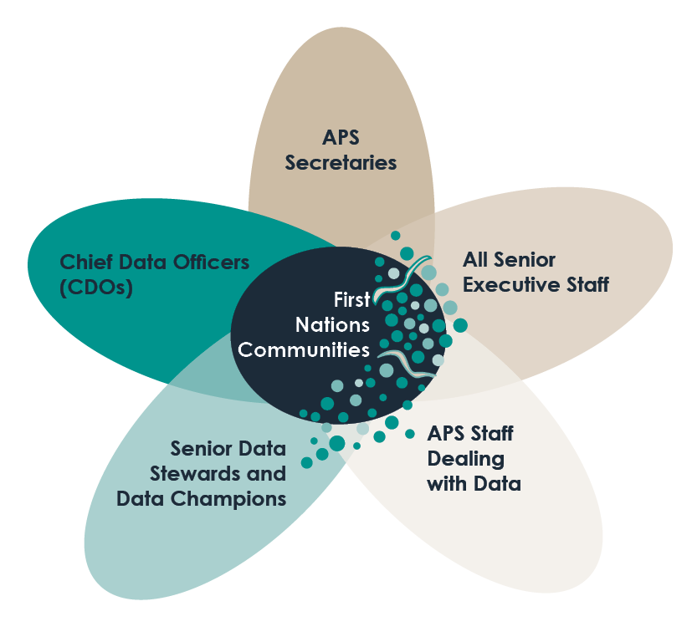
data as an asset, and building data capabilities.

Executive Level
Accountable for proper use of government data within
their business responsibility, and supporting efforts to
build APS data capabilities.

Tactical Level
Accountable for overseeing day-to-day management of
data collected and held by an agency within a defined
data domain or business area. Sometimes referred to as
Domain Data Stewards.

Operational Level
Accountable for everyday operations of the
department or agency, coming into contact with
Indigenous Data over their entire lifecycle.

First Nations Communities
Figure 1: Data governance in partnership
First Nations community are partners, and their involvement is at all stages across the data lifecycle, and have interactions across all levels of data governance.

Guideline 1: Partner with Aboriginal and Torres Strait Islander people
The Australian Government is committed to building genuine partnerships (e.g. through Priority Reform One of the National Agreement on Closing the Gap). This sets out strong partnership elements (clause 32). Further support to agencies to establish and strengthen partnerships, and shared-decision making,
is being developed through a Commonwealth Engagement and Partnership Framework.
Aboriginal and Torres Strait Islander people have successfully governed Indigenous data (information
and knowledge) for millennia. Their voices should have significant weight over decisions made about Indigenous data held by governments, from its conceptualisation and creation, through to its collection, access, analysis, interpretation, management, dissemination and reuse. Historically, however, Aboriginal and Torres Strait Islander people have been excluded from making decisions on data affecting them.
Overturning this imbalance of power requires APS agencies to form genuine partnerships with Aboriginal and Torres Strait Islander people. This aligns with Priority Reform One that governments will establish formal partnerships and shared decision-making with Aboriginal and Torres Strait Islander people.
The Guideline recognises that government-held data quality cannot be improved without embedding Indigenous leadership into its governance. Aboriginal and Torres Strait Islander leadership is crucial for improving the relevance, accessibility, interpretability, and timeliness of Indigenous data in the APS.
Agencies should be mindful that Aboriginal and Torres Strait Islander people are often expected by government to provide expertise on matters affecting them. To avoid overburdening Aboriginal and Torres Strait Islander peoples, agencies need to consider the demands placed on Aboriginal and Torres Strait Islander people. Part of this will require agencies to build cultural capability in line with Guideline Two, which will help agencies to demonstrate respect for peoples’ time and space.
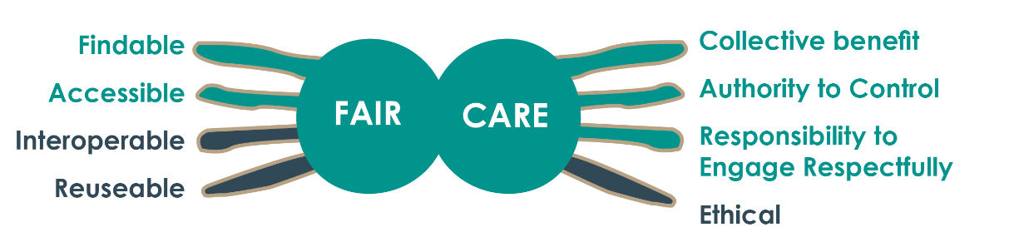

‘The Stronger Places, Stronger People case study highlighted the importance of working with communities and other key stakeholders to help understand and navigate what data are available and might be useful. All too often communities don’t have a real appreciation of the data that might be available and the story it tells. Mapping the data landscape is a key component of engagement.
Governments need to shift from a risk management mindset that prevents real engagement on data, to an approach that seeks to work with people to find solutions to their data priorities.’
Stronger Places, Stronger People case study – DCN Working Group

Actions

Prepare:
- Ensure APS staff are aware of and understand their obligations under the National Agreement on Closing the Gap, including its Priority Reforms and application to data (in particular Priority Reform One – Formal Partnerships and Shared Decision-Making – and Priority Reform Four – Shared Access to Data and Information at a Regional Level).
- Provide partnership and engagement resources to staff to support engagement with Aboriginal and Torres Strait Islander people at all stages of the data lifecycle (see example actions below).
- Each government agency to develop appropriate governance mechanisms for overseeing the implementation of actions under this Framework, in agreement with relevant Aboriginal and Torres Strait Islander partners. This could include:
- Reviewing existing data governance committees and ensuring the inclusion of relevant Aboriginal and Torres Strait Islander partners across those committees; or
- Developing a new governance committee(s) with relevant Aboriginal and Torres Strait Islander partners.
- Governance mechanisms developed for implementing this Framework should:
- Where appropriate, seek representation from Aboriginal and Torres Strait Islander stakeholders that are as connected as much as possible to affected communities;
- Have appropriate authority to influence agency actions under this Framework.
- Provide data leadership, in line with ‘shared decision-making’ as defined by Clause 32(c) of the National Agreement;
- Span horizontally across the diversity of the organisation’s data holdings (i.e. both Indigenous-specific and mainstream datasets), and span vertically including relevant organisational senior executives; and
- Raise awareness amongst agency staff (at all levels) of the guidelines and actions within this Framework.
- Consider resourcing requirements to support partnerships prescribed by this Framework, including funding to pay partners for their time and expertise, and APS staffing needs. Co-investment opportunities with state and territory governments, the private sector, or philanthropic organisations should be considered where appropriate.

Grow:
- Develop partnership arrangements between Aboriginal and Torres Strait Islander stakeholders and government agencies to facilitate agreed regular systematic data sharing.
- This could include establishing formal data sharing agreements where appropriate.
- A key aspect of these partnerships is to develop shared understanding of what data are relevant for specific Aboriginal and Torres Strait Islander stakeholders.

Extend:
- Conduct regular ‘partnership health checks’ involving external and impartial monitoring of internal APS practice to ensure actions agreed in partnership are implemented.
- The arrangements for partnership health checks should be determined and agreed between partners including identification and agreement of data priorities and expectations of partners.

Example actions:

Include data governance in the terms of reference for an existing stakeholder engagement or steering committee.

Add news alerts or information pages on Closing the Gap Priority Reforms to agency intranet resources.

Provide information about the Framework to senior executives to support discussions with teams.

Develop internal partnership frameworks or ‘how-to’ guides to support staff to better partner with Aboriginal and Torres Strait Islander stakeholders. Agencies may leverage existing resources, including partnership guidance under the National Agreement on Closing the Gap or engagement frameworks used by other agencies.

The Closing the Gap Partnership Agreement includes an annual Partnership Health Check.

Guideline 2: Build data-related capabilities
Building data-related capability is a key determinant for the success of the Framework. Technical skills comprising data literacy need to be developed and should include data creation, collection, access, analysis, interpretation, dissemination, reuse, review and retirement. These skills need to be supplemented by an understanding of how government collections of Indigenous data have often been rooted in deficit-based narratives and an understanding of the challenges in using existing administrative datasets to make inferences about Aboriginal and Torres Strait Islander people. When considering how to implement this Framework’s recommendations, agencies should ensure that principles and actions can be incorporated into your organisation’s current strategies and policies. In addition, the APS needs to develop skills on relationship building and shared decision-making with Aboriginal and Torres Strait Islander people. By developing data skills and working in partnership, APS staff can support Aboriginal and Torres Strait Islander people to tell their own stories and support self-determination.
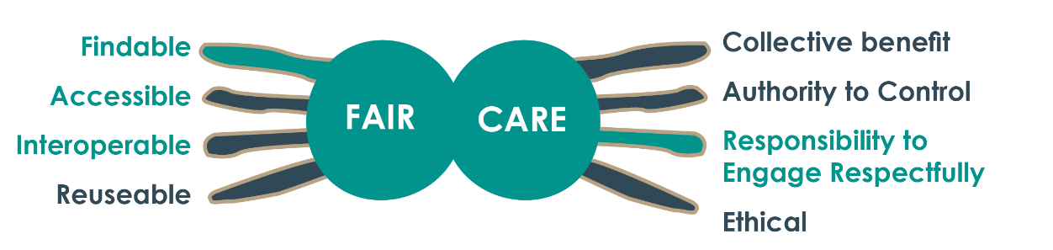
Data-related capability must also be supported and built in Aboriginal and Torres Strait Islander organisations and communities, including members of the specific communities the data relates to, by training and up-skilling Aboriginal and Torres Strait Islander people. This will require support to enhance Information Communications Technology (ICT) infrastructure and incorporate data expertise within Aboriginal and Torres Strait Islander organisations. This aligns with building the community-controlled sector, outlined in Priority Reform Two of the National Agreement on Closing the Gap (though it can also go beyond Aboriginal and Torres Strait Islander Community Controlled Organisations to include any relevant Indigenous stakeholder involved with government-held data). Without the necessary skills and training of Aboriginal and Torres Strait Islander people and APS staff, Aboriginal and Torres Strait Islander organisations and APS agencies cannot work together effectively to improve the governance of Indigenous data.

‘It is easier to get data from local health services than it is from State or Commonwealth departments. And it is harder to get data if there is no existing relationships with people in relevant government agencies.’
DCN Working Group

Actions

Prepare:
- Build agency capabilities related to partnering with Aboriginal and Torres Strait Islander people.
This involves:
- Assessing current capabilities related to cultural competency in line with the Aboriginal and Torres Strait Islander Cultural Capability Framework (Australian Public Service Commission); and
- Improving cultural competence through training by an Aboriginal and Torres Strait Islander-owned and appropriate training organisation (for example, an organisation recommended or accepted by stakeholders).
- Assess current agency data capability in partnership with Aboriginal and Torres Strait Islander partners, using the APS Data Capability Framework and build the capability of all staff to meet stakeholders’ data aspirations.
- Build understanding of key Indigenous data concepts amongst agency staff by embedding definitions such as ‘Indigenous Data Sovereignty’, ‘Indigenous Data Governance’, and ‘BADDR data’ (blaming, aggregate, decontextualised, deficit and restricted access, see Key Terms) into agency or whole-of-government data training programs.
- This may include key Indigenous data concepts being embedded into the APS Data Capability Framework and APS Data Professional Stream Strategy.
- Develop employment/secondment opportunities to build data-related capability (secondments in both directions between Australian Government agencies and Indigenous community organisations).
- Communities of practice related to data within the APS should incorporate consideration of this Framework into their terms of reference to embed a culture of best practice and knowledge sharing for governance of Indigenous data amongst APS staff.

Grow:
- Provide meaningful opportunities to strengthen data capability of Aboriginal and Torres Strait Islander Community Controlled Organisations, and other stakeholders. This will involve:
- Working with Aboriginal and Torres Strait Islander partners to co-design measures of data governance and data capability, including the data readiness and preparedness of their communities and organisations.
- Leverage existing and related initiatives to develop an APS-wide glossary/dictionary/business process/checklist so there is consistency across agencies in articulating data holdings for Aboriginal and Torres Strait Islander people.
- Review grant operations guidelines with Aboriginal and Torres Strait Islander people to ensure they support Indigenous organisations to build their ICT infrastructure and data capability.
- Ensure funding agreements are culturally appropriate and incorporate conditions to support grantees to build their data infrastructure and capability.

Extend:
- Use monitoring and evaluation to ensure capability and capacity building is effective. Focus groups, surveys and targeted consultations with the community could be some of the approaches to achieve this.

Example actions:

Create internal information resources to increase understanding of Indigenous Data Sovereignty.

Update Data Governance policies and frameworks to align with this Framework.

Include data specialists in project teams when implementing new programs to build understanding of community data priorities through working in partnership.

Consider two way secondment models similar to Jawun secondments.

Guideline 3: Provide knowledge of data assets
Agencies should support Aboriginal and Torres Strait Islander people to find and access relevant government-held data. This involves meaningfully informing Aboriginal and Torres Strait Islander peoples about what data are held by government, their usage and access permissions. Currently, approaches to informing communities of data holdings vary across Australian Government agencies. Formal data access processes are often opaque and have low accountability for providing Indigenous data to requesting parties. The further away the data custodian is from the requesting party, the harder it is to secure data release.
Community awareness and equitable access to data is a foundation on which Aboriginal and Torres Strait Islander people can make informed decisions about their lives. Information about how to request data along with expected response times should be easily accessible for Aboriginal and Torres Strait Islander people, and should be communicated in clear, plain and easily understood language. Data held by Government is not always shared and stakeholders are generally not involved in determining what data might be useful and this needs to change.
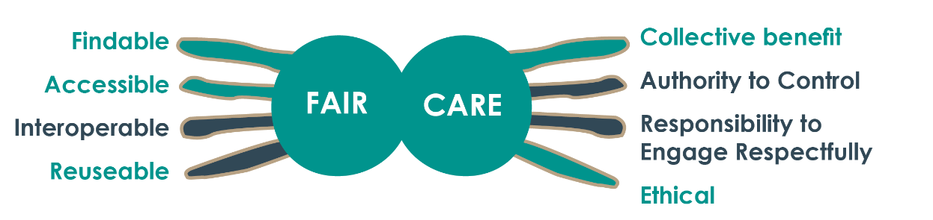
This guideline aligns to Priority Reform Four of the National Agreement on Closing the Gap as it will support access to information and make data more transparent by raising visibility of existing assets and how they can be accessed.

‘Relationships between APS data custodians and communities can lead to data access, but without those relationships access is difficult.’
Binarri Binyja Yarrawoo Aboriginal Corporation (BBY) case study – DCN Working Group

Actions

Prepare:
- Map all agency-held data assets containing Indigenous data, and share this information with Aboriginal and Torres Strait Islander people (where legally possible) by publishing in an accessible format to enable understanding of what data are available and what are not.
- Where possible, leverage Office of the National Data Commissioner (ONDC) Data Catalogue to implement this action.
- Be clear on the currency of the data (timestamp, source and collection methodology) and advise how frequently the data set will be updated (if known) and ensure capability building activities incorporate latest updates.
- Ensure the Indigenous data catalogue is easily findable for and accessible to Aboriginal and Torres Strait Islander people.
- Partner with Aboriginal and Torres Strait Islander peoples when revising or establishing the data collection and management processes for any existing or new programs or datasets.
- In alignment with the Australian Government policy of making data open by default, identify opportunities and continue to invest in the development of de-identified data assets that are valued by Aboriginal and Torres Strait Islander people and organisations.
- Establish easily understandable and transparent processes for Aboriginal and Torres Strait Islander people to request access to government-held data. Key requirements for understandable and accountable processes include:
- No data request should be denied unjustifiably, or go unanswered.
- Reasons for refusal must be communicated to applicants and alternative options suggested.
- Where privacy is a legitimate reason for denial of access to data, agencies should work with applicants to identify relevant data that can be released.
- Data request processes should be published online, be easy to follow, and be free to access wherever possible
- Processes should include minimum response time and mechanisms for the right of review/appeal.
- Ensure data governance frameworks note touchpoints along the data lifecycle (Appendix C) where Aboriginal and Torres Strait Islander people can partner with government to influence governance.

Grow:
- Work with Aboriginal and Torres Strait Islander people providing training and up-skilling as necessary to identify appropriate data asset metadata labels to make data more findable.
- Once developed, use Indigenous status identifiers and/or data asset metadata flags to improve alignment of government-held Indigenous data assets with FAIR and CARE.
- Develop an APS-wide Aboriginal and Torres Strait Islander data catalogue which would provide data requesters with an easier path to locate the relevant data assets and request access.

Extend:
- Develop strategies and explore different approaches to better capture Aboriginal and Torres Strait Islander people’s identities through recognition of Nations or Language Groups in the relevant National collections.
- Where Aboriginal and Torres Strait Islander partners consider it a priority, develop processes for the appropriate curation of archived data sets containing Indigenous data.

Example actions:

Publish data access protocols on your agency’s externally facing website.
When publishing data access protocols, ensure they are promoted to Aboriginal and Torres Strait Islander people and communities.

Create a project team to comprehensively compile a register of data assets
and identify those that contain Indigenous Data.

Guideline 4: Build an inclusive data system
While partnerships are important, their cumulative success at a systemic level will require data systems to undergo structural transformation. Australian Government agencies need to transform their data systems to support the inclusion of Aboriginal and Torres Strait Islander people in data governance. Without adapting to different ways of doing business and transforming government organisations, improvements in the governance of Indigenous data are unlikely to be realised.
Building an inclusive data system aligns with Priority Reform Three of the National Agreement on Closing the Gap. As part of the reform, there is a commitment to the systemic and structural transformation of mainstream government organisations (part of which involves identifying and calling out institutional racism, discrimination and unconscious bias).
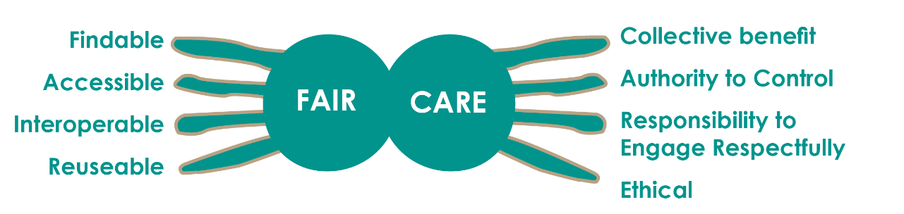
At present, Aboriginal and Torres Strait Islander people are marginalised by the Australian Government data system and the governance of Indigenous data. This is reflected in the mainstream production and use of data about Aboriginal and Torres Strait Islander people that tends to be Blaming, Aggregate, Decontextualised, Deficit-based and has Restricted access (BADDR). This is the result of ways the public sector has operated excluding the voices and priorities of Aboriginal and Torres Strait Islander people. It is critical that current data systems be reviewed with Aboriginal and Torres Strait Islander partners to address barriers and ensuring data supports self-determination. To achieve this, organisation and culture change is necessary, alongside Indigenous governance mechanisms and appropriate Aboriginal and Torres Strait Islander representation on mainstream data governance groups. While relationship building is important, it should not be a prerequisite for access to data. Structural changes must be made to ensure data systems are inclusive of Aboriginal and Torres Strait Islander peoples at all stages of the data lifecycle.

‘Cultural, Language Group, and First Nations affiliations tend not to be included in standard administrative datasets resulting in Indigenous people not seeing themselves within the data. Some datasets are decontextualized and lack additional information that makes them meaningful for researchers or Indigenous people and their communities. This highlights the need for First Nations people to be involved in national data collections throughout the data lifecycle.’

National Perinatal Data Collection case study – DCN Working Group

Actions

Prepare:
- Establish an Indigenous data champion in each agency to establish, enhance and drive capability and capacity to implement this Framework.
- The Indigenous data champion would provide guidance and support in the governance and management of Indigenous data assets. This champion would preferably be an Aboriginal or Torres Strait Islander staff member at executive level, but importantly the role should have the appropriate authority and support to influence the work of the agency. If an Aboriginal or Torres Strait Islander staff member is not currently available, upskilling and recruiting should be a priority for this role, so that it can be held by an Aboriginal or Torres Strait Islander person.
- Ensure all agency policies, programs, corporate plans, and digital or data frameworks or strategies incorporate the guidelines and actions in this Framework.
- Identify organisational resources necessary to implement this Framework or seek additional resources where necessary.

Grow:
- Evaluate current data governance practices using the FAIR and CARE principles for Indigenous data governance.
- Agencies to review templates for contracts and funding agreements, and at time of contract/agreement renewal for existing organisations, to ensure:
- Funded organisations collect and manage data in accordance with this Framework;
- Key Performance Indicators (KPIs) are informed by Aboriginal and Torres Strait Islander people’s understanding of place-based success, while collecting minimum data required for accountability under Commonwealth legislation and regulations.
- Identify mechanisms and supports so data collected by Aboriginal and Torres Strait Islander organisations receive improved recognition by government as legitimate sources of information, acknowledging input from Aboriginal and Torres Strait Islander stakeholders in relation to culture is essential.
- Co-design Indigenous-led definitions of the meaning of ‘local and regional’ beyond boundaries used by mainstream datasets (for example, the Australian Statistical Geography Standard).
- Improve the quality of government-held Indigenous data assets, including those which perpetuate BADDR data (refer to Key Terms), through:
- Working in partnership with Aboriginal and Torres Strait Islander people to better identify Aboriginal and Torres Strait Islander people in mainstream data collection (reduce under-identification and misidentification, minimise collection bias).
- Partnering with Aboriginal and Torres Strait Islander people in all phases of the data lifecycle following collection (access, analysis, interpretation, dissemination, reuse/review/retire).
- Through partnership arrangements developed under Guideline 1, build an understanding of the additional or alternative data Aboriginal and Torres Strait Islander people wish to have collected and investigate options to address these gaps. Training and upskilling Aboriginal and Torres Strait Islander people in communities to collect the data should be included to improve collection and minimise impact on community cultural practices.

Extend:
- Include Aboriginal and Torres Strait Islander partners in relevant cross-jurisdictional processes for data sharing between federal, state/territory and local governments (by leveraging initiatives such as the Intergovernmental Agreement on Data Sharing).
- If requested by Aboriginal and Torres Strait Islander partners, agencies will explore opportunities within existing legislation to release disaggregated data at the appropriate level where legally and ethically acceptable to do so, such as through Public Interest Determinations available within the Privacy Act 1988.
- Working with Aboriginal and Torres Strait Islander partners, agencies will explore ways to promote the ‘collective’ or ‘group’ privacy of Aboriginal and Torres Strait Islander people through the ethical collection, use and dissemination of demographic information about Indigenous groups.
- Explore options and prioritise resources to update the Data Availability and Transparency Act (DATA) 2022 to allow Aboriginal and Torres Strait Islander Community Controlled Organisations and Registered Native Title corporate bodies to become ‘accredited users’ under the DATA Scheme.
- Establish user-friendly technologies and infrastructure, and community focussed data platforms that can enhance the capabilities of the community to access, interpret, use and maintain their own data. Training and up-skilling of Aboriginal and Torres Strait Islander peoples in these technologies should be provided.

Example actions:

Establish a project team to review existing legislation for which your agency is responsible to identify barriers to implementation of the Framework, and discuss solutions in partnership with your governance committee (in partnership) – Guideline 1 refers.

Once an Indigenous Data Champion is established, raise staff awareness of the role and purpose of this position through an internal campaign.

Ask staff drafting new policy proposals to identify any actions in this Framework that should be incorporated.

Appendices

Appendix A: Development of the Governance of Indigenous Data Framework

The APS has two bodies responsible for data reform – the Data Champions Network (DCN) and the Deputy Secretaries Data Group (DSDG).
This Framework has been developed by a DCN Working Group, with oversight by a DSDG Sub--Committee. Both the DCN Working Group and DSDG Sub-Committee comprise APS representatives and non-APS/Aboriginal and Torres Strait Islander representatives. The DCN Working Group has met on a monthly or fortnightly basis from May 2022 to June 2023, and the DSDG Sub Committee has met quarterly.
In Figure 2 the roles, responsibilities, and relationships of the groups are outlined. Membership of the DSDG Sub-Committee is provided in Table 1; membership of the DCN Working Group is provided in Table 2.
Figure 2: Roles and responsibilities

Table 1: Membership of the DSDG Sub-Committee on the Governance of Indigenous Data (as at 30 March 2023)
APS members | APS members
- Ms Rachael Jackson  National Indigenous Australians Agency  - Ms Liz Hefren-Webb  Department of the Prime Minister and Cabinet  - Dr Craig Ritchie  Australian Institute of Aboriginal and Torres Strait Islander Studies (proxy representative: Ms Kate Thomann)  - Ms Teresa Dickinson and Mr Michael Smedes  Australian Bureau of Statistics  - Mr Matthew James PSM  Australian Institute of Health and Welfare  - Ms Catherine Andersson  Productivity Commission  - Mr Matt Flavel  Department of Social Services  - Mr Marcus Markovic  Department of Education | - Mr Gavin Matthews  Department of Health and Aged Care  - Ms Rosemary Deininger  Department of Agriculture, Forestry and Fisheries  - Ms Gayle Milnes  Office of the National Data Commissioner  - Mr Simon Froude  National Archives of Australia  - Mr Nathan Smyth  Department of Employment and Workforce Relations  - Ms Michelle Dowdell  Department of Industry, Science and Resources  - Mr Philip Smith  Department of Infrastructure, Transport, Regional Development, Communications and the Arts

Non-APS/Aboriginal and Torres Strait Islander members | Non-APS/Aboriginal and Torres Strait Islander members
- Mr Geoff Richardson PSM  First Nations Development Services  - Commissioner Maggie Walter (PhD, FASSA),  Yoorrook Justice Commission / Distinguished Professor Emerita University of Tasmania / Maiam nayri Wingara  - Mr Beau Williams  Coalition of Aboriginal and Torres Strait Islander Peak Organisations  - Associate Provost Professor Dr Marcia Langton AO  University of Melbourne  - Professor Megan Jane Davis  University of NSW / United Nations Human Rights Council | - Professor Ian Anderson AO (MBBS, PhD, DMedSci (honouris causa) FAFPHM, FASSA, FAAHMS)  University of Tasmania  - Ms Eunice Yu  Nagula Jarndu Design  - Mr Alistair Ferguson  Maranguka Backbone Organisation  - Emeritus Professor John Taylor  Australian National University  - Associate Professor Vanessa Lee-Ah Mat (BTD, MPH, PhD, SFHEA)  University of Sydney / Maiam nayri Wingara / Black Lorikeet Cultural Brokering Consultancy

Table 2: Membership of the Data Champions Network Working Group on the Governance of Indigenous Data (as at 30 June 2023)
APS members | APS members
- Dr Jessica Hartmann  National Indigenous Australians Agency  - Ms Malika Bouhafs  Department of Finance  - Mr Michael Burn  Australian Institute for Aboriginal and Torres Strait Islander Studies  - Dr Fui Choong  Department of Health and Aged Care  - Mr Pourus Bharucha  Treasury  - Ms Shonella Tatipata  Australian Bureau of Statistics  - Ms Lauren Power  Department of Infrastructure, Transport, Regional Development, Communications and the Arts  - Ms Cat Stanley  National Archives Australia  - Mr James Vecchio  Department of Social Services | - Dr Deanna Pagnini  Australian Institute of Health and Welfare  - Ms Trisha Moriarty,  Geoscience Australia  - Ms Jo Bunting  Department of Agriculture, Forestry and Fisheries  - Ms Julie Watson  National Library of Australia  - Mr James Shin,  Office of the National Data Commissioner  - Mr Brendan Price  Department of Education  - Mr Brad Knight  Department of Employment and Workplace Relations  - Dr Michael Amon  Attorney-General’s Department  - Mr Ben Taylor  Australian Taxation Office
Non-APS/Aboriginal and Torres Strait Islander members | Non-APS/Aboriginal and Torres Strait Islander members
- Dr Jacob Prehn  University of Tasmania  - Ms Corinne Hodson  Barang Regional Alliance  - Mr Levi Murray  University of Melbourne  - Mr Jon Willis  University of Queensland Poche Centre for Indigenous Health  - Ms Julia Curtis  University of Tasmania  - Ms Bianca Brim  Coalition of Aboriginal and Torres Strait Islander Peak Organisations  - Ms Jessie Sleep  Far West Partnerships, South Australia | - Mr Isaac Torres  Kimberley Aboriginal Health Research Alliance (KAHRA), Western Australia  - Ms Kristi Mansfield  SEER Data & Analytics  - Dr Scott Avery  Western Sydney University  - Mr Peter Riley  Central Australia Academic Health Science Network  - Ms Peta McGillivray  University of NSW  - Mr Raymond Brunker  Aboriginal & Torres Strait Islander Community Health Service Brisbane  - Mr Gary Field  Barang Regional Alliance

Appendix B: Related and Previous Work

Data Availability and Transparency Act 2022
- The Data Availability and Transparency Act 2022 (the Act) commenced in April 2022 and was a key recommendation from the Productivity Commission Inquiry Report into Data Availability and Use (2017). The Act establishes the DATA Scheme under which Commonwealth bodies are authorised to share their public sector data with Accredited Users. The Act establishes the role of the National Data Commissioner, who is the regulator for the DATA Scheme.
- https://www.legislation.gov.au/Details/C2022A00011

Indigenous Data Sovereignty Principles - Maiam nayri Wingara
- Maiam nayri Wingara Aboriginal and Torres Strait Islander Data Sovereignty Collective was formed in early 2017. Maiam nayri Wingara’s goal is to develop Aboriginal and Torres Strait Islander Torres Strait Islander data sovereignty principles, identify Aboriginal and Torres Strait Islander strategic data assets, and empower Aboriginal and Torres Strait Islander people to engage in Indigenous Data Sovereignty. The Indigenous Data Governance protocols and principles were developed during the National Indigenous Data Sovereignty Summit in 2018.
- https://www.maiamnayriwingara.org/mnw-principles

Data Sovereignty Readiness Assessment and Evaluation Toolkit – Lowitja Institute
- The Lowitja Institute is a First Nations community-controlled health research institute. The Lowitja Institute launched the Indigenous Data Sovereignty Readiness Assessment and Evaluation Toolkit (the Toolkit) in 2022. The Toolkit was designed to assist researchers, governments, and communities, to strengthen community control, use and protection of First Nations data and information.
- https://www.lowitja.org.au/page/services/tools/indigenous-data-sovereignty-readiness-assessment-and-evaluation-toolkit

OCCAAARS First Nation Data Sovereignty Framework – Kowa Collaborations
- This is a conceptual framework for researching, evaluating, and designing First Nations programs, initiatives and Organisations.
- https://www.kowacollaboration.com/resources

AIATSIS Code of Ethics for Aboriginal and Torres Strait Islander Research – Australian Institute of Aboriginal and Torres Strait Islander Studies (AIATSIS), 2020
- The AIATSIS Code of Ethics for Aboriginal and Torres Strait Islander Research (the Code) is informed by the recognition of and respect for the rights of Aboriginal and Torres Strait Islander peoples as articulated in the United Nations Declaration on the Rights of Indigenous Peoples. The Code outlines four principles that underpin ethical research that involves and impacts Aboriginal and Torres Strait Islander people.
- https://aiatsis.gov.au/sites/default/files/2020-10/aiatsis-code-ethics.pdf

Appendix C: Data Lifecycle

Conceptualising the Data Lifecycle
The diagram provided below is part of a co-design process led by the NIAA to develop an APS-wide Framework for the Governance of Indigenous Data. It is intended to open dialogue on where co-design with Aboriginal and Torres Strait Islander people can be embedded in touch-points across the Australian Public Service (APS) data lifecycle to progress the development of an APS-wide Framework on the Governance of Indigenous Data. The text below has been informed by discussions held by the Data Champions Network (DCN) Working Group, and each phase of the lifecycle has been labelled in line with Maiam nayri Wingara definitions.
System design & Technology
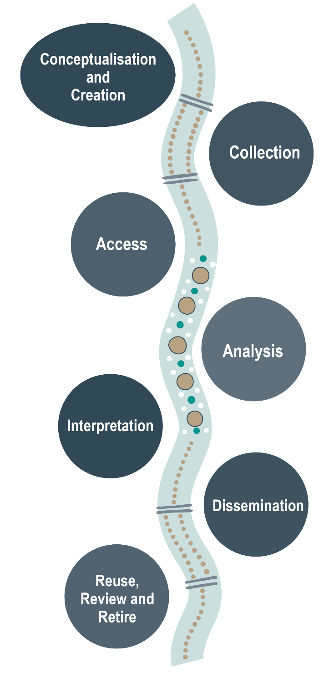
System design underpins every stage of the data lifecycle
- The data lifecycle of First Nations data should be underpinned by a system that is co-created by Aboriginal and Torres Strait Islander people to reflect needs and priorities.
- Systems design of data storage should be grounded in Aboriginal and Torres Strait Islander design and stewardship of data, including appropriate identifiers.
- System design should articulate a clear model of governance that is rooted in Indigenous governance.
- The data system design should facilitate data linkage that meets the information needs of communities.

Conceptualisation and Creation
- Aboriginal and Torres Strait Islander people, including from communities about which the data relates as appropriate, should have significant input in the conceptualisation and creation of Indigenous data.
- Is government asking the right questions to respond to Aboriginal and Torres Strait Islander communities’ priorities and aspirations? Where possible, data should be viewed as a commons that groups exercise a collective right to shape and access.
- Indigenous data should be subject to change where Aboriginal and Torres Strait Islander people request.
- Government should learn data priorities from Aboriginal and Torres Strait Islander organisations before collecting and creating. Indigenous data includes collection methods and forms outside of the bureaucratic frame, e.g. yarning circles.
- Administrative data collected by Government should consider its end use and purpose beyond the administrative needs of a particular program.
- Data are to be viewed as a common asset that should be available outside APS institutions.
- Data should be created to support Indigenous data needs and empower sustainable self-determination and effective self-governance.
- Data should be conceptualised to reflect the Indigenous Lifeworld.
- Data is contextualised so that it is strengths-based rather than deficit-focused where possible.
- Government-set KPIs for Indigenous grants funding should be informed by Aboriginal and Torres Strait Islander people’s understanding of place-based success.

Collection
- Indigenous data should always be collected ethically and respectfully.
- Free, prior, and informed consent should be obtained in culturally safe and appropriate ways, clearly articulating benefits and risks.
- Collection practices should be grounded in ethical standards that are grounded in Aboriginal and Torres Strait Islander people’s priorities.
- Community surveys should be able to be temporarily or on an ongoing basis suspended at the discretion Aboriginal and Torres Strait Islander people to align with community practices and needs (including Sorry Business, etc.).
- Metadata from the collection should include contextual information, including the provenance of Indigenous data.

Access
- Aboriginal and Torres Strait Islander people need access to their data.
- What legislation can be used, or needs reform, to enable Aboriginal and Torres Strait Islander people to have access to Indigenous data at a local and regional level?
- Support should be provided to Aboriginal and Torres Strait Islander communities, where necessary, to access the required IT capacity and infrastructure for community data access.
- Aboriginal and Torres Strait Islander people need access to their data in useable forms.
- Aboriginal and Torres Strait Islander communities should be supported by the government, where appropriate, to manage and maintain their own data resources.

Analysis
- Aboriginal and Torres Strait Islander people need to be involved in analysis to provide context and build capability to analyse data.
- Aboriginal and Torres Strait Islander perspectives should shape not only the choice of methods, but how the data are analysed.
- Methodology for analysis should be designed in collaboration with Aboriginal and Torres Strait Islander people.
- The APS should seek to increase support for Aboriginal and Torres Strait Islander researchers and data users through secondments, scholarships, training programs and on the ground support to build data manager and data analyst qualifications.

Interpretation
- Anyone interpreting Indigenous data needs to have an understanding of Aboriginal and Torres Strait Islander perspectives and the complexities of colonisation.
- Aboriginal and Torres Strait Islander people should have the right to self-determination over their data-driven narrative.
- Indigenous data interpretation should be in collaboration with Aboriginal and Torres Strait Islander people.
- Aboriginal and Torres Strait Islander communities should be supported by the government, where appropriate, to integrate multiple data sources, conduct analyses, and produce self-determined interpretations of issues.
- The APS must promote Aboriginal and Torres Strait Islander people’s cultural safety to better attract and retain staff with data expertise to build the APS capability to interpret data appropriately.

Dissemination
- Aboriginal and Torres Strait Islander people, including those in communities, should govern in partnership with Government the dissemination of Indigenous data inclusive of the what, how, why, and to mitigate and manage adverse data narratives and deficit discourse.
- Aboriginal and Torres Strait Islander people should be provided with the tools and capability to publish and disseminate their own data.

Reuse, Review and Retire
- Decisions about the reuse, review and retirement of data should involve Aboriginal and Torres Strait Islander people. This relates to decisions about current data assets but also includes historical data.
- For ongoing and administrative datasets, regular review of collection should be conducted to consider whether practices align with Aboriginal and Torres Strait Islander priorities.
- Entities that are accredited data service providers (ADSPs) will ensure that data linkage that includes any data involving or affecting Aboriginal and Torres Strait Islander people, will ensure that there is and has been appropriate engagement with Aboriginal and Torres Strait Islander people, as required under the National Statement on Ethical Conduct in Human Research.
- Aboriginal and Torres Strait Islander people should be able to set their licensing agreements, and exercise their patents, trademarks, designs and plant breeders’ rights, to maintain and protect their Traditional Knowledge (TK) and Traditional Cultural Expressions (TCEs).

Appendix D: Case Studies
The DCN Working Group used three case studies to explore the current state of the governance of Indigenous data within the APS. The findings are summarised below. The case studies provide lessons for other similar data collections/projects in terms of improving the governance of Indigenous data.
National Perinatal Data Collection  Australian Institute of Health and Welfare | The National Perinatal Data Collection (NPDC) is a national population-based cross-sectional collection of data on pregnancy and childbirth. The data are based on births reported to the perinatal data collection in each state and territory in Australia. Midwives and other birth attendants, using information obtained from mothers and from hospital or other records, complete notification forms for each birth. A standard de-identified extract is provided to the Australian Institute of Health and Welfare (AIHW) on an annual basis to form the NPDC.  The NPDC was chosen as an example of an administrative dataset for discussion by the DCN Working Group. Many of these findings would be applicable to other administrative datasets.
Key findings | - There can be a mismatch between government purposes for collecting data and what an Aboriginal and Torres Strait Islander community would find useful.  - For the NPDC, much of what is collected can be shared at appropriate levels of disaggregation – but this may not be widely known to Indigenous communities.  - The data lifecycle for datasets like the NPDC tends to lack consideration of Indigenous data sovereignty and Indigenous data governance.  - This lack of consideration of Indigenous data sovereignty and Indigenous data governance at the conceptualisation stage of the data lifecycle can lead to the creation of administrative datasets that do not capture all relevant data or that do not reflect the priorities of the community.  - There is little visibility of Aboriginal and Torres Strait Islander people’s involvement in the governance structures of the NPDC, particularly at the collection stage of the data lifecycle.  - Cultural, Language Group, and Aboriginal and Torres Strait Islander people’s affiliations tend not to be included in standard administrative datasets resulting in Aboriginal and Torres Strait Islander people not seeing themselves within the data. Some datasets are decontextualized and lack additional information that makes them meaningful for researchers or Indigenous people and their communities. For example, broader information about reproductive health is not available in the NPDC.  - Under-identification and misidentification are key data quality issues.  - There are aspects of the NPDC which can be framed from a strengths based perspective (such as healthy birthweight).  - Greater involvement of Indigenous people in the analysis and interpretation stages of the data lifecycle would enable more strengths based reporting and promote a more respectful understanding of their experiences.

Stronger People Stronger Places (SPSP)  Department of Social Services | SPSP is a community-led, collective impact initiative stewarded by the Australian Government in partnership with state and territory governments and 10 communities across Australia.  A unique feature of collective impact is the shared commitment to a local strategy by communities with shared accountability for planning, decision-making and results. It focuses on locally tailored and evidence-driven solutions to local problems, in partnership with local people.
Key findings | - Most of the work required to work with communities is internal to government in efforts to build capability around data and engagement.  - Cultural barriers to sharing data within the APS can be navigated by proactively addressing concerns about risk, whilst demonstrating the potential value for communities.  - The APS needs to build its capability to work in new ways whilst upholding legislative responsibilities.  - Change will require a willingness to address the system and authorisation from leaders to do things differently.  - Working with communities is different to working with peak organisations.  - The importance of building relationships between APS staff and communities.  - Lack of resourcing is a big barrier to supporting Indigenous Data Governance on-the-ground.  - SPSP works within the dominant frame of mainstream and non-Indigenous data governance, and so is mostly focused on providing access to existing government-held datasets. So, though it works more closely with communities, it still focuses on what is available rather than what is directly needed.  - The datasets offered by SPSP were created without reference to what communities say they need now. It is crucial to consider the conceptualisation and creation phases of the data lifecycle.

Binarri Binyja Yarrawoo Aboriginal Corporation (BBY)  Empowered Communities East Kimberley | BBY is an Empowered Communities backbone organisation based in the East Kimberley. ‘Empowered Communities’ involve Aboriginal and Torres Strait Islander communities and governments working together to set priorities, improve services and apply funding effectively at a regional level. Importantly, it aims to increase Indigenous ownership and give Aboriginal and Torres Strait Islander people a greater say in decisions that affect them.
Key findings | - Capacity building in communities with varying data maturity involves talking about data, what it means and empowering people to understand it; and talking about Indigenous Data Sovereignty and breaking it down.  - People in communities do not always talk about ‘Indigenous Data Sovereignty’ in those exact words, but they do respond well to talk about telling their own stories.  - Lack of resourcing is the biggest barrier to effective Indigenous Data Governance.  - Data requests have been difficult to progress at local, State/Territory and Federal governments.  - A big reason why data requests are rejected is privacy. Disaggregated data by Indigenous status can’t be accessed for smaller towns.  - Currently service mapping is limited because there is only access to NIAA Indigenous Advancement Strategy (IAS) funding; the vision is to look at all funding from all agencies.  - Relationships between APS data custodians and communities can lead to data access, but without those relationships access is difficult.  - Key Performance Indicators (KPIs) for funding agreements do not measure the right things, with a detrimental focus on outputs to the exclusion of longer term outcomes.  - The push in government toward standardised KPIs (for better comparison between regions) is in tension with the need for place-based, locally informed, and Indigenous-led measures of success.  - Communities are keen to understand the impact of programs.  - Data enables joint decision-making.

Key concepts
Concept | Explanation
Australian Indigenous Data Sovereignty Principles | The Maiam nayri Wingara Indigenous Data Sovereignty Collective and the Australian Indigenous Governance Institute assert that in Australia, Aboriginal and Torres Strait Islander people have the right to:  - Exercise control of the data ecosystem including creation, development, stewardship, analysis, dissemination and infrastructure.  - Data that are contextual and disaggregated (available and accessible at individual, community and First Nations levels).  - Data that is relevant and empowers sustainable self-determination and effective self-governance.  - Data structures that are accountable to Indigenous peoples and First Nations.  - Data that is protective and respects Indigenous peoples individual and collective interests.
FAIR Guiding Principles and CARE Principles for Indigenous Data Governance | The FAIR Guiding Principles (Findable, Accessible, Interoperable, Reusable) focus on increasing data sharing but do not address the tension for Indigenous people in also seeking greater control over and use of Indigenous knowledge for collective benefit.  The CARE principles (Collective Benefit, Authority to control, Responsibility, and Ethics) reflect the important role data plays in advancing self-determination. They complement the FAIR Guiding Principles and encourage greater consideration of people and purpose.
Priority Reforms under the National Agreement on Closing the Gap | At the centre of the National Agreement are four Priority Reforms that focus on changing the way governments work with Aboriginal and Torres Strait Islander people.  The Priority Reforms are:  - Formal partnerships and shared decision-making;  - Building the community-controlled sector;  - Transforming government organisations; and  - Shared access to data and information at a regional level.  Priority Reforms Three and Four are a particular focus of this Framework.

Key Terms
Term | Source | Definition
Administrative data | Australian Bureau of Statistics (ABS) | Information (including personal information) collected by agencies for the administration of programs, policies or services.
Aggregate data | Australian Bureau of Statistics (ABS) | Produced by grouping information into categories and combining values within these categories.
BADDR Data | Walter (2018) | Defined by Walter (2018) to describe the dominant deficit discourses within data about Aboriginal and Torres Strait Islander peoples:  • Blaming data,  • Aggregate data,  • Decontextualised data,  • Deficit, Government Priority data,  • Restricted Access data.
CANZUS | Kukutai & Taylor (2016) | Canada, Australia, New Zealand, and the United States – A group of Anglo-Colonised countries with a similar experience of colonisation.
Data custodian | Australian Bureau of Statistics (ABS) | An organisation or agency responsible for the collection, management and release of data; including ethical and legal obligations to keep the information they are entrusted with confidential.
Data Ecosystem | Stobierski (2021) | The programming languages, packages, algorithms, cloud-computing services and general infrastructure an organisation uses to collect, store, analyse and leverage data.
Data governance | Derived from APS Data Capability Framework | Practices and processes ensuring the formal management of data assets within an organisation.
Data integration | Australian Bureau of Statistics (ABS) | Data integration is the process of combining data from two or more sources at the unit level (e.g. person and/or business).
Data lifecycle | Refer to Appendix C | The data life cycle involves the: creation, collection, access, analysis, interpretation, management, dissemination and reuse of Indigenous data.
Data linkage | Australian Institute of Health and Welfare (AIHW) | Bringing together (linking) information from two or more data sources believed to relate to the same entity, such as the same individual or the same institution. The resulting data set is called linked data.
Data provider | Australian Bureau of Statistics (ABS) | An individual, household, business or other entity that supplies data for statistical or administrative purposes.
Data sharing | Derived from Actionable Intelligence for Social Policy | Data sharing is the practice of providing partners with access to information or knowledge they can’t access in their own data systems. Data sharing allows stakeholders to learn from each other and collaborate on shared priorities.
Data structure | Lenovo AU | The way data is organized, stored, and manipulated in a computer system. It provides a means to efficiently manage and access data, enabling faster and more effective computations. By using different data structures, programmers can optimize their code and improve the performance of their applications.
De-identification | Office of the Australian Information Commissioner (OAIC) | A process which involves the removal or alteration of information that identifies a person or is reasonably likely to identify them, as well as the application of any additional protections required to prevent identification.
Disaggregated Data | National Indigenous Australians Agency (NIAA) | Data that is broken down into smaller units. For example, data being available at the Aboriginal and Torres Strait Islander community, clan or Nation level.
Governance of Indigenous Data | NIAA | The practices and processes of governing the creation, collection, access, analysis, interpretation, management, dissemination and reuse of Indigenous data.
Identified data | Australian Bureau of Statistics (ABS) | Data that includes information that refers directly to an individual or organisation, such as name or address, ABN, Medicare number, Indigenous status.
Indigenous Data | Maiam nayri Wingara 2018 | Information or knowledge, in any format or medium, which is about and may affect Indigenous peoples both collectively and individually.
Indigenous Data Governance (IDG) | Maiam nayri Wingara 2018 | The right of Indigenous peoples to autonomously decide what, how and why Indigenous Data are collected, accessed and used. It ensures that data on or about Indigenous peoples reflects [their] priorities, values, cultures, worldviews and diversity.
Indigenous Data Sovereignty (IDS) | Maiam nayri Wingara 2018;  Additional definitions in Indigenous Data Sovereignty: Towards an Agenda (2016) | The right of Indigenous people to exercise ownership over Indigenous Data. Ownership of data can be expressed through the creation, collection, access, analysis, interpretation, management, dissemination and reuse of Indigenous Data.
Indigenous Data Sovereignty Principles | Maiam nayri Wingara 2018 | In Australia, Indigenous Peoples have the right to:  - Exercise control of the data ecosystem including creation, development, stewardship, analysis, dissemination and infrastructure;  - Data that are contextual and disaggregated (available and accessible at individual, community and First Nations levels);  - Data that are relevant and empower sustainable self-determination and effective self-governance;  - Data structures that are accountable to Indigenous peoples and First Nations;  - Data that are protective and respect Aboriginal and Torres Strait Islander peoples’ individual and collective interests.
Metadata | Australian Bureau of Statistics (ABS) | The information that defines and describes data by providing data users with information about the purpose, processes and methods involved in the data collection.
Open data principles | Open Data Charter | - Open by default;  - Timely and comprehensive;  - Comparable and interoperable;  - For improved government and citizen engagement; and  - For inclusive development and innovation.
Open government data | Organisation for Economic Co-operation and Development (OECD) | Open Government Data (OGD) is a philosophy- and increasingly a set of policies - that promotes transparency, accountability and value creation by making government data available to all. Public bodies produce and commission huge quantities of data and information.
Strengths-based approach | Saleebey (1996) | - Every individual, group, family, and community has strengths;  - Trauma, abuse, illness, and struggle may be injurious, but they may also be sources of challenge and opportunity;  - Assume that you do not know the upper limits of the capacity to grow and change, and take individual, group, and community aspirations seriously;  - We best serve people by collaborating with them;  - Every environment is full of resources; and  - Caring, caretaking, and context.
UNDRIP | United Nations | United Nations Declaration on the Rights of Indigenous Peoples.
Unit record data (microdata) | Australian Bureau of Statistics (ABS) | Datasets of unit records where each record contains information about a person, organisation or other type of unit.

Resources

- AIATSIS Code of Ethics | Australian Institute of Aboriginal and Torres Strait Islander Studies
- APS Data Capability Framework | Australian Public Service Commission
- CARE Principles for Indigenous Data Governance | Global Indigenous Data Alliance
- Data Development Plan – 2022-2030 | Closing the Gap
- Establishing an information governance committee | National Archives of Australia
- Ethical conduct in research with Aboriginal and Torres Strait Islander Peoples and communities | National Health and Medical Research Council
- FAIR Guiding principles for scientific data management and stewardship | GO FAIR
- Five Safes Framework | Australian Bureau of Statistics
- Indigenous Data Sovereignty and Policy (Edited by Maggie Walter, Tahu Kukutai, Stephanie Russo Carroll, Desi Rodriguez-Lonebear) | Routledge
- Indigenous Data Sovereignty Readiness Assessment and Evaluation Toolkit | Lowitja Institute
- Indigenous Data Sovereignty: Toward an agenda (Edited by Tahu Kukutai, John Taylor) | Australian National University Press
- National best practice guidelines for collecting Indigenous status in health data sets | Australian Institute of Health and Welfare
- National best practice guidelines for data linkage activities relating to Aboriginal and Torres Strait Islander people: 2012 | Australian Institute of Health and Welfare
- The Foundational Four (Starting an ongoing data improvement journey) | Office of the National Data Commissioner
- Yumi Sabe (Indigenous Knowledge Exchange) | Australian Institute of Aboriginal and Torres Strait Islander Studies



The term ‘Aboriginal and Torres Strait Islander people’ refers to Australia’s first peoples. This term is generally preferred by members of the Working Group.
Maiam nayri Wingara. (2018). Indigenous Data Sovereignty Communique Indigenous Data Sovereignty Summit 20th June 2018, Canberra, ACT.
CARE Principles — Global Indigenous Data Alliance (gida-global.org)
National Agreement on Closing the Gap | Closing the Gap

