Thomas Ham, New Physics Searches with Single Electromagnetic Shower Events at the Fermilab Short Baseline Neutrino Program

List of required corrections

# Abstract



1. ND280 -> T2K ND280. Need to introduce it in the first paragraph.

# Chapter 1

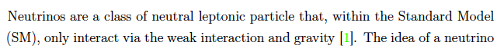

1. P1: SM does not include gravity.

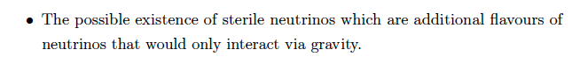

1. P2: it does not make sense to talk about gravity here. Same comment to all other places like in p8.



1. P2: “additional evidence”, oscillation is already evidence BSM. Same comment to all other places like p9.

1. P2: “, developing large scale LArTPC technology and” does not belong to the same category of those physical aims. Suggest move this to a new sentence.

# Chapter 2

1. Add Feynman diagram for inverse beta decay.



1. P9: ambiguity due to (anti)neutrino. More precise is “baryon-antibaryon asymmetry”.

1. P10: confusing expression. Need to remove the neutrino here in a new equation.

1. P10: need to explain better. See below from wiki. Add illustration.A picture containing text, font, screenshot, algebra

   Description automatically generated

1. P11: how does the sum work? Why only NC has this sum?

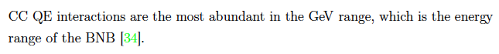

1. P13: not precise. GeV range is wide: there are more abundant RES and DIS.
2. P14. Add explanation for the term “2 Particles 2 Holes”
3. P.26: Add explanation how Planck measurements constrain the neutrino mass.

# Chapter 3

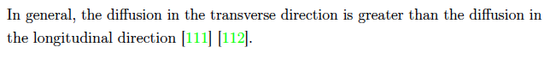

1. P70: what are the typical values of the diffusion? Give the numbers for the three SBN detectors.

1. P70: perform the calculation of the drift distance.



1. P71: “the recombination value” not clear, e.g. what is the unit?

1. P72: how large is the space charge effects for the SBN experiments? How is it quantified?

1. P74: Explain the time periods related to the fast and slow components.
2. P74: what is the drift time?



1. P75: what is the power of the proton beam?

1. P76: where is the remaining BR? (non-leptonic channels, like 2pi)

1. P78: why 3 mm? (limited by diffusion)
2. P82: What are wavelengths after dichroic filter?
3. P88: Add discussion or illustration related to the case when or is the same but the other parameter is different.
4. P90: Add more details on large extra dimensions. What is the signature?

# Chapter 4

1. Add information on the goodness of the fit to waveforms.

1. P97: it is demonstration rather than calibration. Or explain how exactly the calibration is done.



1. P98: point out (as did in the text) that this is a simulated sample.

1. P104: the tail might be caused by a varying Gaussian shape as a function of the true energy. Should make the fractional bias in a slice of true energy and fit individual slice (like in Figs. 4.14 and 4.15). Consider removing the fit and using statistical parameters (Mean, RMS).

1. P105: too few bins—no shape to describe! And not only sigma, but also the man needs to be reported—that is the bias!

1. P105: fit quality might be compromised when so sensitive to binning. Consider removing the fit and using statistical parameters (Mean, RMS).

1. Update the table with the statistical parameters.
2. P112: these biases can be corrected, introducing a systematic error. But it is not incurable.

# Chapter 5



1. P116: incorrect wording, should be “smeared by a Gaussian…”



1. P116: “resolution” of what?

1. P116: how to understand this 21 MeV? (minimum range determined by the pitch and diffusion)

1. P116: missing units



1. P117: what about efficiency?



1. P118: Is there a study of efficiency? How good is the assumption? Need to show efficiency and check this assumption before talking about its systematics in 6.5.3.

1. P118: how is the vertex defined when there is only 1 gamma and no other stuff?



1. P118: “If … identified” confusing.



1. P118: the above is signal selection. So “selection” and “similar” is inconsistent for dirt events. Should be for “not-dirt events”.



1. P123: reference missing.

1. P124: how are f_pi+/- related to the c’s?



1. P131: how to justify this? It is common to go above 100% (upward).

# Chapter 6



1. P134: how is efficiency treated exactly in Eq. 6.1?

1. P135: explain/derive this. (it is not likelihood, but likelihood ratio)

1. P135: why is this penalty needed? How to justify/understand it?

1. P135: how is V determined?



1. P135: Explain/justify (Only when lambda is Gaussian).

1. P135: Explain/justify (it is an indication or definition, no absolute status).



1. P138: how to get this true baseline in real data analysis?



1. P148: confusing. Better to use equation.



1. P148: confusing. Rewrite.

1. P151: need to connect to Eq 6.2 and explain what is fitted (f is bounded but theta is fixed)



1. P151: why u is 1 in this case?



1. P154: Tab 6.5-6.7, and Fig. 6.9-6.11, all add assumed POT in captions.

1. P157: what errors are constrained? In Fig. 6.11 how is sys. errors compared to stat errors?



1. P165: “entire SBN” is it equal footed joint fit, or SBN is used to constrained for uB and ICARUS? What is the difference between the two approaches?

1. P165: need to explain in the fitting part how statistical-only sensitivity is done.

1. P169: are they constrained by SBND? (Need to make it clear from the outset in what circumstances SBND constraint are used)

1. P175: need to explain why these become the largest in physical terms?

1. P175: is it really so? Why only these two, while CCRES_M_A/V are still so large?



1. P177: “don’t” -> “do not”.

1. P177: need discussions to illuminate why they are important/unimportant.



1. P180: why exclusive better than inclusive alone?



1. P180: intro/ref is missing.

1. P180: how large is the RPISM flux uncertainty? How well can the xsec measurement be?



1. P189: unit



1. P194: how to understand this?

# Chapter 7





1. P198: should use future tense.

EOF