Pegboard Game Solver Report

*Thomas Laverghetta*,   
Old Dominion University – Computational Modeling and Simulation Engineering

# Introduction

In this report, I will be analyzing four different search algorithms when applied to a pegboard game.

# Pegboard Game Rules

Pegboard problems are single-player games played on a grid, in which moves are made by successively jumping and removing pegs from the pegboard. A peg can jump an adjacent peg if there is a slot adjacent to that peg in the opposite direction – horizontally or vertically. Diagonal jumps are not allowed. After a peg has been jumped, it is removed from the board (and possibly eaten). A typical objective of this problem is to begin with a full pegboard from which one peg has been removed and determine a sequence of jumps which will result in one peg remaining. The pegboard game has been a challenging problem for a human being. Figure 1 illustrates a solution of a 6x6 pegboard game. [1]

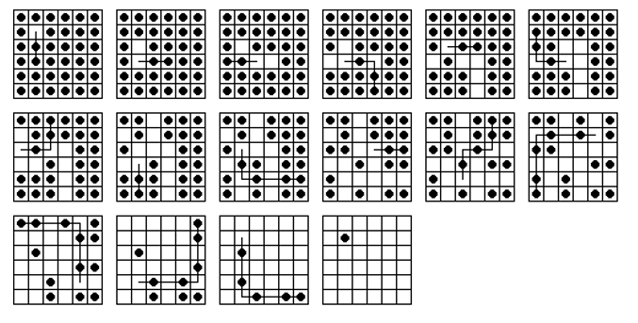

Figure . 6x6 Solution [2]

# Algorithms

In this section, I will be discussing the algorithms used to search for solutions to pegboard game. The algorithms I will be discussing are breadth-first search (BFS), depth-first search (DFS), greedy-best search, A* (A-star) search, and heuristic to support greedy-best search and A*.

## Breadth First Search Algorithm

## Depth First Search

## Greedy Search

## A* Search

A* (A-Star)