MSIM 460 – Homework 3

*Thomas Laverghetta*,   
Old Dominion University – Computational Modeling and Simulation Engineering

# Design

For this homework assignment, Dr. Leathrum gave us most of the design for the airplane and communication; thus, the only things I had to design was main (airports of simulation) and a few additions to Dr. Leathrum’s airplane and communication classes. The additions to Dr. Leathrum’s original design are: method for checking if plane has reached max flights (MaxFlight) and broadcast to notify all airports that plane has finished (Broadcast).

*Main (void):*

*1. Initialized MPI communication*

*2. create 3 airplanes and send them to a random location*

*3. While all planes have not finished (number planes finished < total number of planes):*

*4. Wait for airplane message*

*5. create new airplane object and deserialize received airplane*

*6. if message tag received is 1 (not finished airplane):*

*7. increase number of flights completed for airplane*

*8. if airplane has reached max flights:*

*9. increase number of planes finished*

*10. end if*

*11. display airplane information*

*12. set previous destination to this airport/processor*

*13. send airplane to random airport*

*14. else (message tag == 0 == broadcast received to notify finished airplane)*

*15. increase number of planes finished*

*16. end if*

*17. end while*

Below is the pseudocode for max-flight check method within airplane. To make this method work, I also added a constant max-flight member variable equal to 10 (10-flights).

*MaxFlight (void):*

*1. return number of flights == max flights*

Below is the pseudocode for broadcast which notifies all airports when airplane has finished. This was implemented within communication class.

*Broadcast (tag = 0):*

*1. Serialize airplane that has finished*

*2. foreach processor:*

*3. if processor is not this processor:*

*4. send serialized airplane to processor*

*5. end if*

*6. end for*

# Team Execution

As per the assignment, we are required to run our program in parallel with our classmates’ program to verify simulation can be distributed. For this assignment, my classmates were Kyle Tanyag and Cierra Hall. There executables can be found under Class_Executables folder. Figure 1 shows programs executing in parallel.

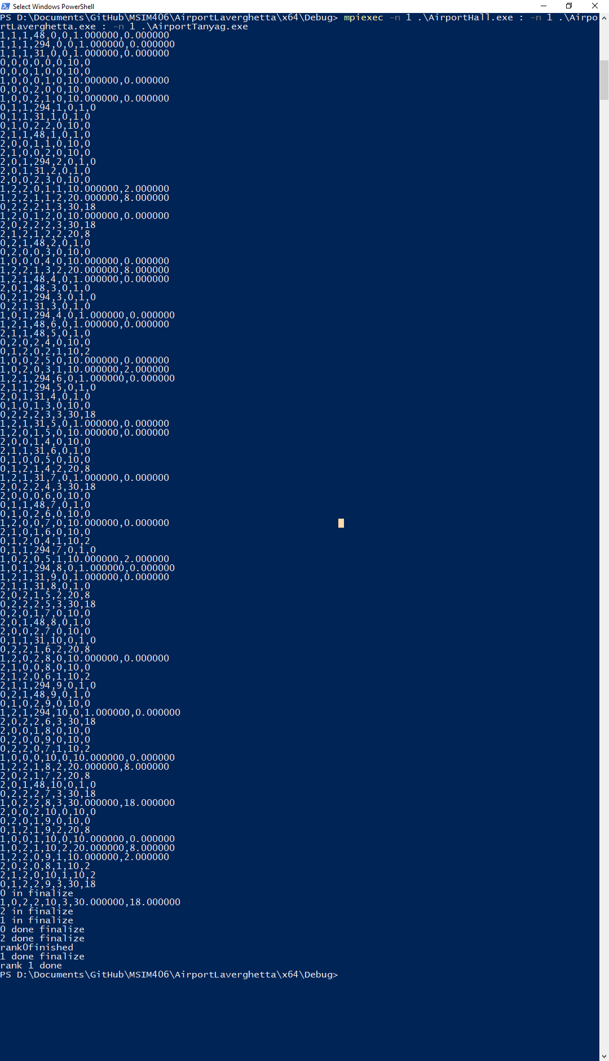

Figure 1. Executing Kyle, Cierra, and My program's in Parallel