HW2 Butterfly Barrier

MSIM 406 – Distributed Simulation

*Thomas Laverghetta*,   
Old Dominion University – Computation Modeling and Simulation Engineering

# Design

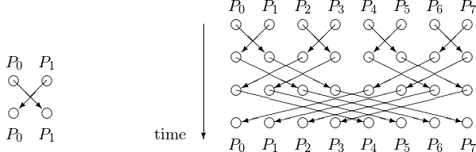

Figure 1. Butterfly Barrier

<http://homepages.math.uic.edu/~jan/mcs572/mcs572notes/lec18.html>

For this homework, I am to implement a butterfly barrier. As seen in figure 1, a butterfly barrier is a multi-layer synchronization method which groups processor information to determine when it is safe to do another time-step. The algorithm is shown below:

*Butterfly Barrier ()*

*1. Get number of processors ($N_{p}$)*

*2. Get this process id ($P_{id}$)*

*3. for bitflip ($b_{f}$) from 0 to $\log_{2}{N_{p}}$:*

*4. calculate next process ($P_{n}$) using $P_{id}⨁(1≪b_{f})$*

*5. send done msg to $P_{n}$*

*6. wait for response msg from $P_{n}$*

*7.end for*

# Testing

To test the butterfly barrier, I designed and implemented a test-harness. The test-harness places a random work delay on each processor to see if butterfly barrier will not allow processors to advance until all processors are done with work.

*Test Harness ()*

*1. Init MPI*

*2. Get this process id*

*3. Get number of processors in system*

*4. Set random seed to this process ID*

*5. for number of work iteration:*

*6. calculate random time delay*

*7. delay thread for random time delay*

*8. Butterfly Barrier*

*9. end for*

# Test Result

I ran serval tests using 2, 4, 8, and 16 processors. Each test I did 5-terations work and butterfly barrier with random work delay between 2 and 8. Within each iteration, I display when the processor has finished work and finished barrier. If the barrier is properly implemented, then you should see all finish work messages then all finish barrier messages.

The following are the test results. Note, in the output, P-values is the processor ID.

As seen in the following figures (2, 3, 4, 5), the barrier preformed as expected. Therefore, butterfly barrier was implemented correctly.

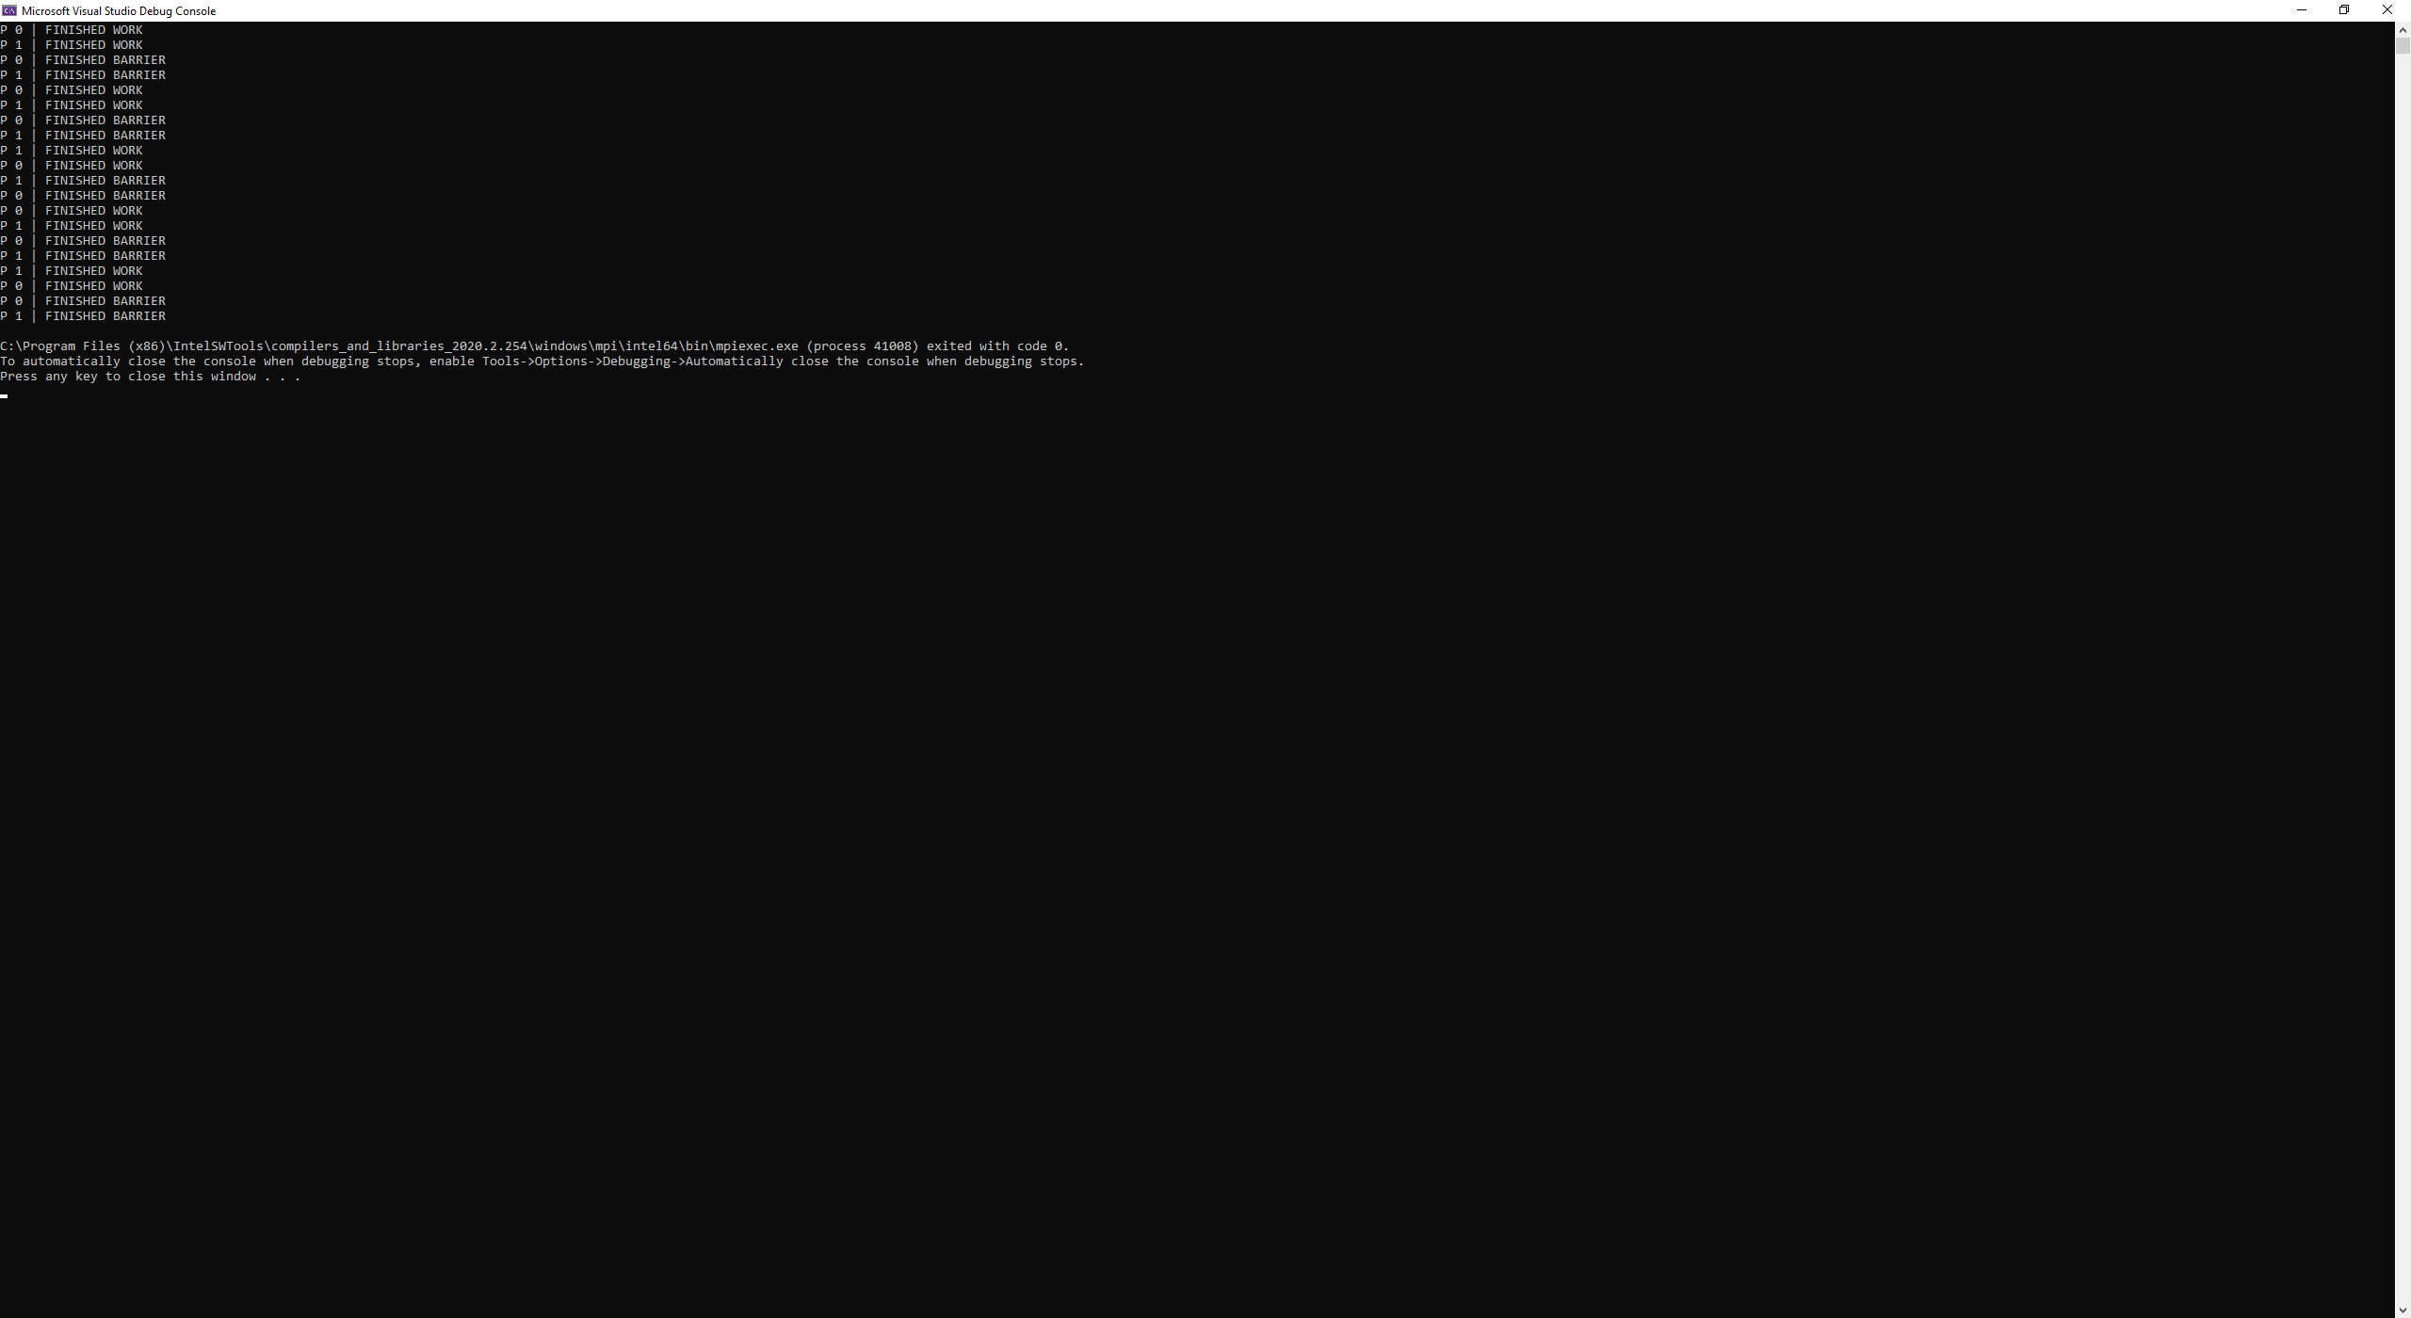

Figure 2. 2-Processors

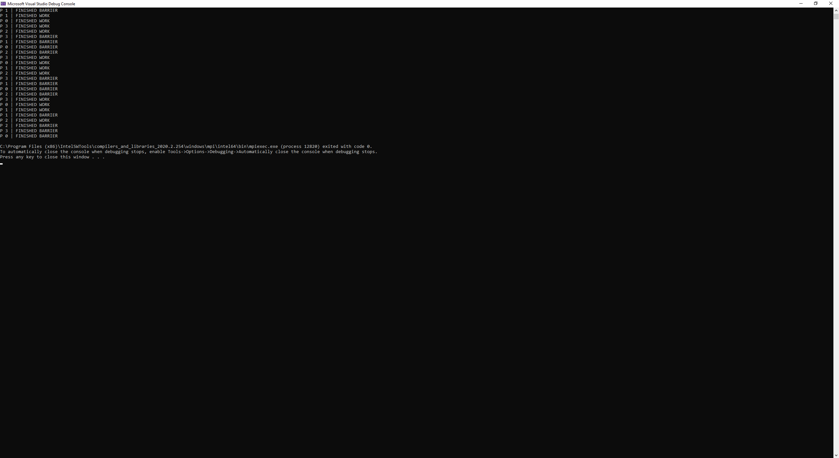

Figure 3. 4-Processor

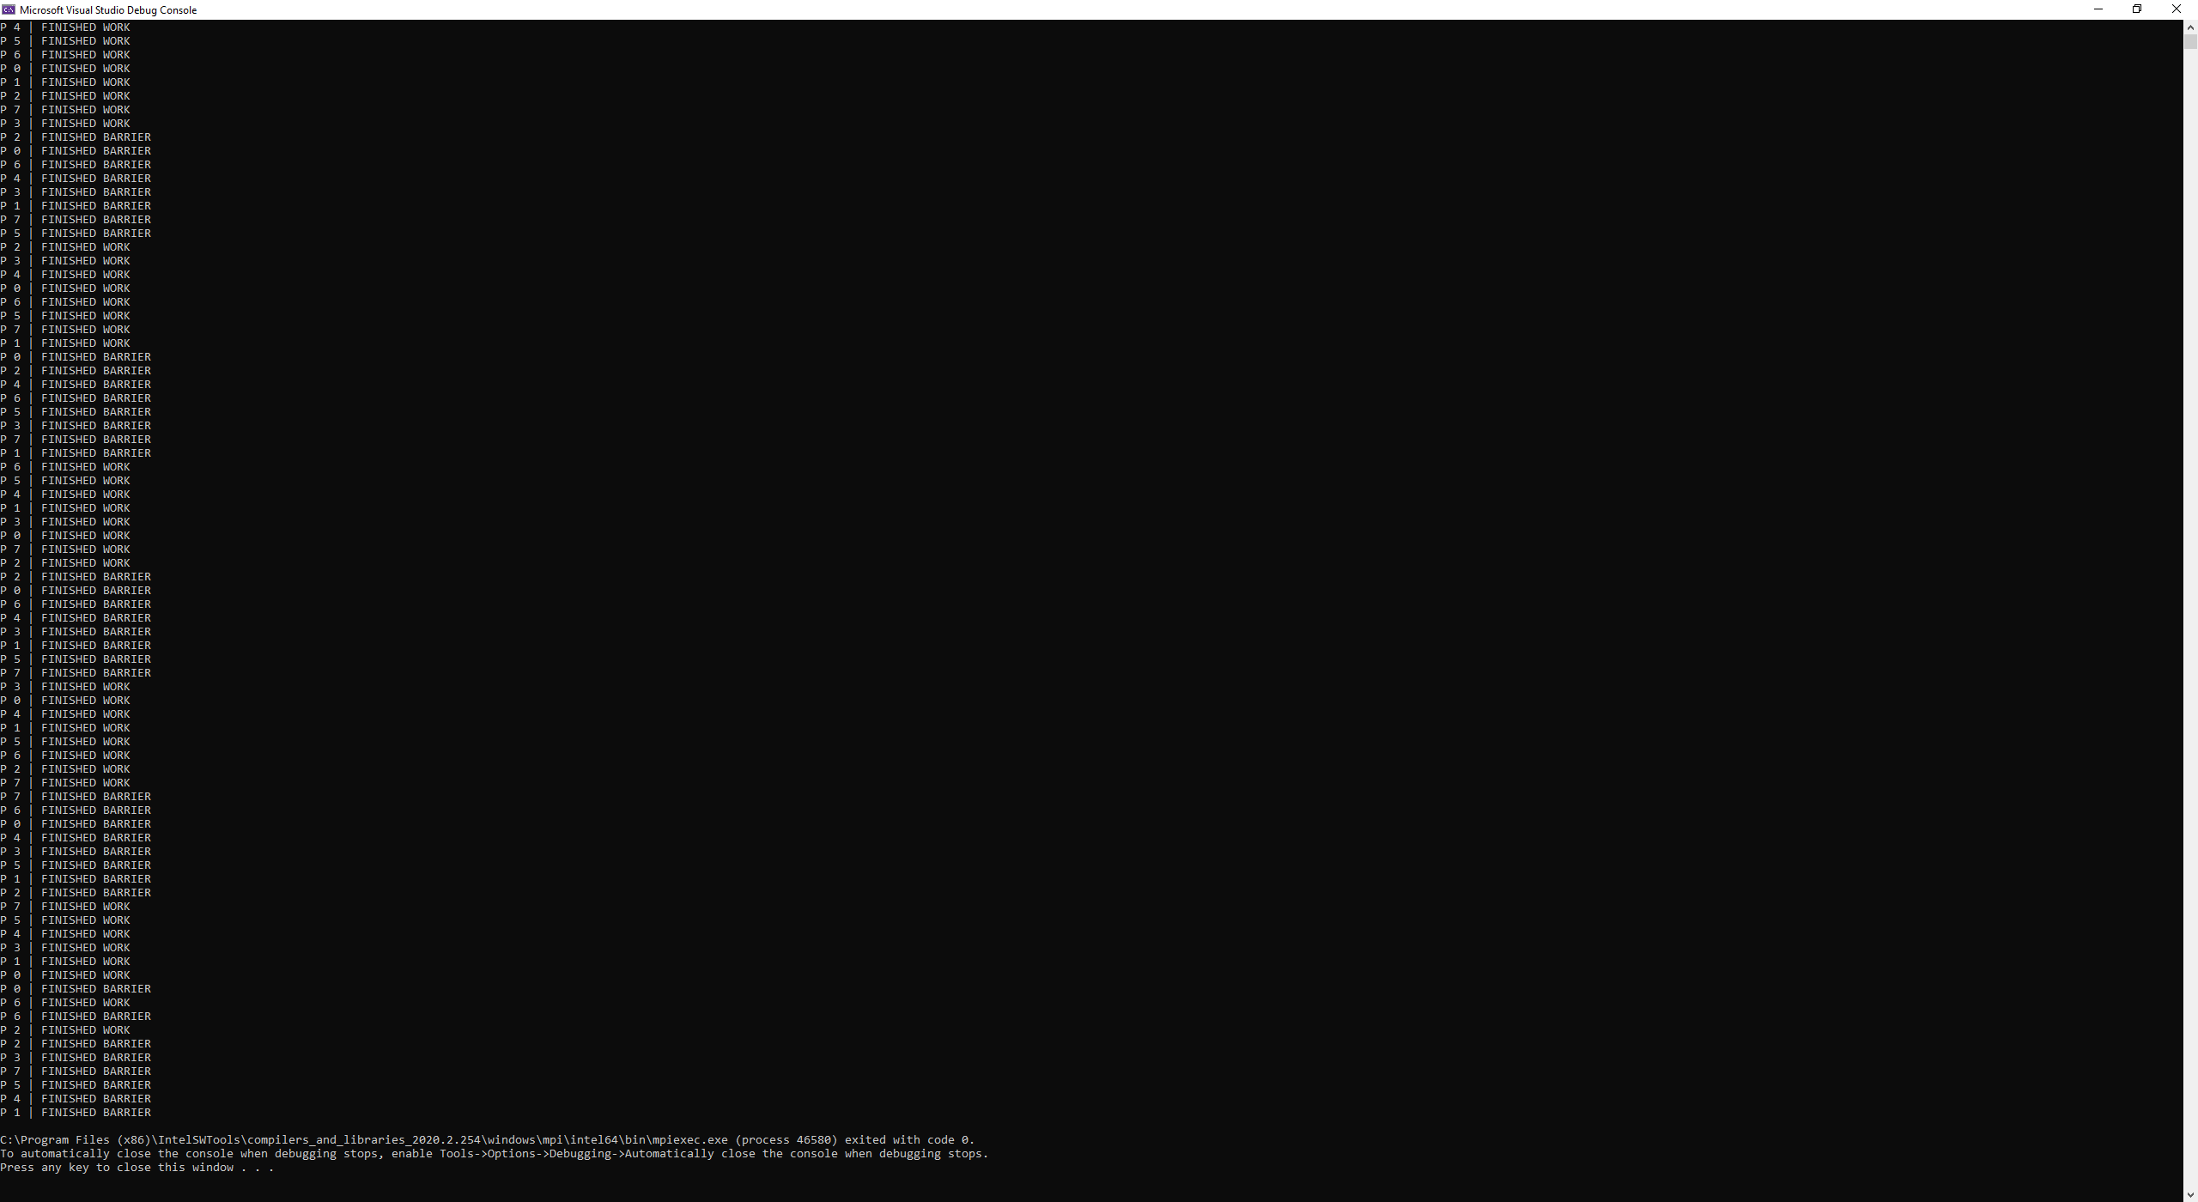

Figure 4. 8-Processors

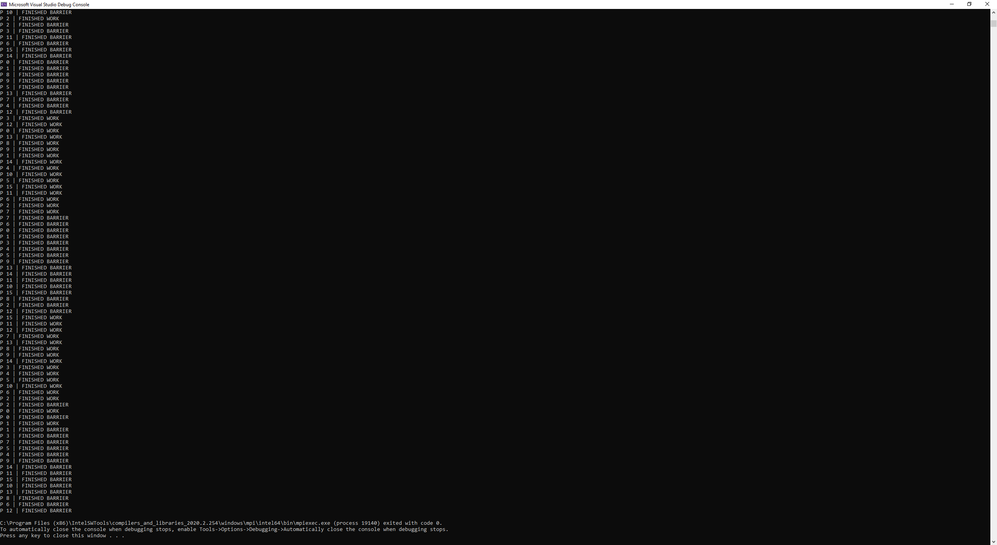

Figure 5. 16-Processors

# Application

To demonstrate the butterfly barrier, a 2D gravitational simulation will be applied. A 2D gravitational simulation application is supplied by Dr. Jim Leathrum. The application was implemented with a ring-barrier. So, I replaced the ring-barrier with butterfly-barrier for my testing. If everything is correct, the ring-barrier should produce the same results has butterfly-barrier.

After implementing butterfly-barrier, serval tests were ran and compared with ring-barrier implementation.