MSIM 441/541 & ECE 406/506

Computer Graphics & Visualization

**Programming Assignment One:**

**Input Analysis Using Histograms**

First Name, Last Name

Your_email@odu.edu

Phone

Site location  
Course CRN

Date

1. Introduction

Overview of the assignment, such as background, objectives, and a summary of what you have done for this assignment.

2. Program Design

You will use doxygen to generate the documentation (help) file for your code. You need to generate documentation for all classes, class variables, class methods, and internal implementations of critical methods, for all types of access modifiers (public, protected, and private). Your documentation should include source code, class diagrams, call graphs, and caller graphs. Your documentation should be contained in a single .chm file.

Describe briefly here how you use doxygen to generate your source code documentation. Include the names of your doxygen folder and the final .chm file you generate.

3. Results

# Describe what you have done for each task specified in Section 3: Tasks. Include results and necessary screen captures for each task. Answer the questions in the task if any.

# Task 4: Input Analysis

Nearly all of the basic functionality of the programming assignment is completed at this point. Adding in two more files to display is as simple as adding two more options in the *File* submenu and corresponding method. The extra files were selected based on my initials: K and C.

* First File = 11 % 10 + 1 = *2.dat*
* Second File = 3 % 10 + 1 = *4.dat*

By manipulating *μ* and *σ* and visually comparing the histogram and PDF, I determined their theoretical distributions.

* File 2.dat, seen in **Figure 6**, follows a normal distribution, with *μ* = x.x and *σ* = x.x.
* File 4.dat, seen in **Figure 7**, follows a normal distribution, with *μ* = x.x and *σ* = x.x.

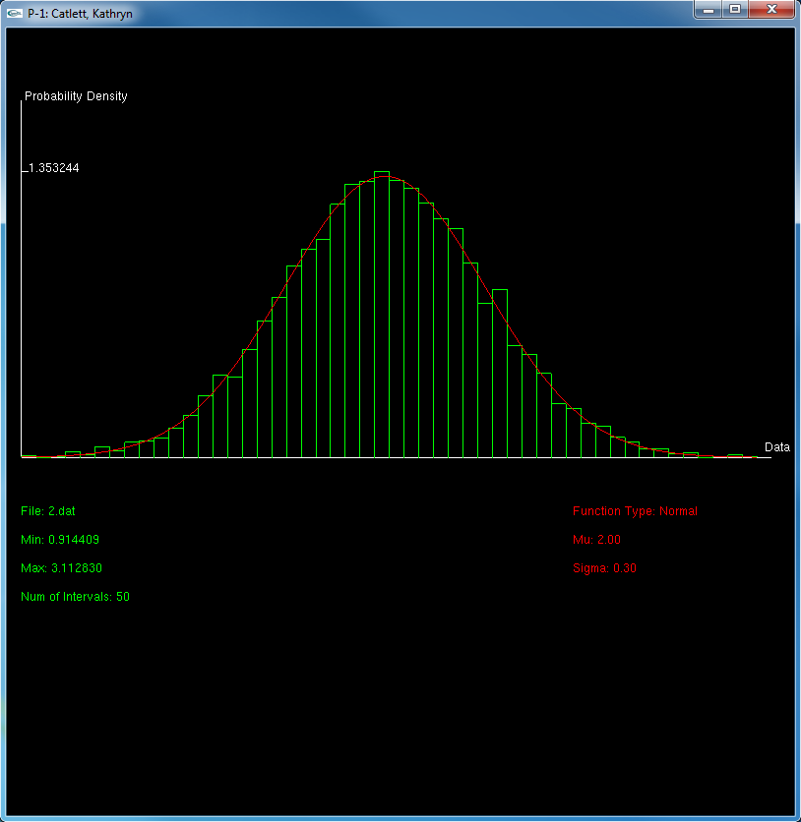

Figure 6 Histogram and PDF for *2.dat*

Figure 7 Histogram and PDF for *4.dat*

4. Conclusion and Discussion

# Discuss your accomplishments, learning outcomes, and difficulties and how you can do better for this assignment. Feel free to suggest other ideas for this assignment and discuss other relevant topics (e.g., the numbers of hours you have spent on this assignment).

# Accomplishments

I must say that I am rather pleased with the outcome of this assignment, especially with the fairly smooth transitions between graphs and the animation that accompanies the automated evaluation functionality. In the past, I had never quite grasped how to properly use the *glutReshapeFunc* callback or how to transform the window coordinates to the viewing world coordinates. Thus, I felt extremely accomplished when a change in the window size did not distort the graph, the different histograms and information blocks remained still throughout changes in aspects of the display, and the mouse was properly detected to print the differences over the individual bins.

I was especially proud, as well, of the small *ColorTest* program I created to easily evaluate different color palettes to be used for this assignment. Though it took some extra time to develop, it was well worth that time, since it saved me the time of changing the individual color definitions in the main assignment program when hunting for the proper shades.

# Learning Outcomes

While I have had past experience with OpenGL, I have never used it to graph functions, develop menus, print text, or track the movement of the mouse….

# Difficulties

My primary difficulties with this assignment arose primarily with the extra credit portion….

# Suggestions

I have two suggestions for future iterations of this assignment. The first deals with the assignment itself, while the second addresses events around the assignment…