MSIM 441/541 & ECE 406/506  
Computer Graphics & Visualization

Homework Ten

**Assigned December 3, Due 12:00 PM December 10**

**Thomas J Laverghetta**

### Tasks

1. Why is JPEG the most widely used image format on the Internet?
   1. Answer: Because of it is a widely used image standard and it has a high compression ratio.
2. Describe the steps to map a 2D texture image to an arbitrary 3D surface.

Answer: The steps are the following:

* 1. First step maps the texture to a simple 3D intermediate surface (e.g., sphere, cylinder, cube, etc.)
  2. Second step maps the intermediate surface to the surface being rendered

1. Define magnification and minification.
   1. Answer: A pixel on the screen correspond to a tiny portion of a texel.
2. How many levels of mipmaps are generated for an image of size 256 x 256?
   1. Answer: A pixel on the screen correspond to a large collection of texels.
3. Run the following programs, experiment with various parameters, and capture several program windows.
   1. Nate Robin’s tutorial: texture.exe

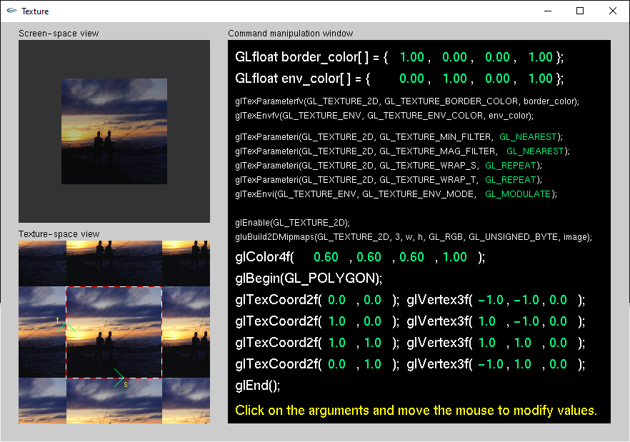

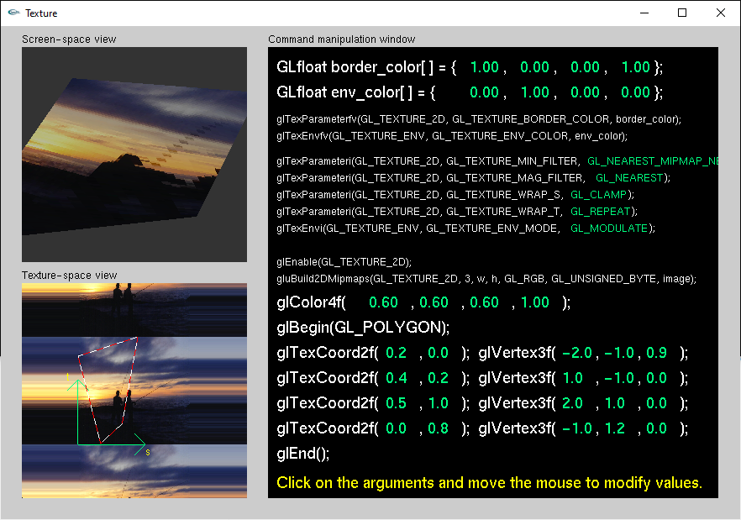

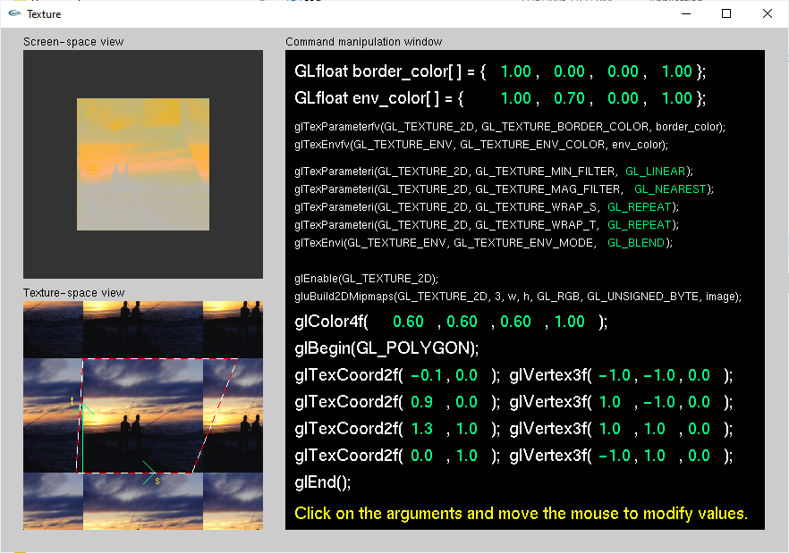

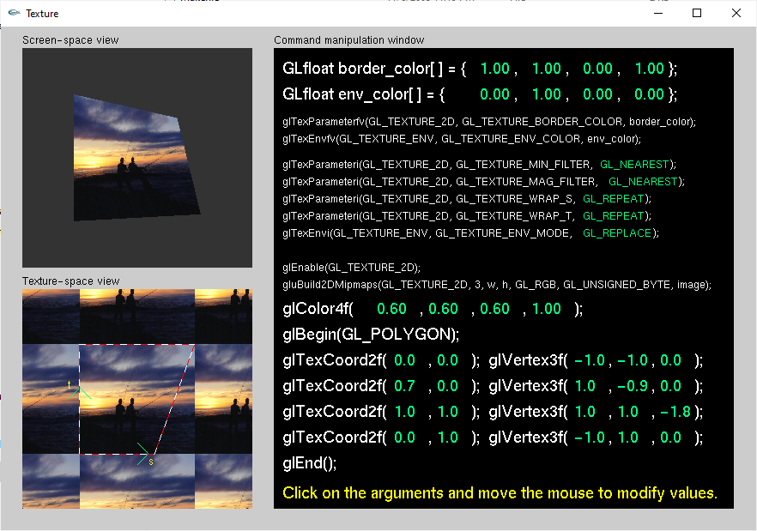

* 1. OpenGL red book: font.c, texbind.c, mipmap.c, texgen.c
* Font.c

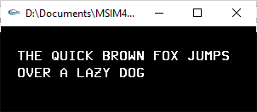

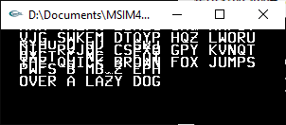

* Texbind.c

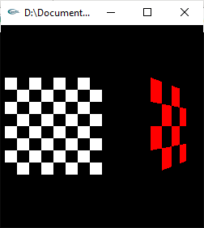

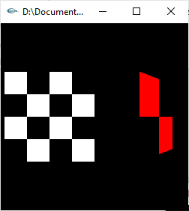

* Mipmap.c

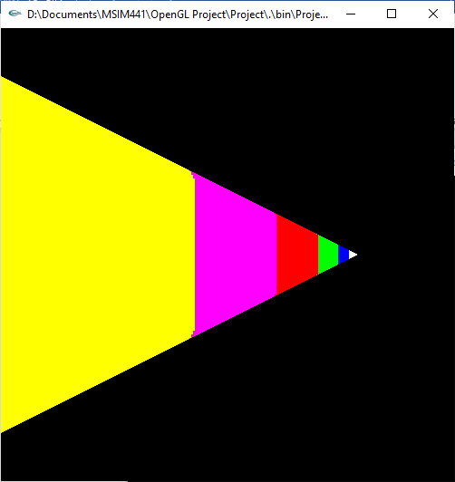

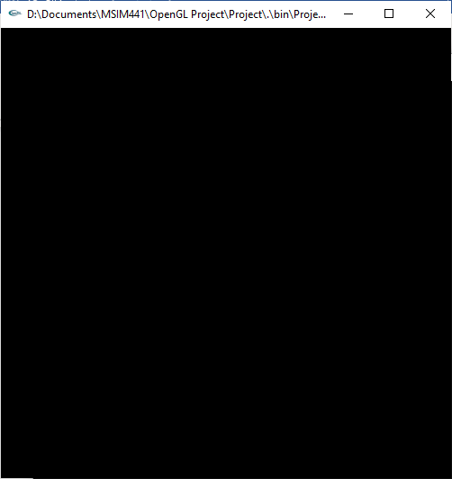

* texgen.c:

