MSIM 441/541 & ECE 406/506  
Computer Graphics and Visualization

Homework Six

**Assigned October 29, Due 12:00 PM November 5**

**Thomas Laverghetta**

### Tasks

1. Check if the following operations are valid or not, where upper-case letters represent points and lower-case letters represent vectors.
   * 1. **Invalid**. No combination of points to produce vector or new point.
     2. **Valid**. Produces new point because of Affine Combination.
     3. **Valid**. Produces new point because of Affine Combination.
     4. **Valid**. Produces new point because of Affine Combination.
2. Compute the dot product and cross product of the following two vectors.

.

**Dot:**

**Cross**:

1. Compute the angle between vectors and .
2. A camera is located at and pointing to the origin, with up direction. Derive the matrix that convert world coordinates to camera coordinates in homogeneous coordinate system. Note that the z-direction of the camera coordinate system points toward the back of the camera.
3. List the coordinate systems used by OpenGL.
   1. Object or model coordinates
   2. World coordinates
   3. Eye coordinates
   4. Clip coordinates
   5. Normalized device coordinates
   6. Window coordinates
4. Run the program transformation.exe provided by Nate Robin’s tutors, experiment with various parameters, and capture several program windows.

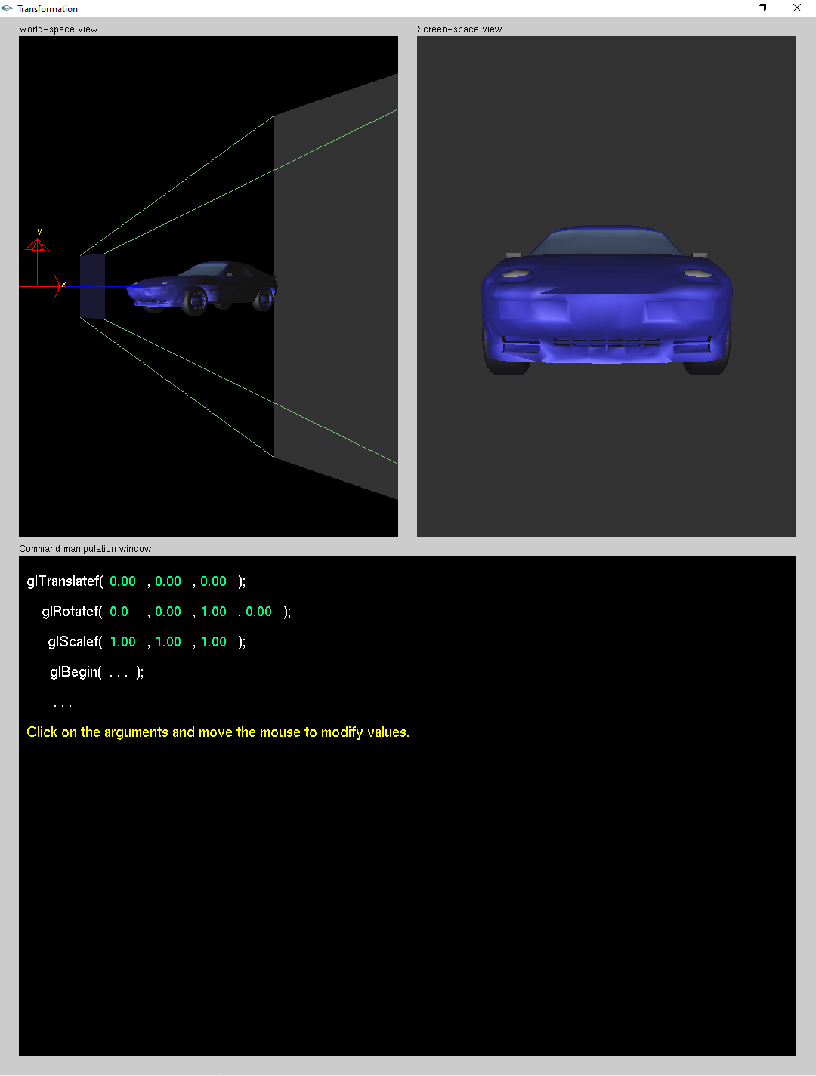

Figure . Original

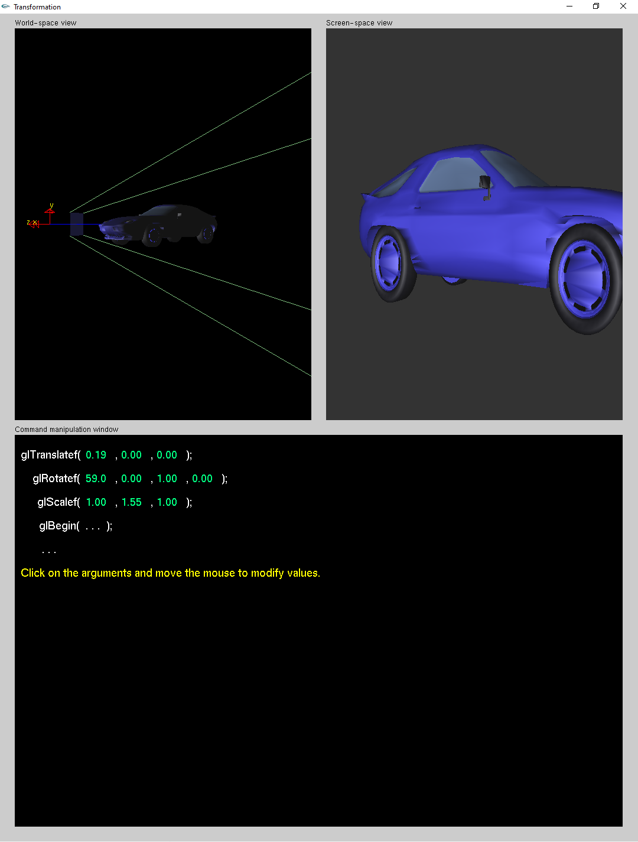

Figure . First Parameter Change

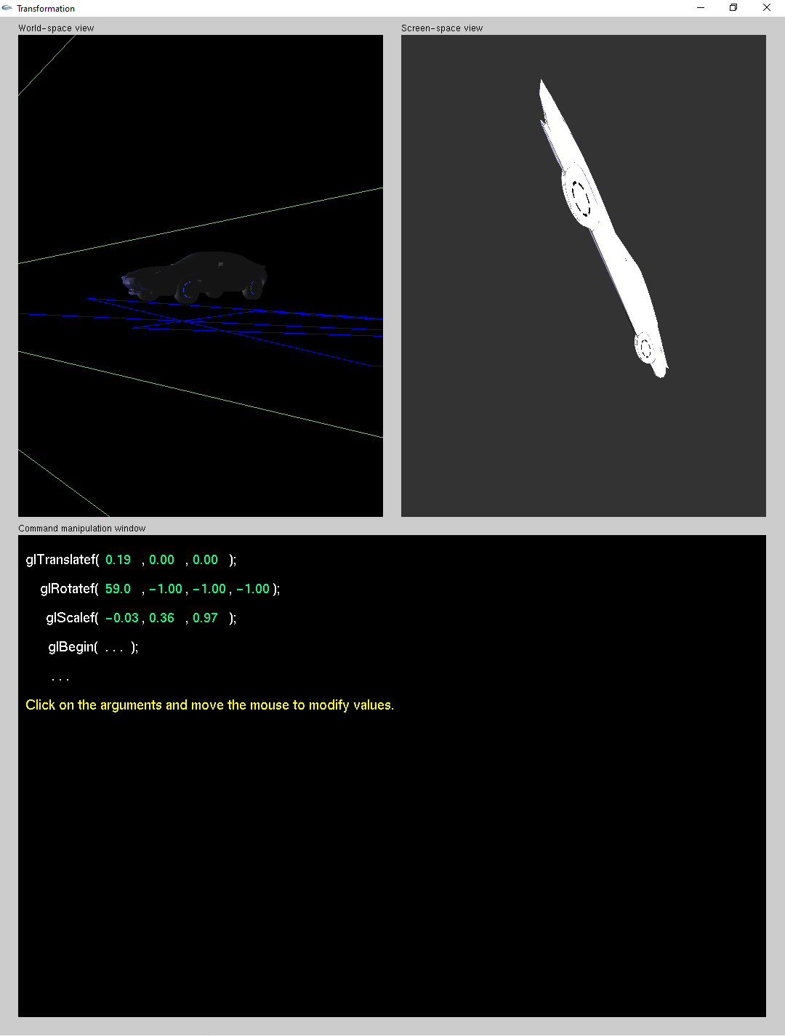

Figure . Second Parameter Change

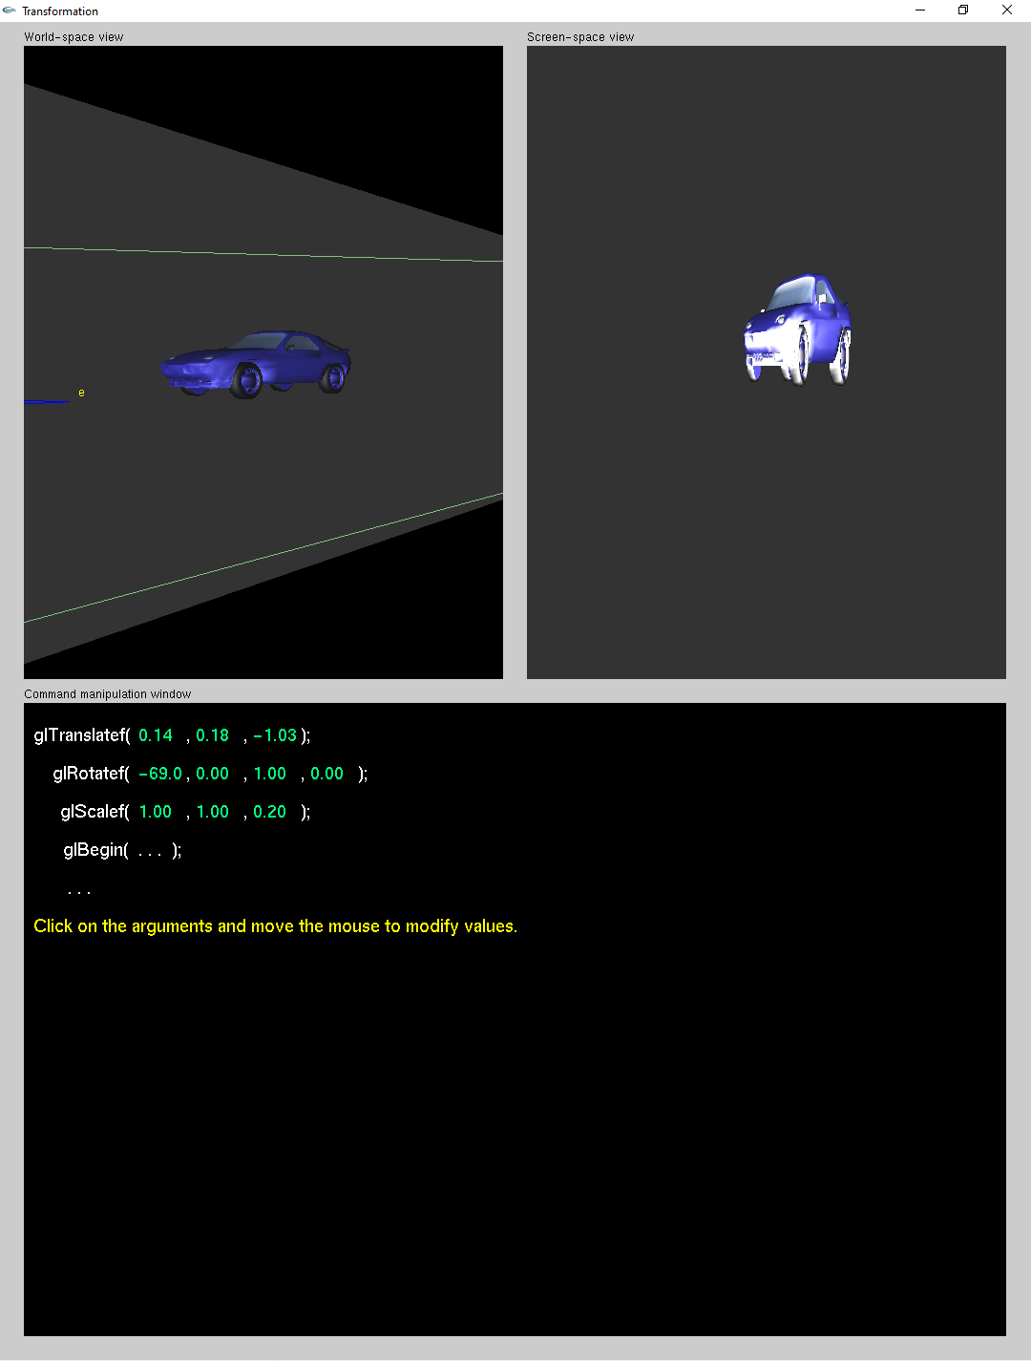

Figure . Third Parameter Change