MSIM 441/541 & ECE 406/506  
Computer Graphics & Visualization

Homework Eight

**Assigned November 12, Due 12:00 PM November 19**

**Thomas Laverghetta**

### Overview

This homework covers the lecture on Chapter 5. Please only submit one single file that includes solutions to the tasks specified below.

### Tasks

1. Describe the components in a synthetic camera model. What are the characteristics of geometric optics?
   1. Components of synthetic camera model:
      1. Objects
      2. Viewer or center of project (COP)
      3. Projectors: lines from objects to COP
      4. Projection plane
   2. Characteristics of geometric optics:
      1. Projection surface is a plane
      2. Projectors are straight lines
2. Define the canonical viewing volume.
   1. When projection metric is applied to view space (view space is normalized). Only x- and y-coordinates will be mapped on to screen and z-component is used for depth. $\left(x,y,z\right)∈[-1,1]$
3. Calculate the projection matrix corresponding to the following OpenGL command

glFrustum(–2, 2, –2, 2, 1, 30) = (l, r, b, t, n, f).

$$n=near, f=far, l=left, r=right, t=top, b=bottom$$

$$P=\left[\begin{matrix}\frac{2n}{r-l} & 0 & \frac{r+l}{r-l} & 0 \\ 0 & \frac{2n}{t-b} & \frac{t+b}{t-b} & 0 \\ 0 & 0 & -\frac{f+n}{f-n} & -\frac{2fn}{f-n} \\ 0 & 0 & -1 & 0\end{matrix}\right]=\left[\begin{matrix}\frac{2}{4} & 0 & 0 & 0 \\ 0 & \frac{2}{4} & 0 & 0 \\ 0 & 0 & -\frac{31}{30} & -2 \\ 0 & 0 & -1 & 0\end{matrix}\right]$$

1. Given the OpenGL command gluLookAt(2, 5, 3, 8, 2, 3, 0, 1, 1). Calculate the direction of positive *z*-axis of the camera coordinate system and the matrix that transforms world coordinates to camera (eye) coordinates.
$$n=eye-at=\left[\begin{matrix}-6 \\ 3 \\ 0\end{matrix}\right], \left|n\right|=\left[\begin{matrix}-\frac{2}{\sqrt{5}} \\ \frac{1}{\sqrt{5}} \\ 0\end{matrix}\right], u=v_{up}×n=\left[\begin{matrix}-3 \\ -6 \\ 6\end{matrix}\right],\left|u\right|=\left[\begin{matrix}-\frac{1}{3} \\ -\frac{2}{3} \\ \frac{2}{3}\end{matrix}\right]$$

$$, v=n×u=\left[\begin{matrix}18 \\ 36 \\ 45\end{matrix}\right], \left|v\right|=\left[\begin{matrix}\frac{2}{2\sqrt{5}} \\ \frac{4}{3\sqrt{5}} \\ \frac{\sqrt{5}}{3}\end{matrix}\right]$$

$$∴A^{-1}={\left[\begin{matrix}-\frac{1}{3} & \frac{2}{3\sqrt{5}} & -\frac{2}{\sqrt{5}} & 2 \\ -\frac{2}{3} & \frac{4}{3\sqrt{5}} & \frac{1}{\sqrt{5}} & 5 \\ \frac{2}{3} & \frac{\sqrt{5}}{3} & 0 & 3 \\ 0 & 0 & 0 & 1\end{matrix}\right]}^{-1}={\left[\begin{matrix}-\frac{1}{3} & -\frac{2}{3} & \frac{2}{3} & 2 \\ \frac{2}{3\sqrt{5}} & \frac{4}{3\sqrt{5}} & \frac{\sqrt{5}}{3} & -\frac{13}{\sqrt{5}} \\ -\frac{2}{\sqrt{5}} & \frac{1}{\sqrt{5}} & 0 & -\frac{1}{\sqrt{5}} \\ 0 & 0 & 0 & 1\end{matrix}\right]}^{}$$

2. Run the program projection.exe provided by Nate Robin’s tutors, experiment with various parameters, and capture several program windows.

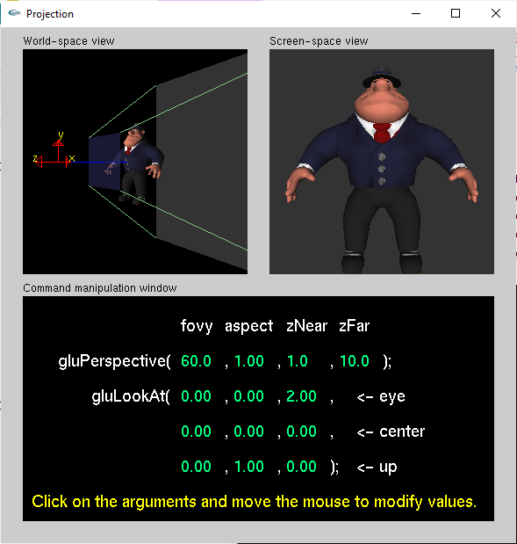

Figure 1. original

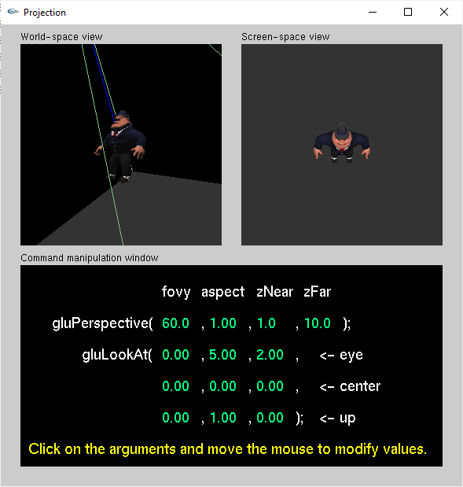

Figure 2. Experiment 1

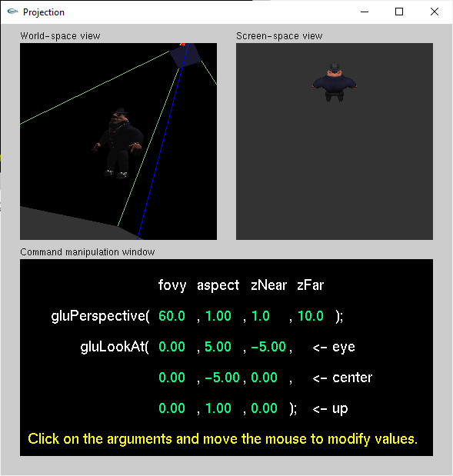

Figure 3. Experiment 2

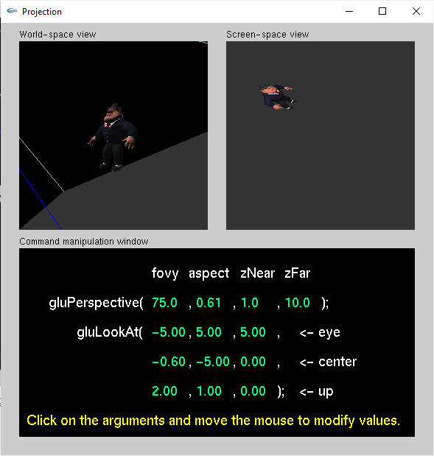

Figure 4. Experiment 3