MSIM 441/541 & ECE 406/506  
Computer Graphics & Visualization

Homework Nine

**Assigned November 19, Due 12:00 PM November 26**

**Thomas Laverghetta**

### Overview

This homework covers the lecture on Chapter 6 – Shading. Please only submit one single file that includes solutions to the tasks specified below.

### Tasks

1. What is the difference between global illumination and local illumination?
   1. Answer:
      1. Local: Only considers single interactions between the light, surface, and observer. Does not consider other object interactions.
      2. Global: Does not only consider the interactions between light and surface, but also has that light propagated and interacts with other objects in the scene. I.e., light reflecting off one object surface can affect light reflecting off [an]other object(s).
2. What is the difference between Gouraud and Phong shading? Which one is directly supported by the OpenGL fixed pipeline?
   1. Answer:
      1. Gouraud shading (i.e., Smooth Shading) is a per-vertex color computation. What this means is that the vertex shader must determine a color for each vertex and pass the color as an out variable to the fragment shader. Since this color is passed to the fragment shader as an in varying variable, it is interpolated across the fragments thus giving the smooth shading. [1]. Also, Grouraud is supported by OpenGL fixed pipeline.
      2. Phong shading is a per-fragment color computation. The vertex shader provides the normal and position data as out variables to the fragment shader. The fragment shader then interpolates these variables and computes the color. [1]
3. List the light models that OpenGL supports and briefly describe them.
   1. Ambient
      1. Light provides uniform lighting (scattered equally in all directions)
   2. Point
      1. Light source emits light equally in all directions.
   3. Spotlight
      1. Light source emits light through a narrow range of angles. I.e., light that radiates in a cone with more light in the center of the cone, then gradually tapering off towards the sides of the cone [2].
   4. Directional light
      1. Produced by a light source an infinite distance from the scene., All the light rays emanating from the light strike the polygons in the scene from a single parallel direction, and with equal intensity everywhere. [2]
4. Is the viewer’s position taken into account in Lambertian reflection? Why?
   1. No, light is scattered equally in all directions; therefore, a Lambertian surface appears equally bright from all viewing directions for a fixed distribution of illumination.
5. A plane is specified by the equation. Compute the plane’s normal.
   1. Normal to plane are the combination of position variable ($x,y,z$) scalars:
$\hat{N}=\left[\begin{matrix}4 \\ 3 \\ -2\end{matrix}\right]$

6. Run the following programs, experiment with various parameters, and capture several program windows.
   1. Nate Robin’s tutorial: lightmaterial.exe, lightposition.exe

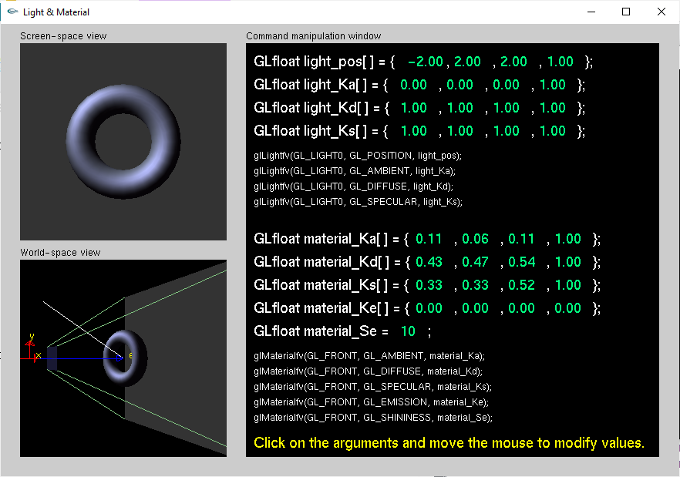

Figure . lightmaterial.exe original

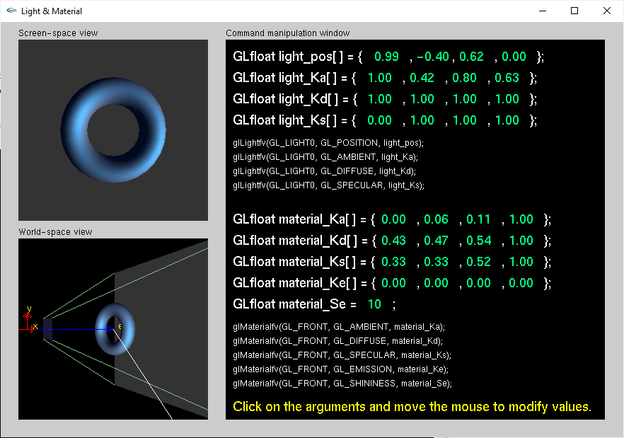

Figure . lightmaterial.exe experiment #1

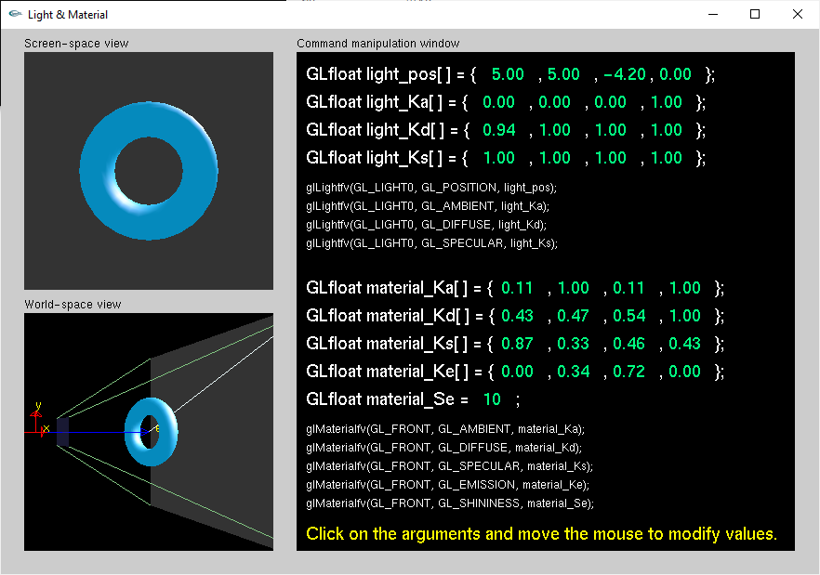

Figure . lightmaterial.exe experiment #2

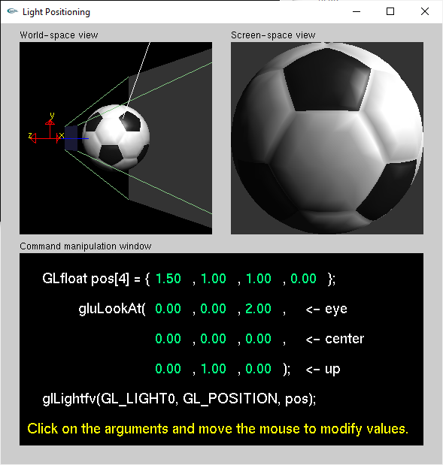

Figure . lightposition.exe original

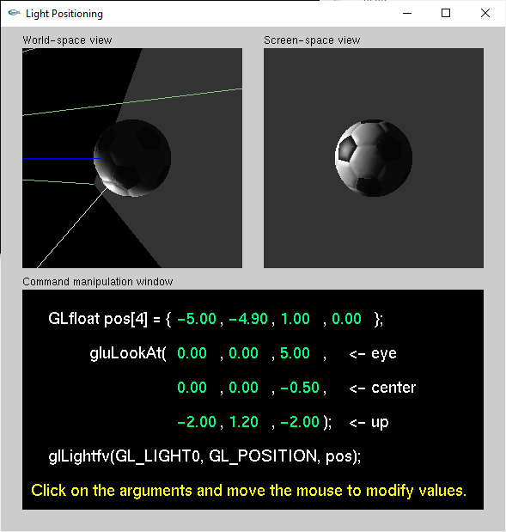

Figure . lightposition.exe experiment #1

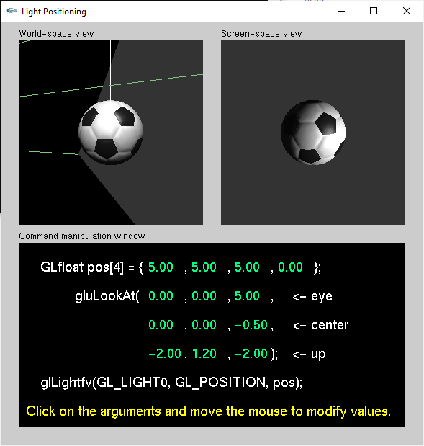

Figure . lightposition.exe experiment #2

* 1. OpenGL red book: smooth.c, light.c, movelight.c, material.c, colormat.c

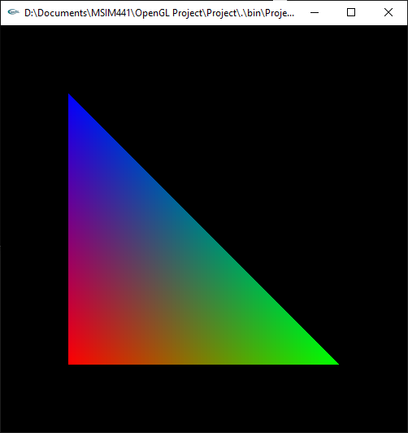

Figure . smooth original

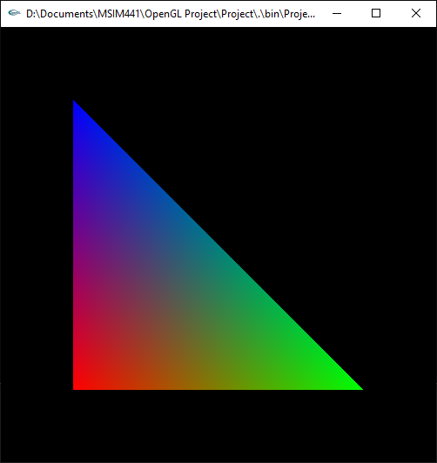

Figure . smooth.exe removed glShadeModel

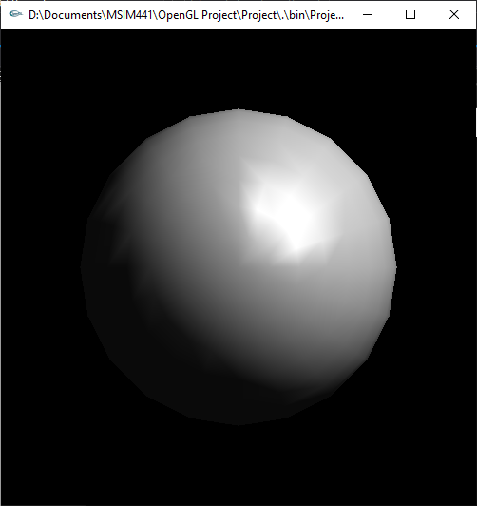

Figure . light.exe original

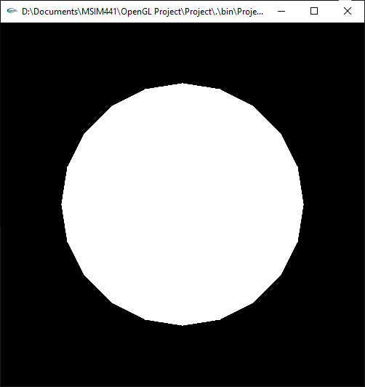

Figure . Removed all model rendering (glMaterial, glLight, glEnable)

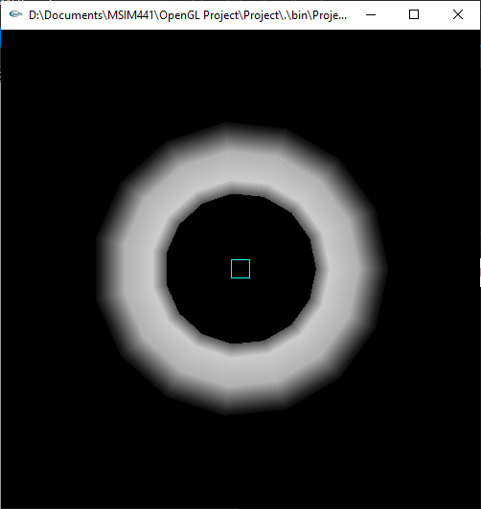

Figure . movelight.exe original

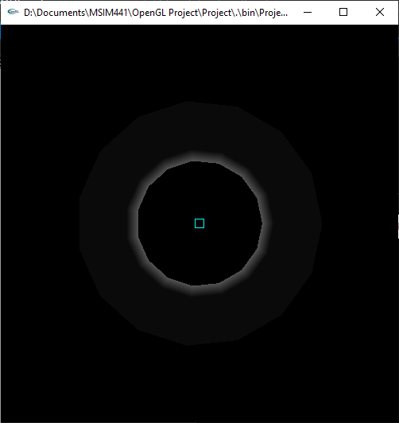

Figure . movelight.exe moved light to back

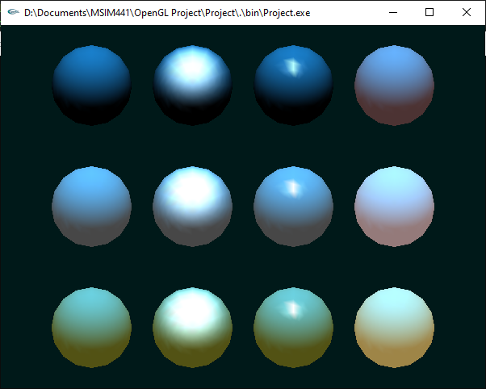

Figure . material.exe original

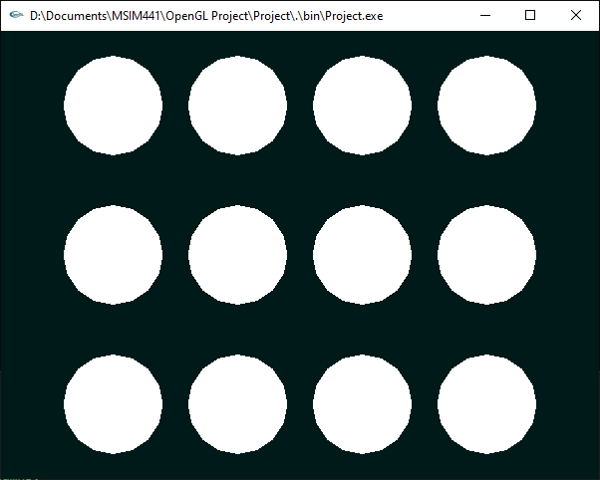

Figure . material.exe removed all shading

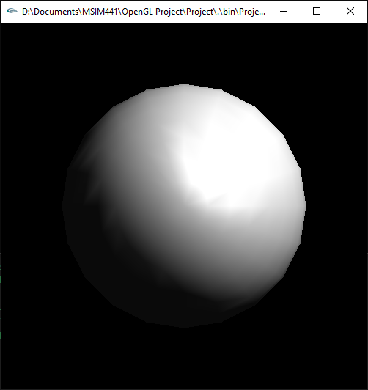

Figure . colormat.exe original

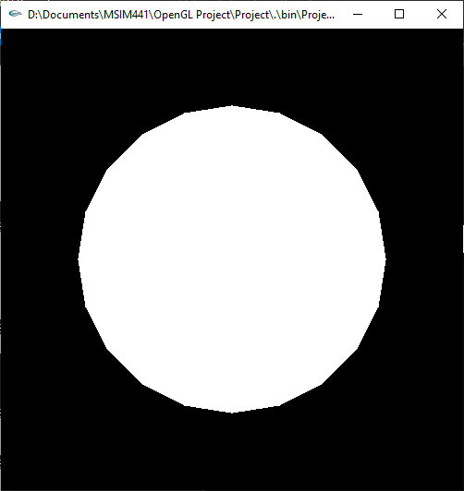

Figure . colormat.exe removed all shading

* 1. Textbook: sphere.c

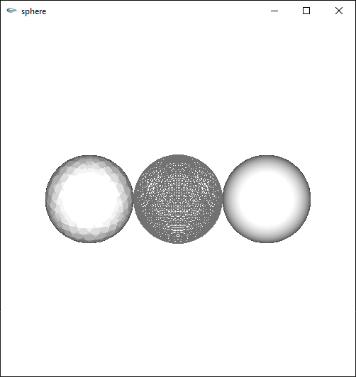

Figure . sphere.exe original

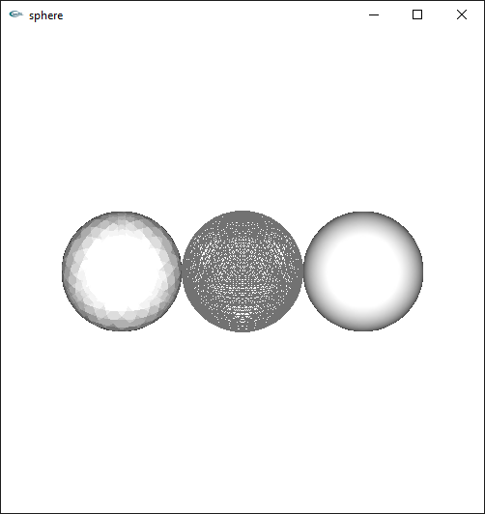

Figure . sphere.exe removed ambient, diffuse, and specular light components

[1] <https://www.haroldserrano.com/blog/what-is-the-difference-between-gouraud-and-phong-shading>

[2] https://www.cs.uic.edu/~jbell/CourseNotes/ComputerGraphics/LightingAndShading.html