**Configuration to run the Project**

The project is coded in C# and is based on the preview version of the latest .NET core 8 build. To run this project, installing the latest preview version of Visual Studio will be required as the standard version only has access to .NET core 7. Furthermore, a local SQL server should be created and using a SQL visualizer such as MS SQL is preferred.

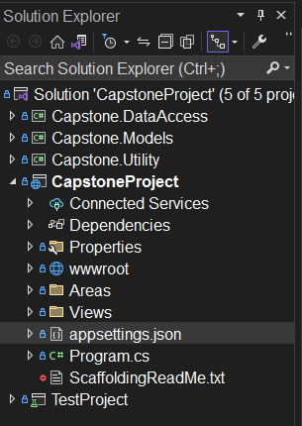

In the solution explorer, navigate to the appsettings.json as shown in the screenshot above.

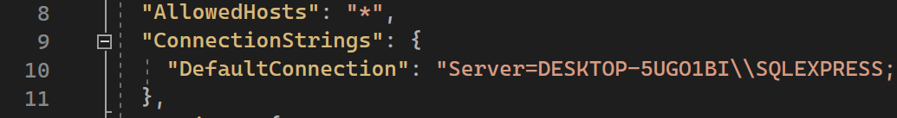 Replace the server name with the name of the local SQL server that you have created.

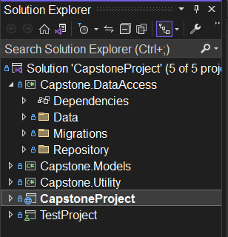

If a migrations folder already exists, then delete it.

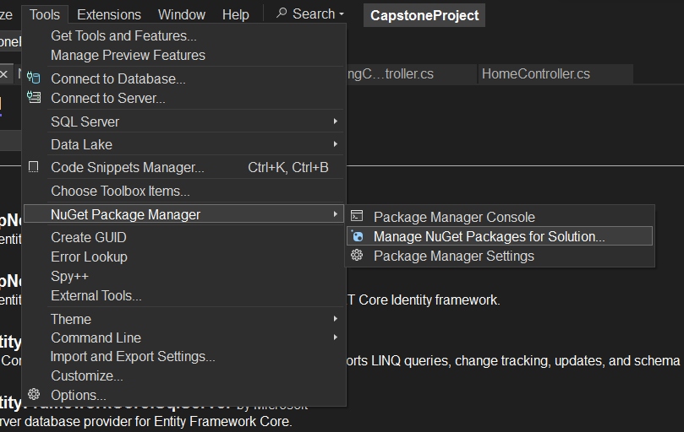 Go to the NuGet Package Manager as shown above to download the necessary packages.

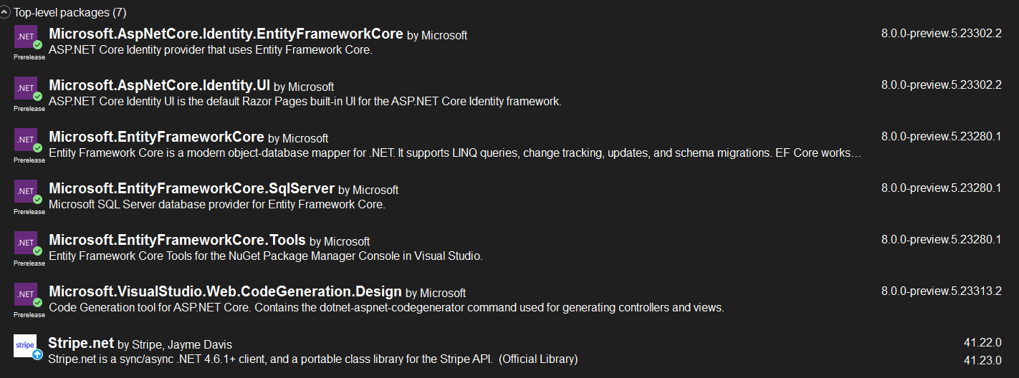 Make sure to download all these packages shown above into your project.

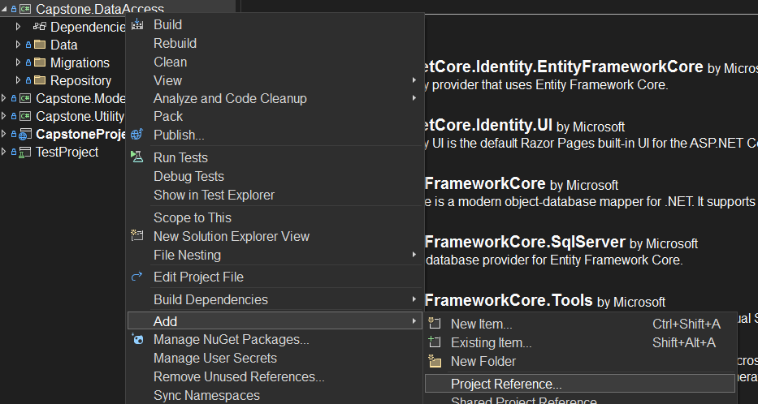 If there are any access issues between the different projects or folders, navigate to the above option and add all project references to each area. Class visibility should then be enabled between all the projects.

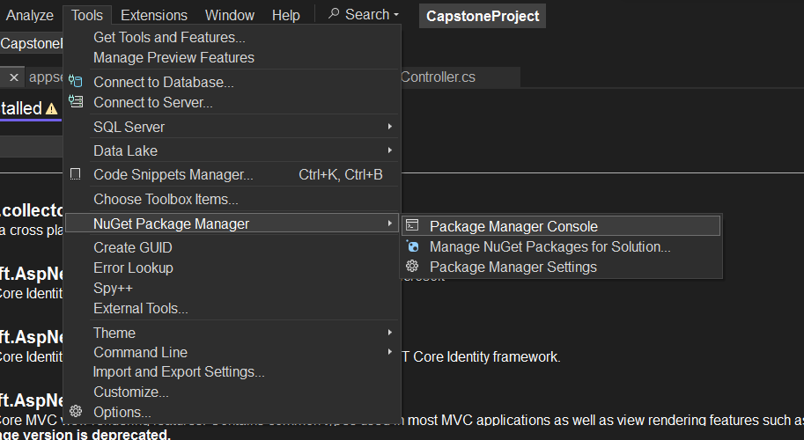 Navigate to the NuGet Packcage Manager Console.

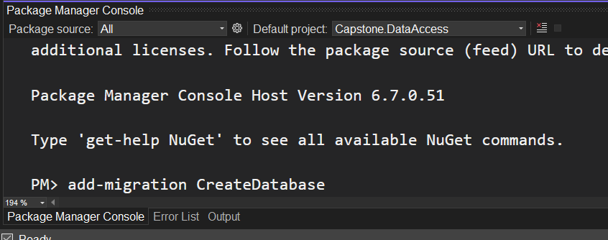 Change the default project to Capstone.DataAccess and type in the command add-migration with a comment. This will create the SQL language to create all the tables. When the build is successful, type in update-migration with a comment in the same console and it will create all the SQL tables and seed data into the database.