**Report**

**Task 1**

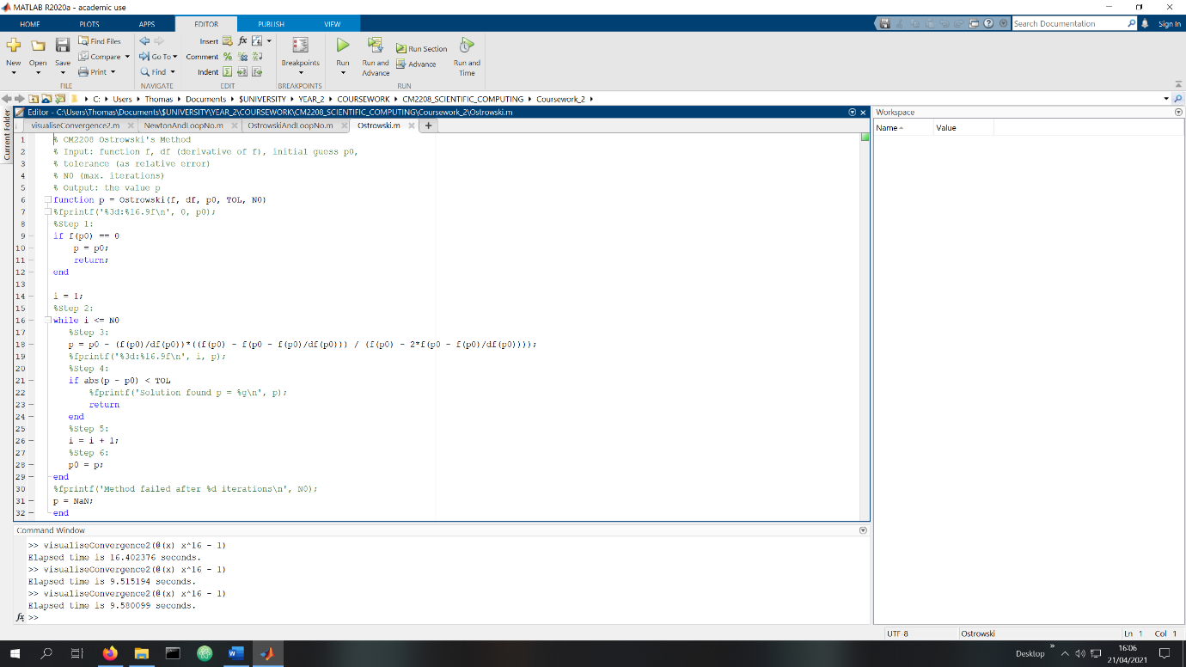

Change made to Newton.m to create Ostrowski.m

To create Ostrowski.m I duplicated Newton.m and renamed it. Then I noticed the qn-1 in the second formula was equal to original formula so I substituted that into the second equation.

**Task 2**

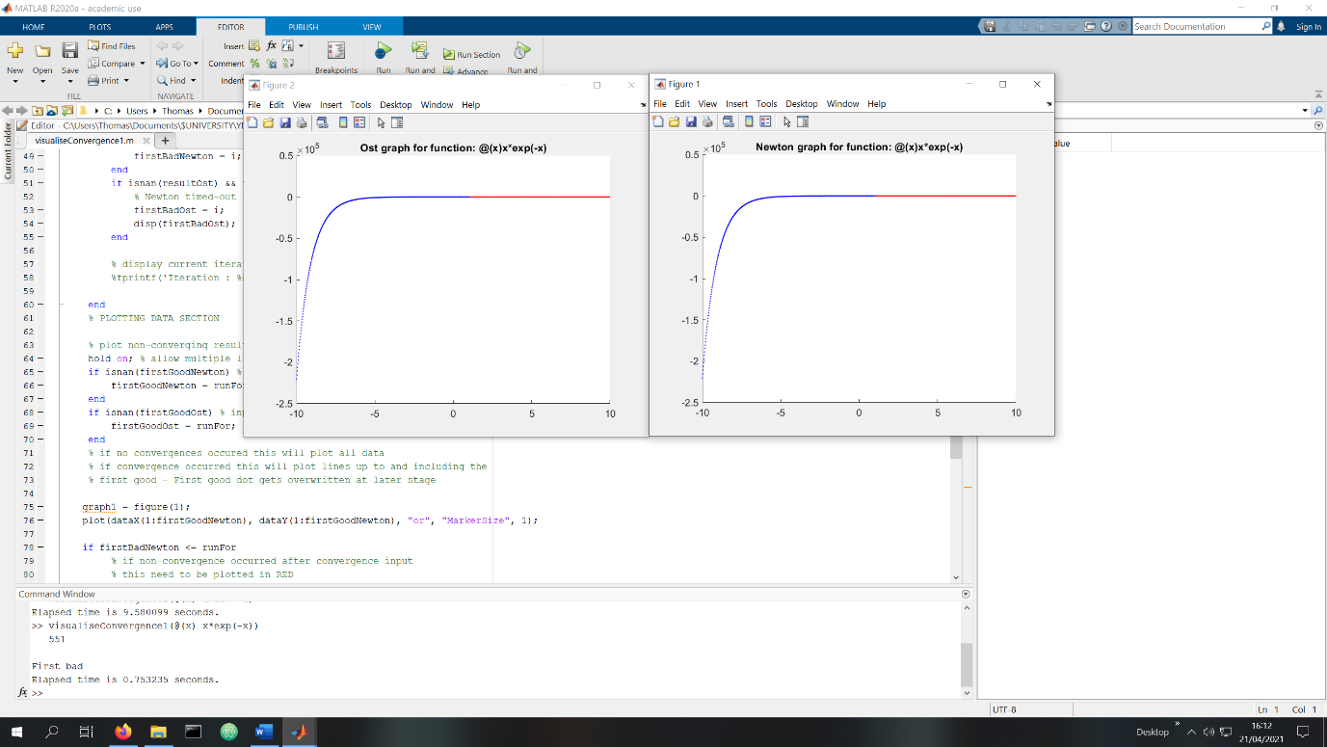

visuliseConvergence1.m with @(x) x*exp(-x) given as the parameter.

visualiseConvergence1.m takes a single parameter, and outputs two graphs, one for the Ostrowski method and another for the Newton method indicating where the beginning those methods with a value x leads to the roots converging within an iteration limit.

The blue indicates convergence occurs within the limit, whereas the red indicates with that value of x it doesn’t within the limit of 100 iterations.

**Task 3**