**Task 1.**

**Definition of Neighbourhood**

R2 is a neighbour of R1 when swapping the position of two adjacent values in R2 would transform R2 into R1.

For instance, if R1 = [1, 2, 3 ,4 ,5], and R2 = [2, 1, 3, 4, 5] R2 would be a neighbour to R1 as the adjacent values 2, and 1 could have their positions swapped to make R1.

R3 = [2, 1, 3, 5, 4] would be a neighbour of R2 but not R1.

**Justification**

In this specific instance this neighbourhood works. If player A beat player B, the Kemeny Score would only include that value if player A was ranked lower than player B. Only their relative position (higher or lower) has an impact not the distance between them.

With that in mind, only the edge between the swapped values need to be considered, as any player with a higher rank would still be higher, and a lower still lower.

Therefore, finding the Change in Cost of the Kemeny Score is very simple.

Two values need to be taken from the matrix: the value of position row A, column B; and row B, column A.

Row A, Column B for a row major matrix refers to the instance of player A beating player B by some margin.

Row B, Column A for a row major matrix refers to the instance of player B beating player A by some margin.

These values are mutually exclusive. Either they are both 0 (draw), or only 1 is zero.

Let a be the value from position row A, column B.

Let b be the value from position row B, column A.

Let player A be the player ranked higher.

Let player B be the player ranked lower.

The change in cost will be: a – b

If A had beaten B then a > 0 and b = 0. Leading to an increase in the Kemeny Score as a better player has been “cheated” of their rank.

If B had beaten A then b > 0 and a = 0. Leading to an decrease in the Kemeny Score as a better player is now ranked higher than a worse player.

If A and B drew, the change would be 0.

For all other players, the relative position of A and the relative position of B is the same. Hence, their values need not be considered.

**Task 3.**

Below is a table of parameters I trialled to find the best solution, in the fastest time. I settled on the best solution became insignificant.

|  |  |  |  |  |  |  |
| --- | --- | --- | --- | --- | --- | --- |
| Trial | Temperature | Temp. Length | Cooling Ratio | NNI* | Best Cost | Time (millisecond) |
| 1 | **1** | 1 | 0.99999 | 4 | 582 | 45 |
| 2 | **10** | 1 | 0.99999 | 4 | 583 | 39 |
| 3 | 10 | **10** | 0.99999 | 4 | 561 | 41 |
| 4 | 10 | **100** | 0.99999 | 4 | 205 | 47 |
| 5 | 10 | **1000** | 0.99999 | 4 | 161 | 72 |
| 6 | 10 | **200** | 0.99999 | 4 | 178 | 47 |
| 7 | 10 | 200 | **0.999** | 4 | 224 | 46 |
| 8 | 10 | 200 | **0.999999** | 4 | 203 | 48 |
| 9 | 10 | 200 | 0.999999 | **40** | 142 | 44 |
| 10 | 10 | 200 | 0.999999 | **400** | 134 | 70 |
| 11 | 10 | 200 | **0.99999** | **4000** | 115 | 151 |
| 12 | 10 | **100** | 0.99999 | **8000** | 104 | 174 |
| 13 | 10 | **10** | 0.99999 | **80000** | 62 | 304 |
| 14 | 10 | 10 | **0.9999** | **40000** | 62 | 132 |
| 15 | 10 | 10 | 0.9999 | **20000** | 63 | 109 |
| 16 | 10 | 10 | 0.9999 | **30000** | 62 | 119 |
| 17 | 10 | 10 | 0.9999 | **20000** | 62 | 109 |
| 18 | 10 | 10 | 0.9999 | 20000 | 64 | 109 |
| 19 | 10 | 10 | 0.9999 | **25000** | 62 | 108 |
| 20 | 10 | 10 | 0.9999 | **23000** | 62 | 110 |
| 21 | 10 | 10 | 0.9999 | **27000** | 62 | 116 |

*using external loop value

**Best Solution Trial 19 w/ 62 @ 108 milliseconds**

**Most Significant Parameter**

The most significant Parameter would be NNI. Without a high NNI there will be inevitably be insufficient allowed iterations to reach the next best solution leading to many local optimas.

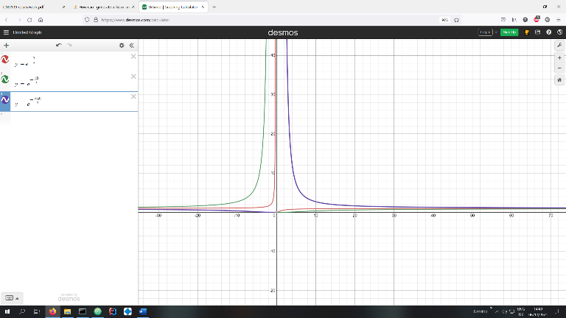

Simulating the values of x using different graphs. There is very little difference between a change of cost of 10 and a change of cost of 1 when temperature > 0 which would be used in the SA

Temperature had very little impact which is to be expected. The temperature has the most affect when change in cost is negative – however, the temperature formula would not be required in that instance.

Cooling Ratio had the biggest impact with the least change, however in this dataset the overall change to the cost value was still small as the Cooling Ratio value was already close to its final state. This would have likely been the most significant value if I had started with a CR of 0.8 for example.

**Local Optima**

I would expect there to be many instances of local optima, as 14/21 trials ended with a solution unique solution that was not the as-yet best solution. However, this will depend significantly on the NNI value – how many iterations past the last best solution to stop searching. The number of local optima found is inversely proportional to NNI, when one is high the other is low.