462 Term Project - Part 1  
HATS

Written by: Thomas Stanton

TABLE OF CONTENTS

**1. Introduction** **4**

1.1 Purpose

1.2 Scope

1.3 Definitions, Acronyms, and Abbreviations

**2. Positioning** **4**

2.1 Problem Statement

2.2 Product Position Statement

**3. Stakeholder and User Descriptions** **5**

3.1 Non-User Stakeholder Summary

3.2 User Stakeholder Summary

3.3 User Environment

3.4 Key High-Level Stakeholder Concerns and potential solutions

**4. Product Overview** **8**

4.1 Product Perspective

4.2 Assumptions and Dependencies

**5. Product Features** **9**

5.1. System Features

5.2. Communication Features

5.3. Ticket Creation Features

5.4. Potential solutions

**6. Other Requirements and Constraints** **10**

6.1 Security

6.2 Usability/Quality

6.3 Capacity

**Appendix A** **11**

Table 3.1.1 Non-users relative to HATS & Table 3.2.1 Stakeholders

Table 3.4.1 Concerns and potential solutions

Figure 4.1.1 Overview of the HATS system product perspective

**Use Case** **13**

**Domain Model:** **17**

**Supplementary Specification:** **18**

**Class Diagram:** **19**

# 1. Introduction

### 1.1 Purpose

The purpose of this document is to analyze and break down the essentials of a successful tech ticketing support system. Our system focuses on House Appliance Technical Support (HATS) web pages. We are offering a simple and consumer-friendly tech support ticketing system for our client’s line of products. The focus of our system is to filter frequently submitted tickets and automate the system by providing pre-programmed troubleshooting and allowing for ticket creation to communicate directly with our team members/specialists. This system is developed to provide support for people experiencing difficulty with home appliances purchased from our stores.

### 1.2 Scope

This Vision Document applies to the HATS web ticketing system, which will be useable for any home appliance website that requires a support ticketing system. HATS provides a system incorporating consumer feedback into its supporting system by implementing those commonly addressed issues as pre-programmed responses. Statistics for ticket frequency are recorded and used to implement a general solution. The dynamic growth of this ticketing system implies that, with age, it will become more apt at tracking an issue to completion.

### 1.3 Definitions, Acronyms, and Abbreviations

HATS: Home Appliance Technical Support.

# 2. Positioning

### 2.1 Problem Statement

|  |  |
| --- | --- |
| The problem of | Customers not having access to support solutions which have already been solved in tickets |
| affects | Customers who have technical issues which are not covered in the base support options. As well as congesting the technical support line with issues that have simple solutions that do not require a specialist’s assistance. |
| The impact of which is | Difficulty in troubleshooting products in our line of home appliances. |
| A successful solution would be | A feature to add a specialist’s ticket response to the database as a support option, cutting the potential support line congestion in half. |

Table 2.1.1 Problem statement

### 2.2 Product Position Statement

For customers, most ticketing systems fail to address their specific needs or the customer tends to receive feedback from a specialist with a significant wait time. Our goal is to cut ticketing congestion and reach out to consumers in a timely and efficient manner. Since HATS offers a dynamic feedback loop that expands the pre-programmed responses for specific issues, we can capitalize on creating more accurate and helpful support for a customer prior to contacting a specialist. For customers, this ticket-based system is the tech support system that will dynamically increase solutions for our clients.

# 3. Stakeholder and User Descriptions

### 3.1 Non-User Stakeholder Summary

|  |  |  |
| --- | --- | --- |
| Name | Description | Responsibilities |
| Consumers | The audience that is submitting tickets for support. | The tickets they send in adds to the stats that the dynamic system will use to generate solutions. Additionally, feedback from consumers help speed this process up. |
| Competitors | Other ticketing systems that other home appliance websites are using. | Gives an idea of product decisions and market value. |

Table 3.1.1 Non-users relative to HATS

### 3.2 User Stakeholder Summary

|  |  |  |
| --- | --- | --- |
| Name | Description | Responsibilities |
| Product Owner | This stakeholder is the owner of the product and brings vision to the products end-goal | Product vision, manages sprints, allocates resources for development, use-cases, |
| Software Architect | This stakeholder manages product development and requirements that are received by the product owner. | Responsible for the overall architecture of the system, and guides design and implementation according to documentation. |
| Ticket Engineer Lead | This stakeholder is in charge of the ticket specialists and maintenance of the software. | Is responsible for the multi-level ticket specialists and workers that deal with the majority of customer interactions. Also edits existing tickets into the system to help it adapt and grow to new issues arising from customers. |
| Front-end Developer | This stakeholder is in charge of developing the UI elements that are visible by access level. | Make UI for ticketing system, view as admin, view as customer with an account, view as customer without an account. |
| Back-end Developer | This stakeholder is in charge of implementing the dynamic nature of the ticketing system according to the statistics of frequently submitted tickets. | Looks into statistics of tickets and solutions that are simple enough to be added to a list of pre-programmed solutions that the customer may see. |
| Logistics Manager | This stakeholder is the primary manager for all products in the software system. | Is responsible for interaction with products under purview of retail, will interact and add product lines to the ticket software as new ones become available to the store. |

Table 3.2.1 Stakeholders

### 3.3 User Environment

1. The HATS application will be used by an array of different people, such as individuals who are “DIY”, mechanics, and people who are interested in their home-appliances.
2. The HATS application should aid individuals in directing them to the most accurate solution to their specific issues, prior to connecting them with a specialist. Types of appliances that will be affected will include:
3. Dishwashers
4. washer/dryer units
5. Refrigerators
6. Water heaters
7. AC units
8. In the case that the system does not have automatic help available to the individuals for common issues. A ticket will be opened and placed in queue for one of our specialists to open and help them case by case.
9. The user will be able to request a ticket after searching through forwarded options.
10. The user will be able to have interactive dialogue with the specialist.
11. If their issue is statistically frequent and a specialist was able to solve the issue for them without direct access to account information, it will be added to the list of solutions at a later date.
12. The system will direct those that are interested in learning about the different features of the products they have in their house.
13. The user on our site can look up devices found within their house.
14. After finding said appliances, information of what their devices can do will be made apparent.

### 3.4 Key High-Level Stakeholder Concerns and potential solutions

|  |  |  |  |
| --- | --- | --- | --- |
| Need | Priority | Concerns | Proposed Solutions |
| Easy of access | High | Ability to navigate and understand how to submit a ticket. | Provide help prompts that will appear on products that when interacted with provide a list of FAQ. This can also include an option that redirects the user to a ticketing page that is relevant to that product. |
| Specifications | Mid | Provide solutions that are product specific as opposed to categorical relevance. | This can be addressed as the FAQ of a product expands and allows for the dynamic nature of the system to grow. |
| Feedback | Mid | Consumer feedback is crucial to advancement in development. | The specialist can base case solutions for the ticketing system. |
| Flexibility | Low | Method of helping consumers with issues that are not immediately solved and need a specialist. | There is a ticketing system in which the customer can send in a description of their issue, along with any desired attachments. The ability to live chat with a specialist is also offered for issues on an account/finance level. |

Table 3.4.1 Concerns and potential solutions

# 4. Product Overview

### 4.1 Product Perspective

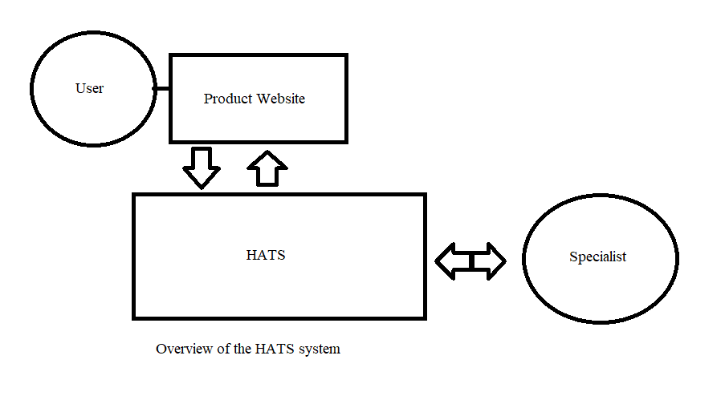

Figure 4.1.1 Overview of the HATS system product perspective

### 4.2 Assumptions and Dependencies

1. It is assumed that the individuals can carry a conversation with the specialist and their communication skills are coherent.
2. As this is a local store in America the default language for us to use will be English.
3. It is assumed that the consumer is contacting us on a computer and with desktop formatting.
4. It is assumed that the consumer has access to an internet connection, e-mail, and an account with the website we are servicing.

# 5. Product Features

### 5.1. System Features

1. Support generation through ticket solutions.
2. Product help specifications.
3. Accessible on any desktop web browser.

### 5.2. Communication Features

1. Layered support selection.
2. Specialists.
3. FAQ.

### 5.3. Ticket Creation Features

1. Ticket Creation.
   1. Text box
   2. Chat
   3. Attachments
2. Ability to assess ticket history and feedback from account details.

### 5.4. Potential solutions

1. Questions and categories that narrow down the issue.
2. Provide potential solutions that have worked in the past and were approved by a specialist.
3. Expands when new recurring issues are presented.

# 6. Other Requirements and Constraints

### 6.1 Security

* This system shall require the consumer to have an account in order to submit a ticket or view feedback history and current/ongoing tickets.
* This system shall not disclose account sensitive information when creating new dynamic solutions to frequently occurring issues.

### 6.2 Usability/Quality

* Support sorting of common issues based on frequency of selection.
* Organization of issues/solutions within product category.
* Provide help prompts that will appear on products that when interacted with provide a list of FAQ.
* Options that redirects the user to a ticketing page that is relevant to that product.
* Shall include a filtering system that allows the user to narrow down issues categorically.

### 6.3 Capacity

* Congestion level of the ticketing system.
* Number of specialists and how many tickets they are assigned/departments.
* The growth of the dynamic system is relevant to the solutions, if the solution is too complicated and needs a specialist then it cannot be automated.

# Appendix A

### Table 3.1.1 Non-users relative to HATS & Table 3.2.1 Stakeholders

* Name: Description of the type of stakeholder that is being specified.
* Description: Describing the significance of the Name, expanding on the purpose.
* Responsibilities: Lists the tasks and responsibilities of the given name according to the description assigned to it. This includes things that, in this instance, the stakeholders need to focus on.

### Table 3.4.1 Concerns and potential solutions

* Need: Lists risks and topics of concern that address the potential success of the software we are implementing (HATS).
* Priority: Split using labels of High, Mid, Low
  + High: denotes an essential feature. Failure to implement this critical feature means that the system will not meet customer needs. All critical features must be implemented in the release of said product.
  + Mid: denotes an important feature. Features important to the effectiveness and efficiency of the system for most applications. The functions cannot be easily provided in some other way. Omitting an important feature might affect customer or user satisfaction or even revenue.
  + Low: denotes features that are useful but not essential for functionality. Features that are useful in less typical applications, are used less frequently, or that can be met with reasonably efficient workarounds. No real significant revenue or customer satisfaction impact.
* Concerns: Descriptions of the issue presented by each level of stakeholder and their respective fields.
* Proposed Solutions: Solutions that have been developed by the teams in their respective departments. As well as proposed ideas or features that could be implemented in order to alleviate concerns with potential customer satisfaction.

### Figure 4.1.1 Overview of the HATS system product perspective

* A figure of the product perspective overview. The diagram briefly illustrates the relationship between the User and their access to the Product Website.
* From the Product website, HATS will retrieve user information and use that to allow for ticket creation.
* HATS is responsible for creating communication between their specialists and the website in order to contact the User via their account information.

# Use Case:

|  |  |
| --- | --- |
| Use Case 1 | Search for Tech Support Solution |
| Goal in Context | The customer chooses troubleshooting options which match their product issue, expects a solution which most closely matches the issue. |
| Scope | System |
| Level | Summary |
| Primary Actor | Customer |
| Stakeholders and interests | Customer |
| Preconditions | Customer is able to access the website. |
| Success End Condition | The Customer obtains a solution for their specific product which accurately solves their issue. |
| Failed End Condition | The Customer cannot obtain a solution for their specific product which accurately solves their issue. |
| Trigger | Support query is initiated. |
| Main Success Scenario | 1. The user requests the support webpage. 2. The system retrieves a list of the different product type categories available (Dishwasher, Refrigerators, Water Heaters, etc) and displays them to the user. 3. The system provides the user with the opportunity to select a product type option or exit the use case. 4. The user selects an option for the category which matches their product type. 5. The system retrieves a dropdown list of products which match the selected category and displays it to the user. 6. The system provides the user with the opportunity to select a product or exit the use case. 7. The user selects an option for the item which matches their product. 8. The system retrieves a list of available solutions for defects related to the selected product and displays it to the user. 9. The system displays a ticket creation option for sending a support ticket in the event that the available solutions do not solve their issue [Use Case 4]. 10. The system provides the user with the opportunity to select the ticket creation option or end the use case. |

|  |  |
| --- | --- |
| Use Case 2 | Answer A Ticket |
| Goal in Context | The employee looking at the submitted ticket sends the ticket to its designated specialist, who answers the ticket for the customer. |
| Scope | Customer Service |
| Level | Summary |
| Primary Actor | Employee/manager/specialist |
| Stakeholders and interests | Customer, Manager, specialist, Ticket Engineer Lead |
| Preconditions | Customer is able to submit a ticket. |
| Success End Condition | A satisfying solution to the issue was presented to the customer and the ticket was successfully closes and marked as ‘solved’. |
| Failed End Condition | The Customer’s issue was more complex than anticipated and the response of the specialist will take an unexpected amount of time to respond. |
| Trigger | The customer makes a ticket and keeps up on updates regarding their case. |
| Main Success Scenario | 1. Employee signs in using their level of credentials. 2. Checks the inbox of tickets associated to their department. 3. Selects a ticket and is able to see the options the customer has selected during the submission process. 4. They are able to then communicate with the customer in text, in response to the ticket, with potential solutions. 5. If the issue persists and/or is too complex for this employee, then the ticket will be forwarded to a specialist. 6. The specialist will follow with the customer either in text chat or voice chat depending on the preference of the customer. 7. When a solution is found, the ticket will be marked as solved and will be closed. 8. The solution will then be added to a statistic that is used to account for whether it should be added to the list of potential solutions prior to ticket submission. |

|  |  |
| --- | --- |
| Use Case 3 | Submit Completed Ticket for Database |
| Goal in Context | Tickets that are deemed satisfactory from customers are submitted into a database for solutions to a given issue, thereby expanding the list. |
| Scope | System |
| Level | Mid |
| Primary Actor | Specialist |
| Stakeholders and interests | Customer/Manager/Specialist/ |
| Preconditions | Specialist has access to database. Tickets have been written off by manager for submission |
| Success End Condition | The specialist submits a satisfactory ticket into the system. The ticket is able to be searched in a query of the database by the user. |
| Failed End Condition | The specialist is not able to submit a ticket into the system. |
| Trigger | Ticket is reopened for specialist and managerial review. |
| Main Success Scenario | 1.Customer that is satisfied with their support issue causes the specialist to close the ticket.  2. After the ticket is closed the customer answers a few questions about their ticket request and what level of satisfaction it has.  3. After a number of satisfactory reviews are processed at a certain level, the documentation for all is brought before the manager for review.  4. Once a problem is reviewed and signed off by the manager, the specialist has permission to submit the newly approved solution.  5. The system prompts the specialist for the data.  6. After entering the data, the system uploads files and picks out keywords for searching.  7. Customer logs into the system and searches for said solution. |

# 

|  |  |
| --- | --- |
| Use Case 4 | Send a Support Ticket |
| Goal in Context | The customer sends a ticket to a specialist for further support. |
| Scope | System |
| Level | Summary |
| Primary Actor | Customer |
| Stakeholders and interests | Customer, Specialist |
| Preconditions | Customer is able to access the ticket option at the end of a support query. |
| Success End Condition | The Customer is able to send a ticket to a specialist for further support. |
| Failed End Condition | The Customer cannot send a ticket to a specialist for further support. |
| Trigger | Support ticket option is selected at the end of the support qwerty [Use Case 1]. |

# Domain Model:

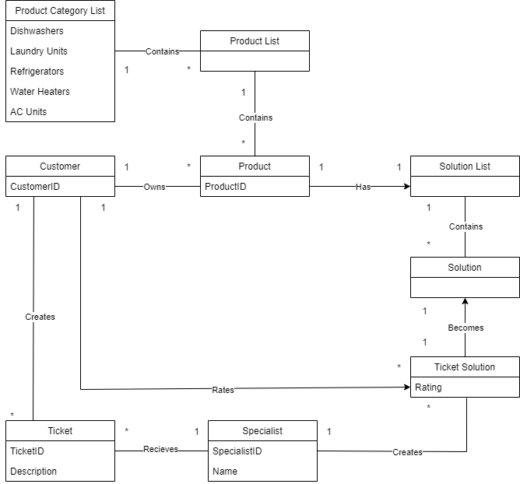

# 

# Supplementary Specification:

* Functional computer or laptop with an OS that allows connection to the WWW.
* Connection to WWW must be stable. Disconnections and time-outs can lead to lost progress and loss of lineplacement if discussing with a specialist. Additionally, it may interrupt the ticket submission process.
* Will be developed using HTML, CSS, and Jscript for front end UI.
* Back-end will be developed with a SQL platform. Search data for known issues will be handled automatically for the user as queries. Execution of scripts that incorporate the data form the database will be handle with additional languages such as Python and Jscript.
* Must get access to high-level software development systems. Find pricing for development in either if any. If price is subscription based; weigh use of programs over sales in store and projected use of site for faulty appliances (over other avenues of troubleshooting and customer care.) This also takes into consideration market value with competitors.
* User information such as name, and device will only be accessed during submission, review, and response. Otherwise data will be stored in a private class database. Only solution and device type will be posted for public use if satisfactory.
* Legal issues might ensue with companies of said products sold. Due to the companies wanting exclusive access to information about their products, and only be serviced by their specialists.
* Issue could be resolved with open end information sharing between databases. embedded within the ticket program as an end-user license agreement for sharing with the parent client.
* One concern with the ticket system is an over abundance of “move to x appliances page” due to lack of ability to interact with the appliances software. This assumes that there is no sharing of information between us and the appliances main manufacturer.
* Keep platform use on Microsoft edge or google. Older models such as firefox or internet explorer could run into errors.
* Service will be based online. Need research into price for server rental or having a computer operate 24/7 to lessen cost. If the latter, architecture set-up will need to be completed for as well.
* Physical environment concerns are minimal. If the user's appliances are on fire, they are calling the wrong service to begin with.
* Soft Scaling background so that the application is easy on the eyes of users. Rounded objects and links. Background colors will be lighter hue mixed in with different colors defining important links and buttons to press.
* After a defined time period for searching in the database for known solutions, the user will be prompted if they want to be serviced by a specialist. Pop-up layered UI.
* Simple design of the website's main page will help provide easy navigation to important sections for user access.

# Class Diagram:

