2021-12-13

https://www.youtube.com/watch?v=CBJMl9MILbg

on server:

sudo apt-get openvpn

getting open-vpn-install.sh from:
https://github.com/angristan/openvpn-install

as root ran:
AUTO_INSTALL=y ./open-vpn-install.sh

seems to have:
commonName :ASN.1 12:'client'

guy in the video got a TUN error:
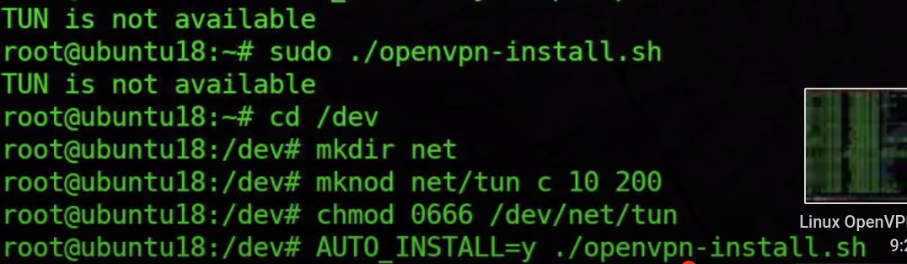
I did not get this error. I have done a ton of stuff with the TUN device on this server already, I wouldn’t be surprised if it is broken. I will check that the device is there. Mine is 660 instead of 666

back on client machine:
> scp root@reasoningtechnology.com:/home/thomas_lynch/client.ovpn .
> openvpn client.ovpn

the video also had this error, he just ignored it:
Tue Dec 14 14:41:35 2021 Unrecognized option or missing or extra parameter(s) in client.ovpn:19: block-outside-dns (2.4.11)

but there are more errors

https://youtu.be/CBJMl9MILbg?t=628

mine is not working, changing the permissions on the TUN device to be like the video, did not help:
Tue Dec 14 14:51:14 2021 TLS Error: TLS key negotiation failed to occur within 60 seconds (check your network connectivity)
Tue Dec 14 14:51:14 2021 TLS Error: TLS handshake failed
Tue Dec 14 14:51:14 2021 SIGUSR1[soft,tls-error] received, process restarting
Tue Dec 14 14:51:14 2021 Restart pause, 5 second(s)
Tue Dec 14 14:51:19 2021 TCP/UDP: Preserving recently used remote address: [AF_INET]35.194.71.194:1194
Tue Dec 14 14:51:19 2021 Socket Buffers: R=[212992->212992] S=[212992->212992]
Tue Dec 14 14:51:19 2021 UDP link local: (not bound)
Tue Dec 14 14:51:19 2021 UDP link remote: [AF_INET]35.194.71.194:1194

https://stackoverflow.com/questions/21065922/how-to-open-a-specific-port-such-as-9090-in-google-compute-engine

get a list of instances:
https://console.cloud.google.com/compute/instances?project=valid-ship-241608
note setup firewall rules at bottom

allowing ingress port 1194, egress is allowed by default on all ports already
used tag, reasoning-technology-vpn

now have to add that tag to the instances
going back to the instance list, and clicking on the instance

looking at details for the instance, I see the existing tags

note at the top of the page the ‘edit’ option .. very top hard to notice,
do not forget ‘save’ at the very bottom after the edit.

there is a section for network tags, just type it there, if it is not already
there, and hit enter

yes now the vpn is active, no reboot was needed, yes the what is my ip address
info comes up clean

> curl ifconfig.me
35.194.71.194
2021-12-14T14:35:59Z

shutting down:
> curl ifconfig.me
86.254.241.251
2021-12-14T14:43:38Z

trying to import the config into network manager, the video says to install:

sudo apt-get install network-manager-openvpn-gnome

but I have this:

> sudo dnf install NetworkManager-openvpn-gnome
Last metadata expiration check: 1:36:22 ago on Tue 14 Dec 2021 02:39:33 PM CET.
Package NetworkManager-openvpn-gnome-1:1.8.12-1.fc33.1.x86_64 is already installed.
Dependencies resolved.
Nothing to do.
Complete!

In the gnome→settings→network add vpn, then do not select open vpn. Instead go to the bottom of the list where it says ‘import file’ and import the client.ovpn file.

Then flip the switch so it is blue and it should be on.

