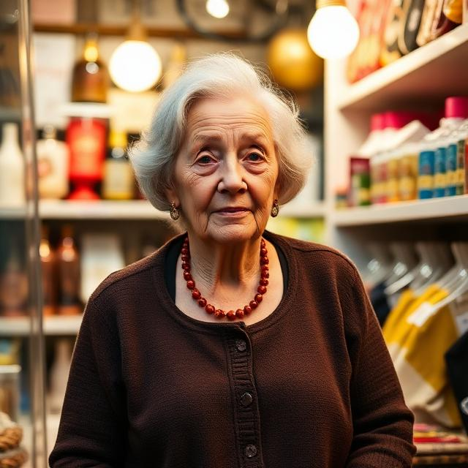
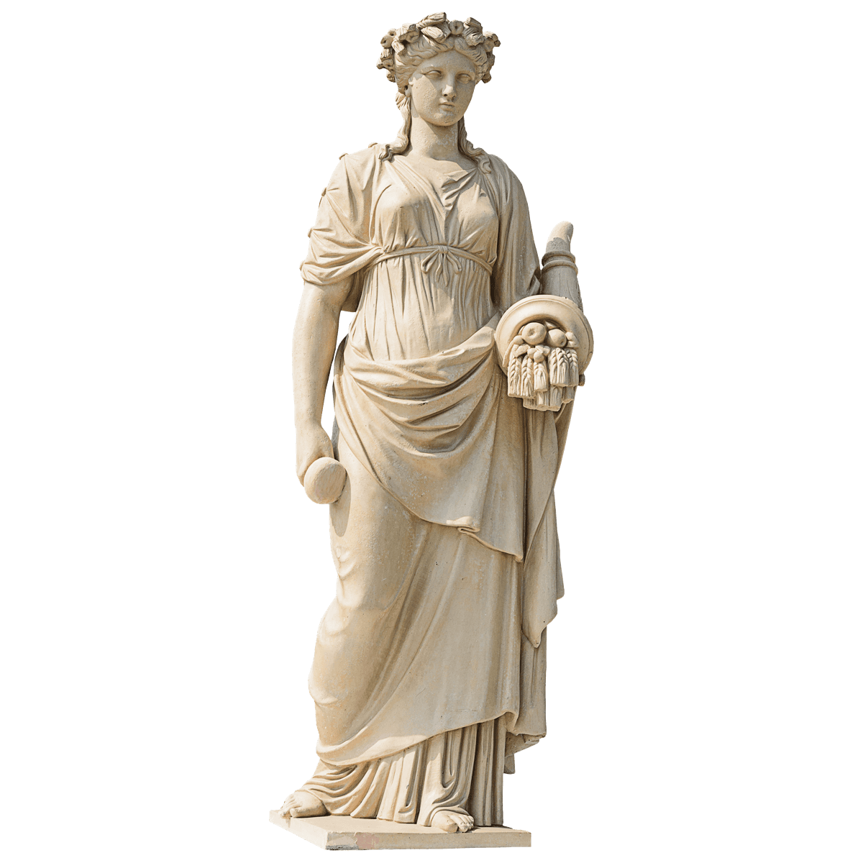
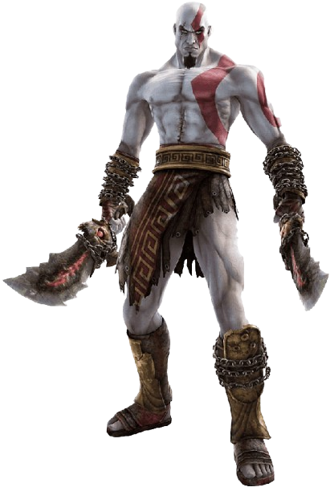
76
Pensioner
Married
Great-Britain
Frustrations

- can’t navigate through the website
- font size is too small → can’t read it
- wishes bigger figure sizes
- too many steps before terminating a buying process

Carla Berdigson

Technology
Interests
Social Networks
Internet
Biography
Carla is married since 45 years and worked half her life as a museum workforce. There she got interested in any kind of statue and was curious about the history and meaning behind them. Living at the country-side, she started collecting those statues and explored a new market where anyone could create their own designs and ‚print‘ them with an actual printer … 3D printing.
AGE
OCCUPATION
STATUS
LOCATION

„I’m an elderly woman who loves 3D printing for creating personalized items and bringing ideas to life.“
Tries to go with modern trends
Collects statues
Goals

- create individual designs
- order an unknown number of personalised figures
- easy handling of the whole ordering process

