Collaborative Course Notebook
Product concept and prototype plan | 31 October 2026
Concept summary
A personal note-taking workspace connected to a shared, course-specific knowledge base. Students write by hand or type as usual. In the background, AI extracts course-relevant information from their notes, matches it to lectures and makes it available for classmates' review. Each student's original notebook remains individually editable. The main features are Make Notes, Suggestions and Quiz Me.
Product hypothesis: students adopt the platform because it is a useful notebook and study assistant. As more students take notes, the course knowledge base becomes more complete without requiring a separate sharing activity. The adoption and learning benefits still need to be tested.

1 Problem and product position
Students often miss explanations, examples, or board work that appear only during lectures. Writing down everything competes with listening, and poor lecture recordings may not recover the missing information. A classmate may have understood or captured exactly what another student missed, but finding that specific information takes effort.
Point of view: Students need to recover missing lecture knowledge from classmates without searching complete shared notebooks, taking additional notes, or relying on unexplained AI summaries.
How might we turn everyday note-taking into a shared source of lecture knowledge while allowing each student to review that knowledge in their own way?
The product combines familiar digital note-taking with course-aware retrieval. Its distinctive function is contextual peer knowledge: an explanation captured by one student can appear beside another student's incomplete note at the relevant lecture topic.

2 Core product experience

Make Notes
Students annotate a slide with a stylus, type on a laptop, insert photos or PDFs, and continue across devices. The application retains the original handwriting and layout while producing searchable text in the background. It suggests course and lecture labels, requesting confirmation when a match is uncertain.

Suggestions
When students highlight a confusing step or open a relevant slide, they can inspect a peer explanation beside their own notes. The suggestion includes a source link, its status as official or peer-supplied material, and clear Add to My Notes and Dismiss actions. Suggestions should be quiet until opened.

Quiz Me
Students choose a lecture, topic or highlighted passage and answer a short question. Feedback explains the reasoning and links back to the source. The system may prioritize previously confusing topics, but it must not present unverified peer claims as established facts.
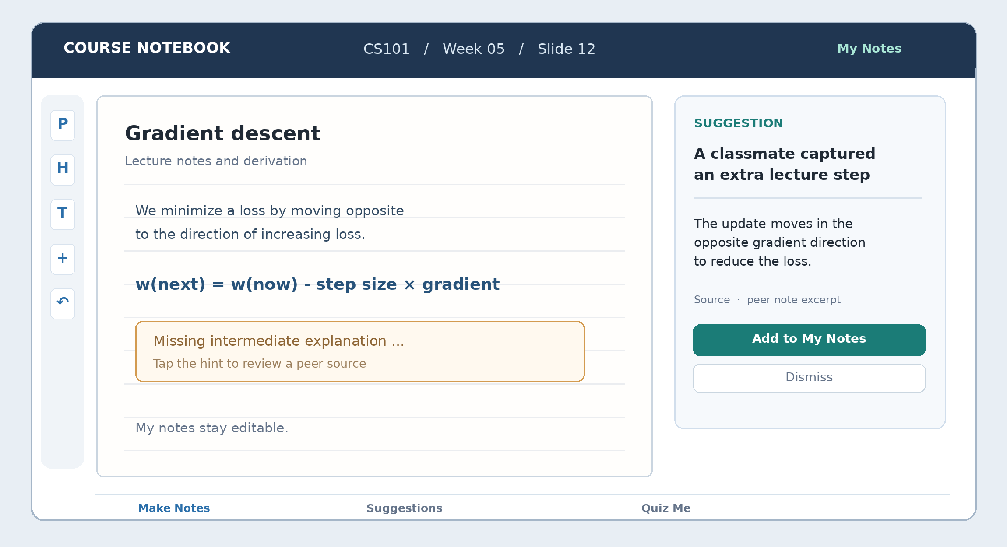
Figure 1 Proposed notebook interface with a source-linked suggestion beside a student's editable notes

The distinction between personal notes and shared knowledge
- Personal notebook view: the student's original handwriting, typed text, layout and corrections remain editable in the format they prefer.
- Course knowledge base: official materials and automatically extracted knowledge fragments from students' notes, grouped by course, lecture and topic.
- Personalized study view: AI retrieves from both layers and proposes relevant explanations. Importing an explanation into personal notes is always optional.
The shared layer is not a single Markdown document that everyone edits. Markdown and structured text can be an internal extraction format, while source files, handwritten pages and the student's preferred layout remain intact.

3 Detailed student workflow
The illustration follows a missing derivation step. During the lecture, Student A records an incomplete explanation while Student B captures the intermediate step. As Student B writes, the system extracts the relevant content and organizes it under Lecture 5, Slide 12 in the shared course knowledge base. Student B has no separate sharing task.
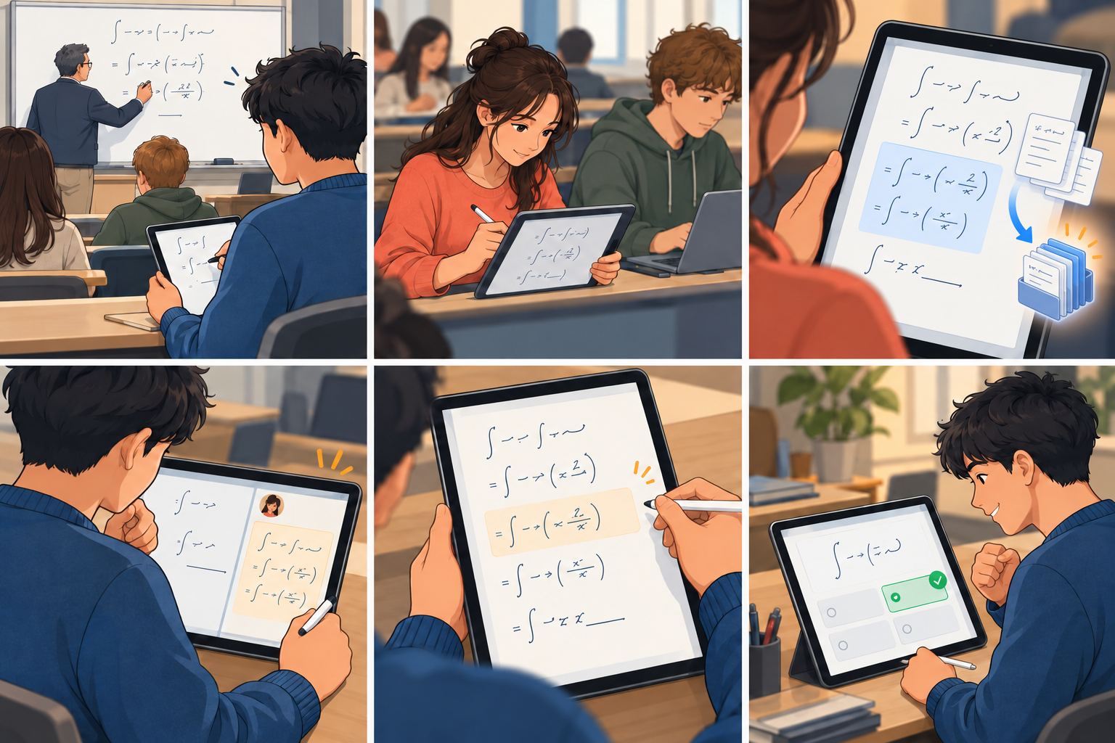
Figure 2 Six scenes showing note-taking, automatic course indexing, recovery of a missing explanation and a quiz
When Student A returns to the same topic, the extracted explanation appears as a source-linked suggestion. Student A may insert it as a separate annotation and then use Quiz Me to check understanding. No one needs to browse or download full classmates' notebooks.

4 Student motivation and network effect
Students already need to take notes. The platform should be useful for that task before peer knowledge becomes available: handwriting and typing must work well, lecture materials should be easy to organize, and personal study support should be immediate. Students contribute to the common database simply by using these features.

Why students would adopt it
The platform must match everyday tablet and laptop workflows and allow imports from existing note apps. Its immediate payoff is organized, searchable notes and access to AI explanations and quizzes. A new student should benefit even when few classmates have joined.

Why collective knowledge improves
Different students record different parts of a lecture. Automatic extraction continuously adds course-related definitions, examples, explanations and derivation steps to a common topic index. More active note-takers should produce broader coverage without being asked to upload notes a second time.

Why a student would use a merged knowledge base
Note layouts are highly personal. The system therefore merges knowledge at the course-topic level, while keeping each person's original notebook style. Suggestions are displayed alongside personal work and inserted only if a student finds them useful. The common database improves the answer, not the appearance of the student's own notes.

5 Technical architecture
The shared database should contain a structured index of source-backed knowledge fragments rather than a continuously rewritten master notebook. Retrieval-augmented generation (RAG) can then assemble an answer from the fragments the requesting student is allowed to see.
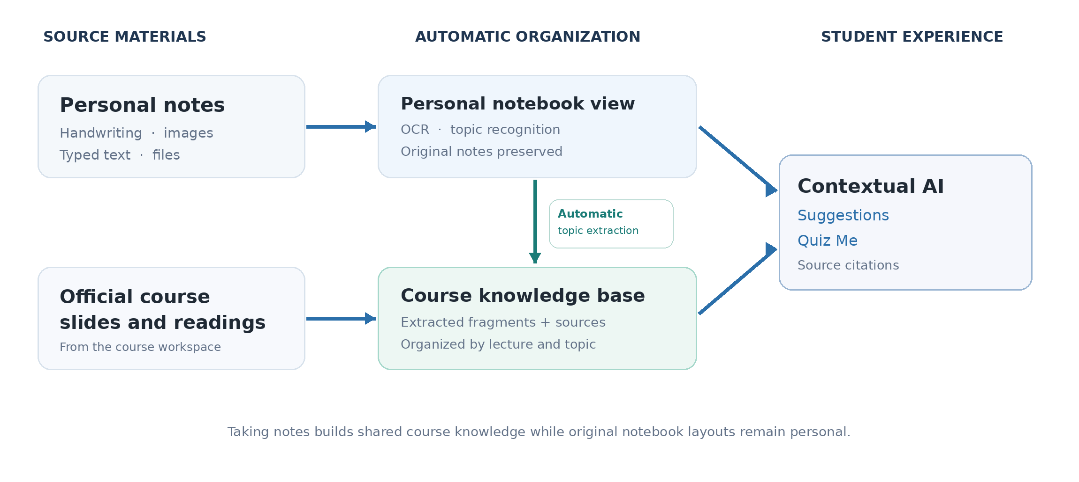
Figure 3 Notes are organized into personal views and a shared course knowledge base automatically

Capture and classify
Store editable pen strokes, typed text and original imported files. Extract searchable text and mathematical expressions with OCR or document models, keeping page coordinates and the original image. Match content to course, term, lecture and slide, with a confirmation step for uncertain labels. An initial prototype can use manually joined courses; LMS integration can follow with authorization.

Aggregate and organize course knowledge
The system continuously extracts course-relevant fragments from note content, classifies them by lecture and topic, and compares them for duplicates, complementary explanations and contradictions. It retains original source references and version history so explanations can be checked and corrected. Peer agreement alone is not proof of accuracy.

Retrieve and generate assistance
At question time, the retrieval service scopes results to the enrolled course, combines keyword and semantic search, and includes the student's own notebook as personal context. The AI cites the underlying evidence and distinguishes official material, student-derived knowledge and model interpretation. Quiz questions use the same source-grounded process.

Proposed content record
Each indexed fragment should retain its course and term, lecture and topic, source type, original page or image reference, position on the source page, extracted text, extraction confidence, version, and any corrections or conflicting claims. These fields support retrieval and source checking.

Source and confidence labels
- Official course source: lecture slide, provided notes or instructor materials; its role should be visible in the answer.
- Student-derived knowledge: an explanation extracted from uploaded student notes. Cite the underlying excerpt and show disagreements when they exist; repeated claims do not automatically become verified facts.
- AI interpretation: a model-generated explanation inferred from the available sources. Clearly separate it from a statement known to have been said by the professor.

6 Key implementation challenges
Risk | Likely failure | Practical safeguard
Incorrect OCR or math | A handwritten minus sign or subscript changes meaning. | Retain the image; detect uncertain formulas; avoid promoting low-confidence fragments as settled facts.
Incorrect peer explanation | A plausible but wrong step spreads across the course. | Keep provenance; allow reports; flag disputes; prioritize official evidence and review high-impact content.
Limited course coverage | Students have not yet recorded enough unique lecture explanations. | Start with official materials and one active study group; track coverage by lecture topic.
Wrong course matching | A fragment about a similar topic is placed in the wrong class. | Use course, term and lecture metadata; flag uncertain matches before indexing them.
Adoption friction | Students prefer a notebook they already know. | Import current notes, keep editing familiar, test a lightweight companion workflow before building a full editor.
Overactive suggestions | Pop-ups interrupt studying or imply a student is wrong. | Use quiet indicators and user-triggered queries; provide dismiss and preference controls.

7 Related products and differentiation
Product | Established capability | Remaining opportunity
Goodnotes | Handwriting, cross-device notebook workflows, document collaboration, AI assistance and quiz generation. | Automatically index student note fragments into a searchable course-level knowledge layer used by classmates.
NotebookLM | Answers grounded in uploaded sources, source citations, quizzes and flashcards. | Connect the study assistant to ongoing personal notes and automatically aggregated peer explanations.
Hypothesis and Perusall | Social annotation, comments and engagement around assigned shared course materials. | Extract useful insights from handwritten or typed notebooks, including notes not attached to a reading.
Studocu | A marketplace of uploaded student study materials, with access incentives for uploaders. | Retrieve a specific explanation at the point of confusion instead of searching through complete documents.

Product boundary: the concept is not differentiated by handwriting, AI Q&A, quizzes or collaborative annotations alone; existing tools offer variations of these. The specific hypothesis is that source-linked peer knowledge can be surfaced in context during personal review.

8 Prototype and evaluation plan

Recommended first prototype
Build a clickable tablet and laptop experience using one lecture, two or three representative sample notebooks and several prepared gaps. Simulate automatic extraction and suggestions manually for the first tests. The research question is whether students value and trust the experience, not whether the complete RAG infrastructure already works.
Screen | Core interaction | Test question
1 Course workspace | Open Lecture 5, select a slide, inspect associated personal material. | Can users find the correct course and lecture quickly?
2 Note editor | Write on a slide, type a note and insert a picture; switch device layouts. | Does this feel compatible with existing note-taking habits?
3 Knowledge suggestion | Open a specific missing derivation; inspect its source; add or dismiss it. | Do students recognize the value and trust the evidence?
4 Automatic organization | Finish writing a note and observe it being linked to the correct course, lecture and topic. | Is the background organization clear and accurate without extra steps?
5 Quiz Me | Attempt a question about the earlier gap, then inspect feedback and source. | Does this verify understanding rather than only repeat content?

User study and success measures
Recruit approximately 8 to 12 students from the same course or comparable lecture context. Ask them to complete note-taking, topic recovery and quiz tasks. Compare the experience with their current notes or class group chat where possible.
- Recovery: time to find the missing step; proportion who retrieve a correct explanation; whether sources are opened.
- Adoption: ability to complete everyday note-taking tasks; perceived effort compared with current apps; willingness to return.
- Coverage: number of useful distinct fragments indexed by topic; proportion of lecture gaps with a retrievable explanation.
- Personalization: preference for a suggestion layer versus automatic alteration of personal note pages; rate of accepted and dismissed suggestions.
- Trust and accuracy: ability to identify a deliberately incorrect peer contribution; confidence in answers with and without provenance.
Treat these as test measures, not demonstrated benefits. The first product decision should depend on whether students actually prefer the note-taking workflow and whether automatic aggregation helps recover missing lecture knowledge accurately.

Build sequence
Phase 1: Figma prototype with scripted AI and user testing. Phase 2: one-course working web prototype with file import, simple editing, automatic topic indexing and source-cited retrieval. Phase 3: richer stylus editing, multi-device sync, stronger quality checks and authorized LMS integration. Recording enhancement and overwriting personal notebooks with a single merged document are outside the initial scope.

References
Official product documentation consulted for the comparison above. Feature availability can vary by plan, platform and account.
Goodnotes Support, Share documents privately and collaborate in real time: https://support.goodnotes.com/hc/en-us/articles/13682950187279-Share-documents-privately-and-collaborate-in-real-time
Goodnotes Support, Compare Goodnotes Plans and Features: https://support.goodnotes.com/hc/en-us/articles/13808767840015-Compare-Goodnotes-Plans-and-Features
Google Gemini Notebook Help, Use chat in Gemini Notebook: https://support.google.com/gemininotebook/answer/16179559
Google Gemini Notebook Help, Generate Flashcards or Quizzes: https://support.google.com/gemininotebook/answer/16958963
Hypothesis, Who can see my annotations in the LMS app: https://web.hypothes.is/help/who-can-see-my-annotations-in-the-lms-app/
Perusall Support, How scoring works for students: https://support.perusall.com/hc/en-us/articles/38972581384727-How-scoring-works-for-students
Studocu, How can I upgrade to a Premium account: https://help.studocu.com/hc/en-us/articles/360019474052-How-can-I-upgrade-to-a-Premium-account

