Lab #10 - Final Project – Work Period #1
Group Members:
Faith Thurrott, Thomas Bourgeois, Andrew Goertzen
TX and RX has been demoed.
TX & RX Modules with Antenna:
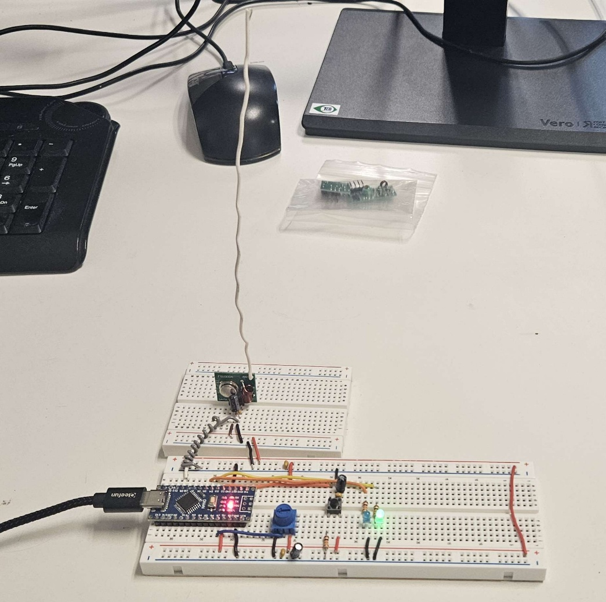
Figure 1 - TX Module With Antenna
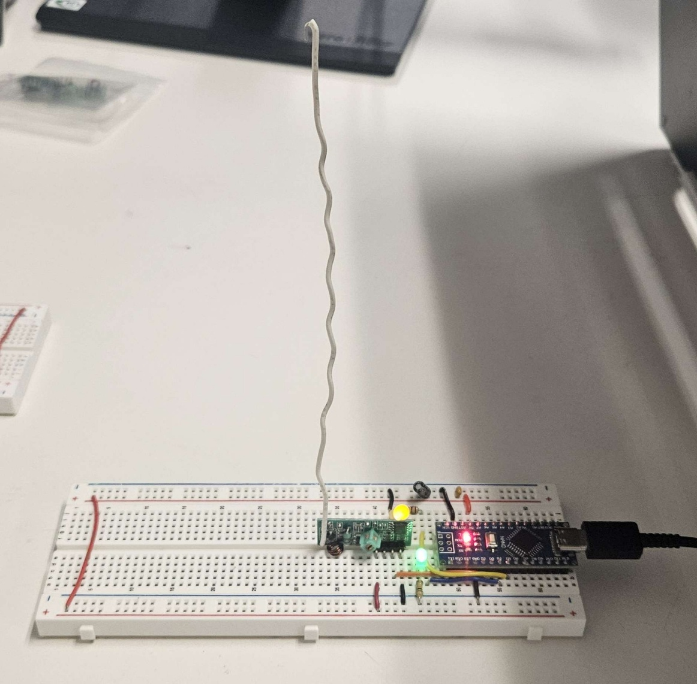
Figure 2 - RX Module With Antenna.

Serial Monitor output of RX:
