Gravity Inventory Center
  - Windows Edition - Beta
COMPREHENSIVE USER MANUAL - COLOR EDITION
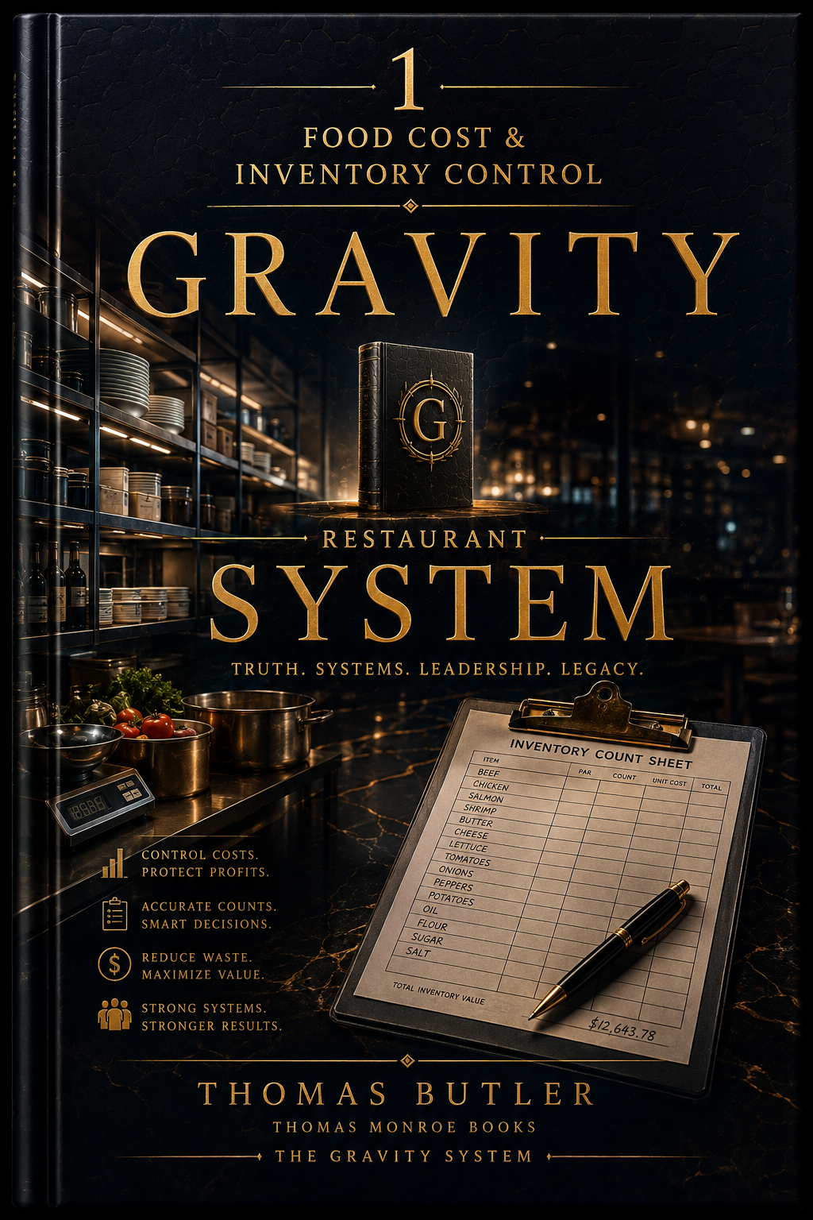
  - A non-enterprise restaurant inventory system for item setup, locations, pars, purchasing, receiving, counts, transfers, waste, supplier pricing, reporting, import/export, history, and backup.
Release: Public Beta | Platform: Windows x64
Distribution: Easy-install ZIP | Edition: Color
This edition uses color diagrams and visual references.
Important
Keep program data and backups under restaurant control. Verify this beta on the restaurant's own Windows hardware before broad operational reliance.

Contents
1. Installation and first launch
2. The inventory process from setup to review
3. Locations and count order
4. Item Master
5. Pars and reorder worksheet
6. Suppliers and purchase sources
7. Purchase orders
8. Receiving
9. Counts and count readiness
10. Transfers, waste, and adjustments
11. Reports and net sales
12. Movement/cost history
13. Import Center
14. Backup, restore, export, help, and glossary
15. Recommended inventory cadence
16. Troubleshooting and release checklist

Quick Start
Install and verify the program before entering production data.

Easy-install sequence
1 | Download the Windows Beta ZIP from Thomas Monroe Books.
2 | Right-click the ZIP and choose Extract All. Do not run the program from inside the ZIP.
3 | Open the extracted folder and double-click the clearly named INSTALL GRAVITY ... command file.
4 | Allow Windows to finish the per-user installation. Administrator rights normally are not required.
5 | Launch the program from the Desktop or Start Menu shortcut created by the installer.
6 | Complete the first-run profile/setup and create a backup after initial configuration.

First-run verification checklist
- Program launches from the Start Menu/Desktop shortcut.
- Restaurant/location profile is correct.
- A small test record can be saved and reopened.
- Print or PDF output works on the intended device.
- A backup can be created and is stored outside the live data folder.
- Any employee/public link or QR feature is tested from a second device where applicable.

Program Map
The map below uses the names of controls in the current packaged Windows beta.
Setup  • Restaurant Profile  • Locations  • Item Master | Control  • Par & Reorder  • Purchasing  • Receiving
Stock  • Counts  • Transfers / Waste | Insight  • Dashboard  • Reports  • History
Data  • Import Center  • Export Items  • Export History  • Export Recipe Costs | Safety  • Create Backup  • Restore Backup  • Help  • Glossary  • Ask Gravity

Core operating flow
1 | Set physical locations and count order
2 | Build the Item Master
3 | Connect suppliers and purchase units
4 | Set pars/reorder points
5 | Create purchase orders as needed
6 | Receive purchases into the correct location
7 | Count inventory on a controlled schedule
8 | Record transfers, waste, and adjustments
9 | Review value, losses, price movement, and variance
10 | Back up and correct the system before the next cycle

Built-in help, examples, and glossary
The Windows Beta includes in-program guidance so a manager does not have to guess what an unfamiliar field, control, or term means. Use the guidance before relying on memory or making assumptions.
- Hover help: pause over supported fields and buttons for a short explanation of what the control does or what belongs in the field.
- Examples: fields that can be confusing include sample formats or entries where practical, such as times, units, locations, roles, or notes.
- Glossary: use the in-program Help and Glossary area for plain-language definitions of inventory, purchasing, count, reorder, variance, and reporting terms.
- If the on-screen guidance and this manual ever appear to disagree, stop and verify the current program behavior before using the result operationally.

Visual workflow note
The workflow map above is the primary visual guide. It uses the current control names and sequence from the packaged application rather than fabricated screenshots.

1. Installation and first launch

Install
Extract the easy-install ZIP and run INSTALL GRAVITY INVENTORY CENTER.cmd. Launch from the Desktop or Start Menu shortcut.

Use the success path
The Dashboard shows what success looks like: set up locations, set up items, then count stock. Follow that order instead of entering transactions before the item/location structure exists.

Back up the initial setup
After locations, item master, suppliers, and pars are established, create a backup before live transaction entry.

2. Locations and count order

Model the physical restaurant
Create locations that reflect where inventory is actually stored or counted: walk-in, freezer, dry storage, bar, line, prep, cleaning, office, etc.

Use route order
Set route order so count sheets follow the physical path managers use. A good route reduces missed shelves and duplicate counting.

Department labels
Use area/department to group locations meaningfully while preserving the actual physical count sequence.

3. Item Master

Create each stock item once
Use a single clean master record per item rather than separate duplicates for each storage location.

Use consistent units
Decide how the restaurant counts the item and how it purchases the item. Correct conversion between purchase units and count units is essential for value, receiving, and reorder accuracy.

Fix item setup before counting
Count Readiness is designed to surface setup problems. Correct item configuration before posting a full inventory.

4. Pars and reorder

Set practical pars
Par should represent the inventory level needed to support operations between deliveries with an appropriate buffer, not a permanently inflated target.

Use the worksheet
The Par & Reorder worksheet compares on-hand/reorder needs and can feed purchasing decisions.

Review unusual reorder quantities
Unexpected suggested orders often point to an incorrect par, unit conversion, missing receiving, or count error.

5. Suppliers and purchase sources

Supplier directory
Create distributors, local/retail stores, specialty suppliers, and other purchase sources.

Connect items to suppliers
Store supplier item code, purchase unit, count-units-per-purchase-unit, order increment, price, and preferred source.

Local purchases
Use a local/retail supplier source for Walmart or similar local purchases rather than pretending every item is supplied by a distributor.

6. Purchase orders

Build suggested PO
Select the supplier and build suggested purchase-order lines from reorder needs.

Review before ordering
Suggested quantities are a starting point. Review events, forecast changes, delivery schedule, stock already on order, and unusual usage.

Import when helpful
Use the PO template/import for larger data sets, then review imported lines before treating the order as final.

7. Receiving

Receive into the correct location
Choose receiving location deliberately. Inventory value is only useful when movements reflect where stock actually went.

Choose purchase or count units
Receive using the selected unit and enter the correct cost per selected unit.

Keep the source document traceable
Enter supplier/receipt/invoice reference, date, and recorded-by information so cost changes can be traced later.

8. Counts

Choose cycle or full inventory
Cycle counts are useful for selected areas/items; full inventory is the controlled whole-restaurant count.

Use count readiness
Fix missing/invalid item setup before a full count.

Blind count where useful
Blind count can reduce anchoring to expected quantities.

Unexpected stock
If an item is found in an unplanned location, add the count row rather than ignoring stock or forcing it into the wrong location.

Post only after review
Review variances and the count sheet before posting. Posting turns the count into an official inventory event.

9. Transfers, waste, and adjustments

Choose the correct action
Use Transfer for movement between locations; use Waste, Spill, Comp, Spoilage, Damage, or positive/negative adjustment for the actual reason.

Require a reason/reference
The reason/reference is required because unexplained adjustments destroy the usefulness of inventory history.

Record near the event
Enter waste and transfers as close to the real event as practical rather than reconstructing them days later.

10. Reports and sales

Inventory value by category
Use the report to understand where cash is tied up in stock.

Largest recent losses
Review large waste/adjustment activity for operational causes, not just accounting symptoms.

Price Movers
Use supplier price changes to identify recipe-cost or purchasing pressure.

Full-count variance
Use the latest full-count variance as a control measure for count accuracy and unexplained movement.

Net sales
Record daily net sales when you want inventory/cost information interpreted against restaurant sales activity.

11. History and imports

Movement and cost history
History provides the audit trail for receiving, counts, transfers, waste, and cost movement.

Import Center
Use the provided templates for Inventory Items, Purchase Order Items, Receiving/Invoice, and supplier price updates. Import into a backup-protected workspace and review the result.

Never guess import units
Unit conversion errors can affect every downstream value. Verify sample rows after an import before processing the rest of the workflow.

12. Backup, restore, exports, help, and glossary

Create Backup
Create backups before large imports, full counts, structural item changes, or application updates.

Restore Backup
Restore only a known-good Inventory Center backup. Keep the source backup file untouched until the restored workspace has been checked.

Exports
Export Items, History, and Recipe Costs are data outputs for analysis/integration; they do not replace a full application backup.

Help and Glossary
Use in-program Help and Glossary when a term or process is unclear. The goal is for the main workflow to be understandable without Help, but the answer should be there when needed.

13. Recommended operating cadence

Daily
Post receiving, transfers, significant waste/adjustments, and sales when used.

Weekly
Review reorder worksheet, supplier price movement, high losses, stale items, and backup status.

Inventory day
Freeze/coordinate movements as required by restaurant policy, count by physical route, review variance, post count, and save a dated backup.

Monthly
Audit unit conversions, pars, supplier links, inactive items, and high-value variance patterns.

14. Troubleshooting

Reorder suggestion is unrealistic
Check on-hand quantity, par, purchase/count unit conversion, order increment, open purchase orders, and recent receiving.

Inventory value is too high/low
Check count units, costs, duplicate items, unposted receiving, and incorrect positive/negative adjustments.

Count is missing a product
Check whether the item is active and assigned/available for the selected location; use unexpected stock handling when physically found elsewhere.

Supplier price looks wrong
Review selected purchase unit, count-unit conversion, imported price updates, and latest receiving cost.

History does not explain a variance
Look for missing transfers/waste, late receiving, wrong location, incorrect count entry, or unit conversion errors before creating a compensating adjustment.

Manager Rollout Checklist
- Install from the extracted easy-install ZIP and confirm the shortcut launches the correct program.
- Enter restaurant-specific setup and save a test record.
- Verify printing/PDF output and any QR/public link behavior used by the restaurant.
- Create and retain a dated backup before live rollout.
- Train the manager who owns the process, not just the person who installs the software.
- Run one controlled live cycle before depending on the program for the entire restaurant.
- Document any beta issue with the screen, action, expected result, and actual result.

Release posture
The software is distributed as a Windows Beta. Use it operationally with normal management controls, backups, verification, and a fallback method until the restaurant has completed its own successful live cycle. The release also includes field-level hover help, examples where needed, and an in-program glossary/help path.

