Gravity SOP Foundry
  - Windows Edition - Beta
COMPREHENSIVE USER MANUAL - COLOR EDITION
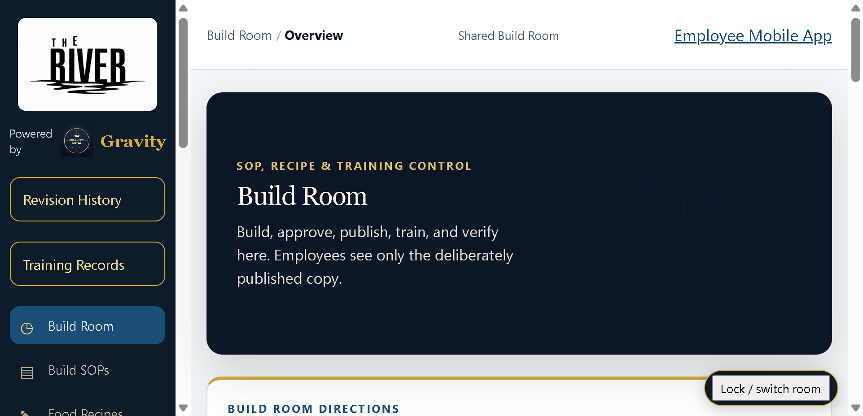
  - A manager workspace for building, revising, publishing, teaching, printing, and maintaining restaurant SOPs, recipes, posters, employee training records, and related operating knowledge.
Release: Public Beta | Platform: Windows x64
Distribution: Easy-install ZIP | Edition: Color
This edition uses color diagrams and visual references.
Important
Keep program data and backups under restaurant control. Verify this beta on the restaurant's own Windows hardware before broad operational reliance.

Contents
1. Installation and first launch
2. How Foundry is organized
3. Build Room and SOP workflow
4. Editing, revision control, and publishing
5. Employee Library and mobile access
6. Training, quizzes, acknowledgments, and records
7. Food and bar recipes
8. Poster Library and Studio
9. Restaurant branding, backup, and restore
10. Gravity Signals and employee messages
11. Ask Gravity and help
12. Printing, binder creation, and export
13. Manager security and PINs
14. Routine operating cadence
15. Troubleshooting and release checklist

Quick Start
Install and verify the program before entering production data.

Easy-install sequence
1 | Download the Windows Beta ZIP from Thomas Monroe Books.
2 | Right-click the ZIP and choose Extract All. Do not run the program from inside the ZIP.
3 | Open the extracted folder and double-click the clearly named INSTALL GRAVITY ... command file.
4 | Allow Windows to finish the per-user installation. Administrator rights normally are not required.
5 | Launch the program from the Desktop or Start Menu shortcut created by the installer.
6 | Complete the first-run profile/setup and create a backup after initial configuration.

First-run verification checklist
- Program launches from the Start Menu/Desktop shortcut.
- Restaurant/location profile is correct.
- A small test record can be saved and reopened.
- Print or PDF output works on the intended device.
- A backup can be created and is stored outside the live data folder.
- Any employee/public link or QR feature is tested from a second device where applicable.

Program Map
The map below uses the names of controls in the current packaged Windows beta.
Build  • Build Room  • Build SOPs  • SOP Editor  • Revision History | Content  • Food Recipes  • Bar Drink Recipes  • Poster Library & Studio
Employees  • Employee Library  • Employee Mobile App  • Training Records  • Employee Messages | Controls  • Restaurant Branding & Backups  • Room PIN Settings  • Backup & Setup
Insight
• Gravity Signals
• Ask Gravity
• Help & User Guide

Core operating flow
1 | Choose a station or procedure
2 | Start from a master SOP or create a new SOP
3 | Edit restaurant-specific steps, standards, and responsibilities
4 | Review and save the revision
5 | Decide whether the revision requires re-teaching
6 | Publish the approved SOP
7 | Employees read, train, quiz, and acknowledge
8 | Review training records, questions, and manager-side signals

Built-in help, examples, and glossary
The Windows Beta includes in-program guidance so a manager does not have to guess what an unfamiliar field, control, or term means. Use the guidance before relying on memory or making assumptions.
- Hover help: pause over supported fields and buttons for a short explanation of what the control does or what belongs in the field.
- Examples: fields that can be confusing include sample formats or entries where practical, such as times, units, locations, roles, or notes.
- Glossary: use the in-program manager glossary for terms such as Draft, Approved, Published, revision, effective date, training requirement, knowledge check, hands-on sign-off, QR code, Gravity Signals, and backup.
- If the on-screen guidance and this manual ever appear to disagree, stop and verify the current program behavior before using the result operationally.

1. Installation and first launch

Install the program
Use the easy-install ZIP. Extract it first, then run INSTALL GRAVITY SOP FOUNDRY.cmd. The installer places the application in the current Windows user profile, creates shortcuts, and registers an uninstall entry.

First manager actions
Open the Build Room, review restaurant branding, change both default room PINs from 0000, confirm the employee experience, and create the first backup before entering substantial custom content.

Beta release note
This is a public beta. The packaged application has been structurally checked, but managers should verify launch, printing/PDF, QR access, and employee mobile behavior on their own Windows hardware before broad staff rollout.

2. How Foundry is organized
Build Room home - manager control center.

Build Room
The manager side is the control center. It provides access to SOP building, recipes, posters, backup/setup, branding, manager-only signals, employee messages, training records, and Ask Gravity.

Employee side
The Employee Library is a read-focused experience for published SOPs, recipes, training, quizzes, acknowledgments, posters, and questions. Managers can open the employee view from Windows for support and verification.

Station organization
SOPs are organized by workstation/station. Employees may browse published material across stations so cross-training is not artificially blocked.

3. Build SOPs and edit procedures
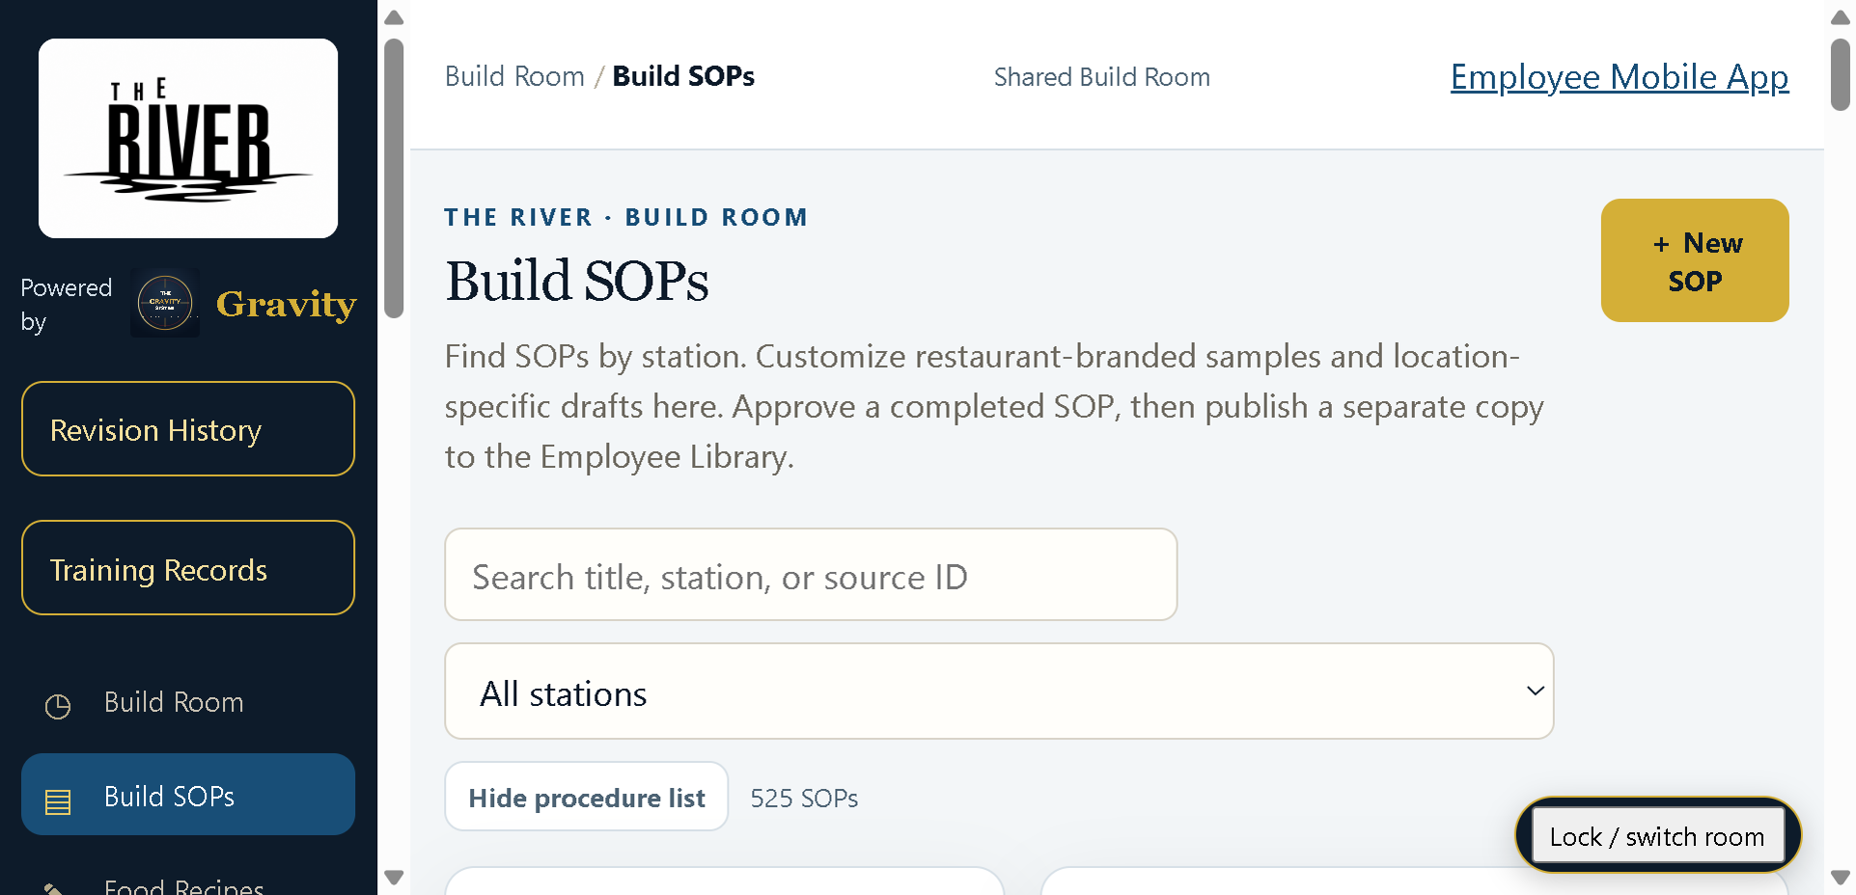
Selected SOP in the Build SOPs workflow.

Start from the procedure list
Open Build SOPs and select a procedure. Use the list to find the right master or restaurant-specific SOP before editing.

Use the larger editor workspace
The SOP Editor provides the main writing area. Keep the procedure actionable: purpose, responsibility, preparation, steps, standards, verification, safety, and corrective action where appropriate.

Avoid duplicate SOPs
Before creating a new SOP, search the existing masters and restaurant library. Revise or adapt the correct source whenever possible so employees do not receive competing instructions.

4. Revision control and publishing

Preserve history
When a published SOP changes, preserve the prior revision. Revision History should remain the record of what changed and when.

Re-teach decision
The person revising the SOP decides whether the change requires re-teaching. Do not let the assistant make that governance decision automatically.

Publish deliberately
Draft, review, and approve before publishing. After publication, verify the employee copy and any QR-linked access to ensure the correct revision is visible.

5. Employee Library, mobile access, and QR

Manager verification
Use the Windows Employee Library to see what staff see before distributing access.

Hosted access
Where hosted employee access is enabled, fresh QR codes should point employees to the current hosted route. Regenerate old codes when a route/version change requires it.

Cross-station learning
Assigned station content should be easy to find first, but published SOPs across other stations remain available for development and cross-training.

6. Training, quizzes, acknowledgments, and records

Training sequence
A typical sequence is Read SOP -> Train -> Quiz/Test -> Acknowledge -> Manager review of training records.

Use records as evidence
Training Records should show what was assigned/completed and support follow-up when a revision requires re-teaching.

Keep employee experience simple
Employees should not need manager controls to learn. Keep editing, publishing, PINs, backups, and manager analytics separated from staff use.

7. Food recipes and bar drink recipes

Maintain recipes as operational standards
Recipes should be specific enough to reproduce the product: ingredients, quantity/unit, method, yield/portion, presentation, holding/storage, and revision notes as needed.

Import existing material
Use recipe import functions for existing source material when practical. Review imported content rather than assuming formatting equals accuracy.

Separate editions correctly
Commercial/customer builds must remain generic and customer-brandable. River-specific recipes or branding do not belong in the customer Windows edition.

8. Posters
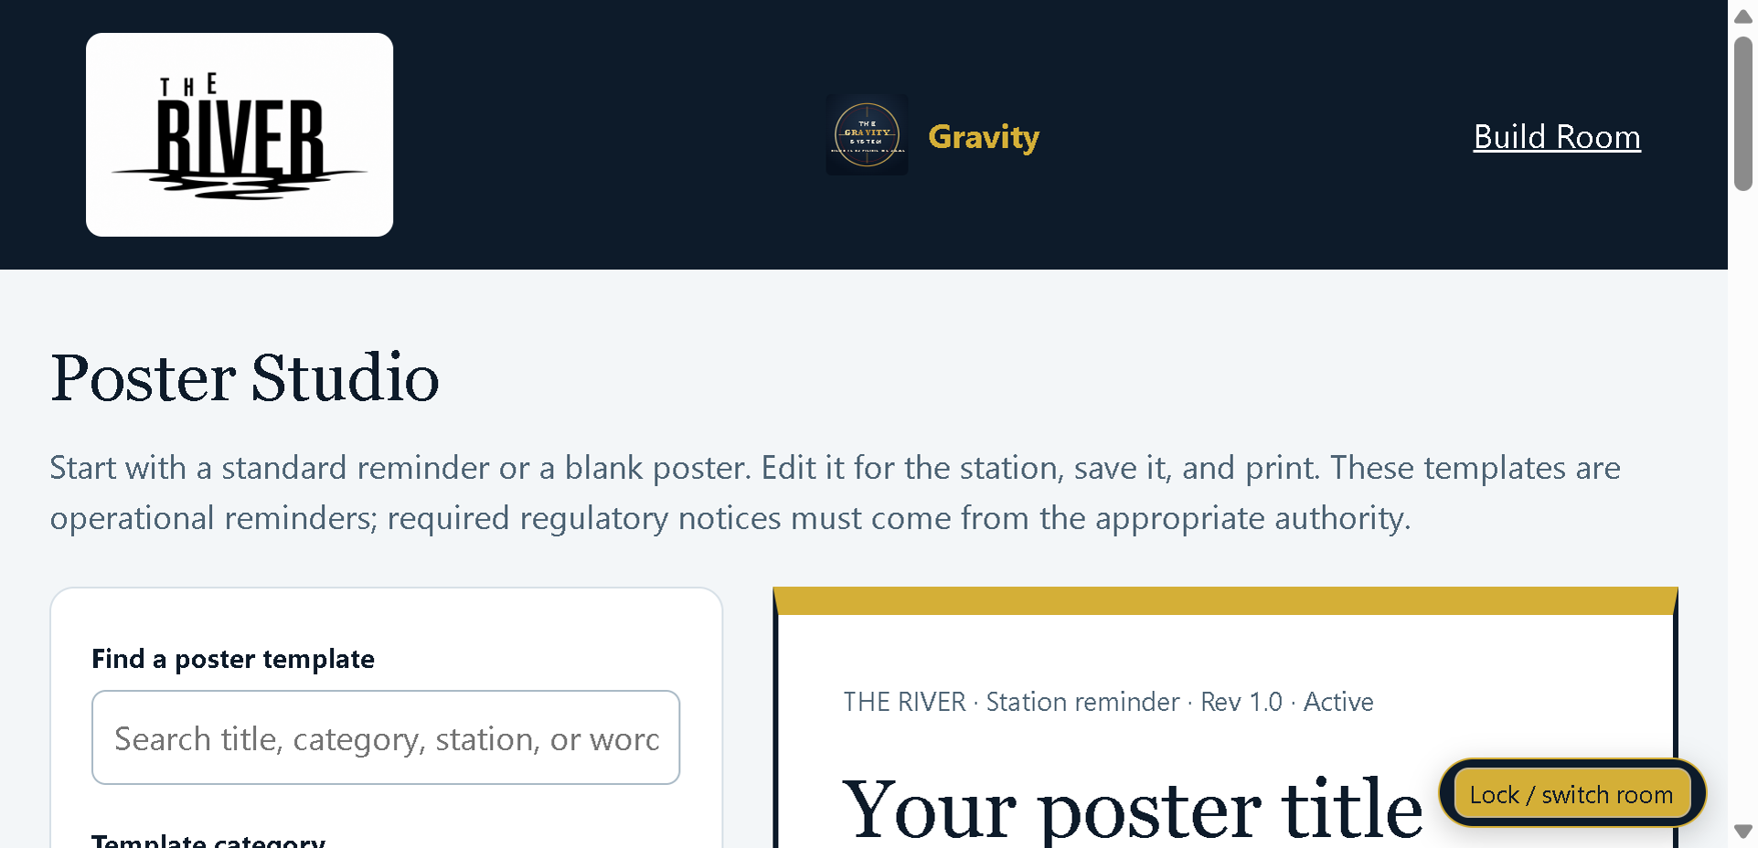
Poster Library & Studio manager view.

Build station-ready references
Poster Library & Studio supports visual station references that complement, rather than replace, the controlling SOP.

Link poster and SOP
Where useful, connect posters to their underlying SOP so an employee can move from a quick visual reminder to the full procedure.

Review after revisions
When a source SOP changes, check related posters for stale instructions and update them where necessary.

9. Branding, backup, and restore
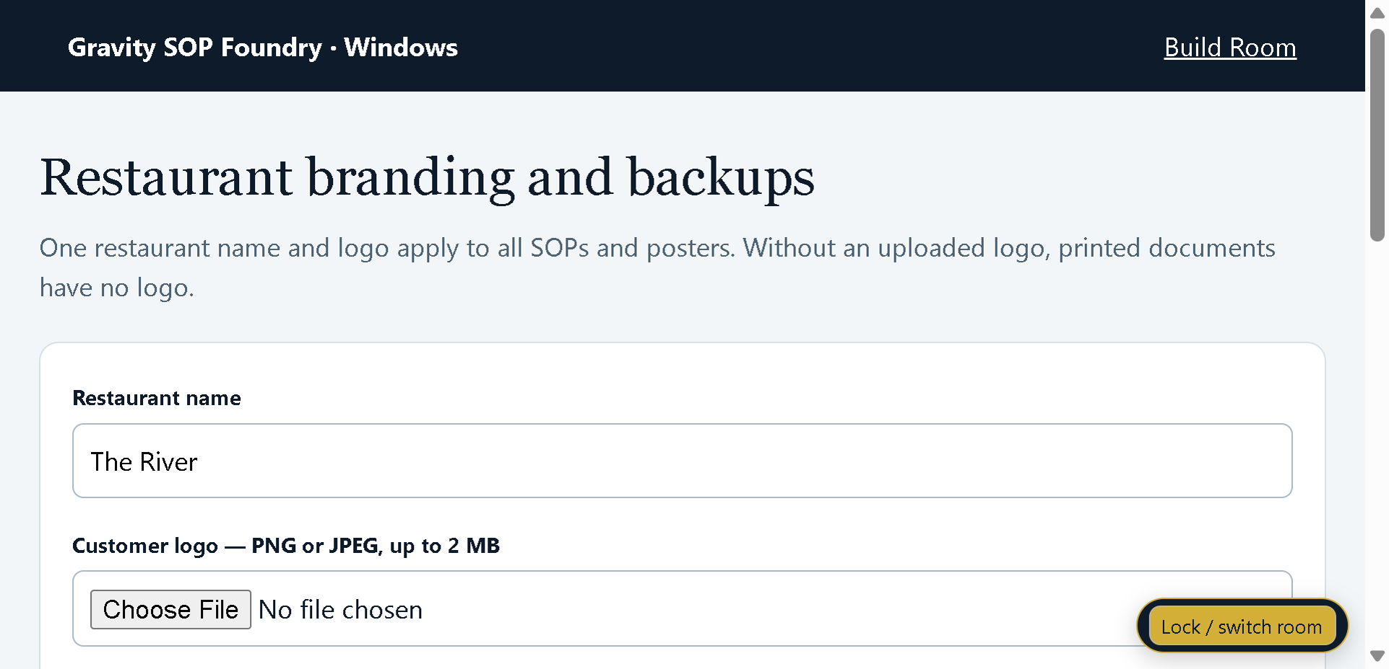
Restaurant branding and backup controls.

Restaurant branding
Use Restaurant Branding & Backups to add customer identity where supported. Gravity branding remains part of the product; the customer logo personalizes restaurant-facing output.

Backup routinely
Back up before large imports, structural changes, major SOP revisions, or program updates. Keep more than one dated backup outside the application data folder.

Test restore intentionally
A backup is useful only if it can be restored. Periodically test restore on a safe copy or controlled environment rather than discovering a problem during an emergency.

10. Gravity Signals, employee messages, and Ask Gravity

Signals are manager-side indicators
Gravity Signals summarizes patterns that may deserve attention, such as repeated SOP/poster views, training trouble, revision revisit spikes, unanswered searches, or station attention. Treat indicators as prompts to investigate, not automatic judgments.

Employee messages
Questions or error reports from the employee side should flow to the manager workspace for review and correction.

Ask Gravity
Use Ask Gravity to explain the Foundry, help locate procedures, or reason through operational questions. The controlling published SOP remains the operating standard.

11. Printing, binder creation, and export

Print employee-ready material
Preview before printing. Verify logo, page breaks, procedure text, revision information, and QR codes on the actual printer or PDF destination used by the restaurant.

SOP binder
Use binder printing to produce a controlled physical reference when the restaurant requires paper access. Printed copies should be reviewed after significant revisions so old pages do not remain in circulation.

Export/backup distinction
An export is for using or moving selected content; a backup is for restoring the workspace. Do not treat them as interchangeable.

12. Manager security

Change default PINs
The initial room PINs are 0000. Change both before staff access.

Protect manager-only areas
Do not share manager PINs casually. Manager-only functions include editing, publishing, backups, settings, and Gravity Signals.

Use least access necessary
Employees should use the Employee Library/mobile experience for routine learning rather than the Build Room.

13. Recommended operating cadence

Each revision
Review -> approve -> decide re-teach -> publish -> verify employee view -> update poster/QR if needed.

Weekly
Review employee questions, training records, signal patterns, stale drafts, and outstanding revisions.

Monthly
Create a dated backup, review restaurant branding/contact details, test a representative QR, and spot-check printed materials against current revisions.

14. Troubleshooting

Program does not open
Confirm the ZIP was extracted before installation. Try the Start Menu shortcut. If Windows blocks an unsigned beta build, review the Windows security prompt rather than disabling security protections.

Employee QR does not open current material
Regenerate the QR when the hosted route has changed, then test it from a phone outside the manager PC.

Print preview looks wrong
Confirm the correct SOP/recipe is selected, check scaling and destination printer/PDF settings, and verify that the customer logo is a supported image.

Data appears missing after update
Do not overwrite or delete the data folder. Restore only from a known-good backup after confirming the program is pointing to the expected user data location.

Manager Rollout Checklist
- Install from the extracted easy-install ZIP and confirm the shortcut launches the correct program.
- Enter restaurant-specific setup and save a test record.
- Verify printing/PDF output and any QR/public link behavior used by the restaurant.
- Create and retain a dated backup before live rollout.
- Train the manager who owns the process, not just the person who installs the software.
- Run one controlled live cycle before depending on the program for the entire restaurant.
- Document any beta issue with the screen, action, expected result, and actual result.

Release posture
The software is distributed as a Windows Beta. Use it operationally with normal management controls, backups, verification, and a fallback method until the restaurant has completed its own successful live cycle. The release also includes field-level hover help, examples where needed, and an in-program glossary/help path.

