Gravity Shift Lab
  - Windows Edition - Beta
COMPREHENSIVE USER MANUAL - COLOR EDITION
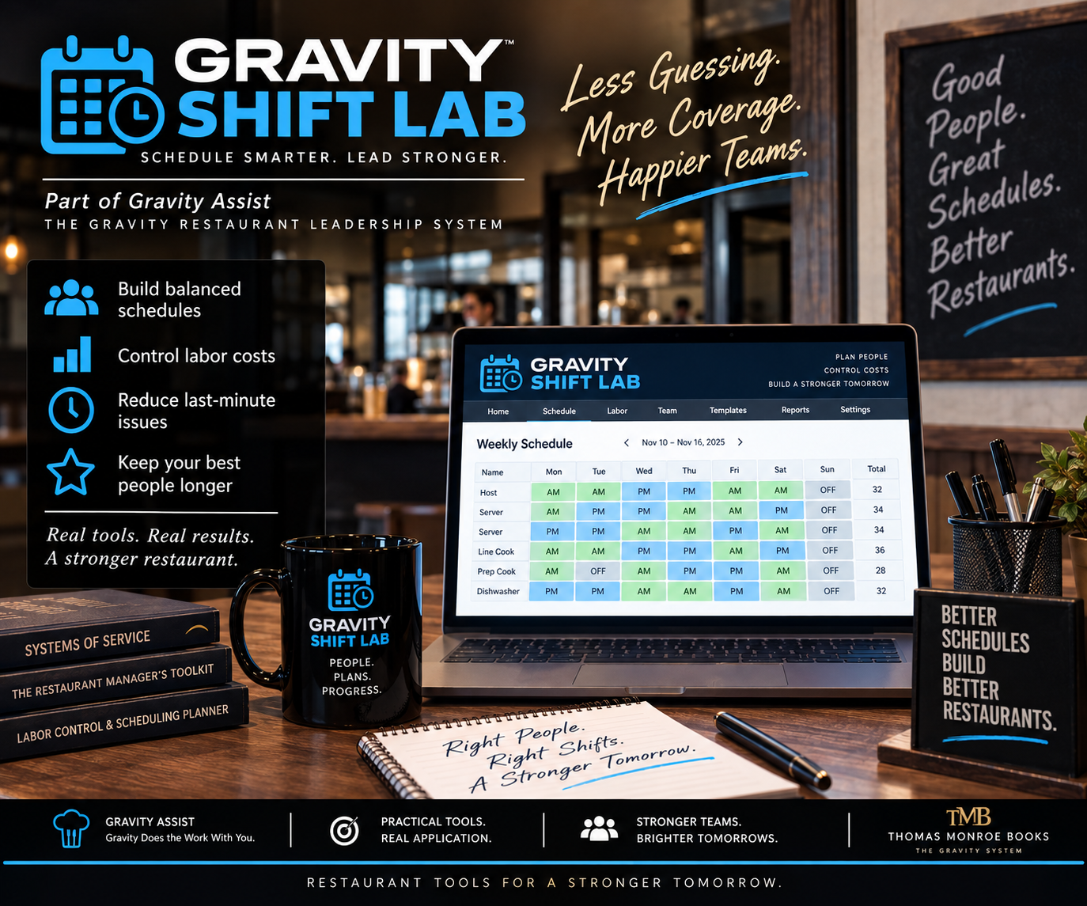
  - A restaurant scheduling and labor-planning workspace for employee rules, availability, stations, weekly schedules, coverage, labor targets, publishing, QR access, printing, and backup.
Release: Public Beta | Platform: Windows x64
Distribution: Easy-install ZIP | Edition: Color
This edition uses color diagrams and visual references.
Important
Keep program data and backups under restaurant control. Verify this beta on the restaurant's own Windows hardware before broad operational reliance.

Contents
1. Installation and first launch
2. Restaurant profile and week controls
3. Employee setup and rules
4. Availability and time-off calendar
5. Sections/stations and opening/closing rules
6. Forecasts, labor targets, and manager pay privacy
7. Building and checking the schedule
8. Finding coverage
9. Publishing and employee QR
10. Printing and manager schedules
11. Week copy/open-next workflow
12. Change log, backup, restore, and CSV export
13. Recommended weekly cadence
14. Troubleshooting and release checklist

Quick Start
Install and verify the program before entering production data.

Easy-install sequence
1 | Download the Windows Beta ZIP from Thomas Monroe Books.
2 | Right-click the ZIP and choose Extract All. Do not run the program from inside the ZIP.
3 | Open the extracted folder and double-click the clearly named INSTALL GRAVITY ... command file.
4 | Allow Windows to finish the per-user installation. Administrator rights normally are not required.
5 | Launch the program from the Desktop or Start Menu shortcut created by the installer.
6 | Complete the first-run profile/setup and create a backup after initial configuration.

First-run verification checklist
- Program launches from the Start Menu/Desktop shortcut.
- Restaurant/location profile is correct.
- A small test record can be saved and reopened.
- Print or PDF output works on the intended device.
- A backup can be created and is stored outside the live data folder.
- Any employee/public link or QR feature is tested from a second device where applicable.

Program Map
The map below uses the names of controls in the current packaged Windows beta.
Week controls  • Week starting  • Copy Previous Week  • Open Next Week  • Save Week | People  • Add Employee  • Availability Calendar  • Advanced Employee Rules
Operations  • Sections / Stations  • Opening / Closing Rules  • Find Coverage | Labor  • Forecast Sales  • Target Labor Hours  • Target Labor %  • Manager Pay Lock
Publish  • Employee QR  • Print Employee Schedule  • Print Manager Labor Schedule | Data  • Change Log  • Workspace Backup  • Restore Backup  • Export CSV

Core operating flow
1 | Set restaurant profile and stations
2 | Add employees and qualifications
3 | Enter recurring availability and date-specific requests
4 | Set forecast sales and labor targets
5 | Build shifts by day and station
6 | Review conflicts, coverage, and labor
7 | Save the week
8 | Publish employee schedule and QR
9 | Print manager/employee views
10 | Carry forward only what is still valid next week

Built-in help, examples, and glossary
The Windows Beta includes in-program guidance so a manager does not have to guess what an unfamiliar field, control, or term means. Use the guidance before relying on memory or making assumptions.
- Hover help: pause over supported fields and buttons for a short explanation of what the control does or what belongs in the field.
- Examples: fields that can be confusing include sample formats or entries where practical, such as times, units, locations, roles, or notes.
- Glossary: use the in-program Help and Glossary for terms such as availability, home section, coverage, labor %, overtime warning, published schedule, revised schedule, backup, and CSV export.
- If the on-screen guidance and this manual ever appear to disagree, stop and verify the current program behavior before using the result operationally.

Visual workflow note
The workflow map above is the primary visual guide. It uses the current control names and sequence from the packaged application rather than fabricated screenshots.

1. Installation and first launch

Install
Extract the easy-install ZIP and run INSTALL GRAVITY SHIFT LAB.cmd. Launch from the created Desktop or Start Menu shortcut.

Create the restaurant profile
Enter restaurant name, store/unit, city/location, and state. Apply the profile to the current workspace so printouts and schedule views identify the location correctly.

Create a backup after setup
Once stations, employees, and base rules are entered, create a workspace backup before building multiple weeks.

2. Restaurant profile and week controls

Choose the week
Week starting uses Sunday as the schedule anchor. Confirm the date before entering shifts.

Save deliberately
Use Save Week as a regular control point while building the schedule. Do not rely on remembering which edits were final.

Copy and advance carefully
Copy Previous Week and Open Next Week are convenience tools. Review copied shifts against new availability, requests, forecast, certifications, and staffing needs before publishing.

3. Employees and scheduling safeguards

Add Employee
Create each employee record with home section/station and qualified sections.

Contact and maximum hours
Phone number and maximum weekly hours are optional safeguards. Use phone visibility controls to protect personal information in coverage workflows.

Certifications and minors
Record required certification/permit and expiration where relevant. Use the minor review reminder and no-closing setting when appropriate to restaurant policy and applicable law.

4. Availability and time-off calendar

Recurring availability
Use the calendar to set rules that repeat every weekday when the employee has a standing limitation or availability pattern.

One-time rules
Use one-time entries for a specific date, including all-day or time-window requests.

Request status
Keep requested, approved, and denied distinctions clear so schedule builders can tell a preference from an approved restriction.

5. Sections/stations and opening/closing rules

Stations first
Define the restaurant sections/stations before scheduling so shifts can be assigned to meaningful work areas.

Opening/closing work
Use posted opening/closing and setup/closing work rules to make operational coverage visible, not just bodies on the schedule.

Qualification matters
Assigning a person to a shift does not make them qualified. Keep qualified sections current as employees cross-train.

6. Forecast and labor controls

Forecast sales
Enter the weekly forecast sales used for planning.

Target labor
Use target labor hours and/or target labor percent as planning boundaries. Labor targets should guide the schedule but not override minimum safe/operational coverage.

Manager pay lock
Use Manager Pay Lock and protected labor/privacy settings when salaried management allocations or sensitive labor details should be restricted.

7. Build and check the employee schedule

Build by operational need
Start with opening, closing, production, service peaks, and station coverage; then place qualified employees within availability.

Watch conflicts
Use the chosen availability conflict mode consistently. A conflict warning is a reason to investigate before publishing.

Review the whole week
Check daily coverage, weekly hours, overtime risk, station gaps, opening/closing requirements, and employee-specific restrictions.

8. Find Coverage

Define the need
Select day, shift needing coverage, station, and optional reason/note.

Find available prospects
Use Find Available Prospects as a decision aid. Confirm current availability and any real-time circumstances before treating a prospect as committed.

Protect contact information
Use the manager privacy setting to control whether employee phone numbers appear in the coverage workflow.

9. Publish employee schedule and QR

Publish only after review
Save and review the current week before publishing.

Employee link and QR
Generate/refresh the QR, copy the employee link when needed, and open the employee schedule yourself to verify what staff see.

Cycle labels
Use the published schedule week label so employees can distinguish the current schedule from a future or prior week.

10. Printing

Employee schedule
Print the employee schedule for posting or PDF distribution when needed.

Manager labor schedule
Use the manager labor schedule when management needs labor details that should not appear on the employee version.

Print verification
Check date range, restaurant/unit, stations, names, and page scaling before posting a printed copy.

11. Change log, backup, restore, and export

Change Log
Use the change log to review schedule changes and support accountability after a schedule has been built or published.

Backup/restore
Download a workspace backup before major edits or updates. Restore only a known-good Shift Lab backup file.

CSV export
Export Schedule Data (.CSV) when data needs to be analyzed or transferred outside Shift Lab. CSV export is not a full workspace backup.

12. Recommended weekly cadence

Before scheduling
Update forecast, approved requests, availability changes, employee qualifications, and station/open-close rules.

Build
Create coverage from operational demand, then balance labor and employee hours.

Before publish
Run a manager review for conflicts, gaps, overtime risk, special rules, and schedule labels.

After publish
Verify employee QR/link, print required copies, and use the change log for post-publish adjustments.

13. Troubleshooting

Wrong week
Confirm Week starting before editing. If copied from another week, review all dates and requests.

Employee missing from a station
Check qualified sections and home station.

Coverage prospect looks wrong
Review availability, date-specific requests, maximum hours, and station qualification.

Labor result seems off
Review forecast sales, labor target basis, salaried management allocation, and whether management labor is included in labor percent.

Schedule will not match posted copy
Use Save Week and reprint after final changes. Verify the published week label and employee link are for the same schedule cycle.

Manager Rollout Checklist
- Install from the extracted easy-install ZIP and confirm the shortcut launches the correct program.
- Enter restaurant-specific setup and save a test record.
- Verify printing/PDF output and any QR/public link behavior used by the restaurant.
- Create and retain a dated backup before live rollout.
- Train the manager who owns the process, not just the person who installs the software.
- Run one controlled live cycle before depending on the program for the entire restaurant.
- Document any beta issue with the screen, action, expected result, and actual result.

Release posture
The software is distributed as a Windows Beta. Use it operationally with normal management controls, backups, verification, and a fallback method until the restaurant has completed its own successful live cycle. The release also includes field-level hover help, examples where needed, and an in-program glossary/help path.

