EE 446 TinyML - Lab 9
American Sign Language Recognition
Thomas Tusty

Software Issue Fixed
The intentional issue was the training objective/metric choice. The notebook originally used a regression-style setup with mean squared error and mean absolute error for a multi-class gesture classification task. Because the model output is a softmax over gesture classes and the labels are one-hot encoded, this was not the correct loss or metric for the problem.
Correction made: I changed the model compile step to use categorical cross-entropy loss and categorical accuracy. This makes the training objective match the classification problem.
model.compile(
optimizer='rmsprop',
loss='categorical_crossentropy',
metrics=['categorical_accuracy']
)

Notebook / Export Consistency Changes
- Updated downstream metric references from MAE-style plots to categorical accuracy plots.
- Updated plot titles, axis labels, and history keys so they match the corrected metric name.
- Kept the model output as a softmax classifier over the two gesture labels: hi and sup.
- Exported the trained TensorFlow Lite model into model.h so it could be included by the Arduino sketch.
- Used the Arduino sketch to read IMU data, run inference, and print the predicted gesture confidence scores in the Serial Monitor.

Hardware Test Results
The Arduino Serial Monitor successfully identified both required gestures. For the first test, the model gave the highest confidence to sup. For the second test, the model gave the highest confidence to hi. These results show that the deployed TinyML model is running on the board and producing the expected gesture predictions.
Test | hi confidence | sup confidence | Predicted gesture
Gesture test 1 | 0.225417 | 0.774583 | sup
Gesture test 2 | 0.906227 | 0.093773 | hi

Arduino Serial Monitor Output
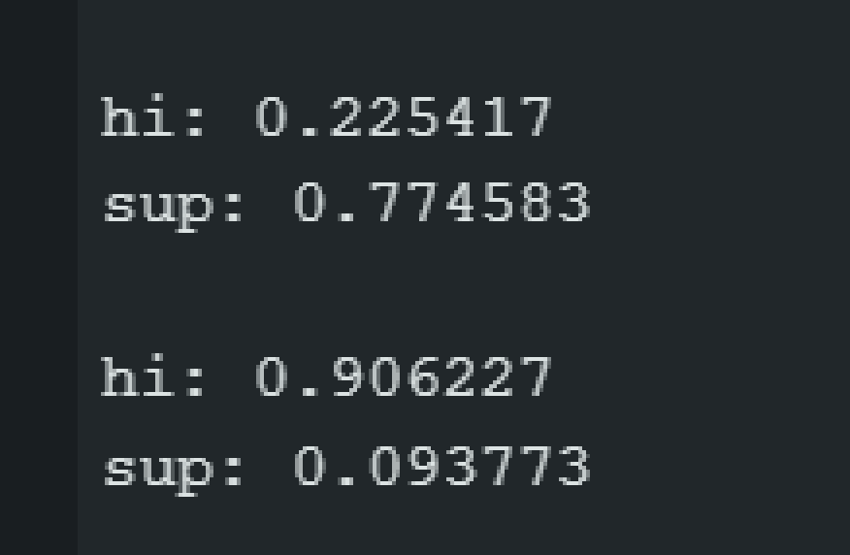
Figure 1. Serial Monitor output showing both ASL gesture classes identified by the deployed model.

Conclusion
After correcting the software issue and keeping the notebook outputs consistent with the classification setup, the model was exported and deployed successfully. The hardware test confirmed that the Arduino implementation can distinguish between the two trained gestures, hi and sup, using the Serial Monitor confidence scores.

