## Lockopedia Page

Lock Name: Master Lock No. 3 (2019 and older)

Producer: Master Lock Co.

Security Level: 3

Body Type: Laminated Steel

Shackle Info:

Material: Hardened Steel

Retaining Mechanism: Ball bearings

Core Info:

Type: 4-pin tumbler

Security Pins: None

Can be removed / modified: No

Non-destructive Vulnerabilities:

Raking

Single-pin Picking

Pick Gun

Bumping

Impression Key

Destructive Vulnerabilities:

Bolt cutters

Grinding

Strikes

**Security Summary**

If somebody is learning lock picking, this is one of the first somebody can practice on and get open consistently. It’s lack of security pins makes this an easy-open for even the newest of beginners using low-skill raking attacks or improvised tools. While somewhat resistant to physical force, this lock will not stand up to any determined or prepared attacker for any significant length of time.

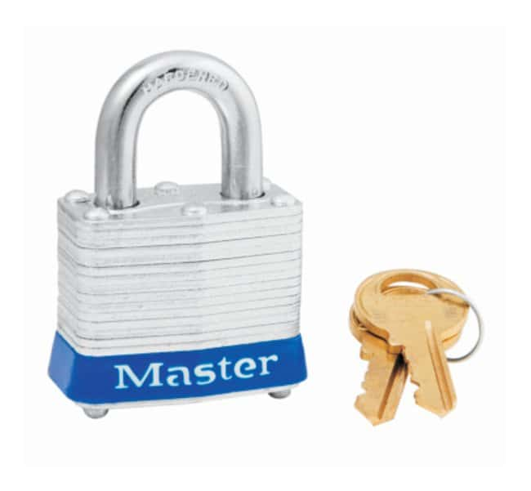

## Delicious Pancakes

Saturday mornings were always pancake days growing up. This recipe for fluffy pancakes has served my family for many years, and I know you’ll love it too!

-*Calanthe M.*

*The following content is copied from* [*allrecipies.com*](https://www.allrecipes.com/recipe/21014/good-old-fashioned-pancakes/)*. Additional formatting has been applied.*

**Ingredients for 8 12-cm wide pancakes**

* 1 ½ cups all-purpose flour
* 3 ½ teaspoons baking powder
* 1 tablespoon white sugar
* ¼ teaspoon salt, or more to taste
* 1 ¼ cups milk
* 3 tablespoons butter, melted
* 1 egg

Directions

1. Sift flour, baking powder, sugar, and salt together in a large bowl. Make a well in the center and add milk, melted butter, and egg; mix until smooth.
2. Heat a lightly oiled griddle or pan over medium-high heat. Pour or scoop the batter onto the griddle, using approximately 1/4 cup for each pancake; cook until bubbles form and the edges are dry, about 2 to 3 minutes. Flip and cook until browned on the other side. Repeat with remaining batter.

About this Recipe

### When to Flip Pancakes

Your pancake will tell you when it's ready to flip. Wait until bubbles start to form on the top and the edges look dry and set. This will usually take about two to three minutes on each side.

## How to Reheat Pancakes

Store leftover pancakes in an airtight container in the fridge for about a week. Refrain from adding toppings (such as syrup) until right before you serve them so the pancakes don't get soggy.

## Can You Save Pancake Batter?

Don't let leftover pancake batter go to waste! Store the batter in an airtight container in the fridge for up to two days. If you plan to keep it longer than that, it's best to freeze the batter.

## Can You Freeze Pancakes?

Yes, you can freeze pancakes and pancake batter.

**· To freeze cooked pancakes**: Allow the pancakes to cool completely, then arrange them in a single layer on a baking sheet (make sure the edges aren't touching). Flash freeze for a few hours or up to overnight. Reheat in an oven set to 350 degrees F until warmed through.  
**· To freeze pancake batter**: Ladle the pancake batter in serving size portions into freezer bags, then wrap the bags in foil. Freeze flat for up to one month. Thaw in the refrigerator overnight.

## Business Home Page

Software Engineered Brilliantly

Software Engineering is craft, but not every Software Engineer is a craftsman/craftswoman. Just like the ability to whittle a stick does not make a master carpenter, knowledge of code does not make an engineer.

The modern corporation cannot afford any compromises in the quality or craftsmanship of key systems, networks, and applications. Good software gives a vital competitive edge, and poor software can cause a maelstrom of problems that could damage, if not ruin, a company’s chances at long-term growth. Trust the software of your business to our expert craftsmen, and see just how easy to use, reliable, expandable, and secure your software can be.

Partners You can Rely On

Day or night, rain or shine, growth or recession, we’ve got your back. Clear communication, effective project planning, flexibility, and business intelligence are only a few of the ways we live to serve! Your success is our success.



Modesty Price, Competitive Quality

Who says you only the big companies deserve all the good stuff? Our negotiable rates and services allow you to tailor our services to meet your needs and budget.

TAM Software Engineering Co.

*The Sky’s the Limit!*

