ML X YARDS NFL Expected Yards Predictor
Thomas Årland 30 October 2026
This report describes a complete machine learning lifecycle for an interactive NFL expected-yards explorer. Five seasons of nflverse play-by-play data are cleaned and split chronologically, candidate regressors are selected on 2024, and the frozen winner is evaluated on 2025. The deployed Streamlit application is useful as an educational exploration tool, but the low test R² and the observational data mean its run-versus-pass comparison must not be interpreted as causal advice.

1 DESCRIBE THE PROBLEM

SCOPE
The project estimates the mean yards gained on an NFL offensive play from information that is available before the snap. A user chooses run or pass/dropback, down, yards to go, field position, score differential, quarter, and time remaining. The website returns the selected prediction, shows the run and pass expectations side by side, and draws the situation on a football field. This is a supervised regression problem because historical plays provide a numerical target, yards gained, for each input situation.
The intended users are football fans and students who want to understand how game context relates to average outcomes. Existing alternatives include box scores, public analytics sites, and manual filtering of play-by-play data. A manual solution could group comparable plays and calculate average yards, but it becomes slow and unstable when several conditions are combined or the group is small. Machine learning can learn smoother relationships across the available situations and provide immediate, reproducible estimates.
The product is educational rather than a commercial decision system. Its practical value comes from accessibility, reproducibility, and honest presentation of uncertainty, not from a claimed profit increase. Success therefore requires that later-season error improves on a simple mean baseline, that the application responds correctly to valid inputs, and that users can inspect the data source, test results, limitations, and model behavior. The tool does not claim to identify the best play call or to replace a coach, because historical play selection is affected by teams, opponents, and strategy.
The end-to-end system has five connected components: (1) nflverse source files and compact, hashed snapshots; (2) a cleaning and feature pipeline that prevents post-play outcome leakage; (3) chronological training, validation, and test splits with candidate comparison and artifact generation; (4) a serialized scikit-learn pipeline loaded by a Streamlit application; and (5) automated tests, analysis charts, documentation, a public repository, and a demonstration video.
A change in the cleaning rules changes the population and all downstream metrics; a feature change requires retraining and interface updates; and an incompatible package change can prevent the serialized model from loading. The included lock file, saved metrics, snapshot hashes, and tests reduce these risks. The project uses Python 3.12, nflreadpy, pandas, scikit-learn, Streamlit, Plotly, joblib, GitHub, and ordinary local CPU resources. A fresh five-season download needs several hundred megabytes of network traffic and approximately 2-4 GB of free memory, while the deployed site only needs the committed model and evaluation artifacts.

METRICS
Validation root mean squared error is the selection metric because squared-error training targets the conditional mean, which matches the meaning of expected yards. Mean absolute error gives a more intuitive typical miss in yards, and R² reports the improvement in squared error relative to a constant prediction. Metrics are reported overall and by play type on the final test season. Software success is assessed by automated checks of data filtering, temporal separation, input validation, serialization, artifact consistency, field coordinates, and Streamlit interactions.
The minimum technical success criterion was to beat the training-mean baseline on 2024 validation RMSE and provide a working, reproducible application. The selected model reduced validation RMSE from 8.594 to 8.441 yards, a 1.78% improvement. This clears the stated technical threshold, but the improvement is modest. No profitability target is appropriate for this non-commercial prototype; equivalent user-facing criteria are successful task completion, understandable output, transparent evidence, and a demonstration that another user can run from the repository.

2 DATA
The source is the nflverse play-by-play collection, loaded through nflreadpy. Regular-season and postseason records from 2021 through 2025 are used. The original input contains 247,284 rows. After excluding irrelevant play types, 175,790 candidate rows remain; removing 1,209 missing, invalid, or overtime rows leaves 174,581 plays. These include 105,928 pass/dropback records and 68,653 runs. Source URLs and SHA-256 fingerprints of the exact selected-column snapshots are recorded with the experiment.
Split | Seasons | Plays | Purpose
Training | 2021-2023 | 105,580 | Fit preprocessing and model parameters
Validation | 2024 | 34,728 | Choose the model configuration
Test | 2025 | 34,273 | Evaluate the frozen winner once

The label is the recorded yards gained on the play, including zero gains and losses. Ground truth comes directly from the play record rather than manual annotation. Consistency is improved by using the published data dictionary, removing duplicate game/play identifiers, validating physical ranges, and applying one cleaning function to every season. Scrambles are reassigned to the pass/dropback category to approximate the intended call, and sacks remain there. That proxy is imperfect for options and broken plays, so the application describes it explicitly.
The model inputs are play choice, down, yards to go, distance from the opponent's end zone, offense score differential, quarter, and seconds remaining in the quarter. Identifiers and season support auditing and splitting but are not predictors. Outcome variables such as completion, air yards, touchdown, post-play score, and recorded gain are excluded from the feature matrix. Special teams, no-play events, kneels, spikes, two-point attempts, overtime, non-finite values, invalid clocks or downs, and physically inconsistent distances or gains are removed. Legitimate negative and long gains are retained.
Play choice is one-hot encoded and numerical inputs are standardized inside a scikit-learn pipeline fitted only on training data. The temporal split is more realistic than a random row split because it evaluates later seasons and keeps each game in one partition. It does not eliminate within-game correlation or distribution shift, so the report makes no claim of statistical significance.
The dataset describes public professional sporting events and contains no private personal records, but ethical risks remain. Team and player quality, injuries, weather, personnel, formation, and play design are absent; observational coaching choices create confounding; and rare situations have limited support. Presenting the comparison as causal would therefore be misleading. The product labels the output as an estimate of mean yardage rather than a guarantee, decision rule, or measure of win probability.

3 MODELING
The experiment compares a mean baseline, Ridge regression with L2 regularization, and two histogram gradient-boosting configurations with 15 or 31 leaves. All candidates use the same preprocessing. The boosting models use squared-error loss, 160 iterations, learning rate 0.06, at least 100 samples per leaf, L2 penalty 10, and random seed 42. The comparison is deliberately small and predefined rather than an exhaustive search. Only 2024 validation RMSE selects the winner, and no 2025 test result is used for tuning.
Candidate | 2024 MAE | 2024 RMSE | 2024 R²
Mean baseline | 5.768 | 8.594 | -0.0001
Ridge | 5.613 | 8.481 | 0.0260
Gradient boosting 15 leaves | 5.578 | 8.441 | 0.0351
Gradient boosting 31 leaves | 5.586 | 8.452 | 0.0327

The 15-leaf gradient-boosting model wins. The larger 31-leaf model achieves a lower training RMSE, 8.299 instead of 8.348, but a slightly worse validation RMSE, which is evidence that training fit alone is not a reliable selection criterion. The winner is kept with the preprocessing and parameters fitted on 2021-2023 rather than refitted on validation data, so validation and test results describe the same fitted pipeline.
2025 test measure | Overall | Run | Pass or dropback
MAE yards | 5.518 | 3.590 | 6.790
RMSE yards | 8.279 | 6.102 | 9.445
R² | 0.0329 | 0.0240 | 0.0198

The test set contains 34,273 plays. Pass/dropback errors are larger because outcomes range from sacks and incompletions to long gains. The overall R² of 0.0329 shows that the available game-state variables explain little of the variation in individual plays. This is the main performance limitation: predictions close to the conditional mean can be sensible expected values while still being poor guesses for a single play.
Permutation importance was computed on 6,000 validation plays with five shuffles per feature. Shuffling field position increased RMSE by about 0.176 yards and shuffling play choice by about 0.133 yards; every other feature increased RMSE by less than 0.010 yards on average. This identifies global model reliance, not causal effects or local explanations. The observed errors and weak R² suggest that future improvement depends more on carefully constructed pre-snap information than on simply increasing model complexity.

4 DEPLOYMENT
The selected pipeline is serialized as a joblib artifact and loaded by a three-tab Streamlit application. It does not retrain when a user changes an input. The Play explorer tab validates the situation, produces automatic predictions for both play choices, and updates the field, line of scrimmage, line to gain or goal, and expected-gain marker. The Model analysis tab reads the generated metrics, predictions, residuals, distributions, error by down, and permutation importance. The Method and sources tab explains the temporal split, data provenance, interpretation, and limitations.
The public repository contains the code, exact compact data snapshots, trained model, evaluation artifacts, dependency files, tests, and reproduction instructions. A captioned 60-second walkthrough demonstrates real browser states and is the submission's deployment evidence. A live Streamlit Community Cloud instance has not been configured, but the repository documents the deployment steps and the application requires no API key or training job when hosted.
Repository: https://github.com/ThomasAarland/MLxYARDS
Demonstration video: docs/demo.mp4 in the repository
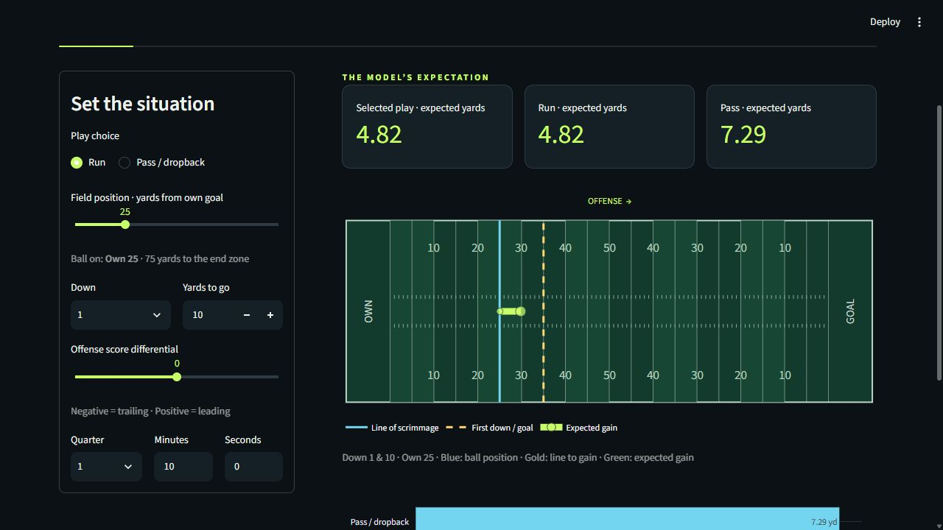
Figure 1. Streamlit play explorer using the saved model artifact.
Monitoring should record input validation failures, inference errors, loading failures, response time, and changes in input distributions. When a new completed season is available, the frozen model should be evaluated before any retraining. A meaningful increase in MAE or RMSE, a package incompatibility, or a systematic change in residuals by play type or down should trigger investigation. Retraining must preserve a new future holdout so that changes inspired by the 2025 results are not evaluated on the same data.
Further work should add leakage-safe historical team strength, formation, weather, personnel, and game-grouped uncertainty estimates; compare temporal cross-validation windows; and evaluate quantile models so the interface can show an outcome range. Expected points or win probability would better represent strategic value than yards alone. Automated tests already cover filtering, temporal separation, invalid inputs, scrambles and sacks, serialization, saved metric consistency, field coordinates, and Streamlit interactions.
OpenAI Codex assisted with implementation, experiment execution, automated tests, interface design, documentation, and report drafting. The named student is responsible for reviewing the submitted work, understanding the model and code, and following the course's rules for AI-assisted work.

5 REFERENCES
Sources were accessed on 26 October 2026 unless otherwise stated.
[1] nflverse data. Play-by-play releases and repository; historical records used for training and evaluation. License: CC BY 4.0. https://github.com/nflverse/nflverse-data
[2] nflreadpy documentation. Python and Polars loading interface used to retrieve nflverse data. https://nflreadpy.nflverse.com/
[3] nflreadr play-by-play dictionary. Definitions used for field position, score margin, clocks, yardage, and play categories. https://nflreadr.nflverse.com/articles/dictionary_pbp.html
[4] scikit-learn documentation. DummyRegressor, Ridge, HistGradientBoostingRegressor, preprocessing pipelines, and permutation importance. https://scikit-learn.org/stable/
[5] Streamlit documentation. Web application framework, testing tools, and Community Cloud deployment guidance. https://docs.streamlit.io/
[6] Plotly Python documentation. Interactive football-field and model-analysis graphics. https://plotly.com/python/
[7] HVL DAT158 assignment 2 brief. Course requirements and machine learning lifecycle structure supplied with the assignment template.
[8] OpenAI Codex. AI-assisted work session used for code, testing, documentation, and report drafting on 26-30 October 2026.

