# 小学期报告

## 网页的大概介绍（孙）

We are now in the era of the Internet, which is a good time. Through Internet technology, everyone can enjoy remote services without leaving home. After the rise of mobile payment, express delivery and delivery services have made our shopping experience more convenient than ever.

That’s the reason why we want to make a web page to display our products. Everyone can via our website to learn more about our company cultures. The idea of our web design is to let every user who enters our website quickly find the most suitable electronic organ from our products through the most concise and direct display.

## 用户登录和注册（孙）

Our login registration system is very easy to use. In order to protect the legitimate rights and interests of users, users can only continue to use the unified user agreement when registering a new account. If you have an account, you can easily log in to your account through your account name and user name, so as to prepare for personal operation later.

If you don't log in to your account, you can preview the product, but that's all. You will not be able to generate your own orders and purchase our products.

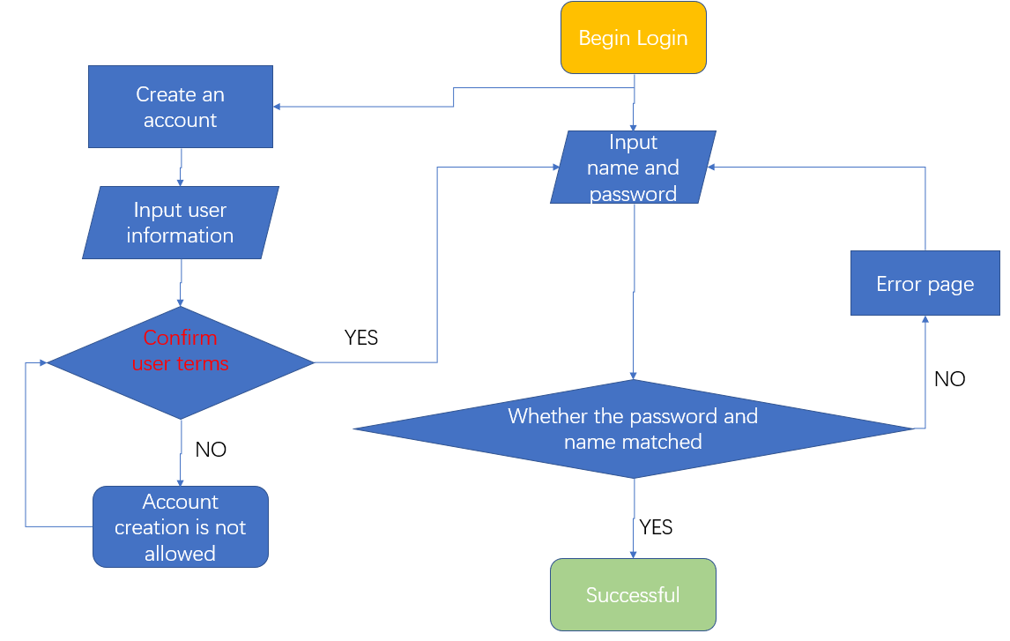

## 商品页面

#### 浏览（孙）

Our products display page consisted of five section.

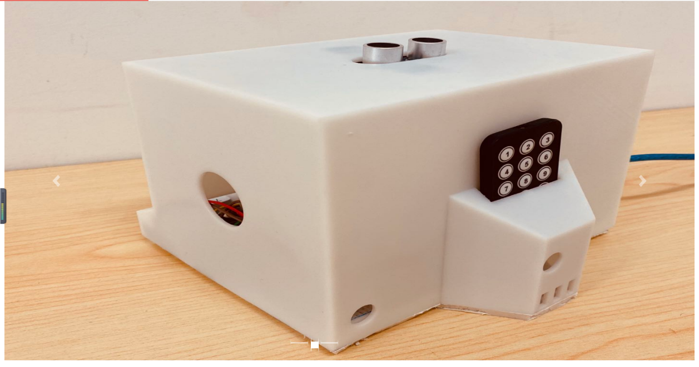The first part is a carousel display page, where our best products will cycle through their own photos from all angles.

The second part, which occupies the entire column on the far right, is our sales list. In this list, we will dynamically display the top 9 most popular items of each month. See if your favorite products have been put on this list.

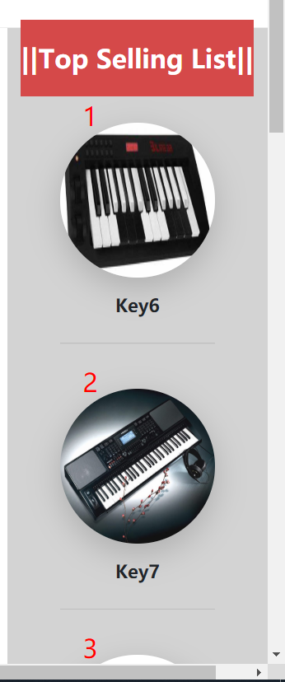

The third part is just below the carousel map, where three items recommended by the store manager are put in the most conspicuous place. If you are still hesitant to buy which product, try the product recommended by the store manager.

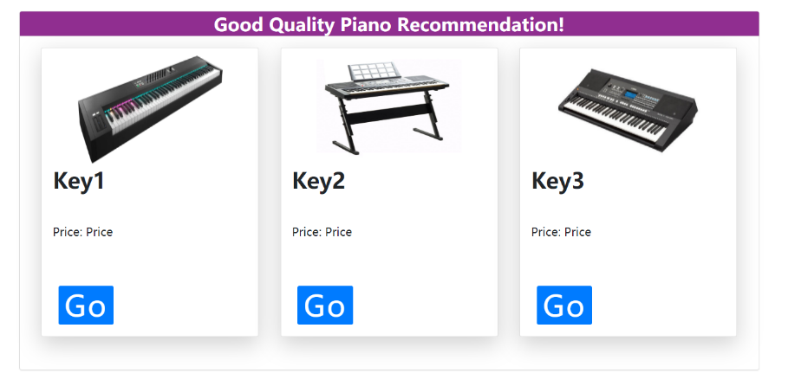

The fourth part is the display of all the products. We divided all the products into five pages. Each page can display six different products at a time.

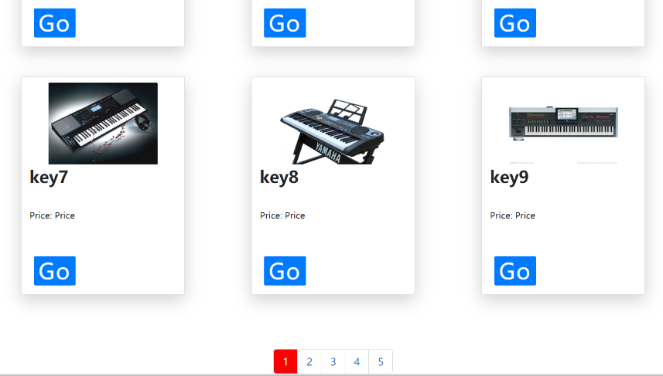

The last part is the commodity inquiry system. Here you can easily find the product you want by the name, color or type of the product.

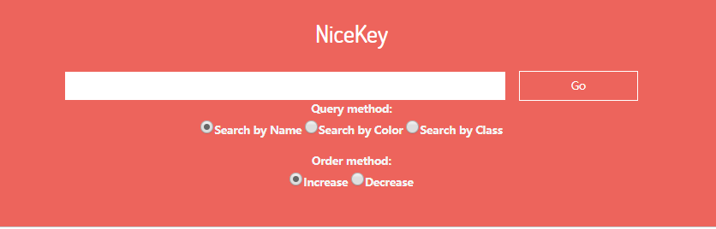

#### 选择和购物车（洛）Go Shopping

Go shopping is the process where customers select products exhibited on our website according to their preferences, add to the shopping cart and finally place the orders for different sellers.

The shopping system combines front end and back end tightly, and the flow path of it is listed below. 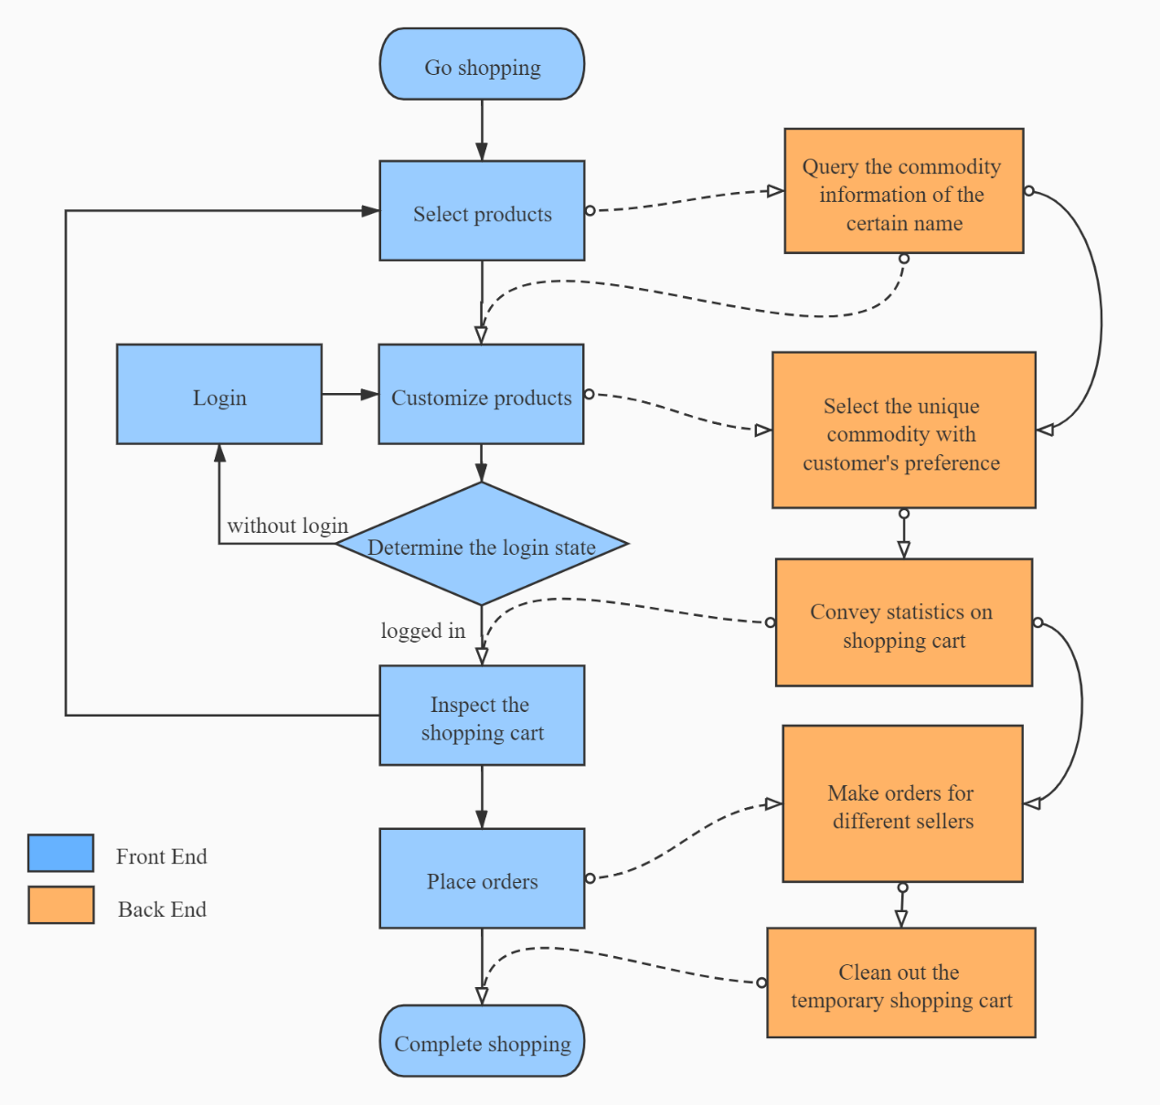

First, when customers decide the products on the display page and click the ***Go*** button of it, the website will skip to the display page especially for concrete information display for single product. The information display is dynamically generated by the user choices on the product, achieved by query product’s name in the database.

（放一张single.jsp展示图）

In this page, customers will view the appearance and features for this product, and can make customizations for the product, such as the purchase amount, the color, etc. Because some versions of certain color are limited, these versions are set on higher prices, and the price label will automatically change in dependency on the changes of the color selection.

（放两张页面图，一张是选了白色，另一张选了黑色）

After customers finish their deciding and click the ***Add to Cart*** button, website will check the login state of them. If customers haven’t login, the add will be cancelled and website will skip to the login page. Else, customers can normally add their products.

（放一张未登陆状态的图，和一张跳转到登陆界面的图）

The choices will be stored in the virtual shopping cart, and the website will skip to the checkout page for customers’ inspection of the cart. The data of choices, like amount and color, are transported by website servlet in the back end. The total price and amount of all the commodities are also calculated and displayed on the page.

（放checkout页面图）

Customers now can place the order, or return to the product display page to look for what else they want. Commodities in the shopping cart will be saved and renewed and re-calculated when customers add new products.

（放选择别的商品，然后跳到购物车的页面，两张图）

When customers click ***Place Order*** button, a popup window will be displayed, informing them of completion of orders. Then the website will skip to the index page automatically, in convenience of continuing to shop.

In the back end, the commodities in the shopping cart will be packaged into orders according to the sellers, and input the records into database. The shopping cart will be also cleaned out, preventing mix of new commodities and old ones.

（放一张提醒图，放数据库记录的两张图来对比更新）

## 4.用户信息展示页面（包括修改信息功能）（唐）

## 5.订单展示（唐&孙）

前端（唐）

后端（孙）

Implementation of database interface：

The following is a schematic diagram of the order query process

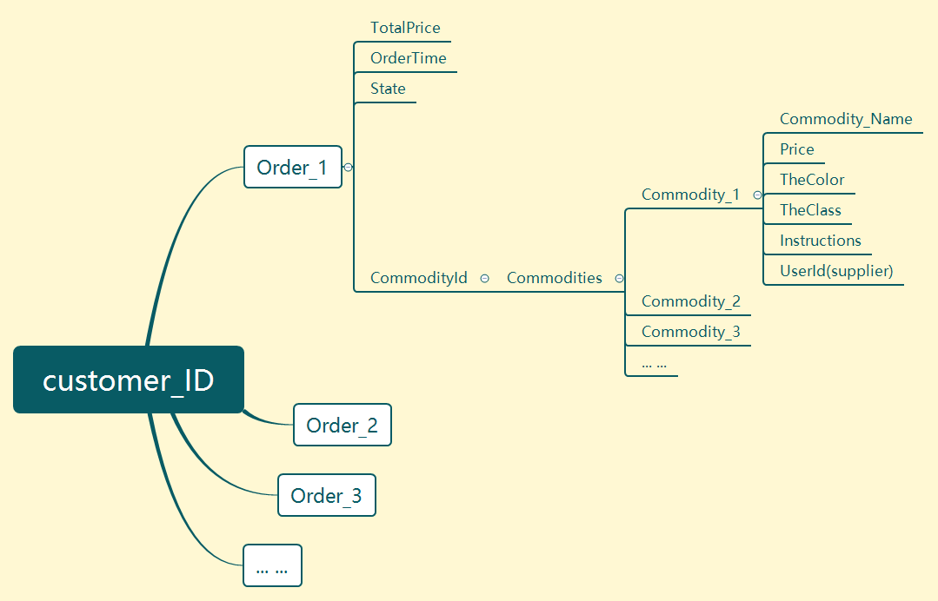

On the realization of order query, we can get all the order data of the user through three nested SQL queries. This data includes the total amount of the order, the generation date, the status, and all the data of all the items in the order.

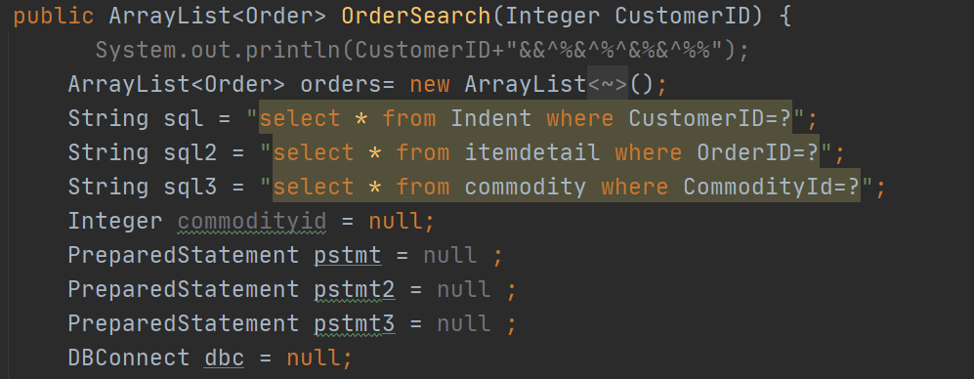

The first cycle gets the basic information of all its orders through the user ID

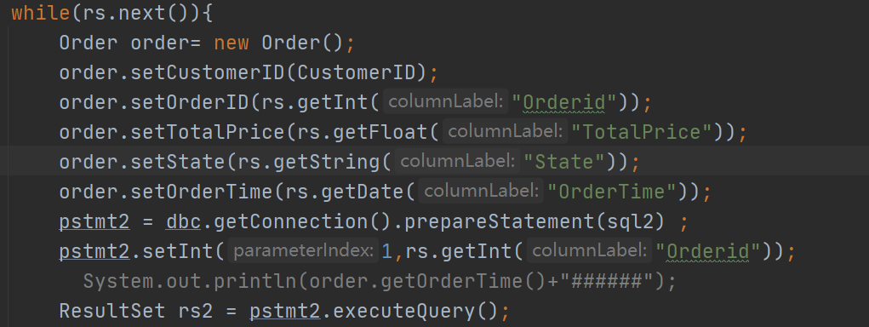

The second cycle gets the ID of all commodities through the ID of one of the order

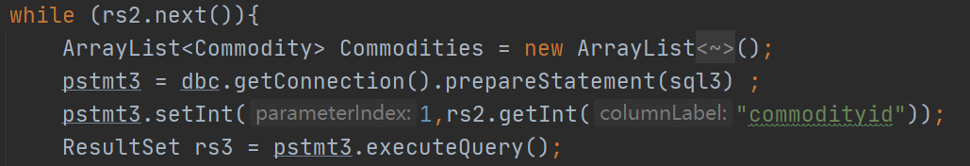

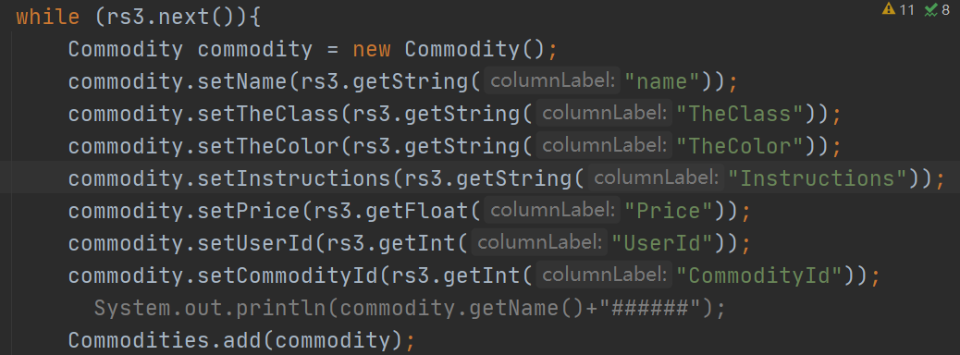The third loop gets all the attributes of each item in turn by its ID.

## 6.关于我们页面（唐）

