MANUAL

1. LOG IN WINDOW

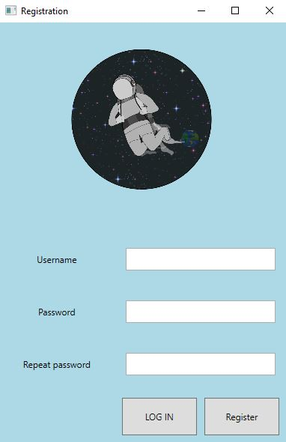

2

3

1

Insert 2(logIN)/3(register) right values into the text boxes [1] and press

Log In[2] or Register[3]

1. MAIN WINDOW