PROJECT NUMBER & NAME:
20025 – CHEOPS2 Low Power
TEST TITLE:
Flow Restrictor Testing
PREPARED BY:
{{ author }} (Testing by {{ testers }})
TEST ARTICLE:  {% for batch in batches %}  {% for part_number in batch.part_numbers %}  {{part_number}}  {% endfor %}  {% endfor %} | MODEL:  FM  FM | SERIAL NUMBER:  {% for batch in batches %}  {{ batch.min_serial }} – {{ batch.max_serial }} ({{ batch.certification }}){% if batch.exclusion %}*{%endif%}  {% endfor %}
ATTACHMENTS:
(Where applicable)

Test results sheet.
{%if frs_excluded%}*{{ exclusion_string }}{%endif%}
Test Description

The following is tested for the flow restrictors:
- Inspection of measurement report for correct flow restrictor dimensioning (orifice, radius and thickness);
- Flow rate through the flow restrictors at various inlet pressures at ambient temperature as per attached test results sheet. Downstream pressure is nominally set to 0.0 barA (vacuum). Mass flow rate backpressure sensitivity is checked at the lowest inlet pressure where indicated. External leakage is checked before each first mass flow rate measurement by pressurizing the set-up to ~2 barA and monitoring of the internal pressure (should remain stable) and flow sensor outputs (should converge to zero) in order not to influence the mass flow rate measurement.

Use test tool 20025.20.AA to interface with flow restrictor parts. Note that tooling is incorrectly labelled/etched (IN/OUT inverted).

Test Set-Up

The schematic representation of the test set-up is given below:

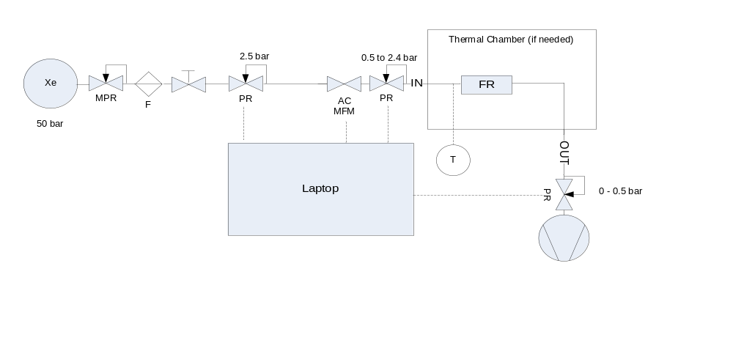
Figure 1: Mass Flow Rate Test Set-Up Schematic

Test Results

The achieved test results for the flow restrictors are given in the tables below:
{% if cathode %}
{{ cathode_table_caption }}
Part Number | SN | Orifice Diameter [mm] M2 | Required Orifice Diameter [mm] | Variation [%] | Compl.  wrt Orifice Diameter [+/- {{ orifice_tolerance }} mm] | Dimension M3  [{{ min_radius }}-{{ max_radius }} mm] | Dimension M1 [{{ nominal_thickness }} +/- {{thickness_tolerance}} mm]
{%for fr in cathode%}
{{fr.drawing}} | {{fr.serial}} | {{fr.orifice_diameter}} | {{ cat_ref }} | {{fr.dev }} | {{fr.c}} | {{fr.radius}} | {{fr.thickness}}
{% endfor %}
* Red highlighted dimensions out of tolerance. Considered acceptable based on flow rate results.

The flow restrictors are not sensitive to outlet pressures < 100 mbar at 0.500 barA inlet pressure.
The flow restrictors are not sensitive to outlet pressures < 300 mbar at 1.000 barA inlet pressure.

The flow results are summarized in annex.

{% endif %}
{% if anode %}

{{ anode_table_caption }}
Part Number | SN | Orifice Diameter [mm] M2 | Required Orifice Diameter [mm] | Variation [%] | Compl.  wrt Orifice Diameter [+/- {{ orifice_tolerance }} mm] | Dimension M3  [{{ min_radius }}-{{ max_radius }} mm] | Dimension M1 [{{ nominal_thickness }} +/- {{thickness_tolerance}} mm]
{%for fr in anode%}
{{fr.drawing}} | {{fr.serial}} | {{fr.orifice_diameter}} | {{ an_ref }} | {{fr.dev }} | {{fr.c}} | {{fr.radius}} | {{fr.thickness}}
{% endfor %}
* Red highlighted dimensions out of tolerance. Considered acceptable based on flow rate results.

The flow restrictors are not sensitive to outlet pressures < 100 mbar at 0.500 barA inlet pressure.
The flow restrictors are not sensitive to outlet pressures < 300 mbar at 1.000 barA inlet pressure.

The flow results are summarized in annex.
{% endif %}

TEST CONDITIONS:
TEMPERATURE (°C) |  | PRESSURE (hPa) | HUMIDITY (%RH)
N/A* |  | N/A | N/A
* As recorded during the test, see annex.

TEST EQUIPMENT
Equipment Description | Model | Serial Number | Equipment Range | Equipment Accuracy  (completed by QA/PA) | Next Calibration Date | Last Calibration Date
{% for c in tools %}
{{c.description}} | {{c.model}} | {{c.serial_number}} | {{c.equipment_range}} | {{c.accuracy}} | {{c.next_calibration_date}} | {{c.last_calibration_date}}
{% endfor %}

{% if cathode %}

Cathode Flow Restrictor Performance Summary Database (Vacuum Outlet pressure):

Cert | Drawing | ID [-] | Thickness [mm] | Orifice Diameter [mm] | Deviation [%] | Radius [mm] | Temperature [degC] | Flow at 1,0 barA [mg/s Xe] | Flow at 1,5 barA [mg/s Xe] | Flow at 2,0 barA [mg/s Xe] | Flow at 2,4 barA [mg/s Xe]
{% for fr in cathode %}
{{fr.certification}} | {{fr.drawing}} | {{fr.serial}} | {{fr.thickness}} | {{fr.orifice_diameter}} | {{fr.dev}} | {{fr.radius}} | {{fr.temperature}} | {{fr.flowrate1}} | {{fr.flowrate15}} | {{fr.flowrate2}} | {{fr.flowrate24}}
{%endfor%}

{{ cathode_plot }}

{{ cathode_figure_caption }}
{% endif %}
{% if anode %}
Anode Flow Restrictor Performance Summary Database (Vacuum Outlet Pressure):

Cert | Drawing | ID [-] | Thickness [mm] | Orifice Diameter [mm] | Deviation [%] | Radius [mm] | Temperature [degC] | Flow at 1,0 barA [mg/s Xe] | Flow at 1,5 barA [mg/s Xe] | Flow at 2,0 barA [mg/s Xe] | Flow at 2,4 barA [mg/s Xe]
{% for fr in anode %}
{{fr.certification}} | {{fr.drawing}} | {{fr.serial}} | {{fr.thickness}} | {{fr.orifice_diameter}} | {{fr.dev}} | {{fr.radius}} | {{fr.temperature}} | {{fr.flowrate1}} | {{fr.flowrate15}} | {{fr.flowrate2}} | {{fr.flowrate24}}
{%endfor%}

{{ anode_plot }}

{{ anode_figure_caption }}
{% endif %}

SIGNATURE PAGE

TEST PERSONNEL
NAME | FUNCTION | SIGNATURE/STAMP
J. Kuiper | System Engineer

REVIEWED BY QA/PA
NAME | SIGNATURE/STAMP | DATE
R. Deijs

FILED BY DOCUMENTATION MANAGEMENT
NAME | SIGNATURE | DATE
L. Karacali

