FAIR code and data to reproduce the results of

‘The geometry of gametic dispersal in a flying mammal’

PCI Evol Biol Open and FAIR code and data policy

As of March 2025, PCI Ecology and PCI Evol Biol are implementing data and code curation for new submissions. Submissions are expected to fill all the criteria listed below to be recommended:

1. Is the data accessible, interoperable, and associated with appropriate metadata and licenses?

2. Is the data as described by the manuscript?

3. Is the code accessible, interoperable, and associated with appropriate metadata and licenses?

4. Does the code match the methods?

5. Does the code run without error?

6. Does running the code with the provided data produce the same results as written in the manuscript?

Self-assessment report

After submission to PCI Evol Biol, we voluntarily committed to submit a FAIR code and data for the research article ‘The geometry of gametic dispersal in a flying mammal, Rhinolophus hipposideros’. A careful audit, code cleaning and a self-assessment of the code and data already deposited in a public institutional repository (https://doi.org/10.57745/GBV4EA) at the date of first submission to PCI Evol Biol revealed difficulties to reproduce the results and minor errors in the results presented in the manuscript.
The code and data were originally produced during the years 2018-2019 and the first draft was written the same years. Since then, only a small part of the code was updated to produce new results, and many values in the first draft remained unchanged. Re-analysing the same data with the legacy code in 2025 was a bit more challenging than expected, due to major changes in package versions, packages not installing anymore and raised many concerns that we addressed thoroughly. Also I improved my coding skills since then. Hence we provide with this report an updated code to improve reproducibility and we suggest the necessary corrections before a further round of review. We apologize for these errors that we overlooked and we acknowledge the data curator, the editor and reviewers for their careful consideration of this report.
(1) One major concern was the inability to reproduce Figure S2 (IBD between colonies). After investigations, the adegenet ‘pairwise.fst’ function used to compute genetic distances between colonies moved to the hierfstat package in ‘genet.dist’ and ‘pairwise.neifst’ functions. We were unable to install the older version of adegenet (< 2.0), hence we updated the code to the new functions. After this, the Fst values substantially changed with the updated code (compare Figures below before and after). It also changed the values of the Mantel test, the parameter (intercept and slope) of the regression line and the mean dispersal distances presented in the manuscript. However, the IBD pattern at fine scale remained and it does not change the interpretations and conclusions in the manuscript. We suggest that this figure and all related values should be updated in a next round of review.

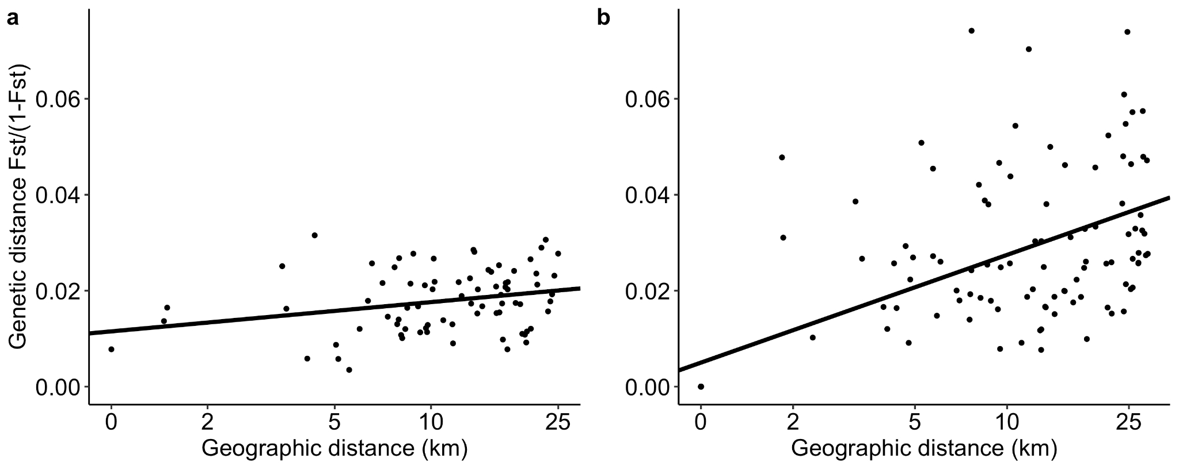Figure 1: Fig S2 (before code update). Isolation-by-distance (IBD) pattern. Relationship between the Euclidean distance in km (logarithmic scale) and the genetic distance FST/(1-FST) (Rousset, 1997). (A) IBD for the adult females of the subset of 13 colonies in Picardy (woodland colonies not genetically isolated). The equation of the regression line is y = 0.003 + 0.006x (Mantel test, 1,000 permutations, p = 0.008). (B) IBD for the adult females of the 19 colonies in Thuringia. The equation of the regression line is y = 0.005 + 0.01x (Mantel test, 1,000 permutations, p < 0.001).
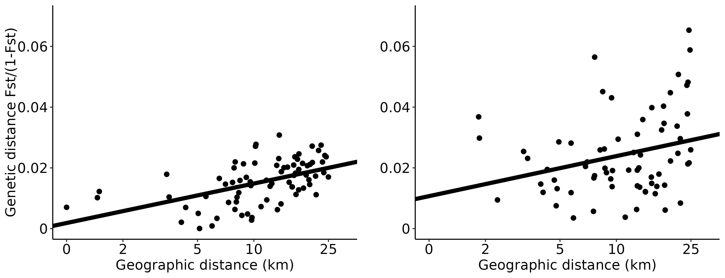Figure 2: Fig S2 (after code update, in red the corrections to the legend). Isolation-by-distance (IBD) pattern. Relationship between the Euclidean distance in km (logarithmic scale) and the genetic distance FST/(1-FST) (Rousset, 1997). Pairwise FST estimated following Weir and Cockerham (1984). (A) IBD for the adult females of the subset of 13 colonies in Picardy (woodland colonies not genetically isolated). The equation of the regression line is y = 0.002 + 0.006x (Mantel test, 1,000 permutations, p < 0.001). (B) IBD for the adult females of the 19 colonies in Thuringia at the same spatial scale as in Picardy (25 km). The equation of the regression line is y = 0.01 + 0.006x (Mantel test, 1,000 permutations, p < 0.001).
(2) We were unable to install the MasterBayes package. It was removed from the CRAN, no conda or docker is available, and manual install failed with our R environment due to compilation errors. MasterBayes is a supplementary analysis, and all the results from the MasterBayes commands were saved and can be analysed. We commented this situation in the README and we apologize for not being able to propose a solution.
(3) After updating R packages to more recent versions (without changing the code), AIC/BIC values changed in Table 1 (model comparison, see the two versions before/after below). Overall, most of the changes are small changes (< 3 in absolute value). They didn’t change the conclusions and the choice of the best model, as the models’ ranks and differences in absolute value are globally conserved.
However, for the Weibull and Gamma functions on the whole distribution (zero + positive distances), the Log-Likelihood drastically improved and these functions seem the best fit. After investigation, it appears that this substantial change is due to a change in the way the functions deal with zero values. Indeed, Weibull and Gamma functions are only defined on strictly positive values. On older versions of the packages, I have the intuition that zero values were not correctly considered, leading to lower log-likelihood. Since the package update, the zero seem to be automatically removed and the fit is done only on positive values. The proof of that is that the log-likelihood value is exactly the same when fitting on zero + positive values than fitting only on positive values. Hence we suggest that keeping in the model comparaison the Weibull and Gamma functions for zero + positive values is confusing and not adequate. We suggest to remove these two lines in a further review and keep the updated values for the rest of the table.

Table 1 before update. The best model based on AICc/BIC and all competing models with ∆ AICc/BIC ≤ 3 are indicated by values in bold.
Model | N parameters | Thuringia AICc | Thuringia BIC | Picardy AICc | Picardy BIC
Gaussian | 2 | 600 | 604 | 675 | 679
Negative Exponential | 1 | 511 | 513 | 636 | 638
Exponential power | 3 | 549 | 555 | 747 | 754
Weibull | 2 | 513 | 517 | 638 | 643
Gamma | 2 | 2758 | 2762 | 2884 | 2889
Binomial + Gaussian | 3 | 499 | 497 | 597 | 596
Binomial + Negative Exponential | 2 | 465 | 465 | 617 | 617
Binomial + Exponential power | 4 | 495 | 491 | 594 | 590
Binomial + Weibull | 3 | 467 | 465 | 590 | 588
Binomial + Gamma | 3 | 467 | 465 | 592 | 590
Binomial + Log-normal | 3 | 464 | 462 | 599 | 598

Table 1 after update. The best model based on AICc/BIC and all competing models with ∆ AICc/BIC ≤ 3 are indicated by values in bold. In red the values that changed.
model | n_parameters | Thuringia_AICc | Thuringia_BIC | Picardy_AICc | Picardy_BIC
Gaussian | 2 | 599 | 604 | 675 | 679
Negative exponential | 1 | 510 | 513 | 636 | 638
Exponential power | 3 | 548 | 555 | 747 | 754
Weibull | 2 | 388 | 392 | 501 | 506
Gamma | 2 | 388 | 392 | 504 | 509
Binomial Gaussian | 3 | 499 | 505 | 597 | 604
Binomial Negative exponential | 2 | 465 | 469 | 617 | 622
Binomial Exponential power | 4 | 480 | 490 | 592 | 603
Binomial Weibull | 3 | 466 | 473 | 589 | 597
Binomial Gamma | 3 | 466 | 473 | 592 | 599
Binomial Log-normal | 3 | 466 | 470 | 601 | 606

(4) I found an error in Fig 3. The histogram of distances was the strictly positive mating dispersal dispersal distances instead of the strictly positive gametic dispersal distances as written in the manuscript. This is now fixed (see the difference before and after). It does not affect much our conclusions because the fitted distribution functions were correct (properly estimated on gametic dispersal distances). The new figure with the correct histogram is more consistent with the fitted distribution functions. The same error applies to Fig S1 and is also fixed. I apologize for this mistake that will be corrected in a next round of review.
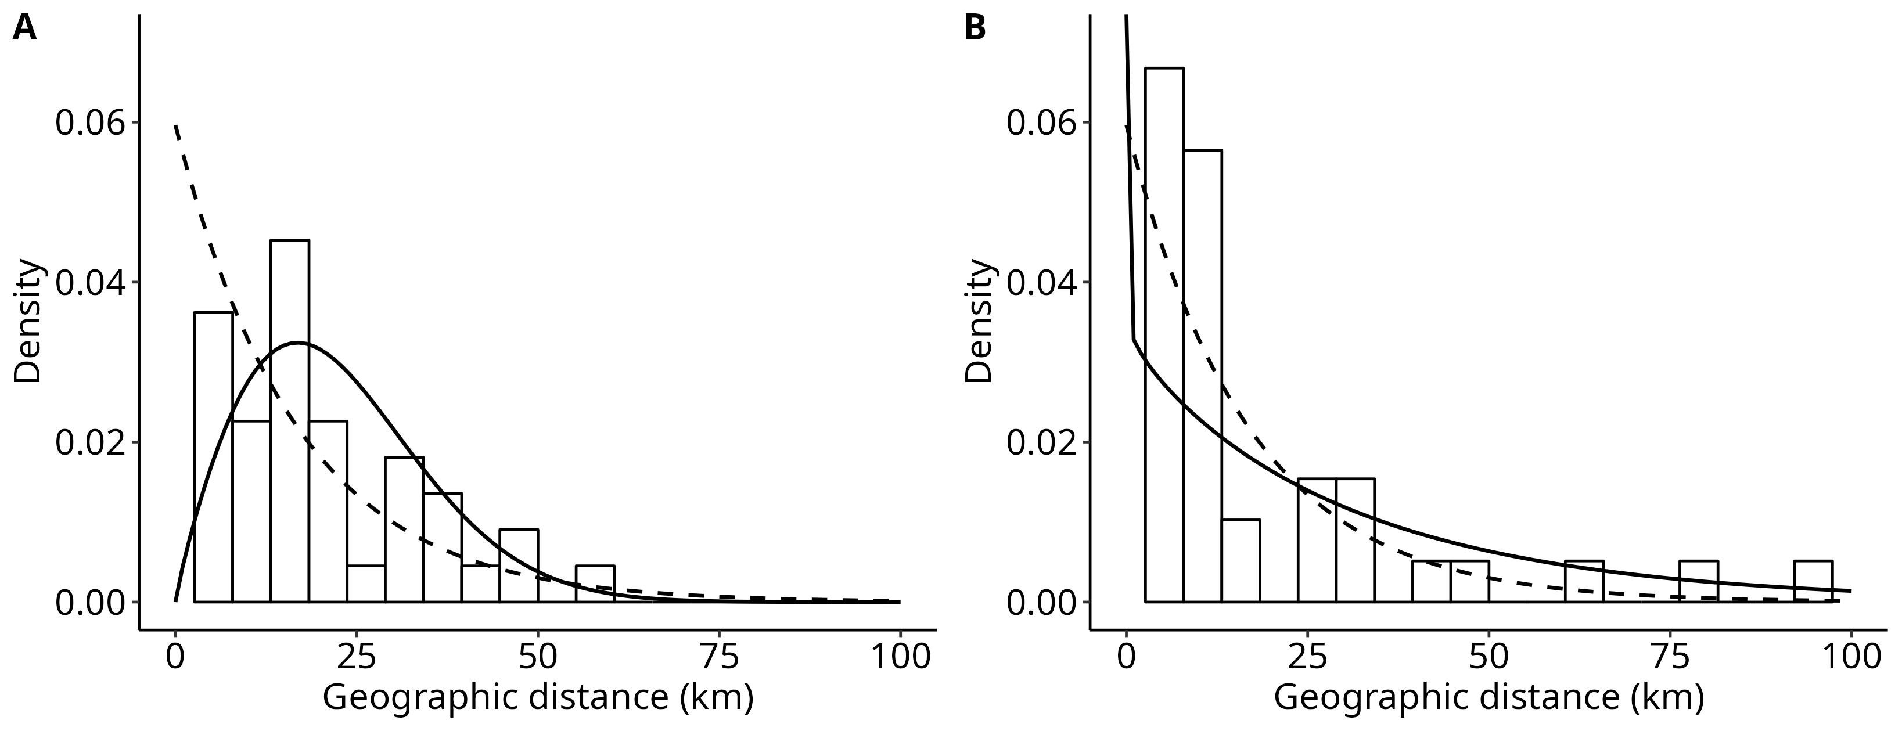Figure 3: Figure 3 before correction.

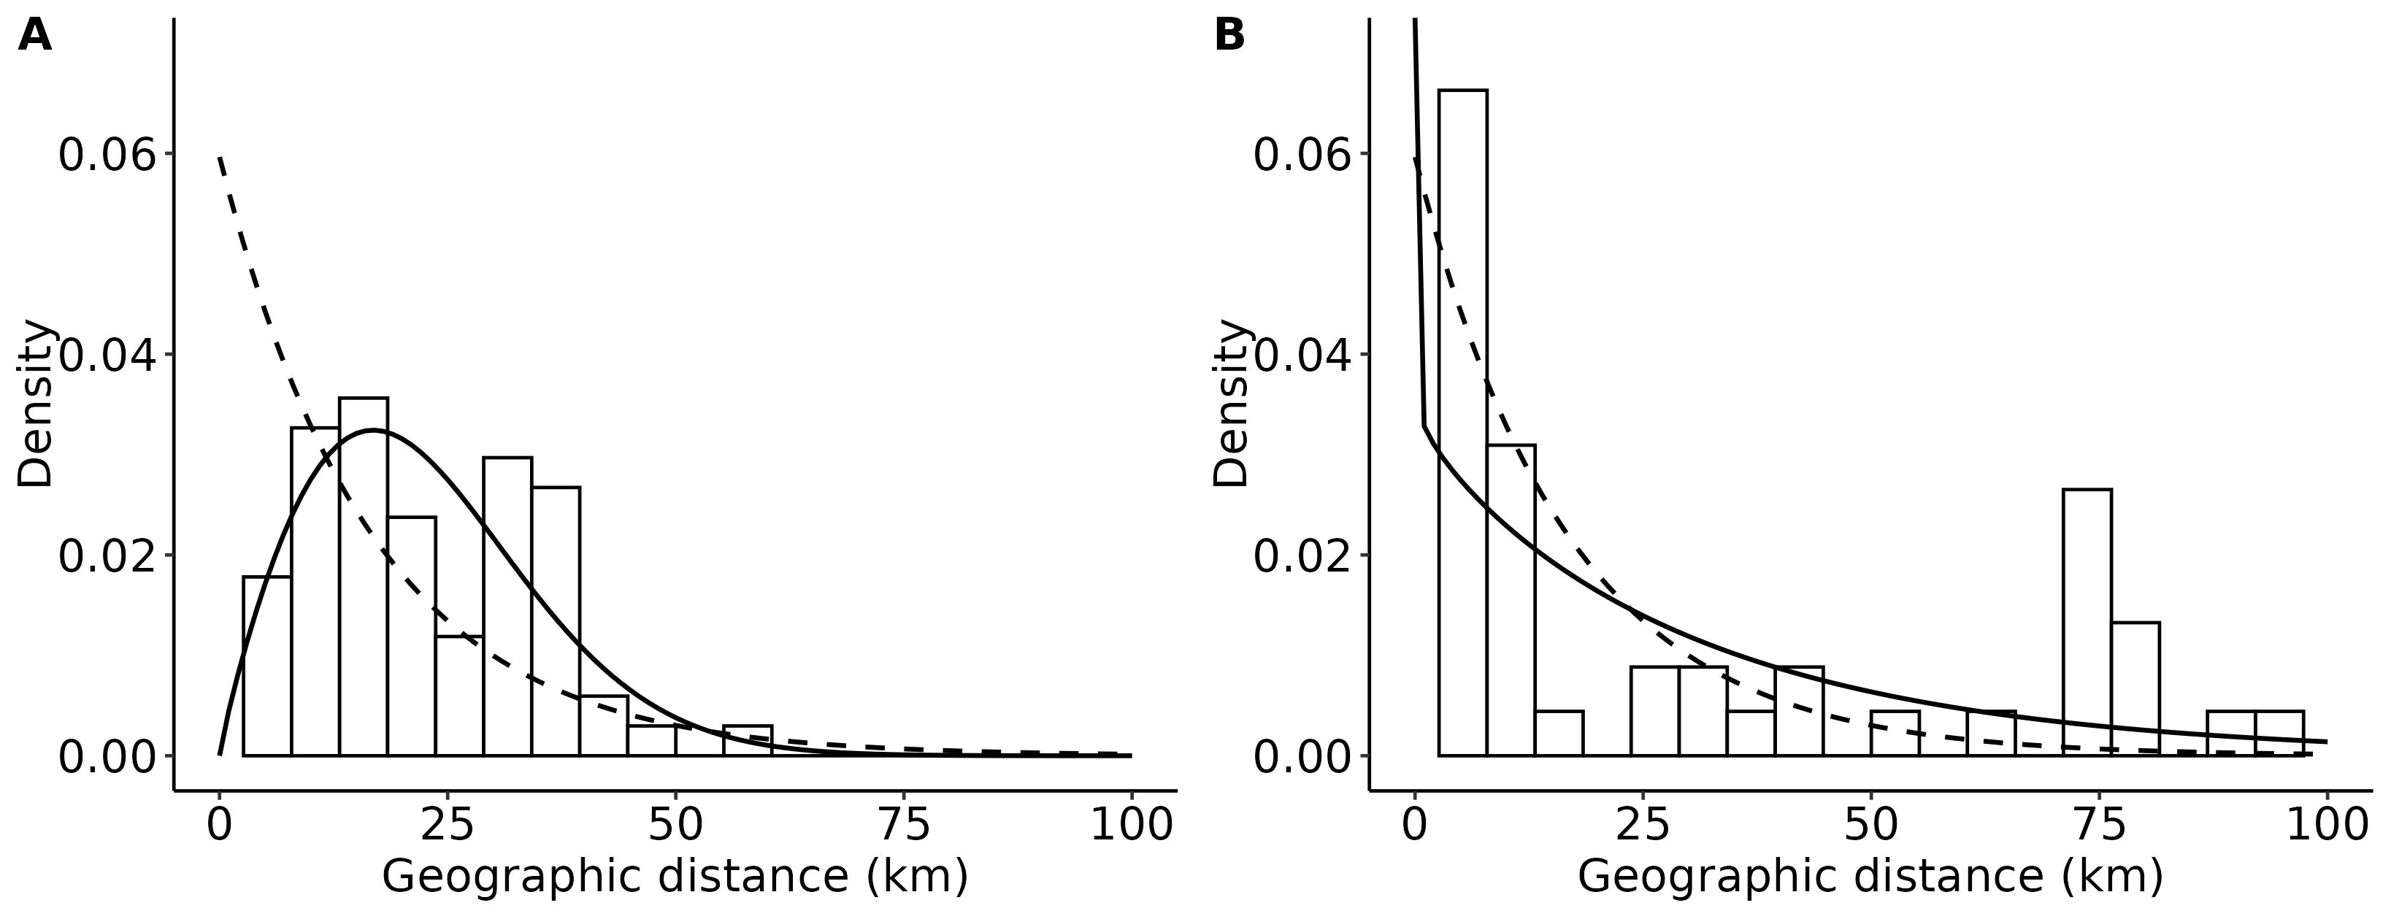Figure 4: Figure 3 after correction.

(5) I found a few inconsistencies between statistics in the manuscript and new statistics after re-running the code. For these minor errors, I do not have any explanation (e.g. copy-paste errors, version changes). I guarantee to the editor that I will thoroughly double check all statistics in a next round of review and tag the new values for the reviewers, based on a script automatically generating all these statistics to avoid further errors. Here is the list of corrections to make:
- Supplementary, l. 22. “the shape parameter (β) for the negative exponential dispersal kernel has been estimated to 0.17 (IC95=[0.12; 0.22]) in France and 0.15 (IC95=[0.12; 0.19]) in Germany.” The actual value in Germany is β = 0.13 [0.11, 0.15]
- l. 78. “19 colonies were sampled over three years (2015-2017) in Thuringia (Germany)”. There was a confusion here, 22 were sampled, one colony was removed because of low sample size (1 individual) and only 19 colonies were kept in the IBD analysis. The summary statistics l. 168-172 described these 22 colonies, not the 19 remaining in the IBD analysis after filtering males and juveniles. We didn’t inferred offspring-father relationship in these two colonies, so none of the downstream analysis is impacted. Consequently, to make it clearer, we must update the l. 78 (“22 colonies”) and rephrase l. 168-172 (it does not change much the values). “In Thuringia (Germany), there were 3,912 unique genotypes with 2,127 potential offspring (54%). 62% of individuals considered as adults were females. 19% of individuals had an incomplete genotype (1 or 2 missing loci). After removing one colony with only one individual, the mean sample size per colony was 186±22 (s.e.m.) for years 2015-2017 (range: 10 to 385).”
- l. 181-182. " From the German dataset with the same procedure, 62 paternities were retained with only 18 fathers over three years." The actual value is 17 fathers.
- l. 187. "The mean mating dispersal distance was 11.3 km (IC95 = [7.4; 15.7], 10,000 bootstraps, n = 82)" The actual value is 10km [7.11, 13.1].
- l. 189. "However, the median distance were much lower in these two populations (7.7 km, IC95 = [5.5, 8.6]" The actual median value is 2.3 km [0, 7.7], which is more consistent with the distribution of distances (~50% of zero distances) and consistent with the median in Thuringia (4.7 [0; 7.8]).
- l. 198. "Z-scores for Thuringia were 0.06 (α) and 0.84 (Log-Likelihood)" The actual value is 0.58 for the Log-Likelihood

In addition to these corrections, we made major improvements to the code to follow the FAIR principles and successfully fulfill the criteria to be recommended in PCI Evol Biol. In order to avoid further errors , I added a script to automatically generate all the values and another script to produce the figures presented in the manuscript. All the code and data are available at a public github repository (https://github.com/ThomasBrazier/inrae-rhino-fair) and I will update the institutional repository (https://doi.org/10.57745/GBV4EA) at the end of the code and data curation step. I added an AGPL v3 LICENSE file and a README file. To ensure the same number for bootstrap and random sampling I set a seed. I created a recipe for a conda virtual environment, including a recipe to get the exact same versions, and I described how to install it. I translated in English all the French comments that I judged important. I did a successful run of the whole updated code (see the README for details).
Finally, I made a careful update of all values in the manuscript. In addition to this new updated version, we will do all the modifications that the data curator and editor will judge necessary before recommendation. I hope this will help us to achieve a higher standard for reproducibility and confidence.
Best regards,
Thomas Brazier

Self assessment after corrections

1. Is the data accessible, interoperable, and associated with appropriate metadata and licenses? Yes. An AGPL v3 license was added. Metadata are described in the INRAE DECOD dataverse (https://doi.org/10.57745/GBV4EA) and will be updated if the submission is finally recommended (doi).

2. Is the data as described by the manuscript? Yes.

3. Is the code accessible, interoperable, and associated with appropriate metadata and licenses? Yes. Code and data are accessible both in github (https://github.com/ThomasBrazier/inrae-rhino-fair) and the INRAE DECOD dataverse (https://doi.org/10.57745/GBV4EA). It is based on R and bash scripts and data in open file format (.csv). A LICENSE file is in the repository.

4. Does the code match the methods? Yes.

5. Does the code run without error? Yes (with exceptions, see the README and report above).

6. Does running the code with the provided data produce the same results as written in the manuscript? Unfortunately not, as described above. I guarantee to the editor that I will revise the whole manuscript with the updated code. I apologize for this, as it would require a new round of review.

