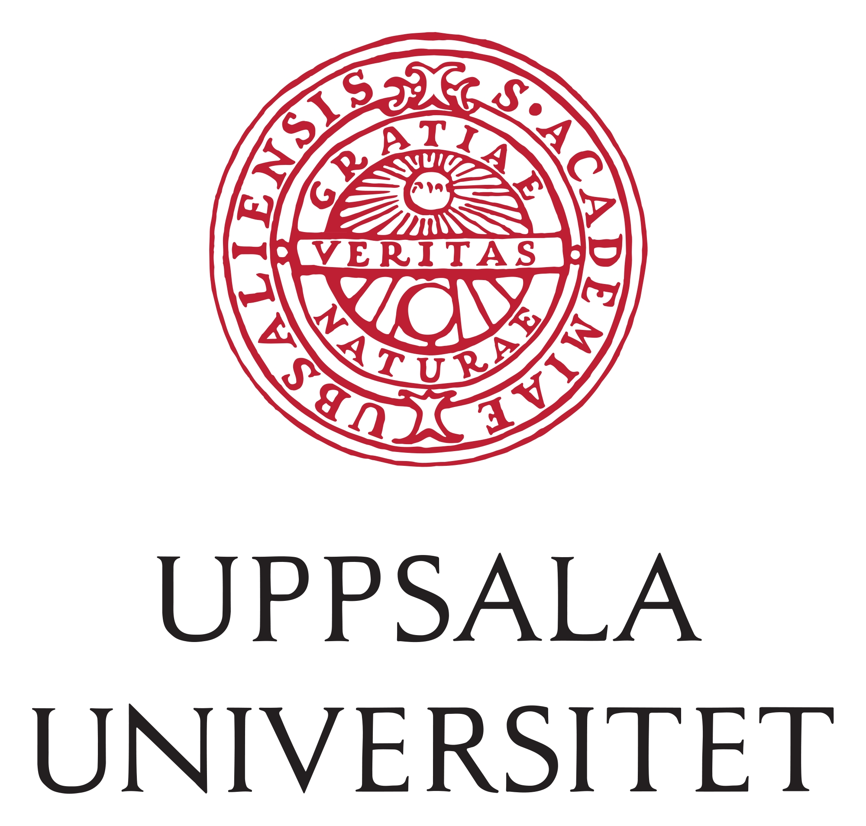






Dr. Thomas Brazier
University of Rennes, CNRS
ECOBIO (Ecosystems, Biodiversity, Evolution)
UMR 6553, Rennes, France
email: thomas.brazier@univ-rennes.fr

Rennes, 11th July 2024

Dear editor,
We are pleased to submit the manuscript “Mating system and the evolution of recombination rates in seed plants” for consideration for publication as a Research Article in the special issue Sex Unfolded of the Journal of Evolutionary Biology.
Across eukaryote species, recombination rates are strongly constrained by chromosome size. . Despite this major genomic determinant of recombination rates, it has rarely been addressed how recombination rates could evolve at a large phylogenetic scale. Recombination rates may evolve between species differing by their life history traits, independently of chromosome size. A longstanding advantage of recombination is to produce genetic shuffling and increase the efficiency of selection. In particular, indirect selection towards higher recombination rates is theoretically expected in selfing species because high selfing rates strongly reduce the efficiency of selection. Genetic maps are increasingly available and mating systems have been extensively described in plant species, allowing us to test the impact of the mating system on the evolution of recombination rates across seed plants.
By leveraging a large dataset with genetic maps, genome sizes, chromosome numbers and life history traits (including the mating system) in 200 seed plant species, we here report a comparative study to test for the impact of the mating system on the evolution of recombination rates. After controlling for the chromosome size effect, the phylogeny and map quality, we found a joint positive effect of the mating system and longevity on recombination rates, with higher recombination rates in mixed-mating and selfing species. We also found that mixed-mating and selfing species had a significantly higher number of crossovers in larger chromosomes than outcrossing species, suggesting selection for relaxed crossover interference in these former species. Our results point to the mating system as an important factor potentially shaping the evolution of recombination despite the strong constraints imposed on the number of crossovers per chromosome.

Given the fundamental role of recombination in many fields of evolutionary biology, ranging from evolutionary genetics and genomics to life histories, we believe that our manuscript fits well with the multidisciplinary scope and broad evolutionary readership of the Journal of Evolutionary Biology and fits well with the special issue Sex unfolded.
We thank you for your consideration,
Sincerely yours,

Thomas Brazier, Roman Stetsenko, Denis Roze and Sylvain Glémin

