Greaves Marine Surveyors, LLC
___________________________________________
6 Whittemore Place
Westbrook, CT 06498
Tel: 860 399-6966

4/18/2021

Mr. David Steinhardt
P.O. Box 8983
New Haven, CT 06532

INSURANCE CONDITION SURVEY REPORT ON 35' KETCH
"ADA"

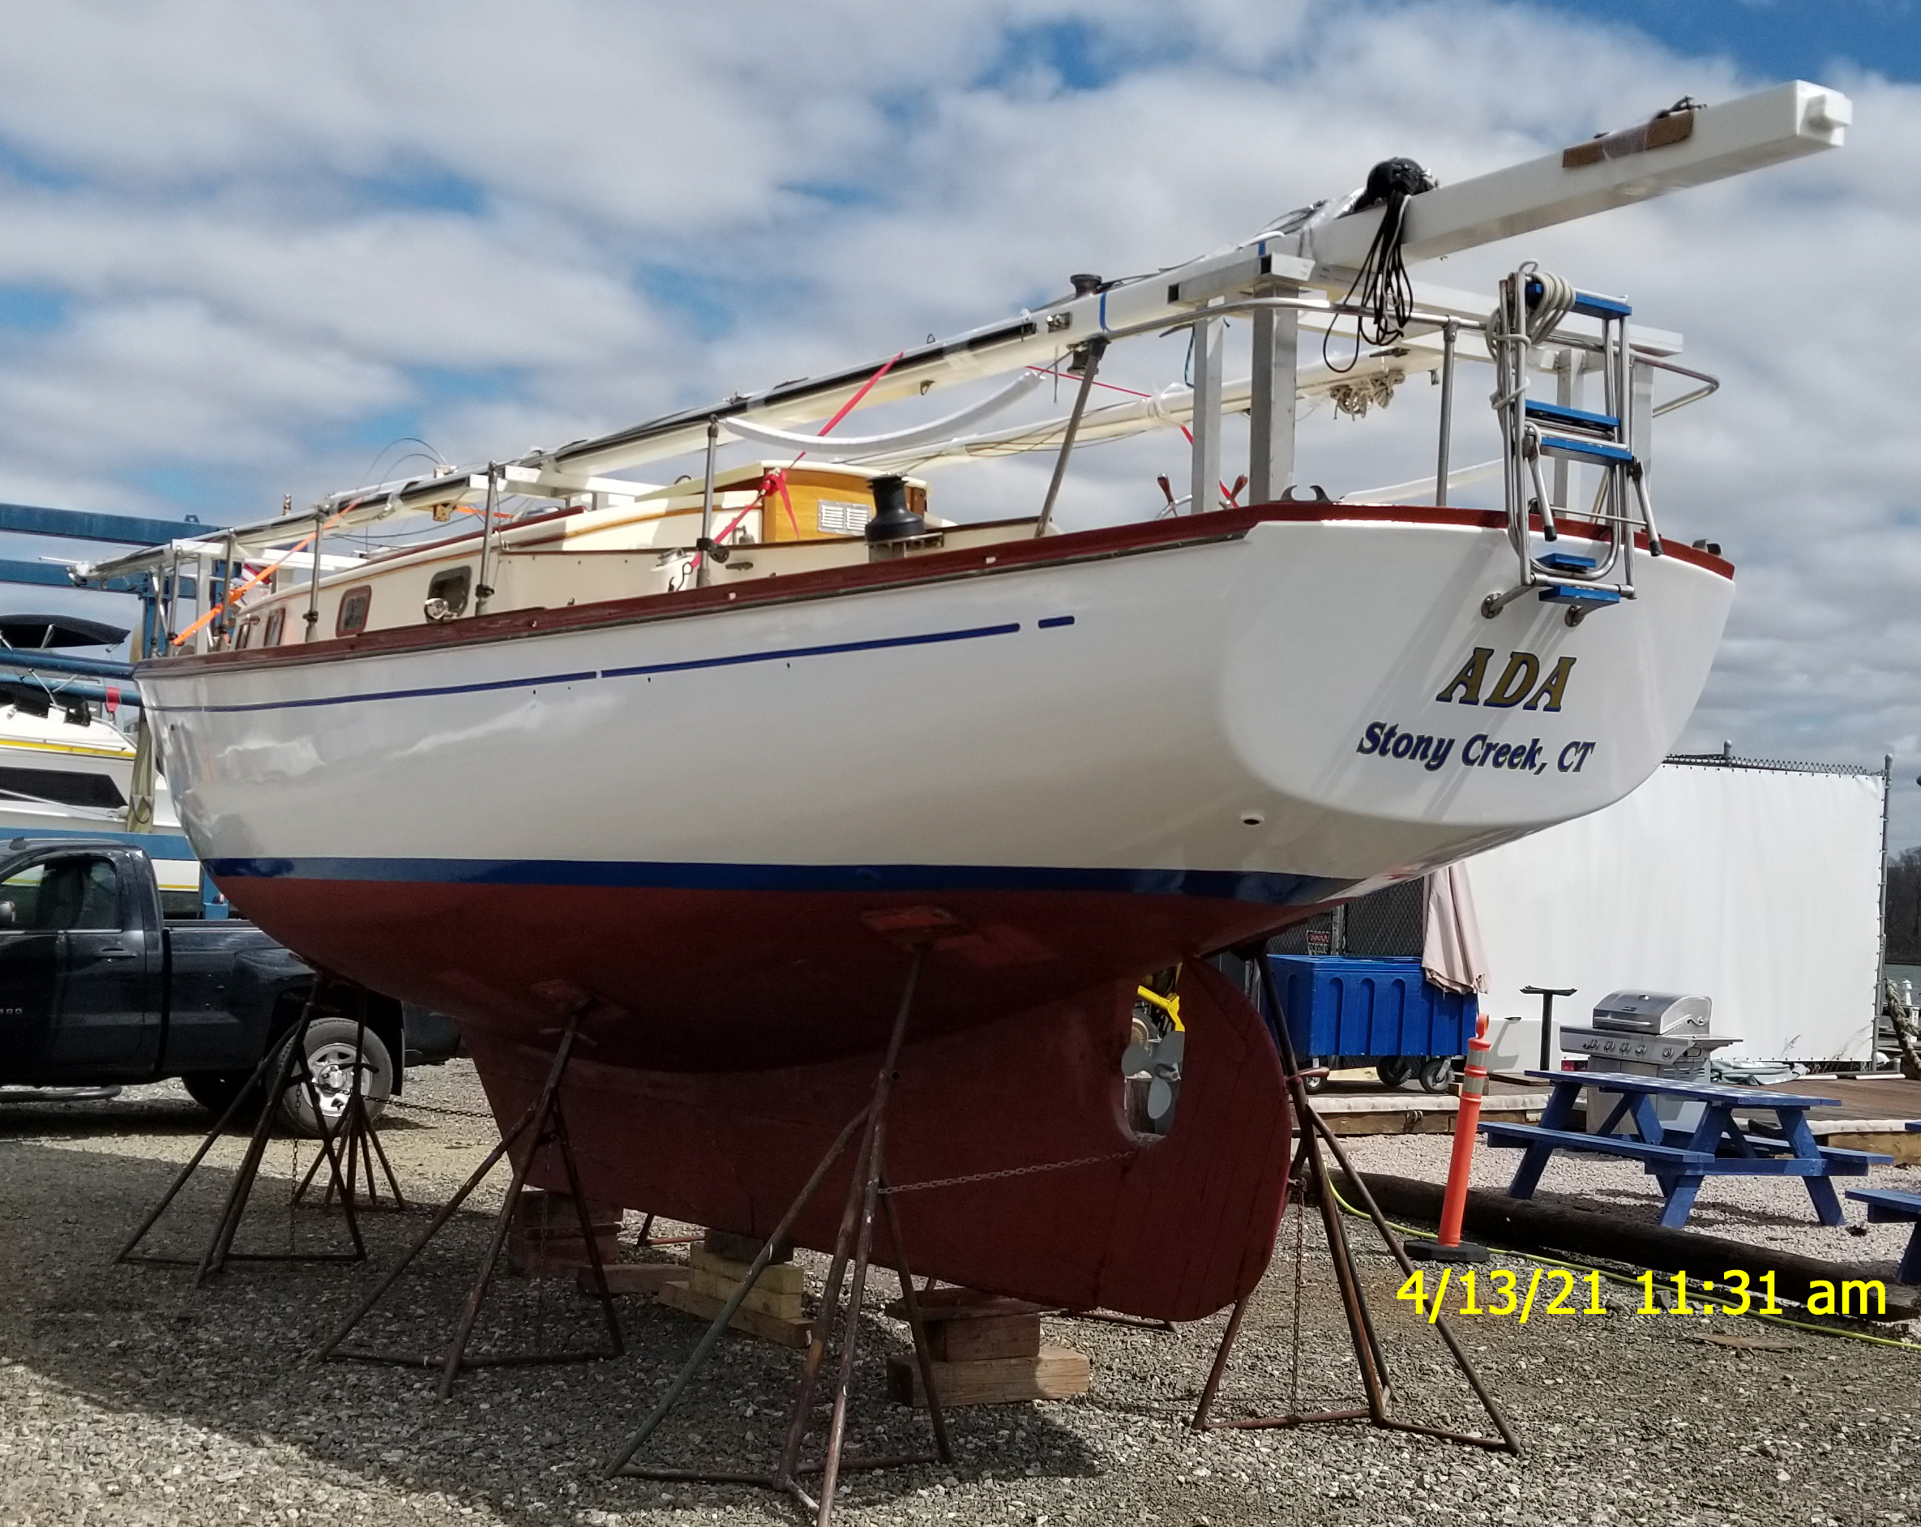

VESSEL: “ADA” DOC/REG #:CT 9583 AP
BUILDER: Dickerson HULL #59
MODEL: Ketch Rig YEAR: 1967
TYPE: Auxiliary Sail DESIGNER: Ernest Tucker
RIG: Wood-Aluminum Single Spreader HULL MAT: Wood
POWER: Single Diesel LOA: 35’
CRUISE SPD: 4 Knots BEAM: 10’4”
MAX SPD: 7 knots DRAFT: 4'
FUEL CAP: 25 US gallons LWL: 26’8”
WTR CAP: 25 US gallons WT/DISP: 12,000 lbs.

GENERAL
The vessel "ADA” is a 35’ single engine Ketch built in 1967 by Dickerson Boat Builders Inc., Cambridge, MD 21673. Registration #CT9583 AP as seen. Hull #59. Construction is 1" Philippine strip plank mahogany over steam bent white oak frames sided 11/4"X13/4" on 9" centers. All fastenings are bronze. Ballast is exterior cast lead with 3/4" bronze keel bolts. Decks are plywood with fiberglass finish over cambered deck beams sided 2"x11/4" on 9" centers. Topsides paint is new white finish. bottom; red and decks are off white. Cockpit is aft with 24" stainless steel wheel steering. Design is Ketch rig with full keel, rudder attached and aft cockpit. The approximate dimensions are LOA-35'. Beam-10’4”. Draft-4'. Displacement 12,000 lbs. Bottom and topsides are coated with epoxy finish under paint finish.

TOPSIDES
Topsides showing new paint finish at this time. Topsides were sounded out with a phonelic hammer with no delaminations noted. All mahogany planking found fair and secure to frames. Hull to deck joint found tight with no movement noted. Hull to deck connection is by inner sheer clamp mechanically fastened from deck and hull. All topside planking is carvel Philippine mahogany. All fastenings are bronze. Stem and horn timbers are white oak along with dead wood and keelson.

BOTTOM
Bottom was inspected on the hard on interior and exterior. There was no evidence of any major grounding or other impact damage noted. All underwater thruhull fittings are the approved bronze ball valve type. All found tight and secure to hull. All seacocks found to operate properly. Moisture content meter reading of bottom planking proved good with readings of 18 on a scale of 5 - 30 with use of a Tramex Skipper moisture meter. Bottom planking was sounded out with a metal hammer with no delaminations noted. Hull to keel joint found tight with no movement noted. All bottom fastenings are new bronze 2" #14. Bottom planking is Philippine mahogany carvel strip planking. Shaft is 1” bronze and appeared straight on dial indicator. Prop is 3-blade bronze 14”DX9”P and appears in good condition and secured in aperture. Shaft log found in good condition with new cutlass bearing. Rudder is oak and found secure in rudder port. Rudder to keel alignment proved correct. Rudder pintles and gudgeons found in good condition. Hull potential meter readings for stray current corrosion was good at .50. Vessel is bonded for lightning protection from shrouds to keel bolts. Bottom paint is new over epoxy coating. New zincs noted on bottom at this time.

DECKS
Decks are plywood with fiberglass finish. Cabin top is plywood over cambered deck beams with fiberglass finish. Overall condition found good with no delaminations noted. All fittings on deck found tight and secure including rails, handrails, cleats and chocks. Steering is single position Edson with binnacle and 24" stainless steel wheel and found to operate properly. Cockpit area found in good condition along with cockpit hatches. Cabin top hatches found secure with proper securing dogs. Main mast is keel stepped. There were no stress signs evident at mast steps or at chain plates. Chain plates are bronze steel through bolted to interior hull grids. Lifelines are single through stainless steel stanchions to bow and stern rails. Stem head fitting is bronze. Companionway entrance is fitted with teak slides and sea hood over sliding hatch. All deck winches found secure with through bolting. Main sheet traveler found secure on bridge deck. Mizzen mast is deck stepped in cockpit. Step found secure. Cockpit coamings are mahogany with varnish finish. Cockpit sole is teak. Toe rails are painted Mahogany.

INTERIOR
Interior was inspected only where accessible. Interior in general found clean with good housekeeping evident. Interior finish is mahogany and plywood with paint and varnish finish. Cabin sole is wood on floor timbers. All interior plywood bulkheads, stringers and floor timbers were found to be properly attached to hull with no delaminations noted. All doors, drawers and lockers found to fit properly. Toilet is Raritan electric flush with holding tank, macerator and overboard discharge. Cooking is by Coleman stove. There were no water leaks evident around hatches or cabin windows. Interior upholstery found in good condition. All cabin sole hatches found to open properly. Companion way is fitted with sliding hatch, dodger and weather board. Icebox found in good condition. Cabin port lights are bronze. Keel bolts are bronze and found in good condition and secured on interior. A number of interior frames showing laminated sister frames with new fastenings.

ENGINE
Auxiliary power is furnished by a 4107AQ 4 cylinder Westerbeke diesel engine. HP is 40. Engine serial #107U3345. Engine cooling is by fresh water. Engine installations appear satisfactory. Beds and mounts found in good condition. Hours on unit are 190 approximately. Exhaust is rubber to fiberglass water lift muffler. Engine gauges are located in cockpit. Transmission is Paragon with 1.1 reduction. Shaft log stuffing box is the adjustable type and found in good condition. Engine is fitted with alarm and emergency shutdown. Shift and throttle are Morse controls and found to operate properly.

FIRE EXTINGUISHERS
Two (2) hand held approved portable ABC dry chemical units noted.

ELECTRICAL
Vessels system is 12-volt. Circuit protection is by panel with breaker switches and battery switch. All wiring is thermo plastic and found in good condition and properly secured. Four 12-volt batteries are provided. All batteries found properly secured in acid proof containers. Battery charging is by alternator on engine. Navigation lights meet International Motor Boat Act requirements. Vessel is bonded for lightning protection through shrouds to keel.

FUEL SYSTEM
One rectangular Monel fuel tank is provided and secured aft of engine. Capacity is 25 US gallons approximately. Installation conforms to ABYC standards. Feed lines are the approved type with Racor fuel filter and shut offs noted. Tank material is Monel tested to 4 psi by manufacturer. Fill is located in cockpit deck and properly marked.

VENTILATION
Ventilation conforms to Coast Guard standard requirements.

GROUND TACKLE
CQR 35lb anchor 5/16” chain and 3/4" rode
(2) Danforth spare anchors 28lb.

BILGE PUMPS
(2) Rule 800 and 1100 GPH electric auto bilge pump
Whale manual gusher mounted pump
Rule high water alarm

SAILS
- (2) Mainsails in new condition
- (2) Genoas in new condition
- Mizzen in new condition
- (2) Mizzen staysails.
- Storm jib
- Mainsail and mizzen covers

SPARS
- Mast is box section Sitka spruce varnished.
- Mizzen is aluminum painted white
- Booms are Sitka spruce and found in good condition
- All standing rigging is 1”x19” stainless steel with bronze turnbuckles
- Turnbuckles and swage fittings found in good condition
Rig was inspected off the vessel
- Spreaders are aluminum and varnished Sitka spruce.
- All mast tangs are bronze and found secure.
- All running rigging found in good condition
- Headstay is fitted with Harken roller furling

WINCHES
Winches are new Lewmar EVO 45ST
All deck winches found secure and operating freely

ELECTRONICS
Cobra radio
Ritchie compass
Raymarine GPS
Fusion stereo
Solar panel
Perko battery switch
Barometer

MISCELLANEOUS
Oil and Marpole discharge cards
Lines and fenders
Life preservers
Life ring
Horn, bell
Orion Flares 2022
Wind vane
Dodger
Honda 15 HP BF15D outboard motor
Livingston hard bottom tender 12' HIN #HCT75627E415
Hand spot light
Emergency tiller
First aid kit

RECOMMENDATIONS
- Add Carbon Monoxide detector to vessels cabin ABYC A24.7,12.
- Test and tag all fire extinguishers ABYC A-4,Ap,5d

MARINE COVERAGE
The vessel "ADA" was found to be in overall good condition and well maintained to good boat yard standards at this time and is considered satisfactory for fire and marine coverage. The vessel conforms to the usual designs and specifications of its type and appears to be well suited for the service intended.

This surveyor having completed a survey of the vessel and having careful and due regard for the condition of the vessel as evidenced by survey and as otherwise noted while attending onboard, and comparing the sum of these qualities, conditions and equipment with those of other and similar vessels and using the skill and experience of many years, together with the constant and current knowledge of the value of such vessels has determined that its present day value on 4/13/2021 is $45,000.00 including all equipment. Replacement value of the vessel new today would be around $250,000.00.

