Chapter 7 Task 3

Assume that you have completed three months of the project. The BAC was $120000 for the six-month project. You can also make the following assumptions:

PV = $60000

EV = $55000

AC = $50000

1. What is the cost variance, schedule variance, cost performance index (CPI) and schedule performance index (SPI) for this project?

Cost Variance (CV) = Earned Value (EV) − Actual Cost (AC)

= 55000– 50000

= $5000

Schedule Variance (SV) = Earned Value (EV) − Planned Value (PV)

= 55000– 60000

= -$5000

CPI = Earned Value (EV) ⁄ Actual Cost (AC)

= 55000/ 50000

= 1.1

SPI = Earned Value (EV) ⁄ Planned Value (PV)

= 55000/ 60000

= 0.91

1. How is the project doing? Is it ahead of schedule or behind schedule? Is it under budget or over budget?

SV % = Schedule Variance (SV) ⁄ Planned Value (PV) \* 100

= -5000 / 60000\* 100

= −8.333 %

According to the schedule variance percentage of the project calculated above the project would be regarded as behind schedule because the result is negative.

CV % = Cost Variance (CV) ⁄ Earned Value (EV)

= 5000 / 55000\* 100

= 9.091%

According to the cost variance percentage calculated above the project would be regarded as under budget-budget because the result is positive.

As a summary, the project is moving slowly because it is both behind schedule and under-budget. More money could be spent on getting more things done

1. Use the CPI to calculate the estimate at completion (EAC) for this project. Is the project performing better or worse than planned?

Estimate at completion (EAC) = Budget at completion (BAC) / Cost performance index (CPI)

= 120000 / 1.1

= 109090.91

1. Use the SPI to estimate how long it will take to finish the project. Is the project performing better or worse than planned

Since the calculated SPI is below 1 the project is performing worse than planned. If it continues at its current level of efficiency then the project will take longer than expected to complete. The timespan of the project is six months. Therefore:

1. Sketch an earned value chart using the information from your answers to part a through d. Use Figure 7-6 as a guide.

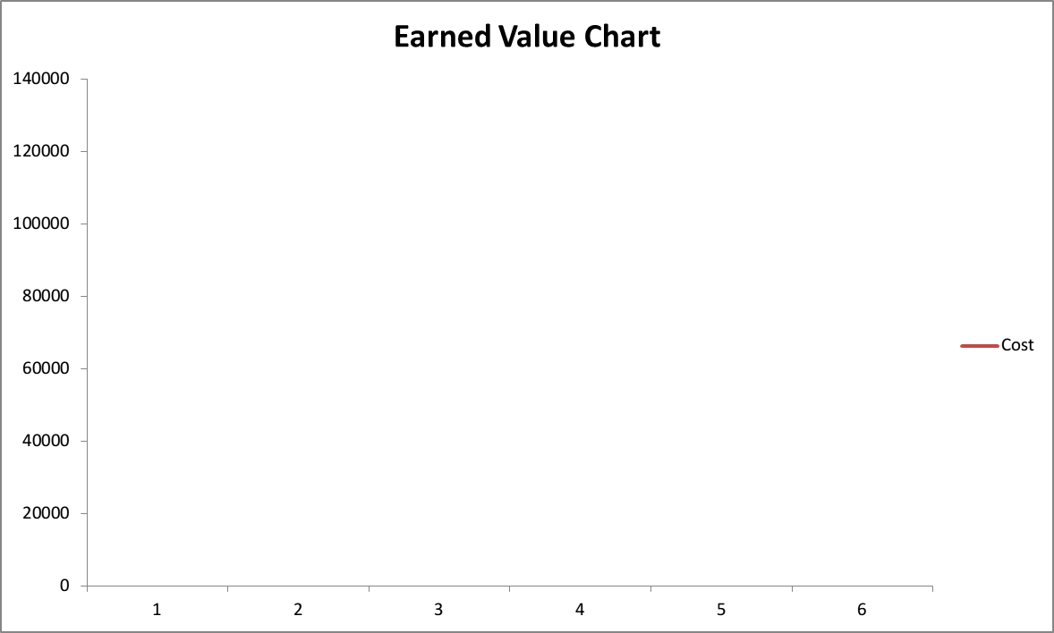

Actual Cost

Planned Value

Earned Value

Budget at completion (BAC)