**Sine test**

**1. Test parameters**

Table 1 - Test parameters

|  |  |
| --- | --- |
| **Parameter** | **Value** |
| Object | Example 2 |
| Test | Sine_Test |
| Date | 17.08.2021 |
| Time | 12:46 PM |

**2. Shaker parameters**

Table 2 - Shaker parameters

|  |  |
| --- | --- |
| **Parameter** | **Value** |
| Shaker | ET-126A |
| Maximum payload weight, kg | 0.50 |
| The supplied mass of the moving coil, kg | 0.16 |
| Working frequency range | 1.0000 - 8500.0000 Hz |
| Force, N | 57.00 |
| Maximum velocity, m/s | 3.05 |
| Maximum displacement, mm | 9.50(max) : 9.50(min) |
| Maximum acceleration, g | 100.00 |
| Maximum driving voltage, V | 10.00 |

**3. Configuration of channels**

**Channels configuration data:**

**Name:**

C:\RULA\Chans\test alliantech.chnx

**Maximum driving voltage, V:**

10.00

Table 3 - Channels data

|  |  |  |  |  |  |  |
| --- | --- | --- | --- | --- | --- | --- |
| **Channel** | **Sensitivity** | **Units** | **Mode** | **Coefficient** | **Serial number** | **Check date** |
| 1 | 10.00 | mV/g | Control | 1.00 | 001 | 6/23/2021 |
| 2 | 100.00 | mV/g | Measuring | 1.00 |  | 7/10/2013 |
| 3 | 10.00 | mV/g | Measuring | 1.00 |  | 7/10/2013 |
| 4 | 10.00 | mV/g | Measuring | 1.00 | 3127 | 10/14/2020 |

The final response is formed as a weighted sum of the measurements values on the channels.

**4. Profile settings**

Table 4 - Profile settings

|  |  |  |  |  |  |  |  |  |  |
| --- | --- | --- | --- | --- | --- | --- | --- | --- | --- |
| **#** | **Start amp.** | **Start frequency** | **End amp.** | **End freq.** | **Sweep rate** | **Abort(-), dB** | **Tol(-), dB** | **Tol(+), dB** | **Abort(+), dB** |
| 1 | 0.30 g | 50.00 Hz | 0.30 g | 2000.00 Hz | 2.00 Oct/min | 6.00 | 3.00 | 3.00 | 6.00 |

Table 5 - Additional task parameters

|  |  |  |  |  |
| --- | --- | --- | --- | --- |
| **Maximum profile value** | | | **Test object mass, kg** | **Estimated test time (hh:mm:ss)** |
| **Acceleration, g** | **Velocity, m/s** | **Displacement, mm** |
| 0.30 | 0.0094 | 0.03 | 0.10 | 00:02:39 |

**5. Schedule**

|  |  |  |  |  |
| --- | --- | --- | --- | --- |
| **No.** | **Command** | **Frequency** | **Level** | **Duration** |
| 1 | Run profile |  | 100.00 % | 1 of sweep(s) start-end-start |

**6. Control settings**

Sample rate, Hz: 6667.00

Abs. comp. rate (inc), dB/s: 10.00

Rel. comp. rate (dec), dB/s*Hz: 5.00

Abs. comp. rate (dec), dB/s: 10.00

Rel. comp. rate (inc), dB/s*Hz: 5.00

Excess time, ms: 10.00

Excess percent, %: 10.00

The minimum number of control periods: 5.00

Regulation time, ms: 50.00

Shut down rate, dB/s: 30.00

Startup end level, %: 95.00

Startup control voltage, V: 0.50

System response coefficient, dB: 5.00

**7. Test progress**

8/17/2021 12:43:22 PM Test "Sine_Test" has been started

12:43:22 PM Command 1: Run profile S-E-S, 1 time (s)

12:43:22 PM Startup

12:43:28 PM Test running

12:46:08 PM Sweep № 1 is complete

12:46:11 PM The test has been completed successfully

**8. Task profile graphs**

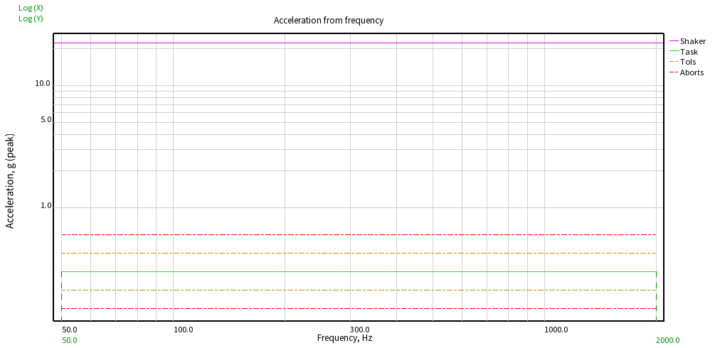

Picture 8.1 - Acceleration from frequency

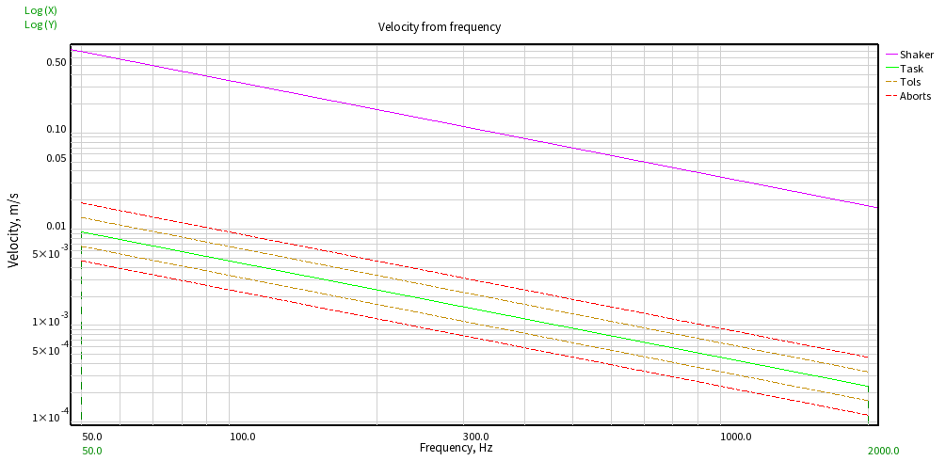

Picture 8.2 - Velocity from frequency

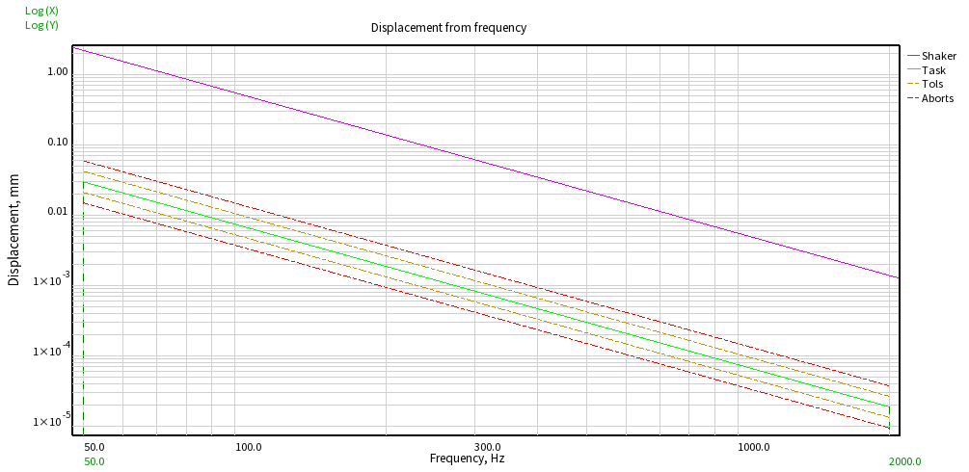

Picture 8.3 - Displacement from frequency

**9. Open graphs**

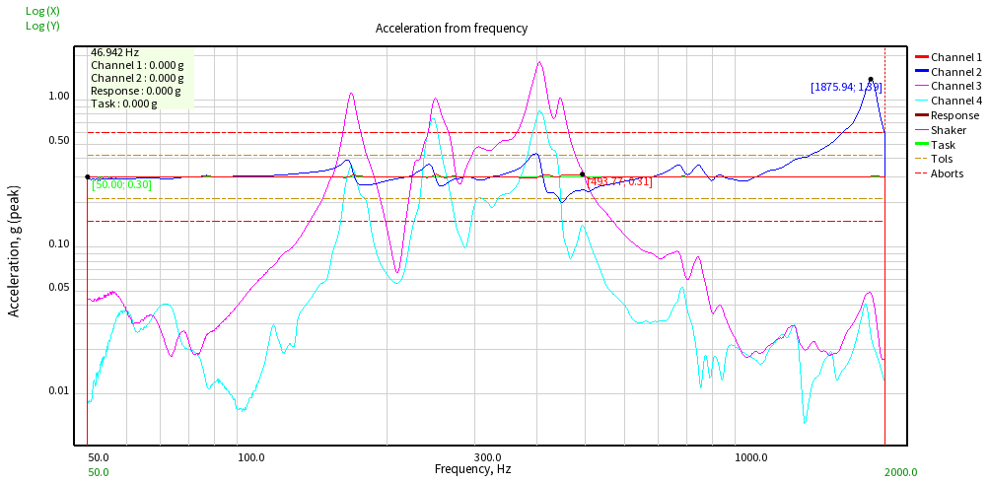

Picture 9.1 - Opened graph: Acceleration from frequency

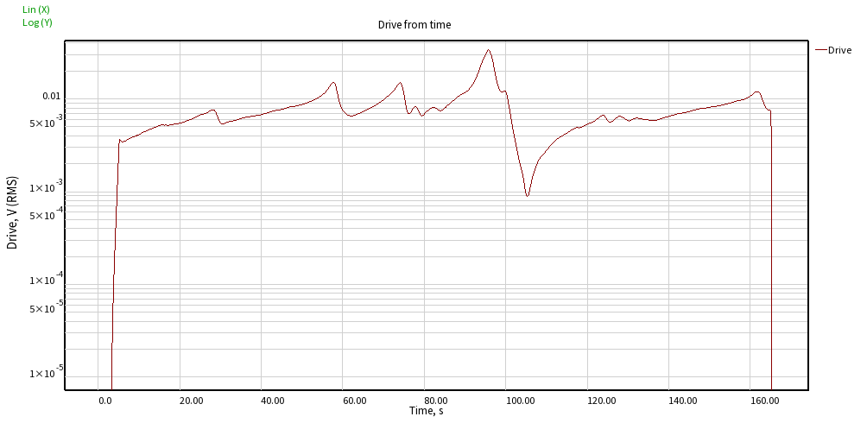

Picture 9.2 - Opened graph: Drive from time

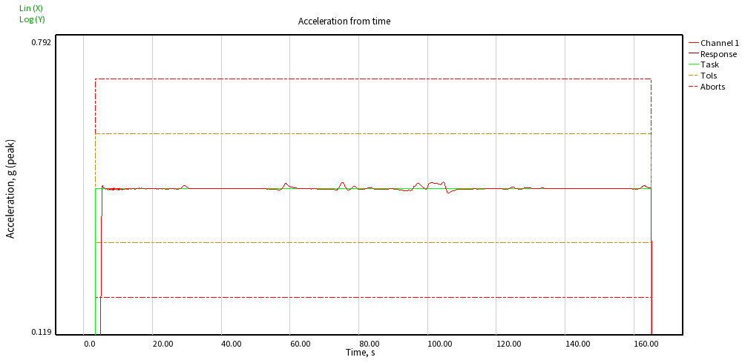

Picture 9.3 - Opened graph: Acceleration from time

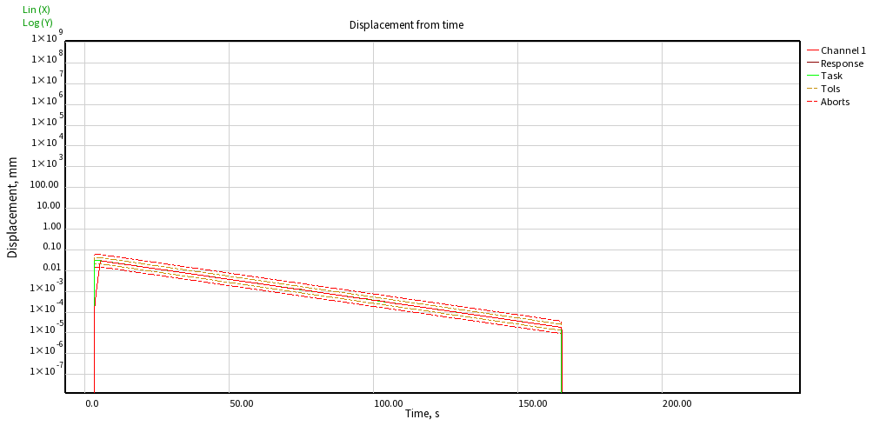

Picture 9.4 - Opened graph: Displacement from time

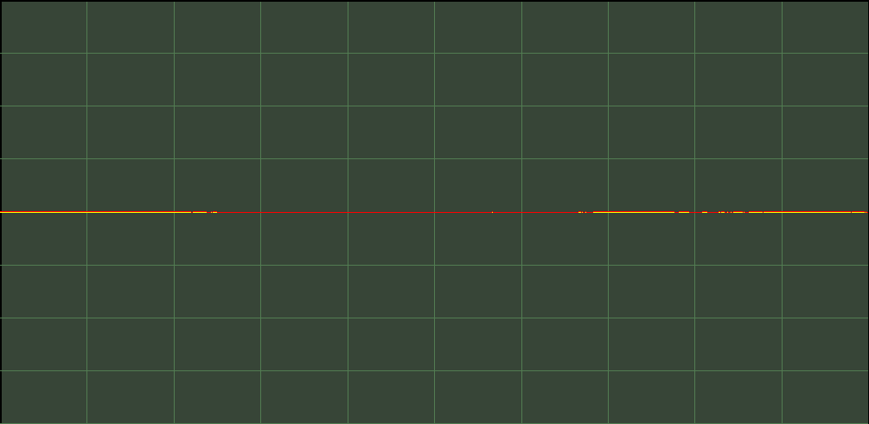

Picture 9.5 - Opened graph: Oscilloscope

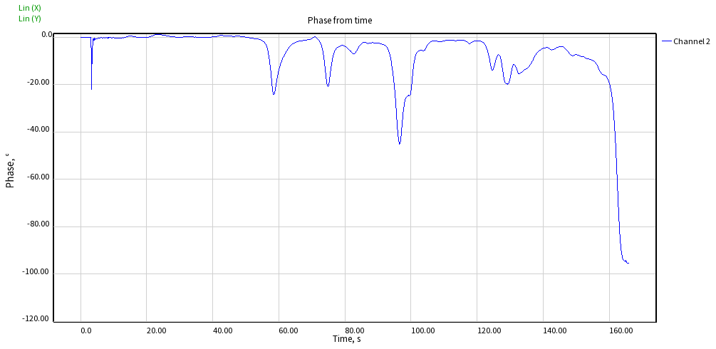

Picture 9.6 - Opened graph: Phase from time

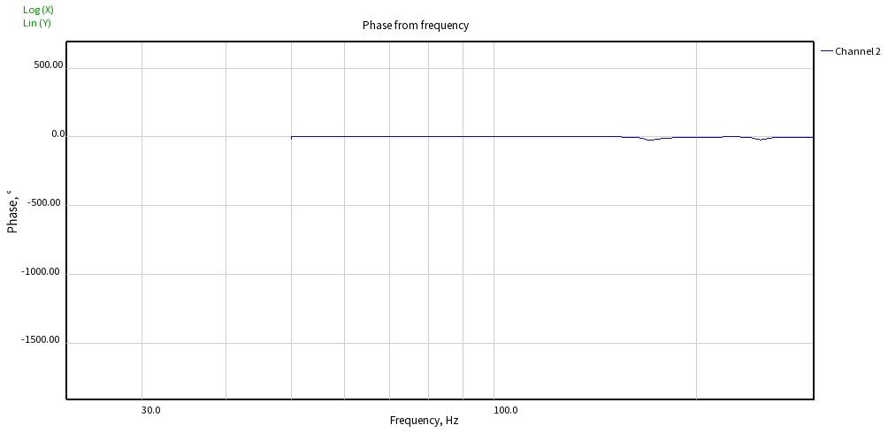

Picture 9.7 - Opened graph: Phase from frequency

**10. Graphs**

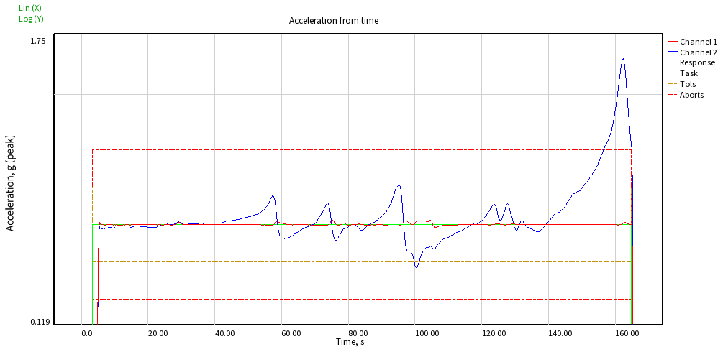

Picture 10.1 - Acceleration from time

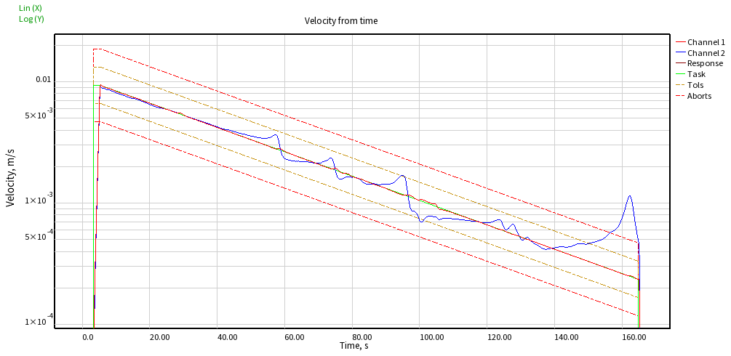

Picture 10.2 - Velocity from time

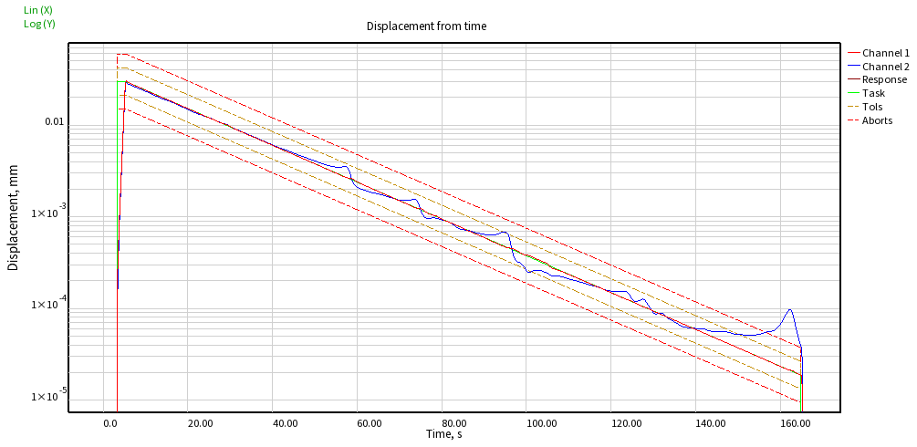

Picture 10.3 - Displacement from time

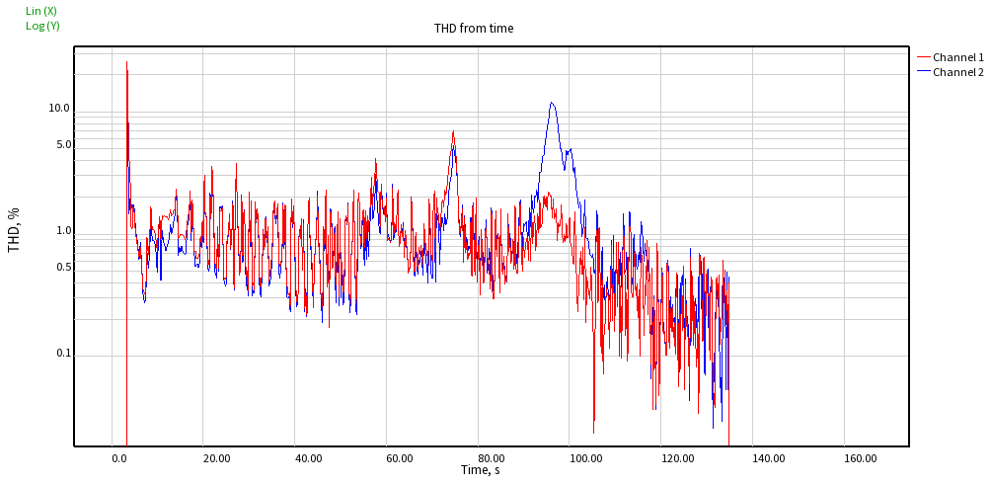

Picture 10.4 - THD from time

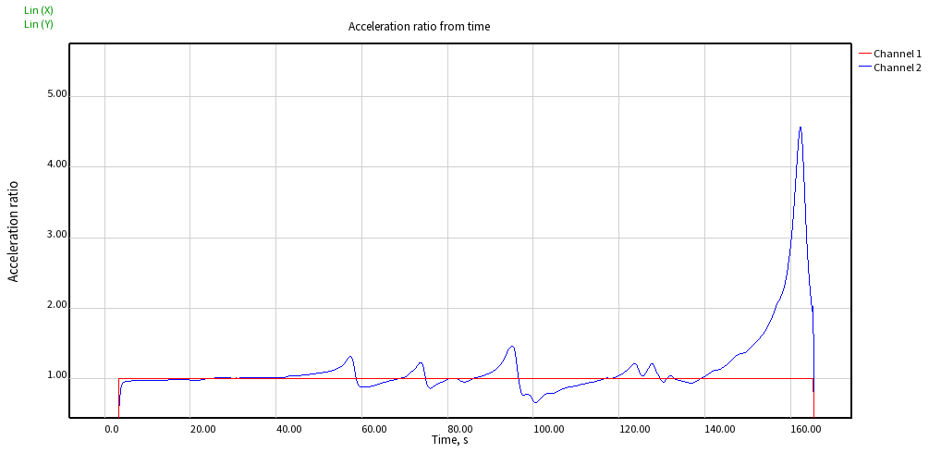

Picture 10.5 - Acceleration ratio from time

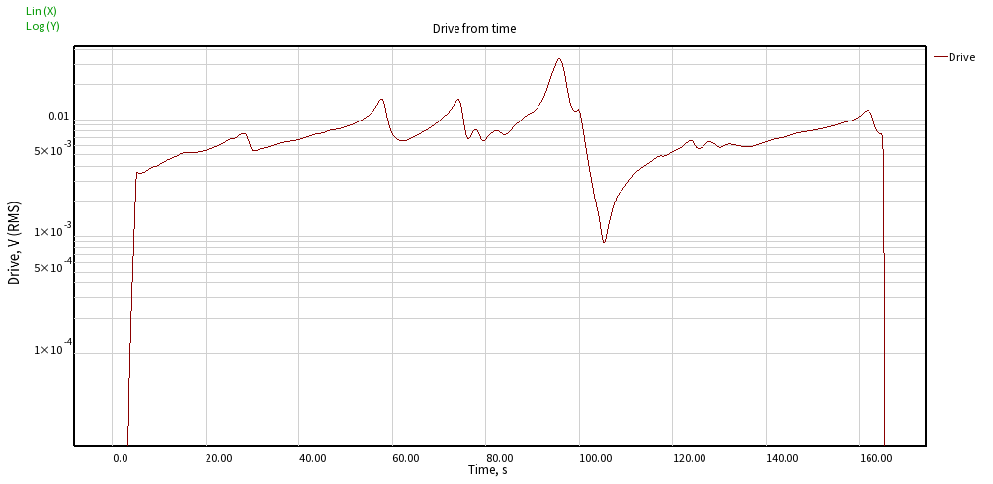

Picture 10.6 - Drive from time

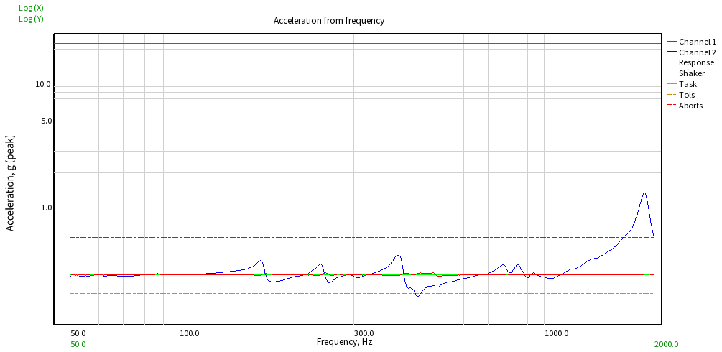

Picture 10.7 - Acceleration from frequency

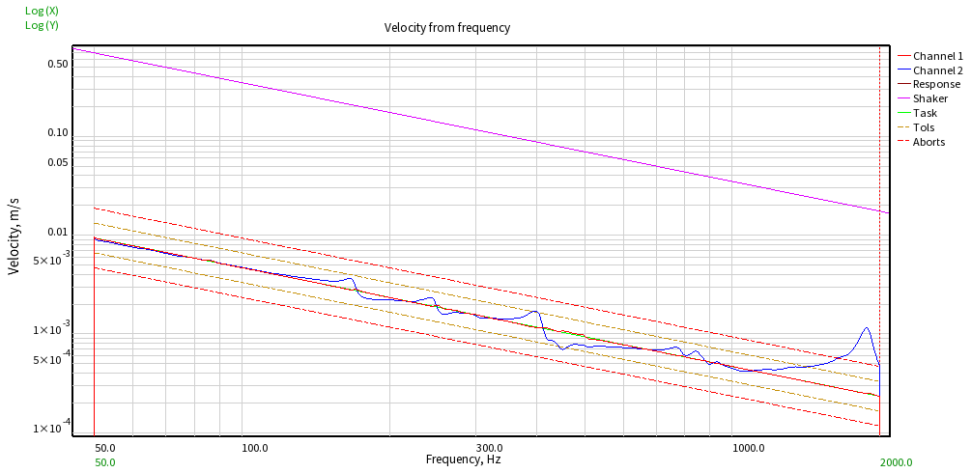

Picture 10.8 - Velocity from frequency

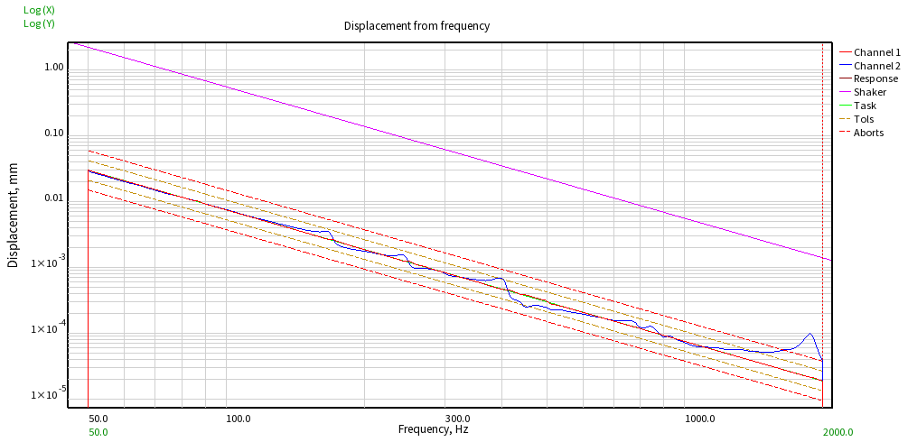

Picture 10.9 - Displacement from frequency

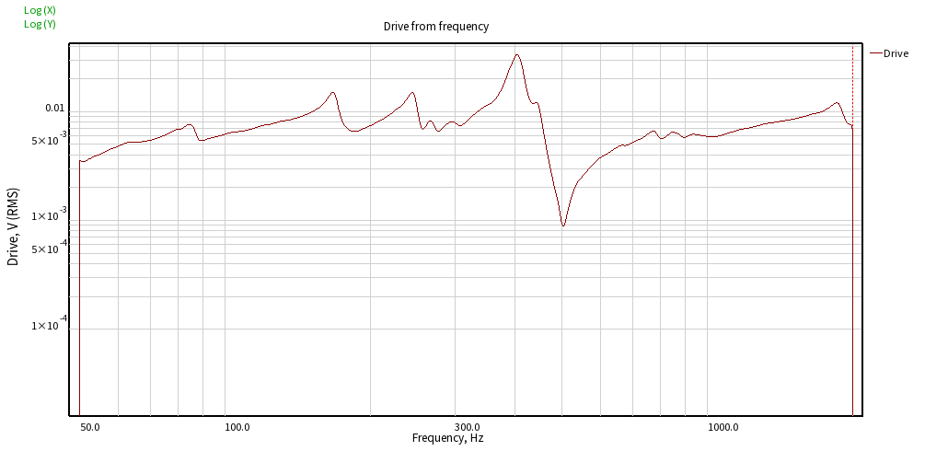

Picture 10.10 - Drive from frequency