1) In order to polarize this light at 45 degrees to produce the state given above, (using the fact that the pump emits V-polarized light), use a half wave plate.

We can think of V polarized light as a superposition of 45 degree polarized light and 135 degree polarized light (Fourier Transform). A rotated polarizer will thus block the 135 degree polarized light.

(2) To adjust the phase difference between H and V we can adjust the thickness of the crystals



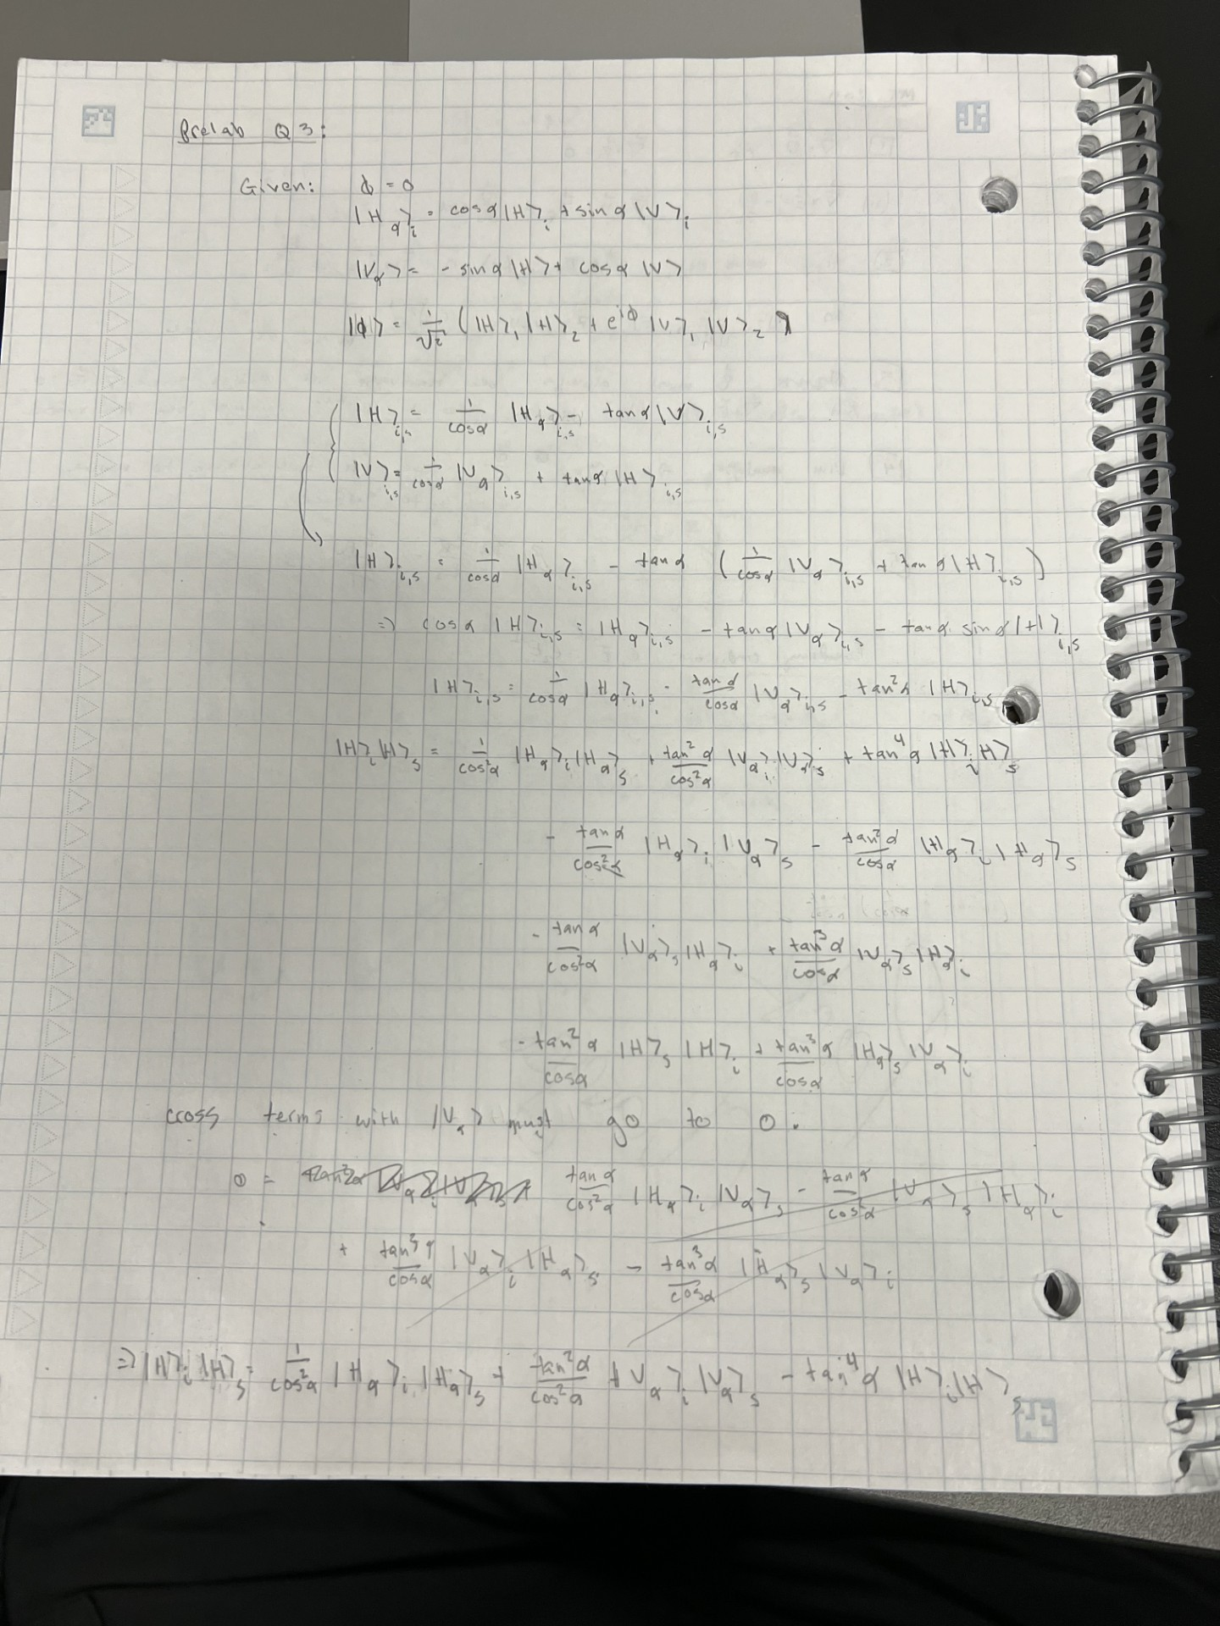



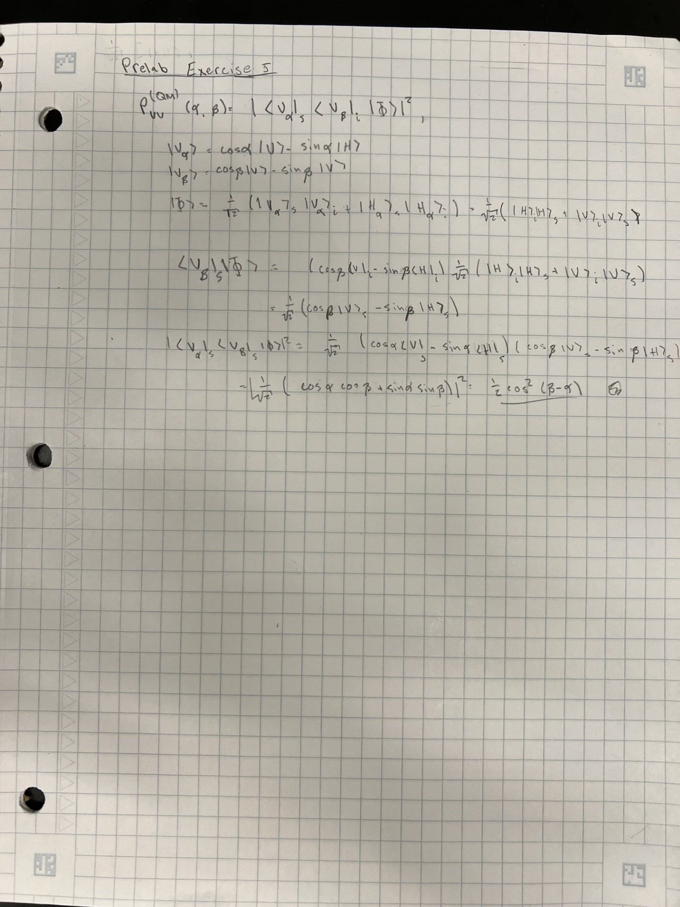

Question 6:



16: 2 for each basis (HH has 2, VV has 2, HV has 2, VH has 2)