IQ 1:

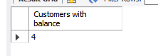

IQ 2:

Bills with balance only

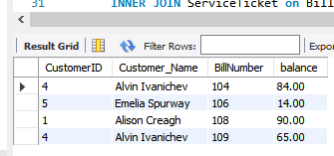

Bills with balance only (Grouped by customer)

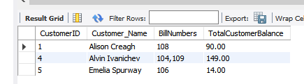

IQ 3:

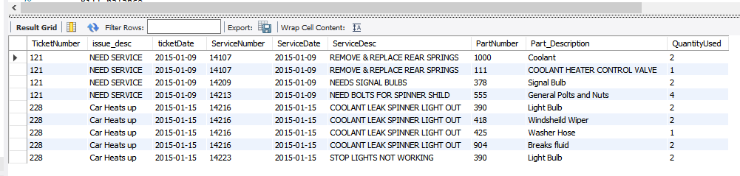IQ 4:

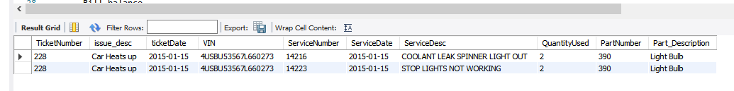IQ 5:

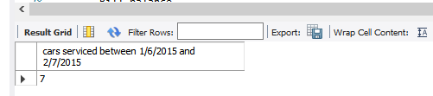

IQ 6:

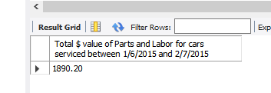

IQ 7:

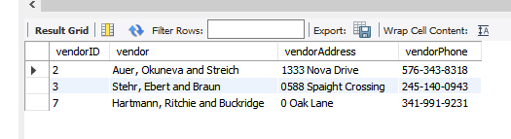

IQ 8:

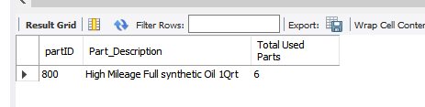

IQ 9:

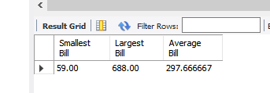

IQ 10:

