3)

The output is:

No, I wug.You wugga wug.I wug.

4)

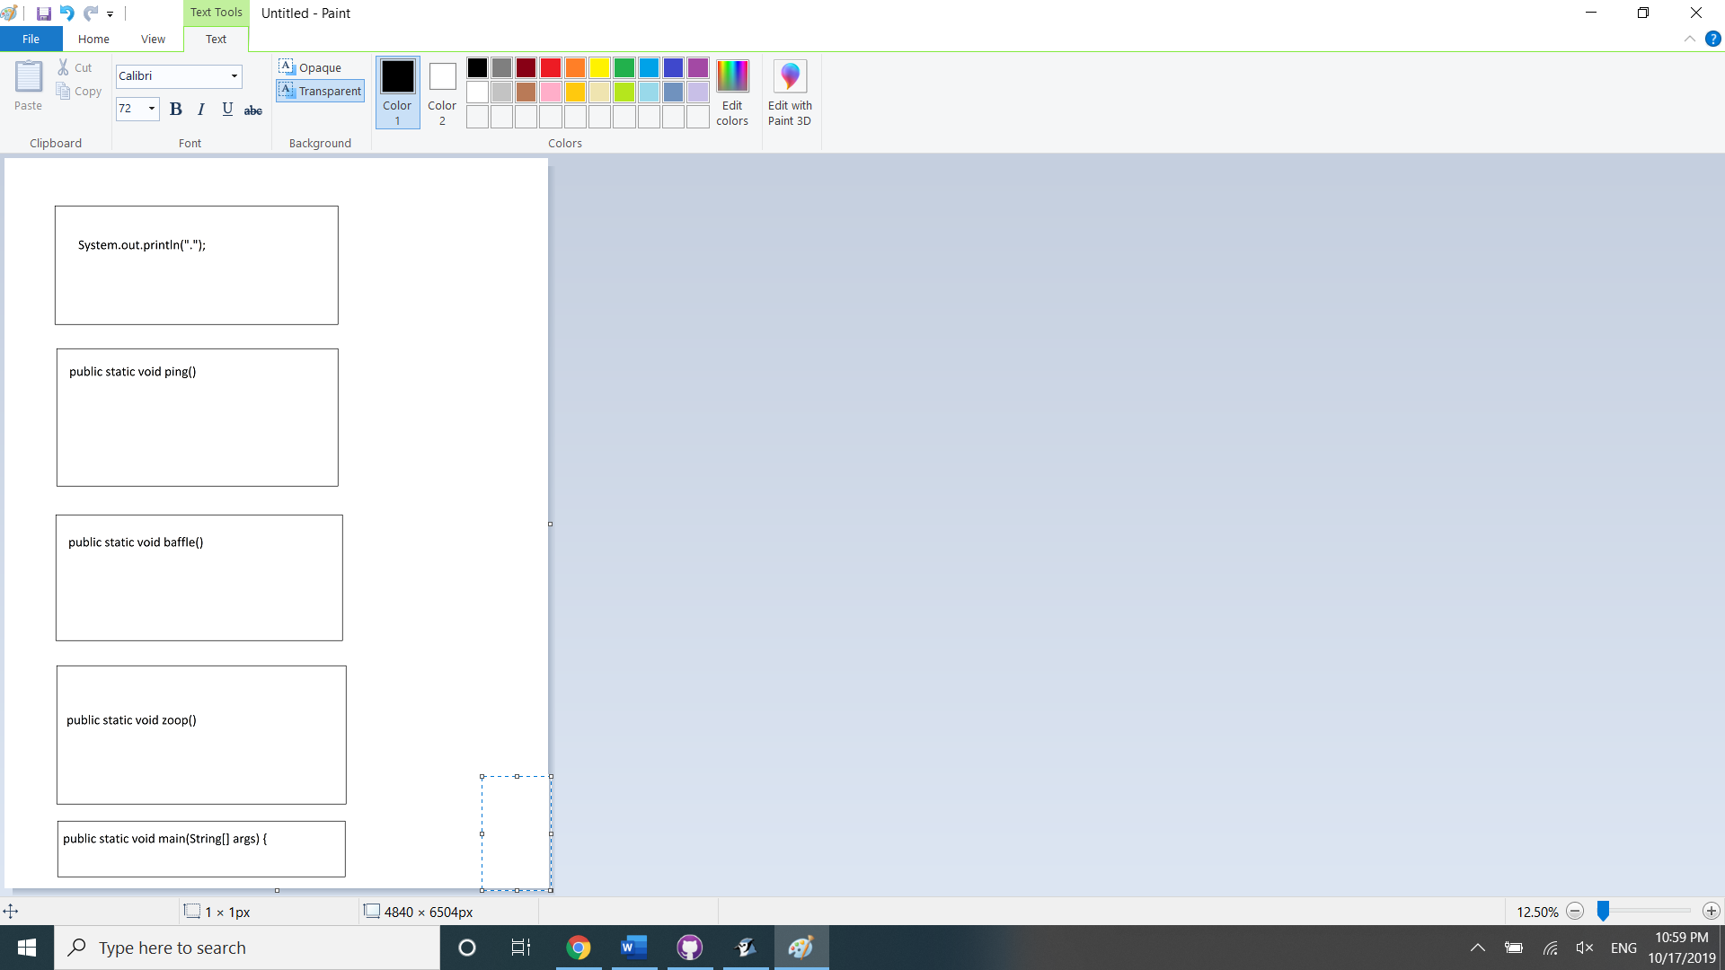

5)

You get an infinite loop that prevents public static void main(String[] args) { from ever finishing.