# Case_1: Set up new repository + upload files to Github

Step_1: Create new repo on Github (like the one below)

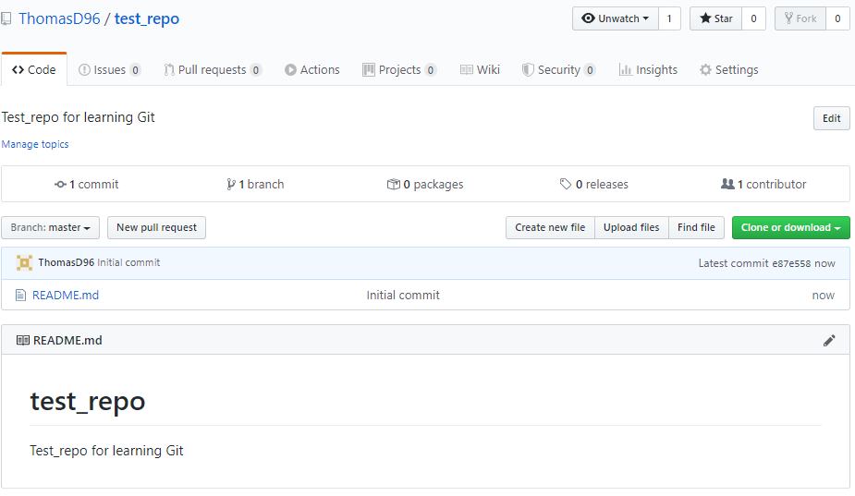

Step_2: Clone the same repo from your remote-repository to your local with following commands:

Step_3: In order to upload files, go to your local repo and move the files you want to upload in the

# Case_2: Upload files to already existing repository