|  |
| --- |
| OFFICE OF THE CHIEF FINANCIAL OFFICER  FMIS / PCBAds Citrix Migration  User Logon Experience      U. S. General Services Administration  Office of the Chief Financial Officer  Washington, DC |

1. Go to http://cfo.fmis.gsa.gov/

[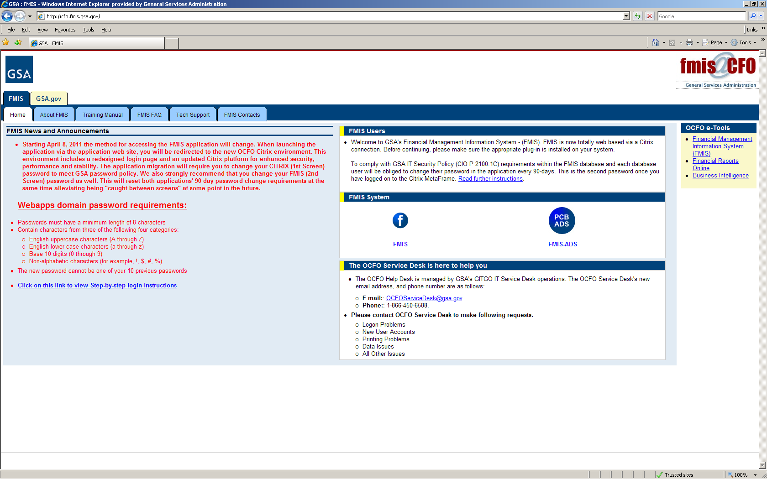](http://cfo.fmis.gsa.gov/)

1. Click on icon to launch FMIS / PCBAds. This will launch the Web Interface of the new CFO Citrix.

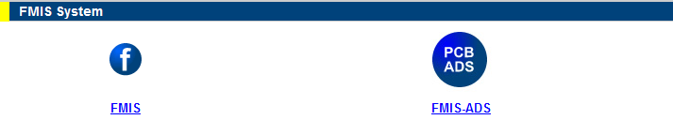

1. Log into the new Web Interface with your existing FMIS domain credentials. The user name would start with the letter U and the second set would be your region.
   1. First time logging in, the system will request the user to change their domain password.

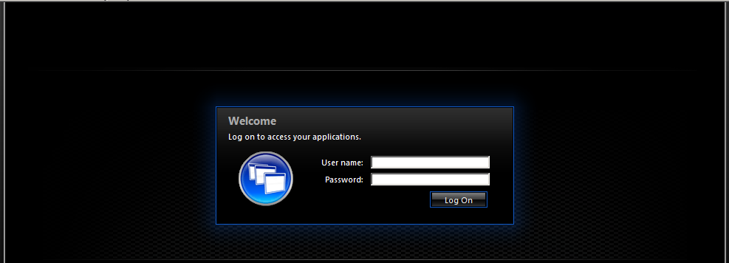

1. Click on either the FMIS or the PCBAds application icon to launch the desired application.

. 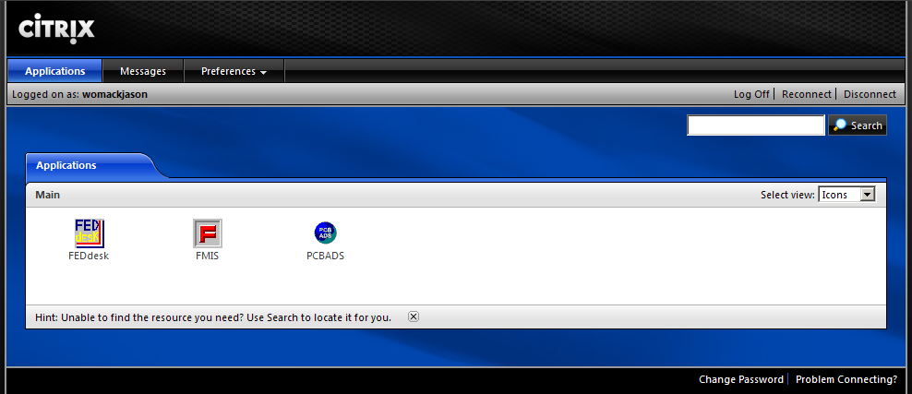

1. Click OK to accept the access agreement.

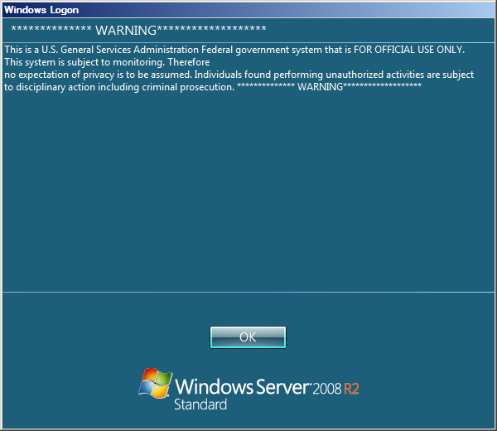

1. Log into FMIS or PCBAds application.

