* **PX** is a Memorandum of Understanding MOU or Inter-agency Agreement where obligations are incurred to procure goods or services between other federal agencies and GSA.



**Introduction**

* **IX** is a MOU or Intra-agency Agreement where obligations are incurred to procure goods or services between GSA services.
* Commercial vendors should never be used with a MOU. A formal contract should be issued through Comprizon.
* Blue fields are mandatory for Pegasys processes, but may not include all fields required by GSA or PBS policy.

1. Log into **Pegasys**.



**Recording an Obligation**

1. Select **Transactions—Purchasing—New— Order** from the menu bar.
2. Enter

* ***PX - Interagency Agreement or***
* ***IX - Intraagency Agreement***

In the **Document Type** field.

**4.** Pegasys generates a unique number in the **Document Number** field after clicking the **Generate** button.

* *Leave the* ***Security Org and Doc Number Prefix*** *fields blank.*

1. Enter the **Pegasys Document Number (PDN)** (the one that was just generated) in the **Title** Field.
2. Click **Finish**.

**Header Page**

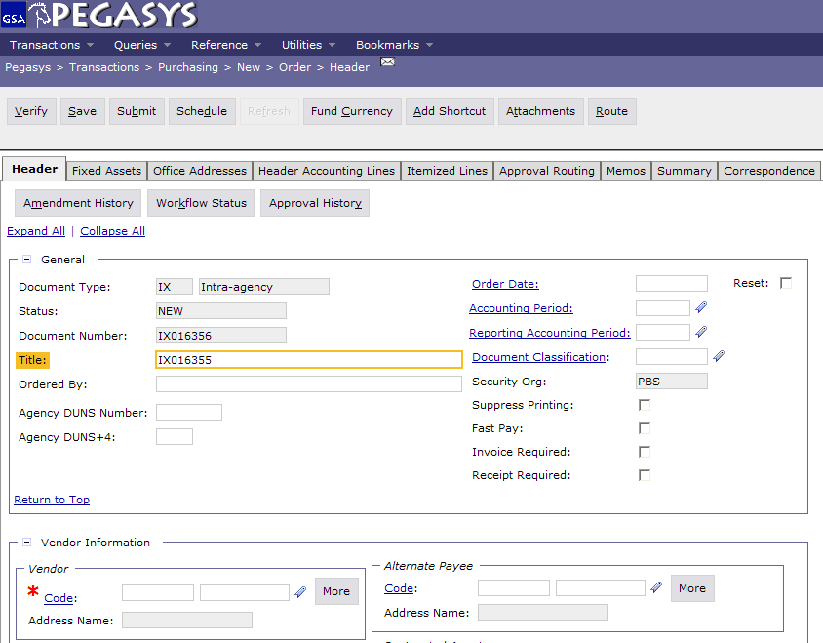

**7.** Click **Code** in the **Vendor Info** section to search for a vendor. Enter applicable search criteria and click **Search**. Find the vendor and click **Select**.

* *The* ***Vendor Name*** *field will populate from the Vendor Code that is selected.*

1. In the **Remit To Address** field, enter the same vendor code that was input in the **Vendor** field (ex., if “00008” was selected in the **Vendor** address code field, enter “00008” in the **Remit to Address** field).
2. If appropriate, type a Contract Number in the **Contracts Number** field.
3. In the **Description** field, enter a brief

description of the supply/services being ordered.

1. Select the **Office Addresses** tab.
2. The **Office Addresses** page displays
3. Select the appropriate **Office Type** and click the **Office Address** hyperlink. The specific Office Address page displays.

*Note:* The “**Invoice**” address is required for MOU documents.

1. Enter the appropriate address in the **Code** field.
2. Click the **Get Address** button to populate the fields in the **Address Information** section.
3. To return to the **Office Addresses** page click the **Office Addresses** hyperlink and repeat steps **12-15** as needed.

**Office Addresses Page**

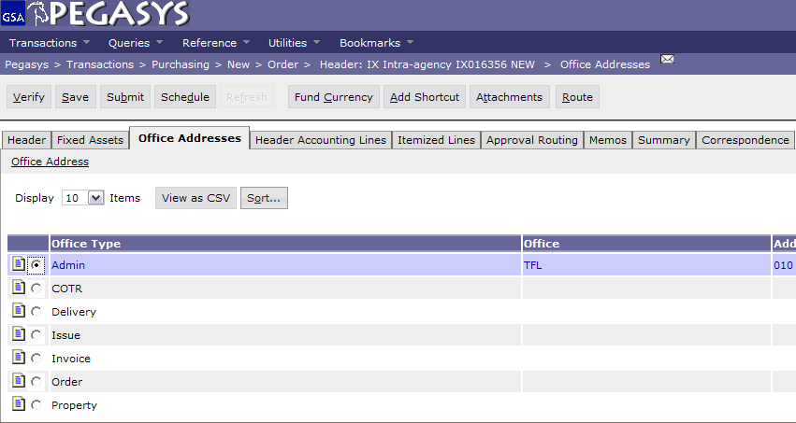

1. Select the **Header Accounting Lines** tab.
2. The **Header Accounting Lines** page displays.
3. To add a line, click the **Add**.
4. To open an existing line, select the appropriate line and click the **Header Accounting Line** hyperlink.
5. The **Header Accounting Line** page displays.
6. Enter the appropriate value in the **Line Amounts** field.

**Header Accounting Lines Page**

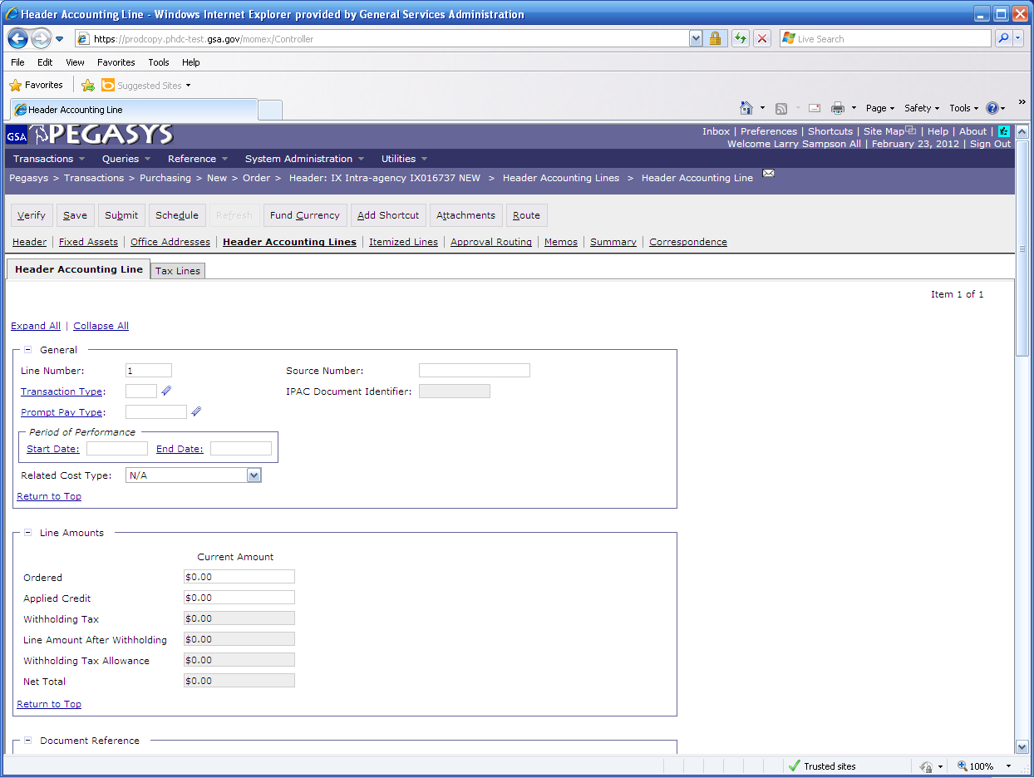

1. Click the **Template** hyperlink (in the **Accounting Dimensions** group box) to search for a template. The **Search—Template** page displays**.** Enter the applicable search criteria and click **Search**. Find the appropriate template record and click the corresponding **Select** button. The selected template will populate in the Template field.



**Pegasys Resources**

**Pegasys 6.5:**

**Creating an**

**Inter/Intra Agency**

**Agreement**

**(IX and PX)**

**Quick Reference**

**Card**

1. Click the **Default** button to populate the fields in the **Accounting** group box if you are using **Favorites**.
2. Complete any other required accounting elements that were not populated by the accounting template. (ex. Function Code, Cost Element, etc.).
3. Go to the **Description** field to view or enter descriptive information about this line.
4. Return to the **Header Accounting Lines** page by clicking the **Header Accounting Lines** hyperlink.
5. New lines can be created by clicking the **Add** button and repeating steps **22-26**.
6. Lines can be copied by selecting the appropriate line, clicking the **Copy** button and then clicking the **Header Accounting Line** hyperlink to open the new line to make needed changes.
7. Lines can be deleted by selecting the appropriate line and clicking the **Remove** button.
8. Click the **Approval Routing** tab and add the appropriate approvers individually or via a routing list.

*Note:* Approvals are required for IX and PX documents

1. Click the **Verify** button.

* *Any errors will be displayed. If necessary, correct the errors and* ***Verify*** *again.*

**33. Cli**ck the **Submit** button to submit the order form to standard workflow for approvals.

* All MOU forms require a minimum of three approvals: Accounting Classification, Funds Authorization, and Manager.
* The **Requisitioner** role is required to have access to **PX** and **IX** documents.



**PBS Business Rules**

|  |  |
| --- | --- |
|  | **General Services Administration** |

* Any modification to **PX/IX** documents should  
  be entered directly in Pegasys by the region.

***The Integrated***

***Financial***

***Management***

***System***



|  |
| --- |
| * **Functional Coordinator** * **Service Representative** * **Pegasys Web Site** [**pegasys.gsa.gov**](http://pegasys.gsa.gov) * **Reference** * **Tips** * **Help** * **Training** * **Pegasys Hotline 1-800-805-3861** |

