* Orders are created in Comprizon when a decision is made to purchase goods or services from a vendor.



**Introduction**



**Recording an Obligation**

* Once awarded, the Purchase order form (i.e., GSA Form 300 or SF-1442) from Comprizon is used to record an obligation in Pegasys. Orders may later be associated to receipts, invoices, and payments. A Purchase Request (Pegasys document type **PR**) can precede an order. (For PBS documents, requisitions/PRs are created & processed in Comprizon)
* Blue fields are mandatory for Pegasys processes, but may not include all fields required by GSA or PBS policy.

1. Log into **Pegasys**.
2. Select **Transactions—Purchasing—New— Order** from the menu bar.
3. Enter

* ***PN – Construction*** *(Comprizon Order  
  awarded on a SF- Form 1442)* ***or***
* ***PJ – PBS-3 Way Obligation*** *(Generally awarded on GSA Form 300)*

In the **Document Type** field.

**4.** Enter the complete PJ or PN number generated by Comprizon in the **Document Number** field.

* *The user’s default Security Org will populate the* ***Security*** *field.*

1. Enter the Contracting Officer/Specialist name in the **Ordered By** field.
2. Click **Finish** to display the form’s **Header** page.

**Header Page**

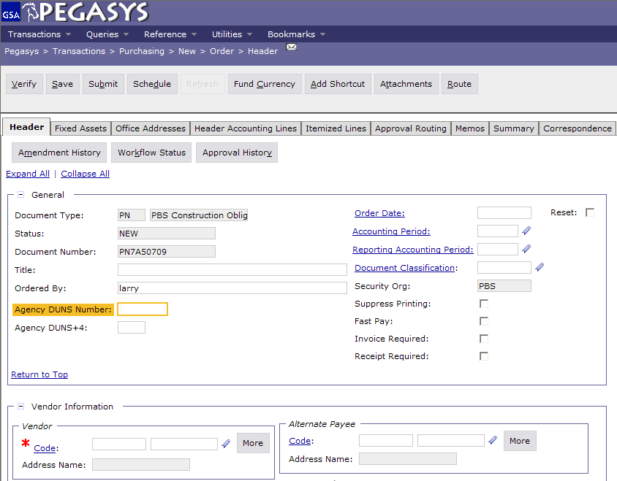

**7.** Enter the **Pegasys Document Number (PDN)** in the **Title** Field

* ***Order Date, Acctg Period,*** *and* ***Reporting Acctg Period*** *fields will default to the current date, when the form is Verified or Processed*
* *Leave the* ***Document Classification*** *field blank.*

**8.** Click **Code** in the **Vendor Info** group box to search for a vendor. Enter applicable search criteria and click **Search**. Find the vendor and click **Select**.

* *The* ***Vendor Name*** *field will populate from the Vendor Code that is selected.*

1. In the **Remit To Address** field, enter the same vendor code that was input in the **Vendor** field (ex., if “00008” was selected in the **Vendor** address code field, enter “00008” in the **Remit to Address** field).

*Note:* It is important that the Remit to Address matches  
the address that will be on the vendor invoice.

1. Enter a Contract Number and if applicable, Delivery Order Number, in the **Contracts Number** and **Delivery Order Number** fields.
2. In the **Description** field, enter a brief description of the supply/services being ordered.
3. Select the **Office Addresses** tab.
4. The **Office Addresses** page displays.
5. Select the appropriate **Office Type** and click the **Office Address** hyperlink. The specific Office Address page displays.
6. Enter the appropriate address in the **Code** field.
7. Click the **Get Address** button to populate the fields in the **Address Information** section.
8. To return to the **Office Addresses** page click the **Office Addresses** hyperlink and repeat steps **11-15** as needed

**Office Addresses Page**

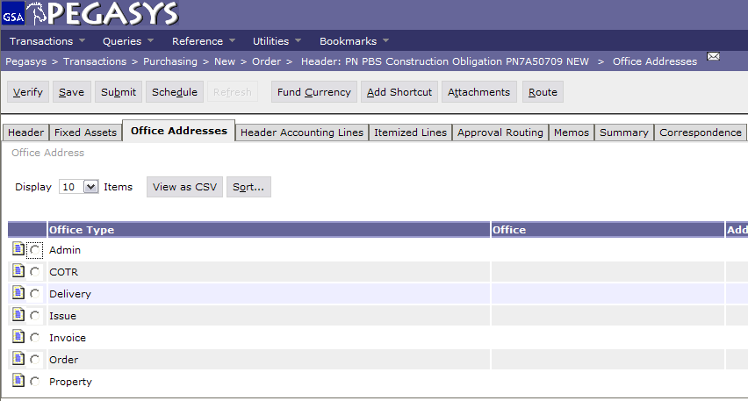

1. Select the **Header Accounting Lines** tab.
2. The **Header Accounting Lines** page displays.
3. To add a line, click the **Add**.
4. To open an existing line, select the appropriate line and click the **Header Accounting Line** hyperlink.
5. The **Header Accounting Line** page displays.
6. For **PN** documents enter CONSTR14 in the **Prompt Pay Type** field (General section). For all other doc types leave the **Prompt Pay Type** field blank.
7. Enter the appropriate value in the **Line Amounts** field.

**Header Accounting Lines Page**

**Pegasys 6.5:**

**Recording PBS**

**Com prizon**

**Commercial/Non**

**Governmental**

**(PJ and PN)**

**Quick Reference**

**Card**

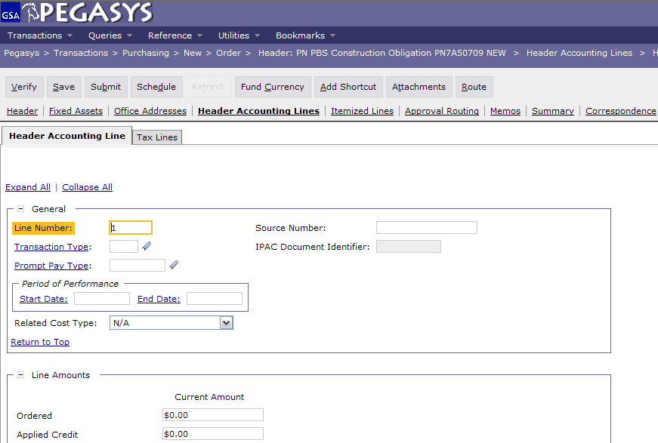

1. Click the **Template** hyperlink (in the **Accounting Dimensions** group box) to search for a template. The **Search—Template** page displays**.** Enter the applicable search criteria and click **Search**. Find the appropriate template record and click the corresponding **Select** button. The selected template will populate in the Template field.
2. Click the **Default** button to populate the fields in the **Accounting** group box if you are using **Favorites**.
3. Complete any other required accounting elements that were not populated by the accounting template. (ex., Function Code, Cost Element, Project No., Bldg No., etc.).
4. In the **Agreement** group box, enter an RWA number if applicable.

* Enter the numeric portion of the Agreement number in field 1 and enter “1” in field 2 of the Agreement field.

1. Go to the **Description** field to view or enter descriptive information about this line.
2. Return to the **Header Accounting Lines** page by clicking the **Header Accounting Lines** hyperlink.
3. New lines can be created by clicking the **Add** button and repeating steps **22-27**.
4. Lines can be copied by selecting the appropriate line, clicking the **Copy** button and then clicking the **Header Accounting Line** hyperlink to open the new line to make needed changes.
5. Lines can be deleted by selecting the appropriate line and clicking the **Remove** button.
6. Click the **Verify** button.

* *Any errors will be displayed. If necessary,  
  correct the errors and* ***Verify*** *again*

**35.** Click the **Submit** button to submit the order form.

* The purchase orders must be signed by the contracting officer prior to obligating funds in Pegasys. No approvals are required for PJs or PNs in Pegasys.
* The **PBSCONTR** role is required to have access to **PJ** and **PN** documents.

***Financial***

***Management***

***System***



**PBS Business Rules**



**General Services Administration**

* Any modifications to PJ or PN documents should be entered directly in Pegasys by the region. Continue to send paper modifications to Finance on existing 1B (non-recurring

service) documents. ***The Integrated***

* Receiving Reports should be processed directly in Pegasys for all contracts created in Pegasys.



**Pegasys Resources**

|  |
| --- |
| * **Functional Coordinator** * **Service Representative** * **Pegasys Web Site** [**pegasys.gsa.gov**](http://pegasys.gsa.gov) * **Reference** * **Tips** * **Help** * **Training** * **Pegasys Hotline 1-800-805-3861** |

