* **PS** document types are used for BA80 lump-sum payments to lessors.



**Introduction**

* The Budget contact provides the Reality Specialist with a Pegasys Document Number (PDN) at the time funds are certified.
* The GSA Form 276, Supplemental Lease Agreement, should be used to document the bilateral agreement between the Government and the lessor.
* Blue fields are mandatory for Pegasys processes, but may not include all fields required by GSA or PBS policy.

1. Log into **Pegasys**.



**Recording an Obligation**

1. Select **Transactions—Purchasing—New— Order** from the menu bar.
2. Enter

* ***PS – Supplemental Lease Agreement***

In the **Document Type** field.

**4.** Pegasys generates a unique number in the **Document Number** field after clicking the **Generate** button.

* ***Order Date, Acctg Period,*** *and* ***Reporting Acctg Period*** *fields will default to the current date, when the form is Verified or Processed.*
* *Leave the* ***Document Classification*** *field blank.*

1. Click **Finish.**
2. Enter the Reality Specialist name in the **Ordered By** field.

**Header Page**

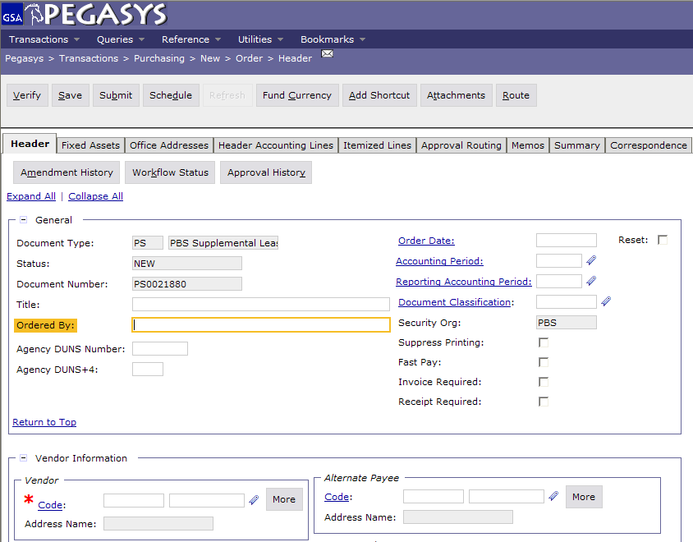

**7.** Click **Code** in the **Vendor Info** group box to search

for a vendor. Enter applicable search criteria and click **Search**. Find the vendor and click **Select**.

* *The* ***Vendor Name*** *field will populate from the Vendor Code that is selected.*

1. In the **Remit To Address** field, enter the same vendor address code that was input in the **Vendor** field (ex., if “00001” was selected in the **Vendor** address code field, enter “00001” in the **Remit to Address** field).

*Note:* It is important that the Remit to Address matches  
the address that will be on the vendor invoice.

1. In the **Contract Information** group box enter the Lease number in the **Contracts Number** field.
2. In the **Description** field, enter a brief description of the services being ordered.
3. Select the **Office Addresses** tab.
4. The **Office Addresses** page displays
5. Select the appropriate **Office Type** and click the **Office Address** hyperlink. The specific Office Address page displays.
6. Enter the appropriate address in the **Code** field.

*Note:* The invoice address code should always be 7BC­0001. Record the Reality Specialist information on the COTR tab.

1. Click the **Get Address** button to populate the fields in the **Address Information** section.
2. To return to the **Office Addresses** page click the **Office Addresses** hyperlink and repeat steps **12-15 (update reference as necessary)** as needed

**Office Addresses Page**

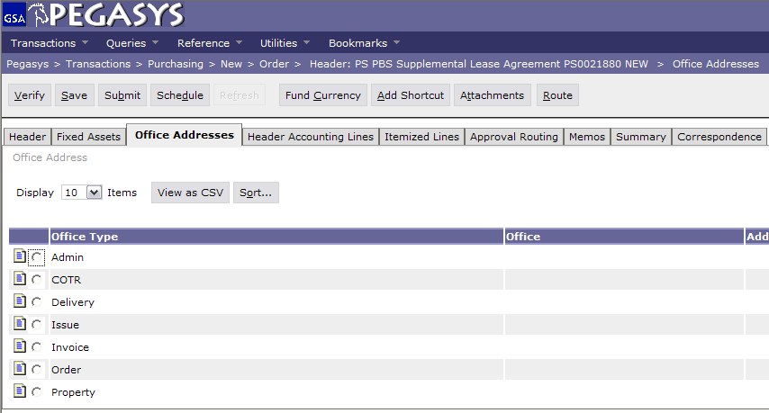

1. Select the **Header Accounting Lines** tab.
2. The **Header Accounting Lines** page displays.
3. To add a line, click the **Add**.
4. To open an existing line, select the appropriate line and click the **Header Accounting Line** hyperlink.
5. The **Header Accounting Line** page displays.

**Header Accounting Lines Page**

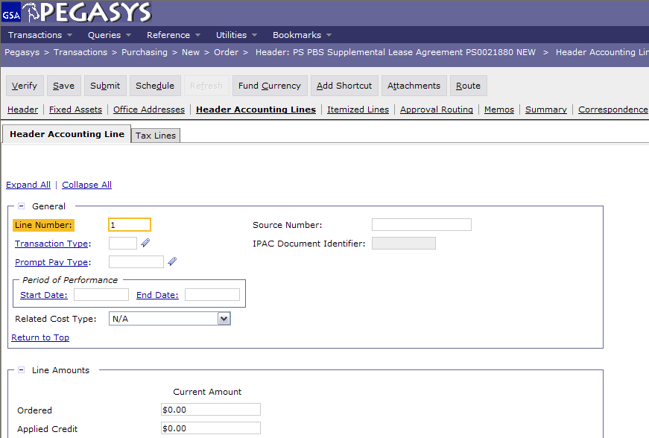

1. Complete the Accounting Line fields with the MDL information.

*Note:* If the award will be made next fiscal year complete  
the accounting information at the beginning of the  
next fiscal year when the templates are loaded.

1. Enter the amount in the **Line Amounts** field for the supplemental lease agreement.
2. Click the **Template** hyperlink (in the **Accounting Dimensions** group box) to search for a template. The **Search—Template** page displays**.** Enter the applicable search criteria and click **Search**. Find the appropriate template record and click the corresponding **Select** button. The selected template will populate in the Template field.
3. Click the **Default** button to populate the fields in the **Accounting** group box if you are using **Favorites**.
4. Complete any other required accounting elements that were not populated by the accounting template. (ex. Function Code, Cost Element, etc.)
5. In the **Agreement** group box, enter an RWA number if applicable.

* Enter the numeric portion of the Agreement number in field 1 and enter “1” in field 2 of the Agreement field.

1. Go to the **Description** field to view or enter descriptive information about this line.
2. Return to the **Header Accounting Lines** page by clicking the **Header Accounting Lines** hyperlink.
3. New lines can be created by clicking the **Add** button and repeating steps **22-27**.
4. Lines can be copied by selecting the appropriate line, clicking the **Copy** button and then clicking the **Header Accounting Line** hyperlink to open the new line to make needed changes.



**Pegasys Resources**

1. Lines can be deleted by selecting the appropriate line and clicking the **Remove** button.
2. Click the **Verify** button.

* *Any errors will be displayed. If necessary, correct the errors and* ***Verify*** *again.*

**33*.*** Click the **Save** button.

* *The document can be submitted once the Reality Specialist completes the award.*

*Note:* Reality Specialists award the SLA and provide a signed copy of the agreement to the Budget contact. (The vendor should be instructed to submit the invoice to Fort Worth Finance).

1. The Budget contact will process the **PS** document.
2. **(Instructions for Budget contact to process form)** Select **Transactions—Purchasing—Correct. Correct Form Page**

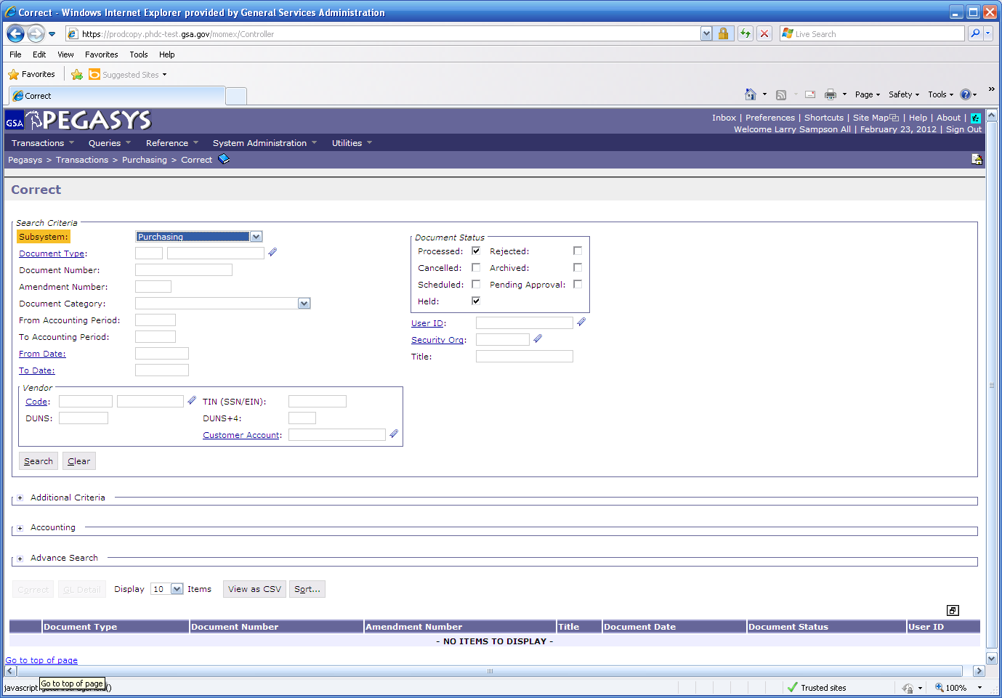

1. Enter the document type **(PS)** and the document number provided to the Reality Specialist
2. Click **Search**
3. Once in the form, add any information that was not known at the time of the award
4. On the Header page – Clear the **Order Date** and enter the **Order Date** from the SLA.
5. On the Header page – Clear the **Acctg Period** and **Reporting Acctg Period** date and leave blank.

* *These fields will default to the current period.*

**41.** Click the **Verify** button.

* *Any errors will be displayed. If necessary, correct the errors and* ***Verify*** *again.*

**42.** Click **Submit**

* *Pegasys will update the database.*
* Any modification to PS documents should be  
  entered directly in Pegasys by the region.
* Supplemental Lease Agreements must be signed prior to obligating funds in Pegasys. No approvals are required for **PS** documents in Pegasys.



**PBS Business Rules**



**General Services Administration**

***The Integrated***

***Financial***

***Management***

***System***



**Pegasys 6.5:**

**Recording a**

**Supplemental Lease**

**Agreement**

**(PS)**

**Quick Reference**

**Card**



* The **Requistioner** role is required to have access to **PS** documents.
* Receiving Reports (**RW** doc type) should be processed directly into Pegasys for all SLAs created in Pegasys.

|  |
| --- |
| * **Functional Coordinator** * **Service Representative** * **Pegasys Web Site** [**pegasys.gsa.gov**](http://pegasys.gsa.gov) * **Reference** * **Tips** * **Help** * **Training** * **Pegasys Hotline 1-800-805-3861** |