VCSS Form Instructions

Section of the Form | Instructions
Type of Access Request | - Select Add, Change or Delete
Agency | - Preset to GSA
Region | - Select your region (1-11)
Service | - Select your Service (PBS, FAS, GM&A, IG, Finance, or Other)
Correspondence Symbol | - Complete Correspondence Symbol according to the guidance provided on GSA InSite (http://insite.gsa.gov/portal/content/500188)
Name | - Complete Name
Internet e-mail address | - Complete Email Address
Security Org | - For Official Use only
Requestor’s Job Function requiring VCSS access | - Identify your job function.
Roles | - Finance Users – Select R6R7 Vendor or R6R7 Customer  - Non-Finance Users – Select Customer Support or View VCSS
Requestor’s Signature | - Click on the “View Signatures” box at the top of the screen. This is on the upper left part of the screen, outside of the form.  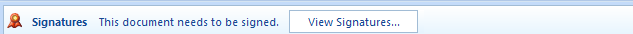  - Right click on Signer1 on the Right Side of the screen (Note: You must be using a SmartCard to proceed).  - Click on Sign  - A dialog box will open up for the digital signature. There will be an X displayed for the user to sign the form  - Type your name and click sign  - The first time you enter your signature, you may be prompted to enter your SmartCard PIN number  - You will see the following confirmation when the signature is completed. You will also see your name and date displayed in the signature block of the form  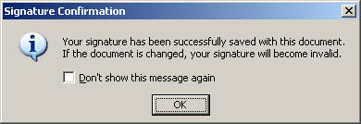  NOTE: The signature will be in very small font. The signature information is captured on the right side of the screen.  The requestor does not enter name and date if digitally signing the form. This is for printed copies only – name and date are automatically captured by the digital signature.
GSA IT Security Rules of Behavior | - Select Yes or No
Mandatory IT Security Awareness Training/ Privacy Act Training | - Select Yes or No

