Pegasys Security Q&A’s and Password Reset Instructions

With the latest 6.5 Pegasys Upgrade, users are now able to reset their password without the need to contact Pegasys Administrators. This can be done by using the “Forgot Password” link on the Pegasys Login screen. → https://phdc.gsa.gov/momexauthservice/login.jsp
However, you must have the Security Questions and Answers set up in your personal Preferences prior to using this function. Please follow the instructions below to set up Security Q&A’s as well as instructions on how to reset your password.

Setting up you Security Questions and Answers
Once you are able to login and have a set up a permanent password please follow these instructions to set up your Security Q&A’s which will allow you to use the “Forgot Your Password?” link.
Once you have received your password from a Pegasys Administrator and have created a permanent password, follow these instructions on setting up your Security Q&A’s.
- Click on the “Preferences” link in the top right-hand corner of the Pegasys screen.
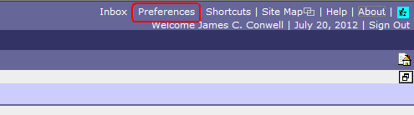
- Click on the “Security Question and Answer Page” tab.
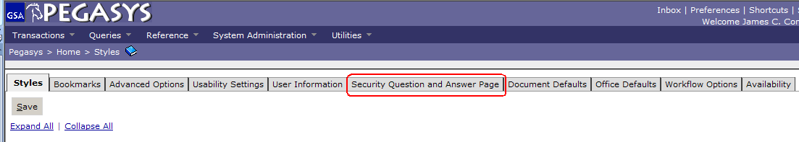

- Type in your current password (the permanent password you have just created).
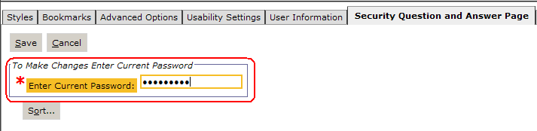

- Click both drop-down arrows in the “Questions” section and select two questions to answer in the future. For each question you select, provide answers in the “Answers” field. *The answers are CASE-SENSITIVE; therefore we recommend that you use all lowercase answers for easier recall in the future.
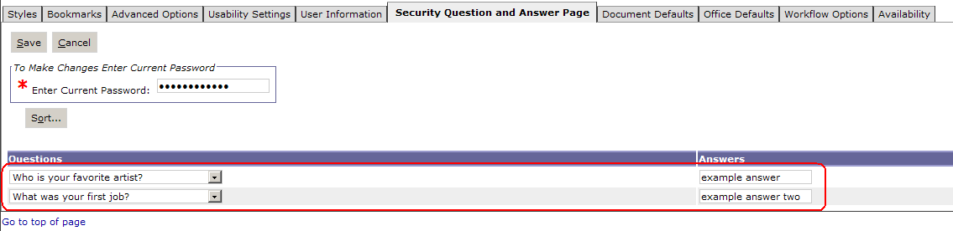
- Click the “Save” button above the “Enter Password” section.
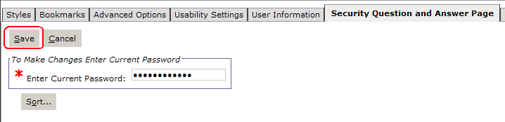

- If you typed in your password incorrectly, you will receive a security question/answer error stating the password is incorrect.
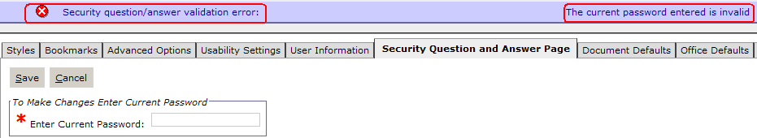

- Once you have typed your password correctly and saved, you will receive a message stating, “Action was successful.” Your answers will also be masked with asterisks when successful.
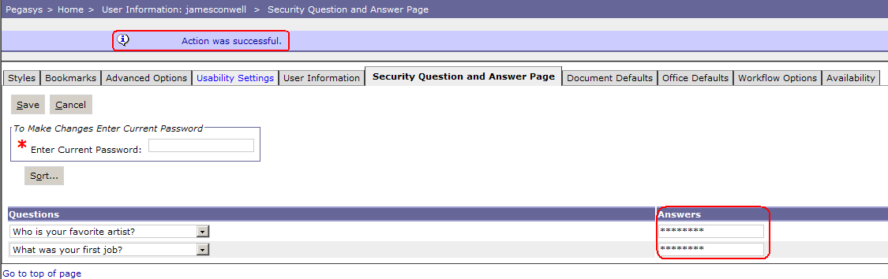
- Now your Security Q&A’s are ready to be used the next time your Pegasys password has expired or you’ve forgotten it.

Using the “Forgot Password” Link

- From the Pegasys login screen, click on the “Forgot your password?” link under the “Sign In” button. → https://phdc.gsa.gov/momexauthservice/login.jsp
- 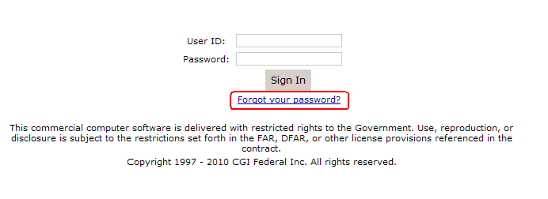Type in your “User ID” and click “Next.”
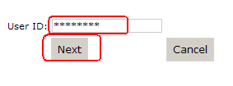
- In the next window, type in your email address and the two answers that you previously set up. *Note: If you followed our previous recommendation of using all lowercase letters for your answers, only use lowercase in this section. These answers are case-sensitive.
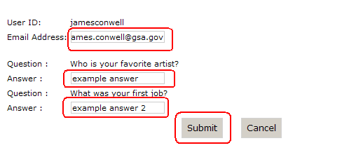

- You will receive the following message: “The password reset link has been sent via email.” Click the “Return to sign in page” link to return to the login screen.
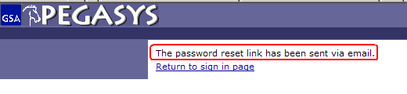

- A password link will be sent to your email from “PegasysNotification” with the subject “Momex Reset.”
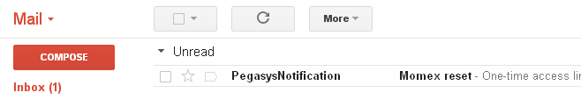
- If you do not receive the email within a few minutes, you may have filters set up that place the email in a “Bulk” or other folder that bypasses your Inbox. You may need to search for the email.

- The easiest way to perform this search is to type “PegasysNotification” in the Gmail search field and click the magnifying glass icon. *Note: If you are an external customer (non-GSA), your email application search function may be different.

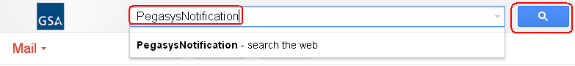

- Once you have found the email, open it and copy and paste the URL into an Internet Explorer window. *For GSA users DO NOT click on the link. The URL will be opened in GMAIL and will not allow you to update your password. Since this is a ONE-TIME link it will be lost and you will have to contact the OCFO Service desk to receive a new password. *For non-GSA users, clicking on the URL may or may not open the link in Internet Explorer. To be safe we recommend copying and pasting the URL into an Internet Explorer window.
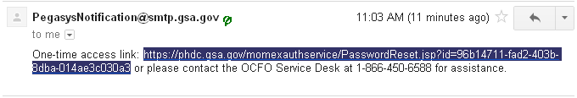

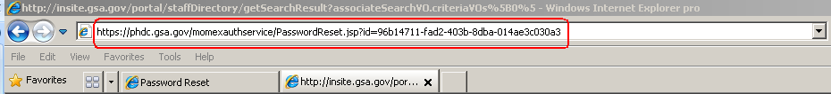

- Once you have opened the one-time password link, type in your User ID, email address, and new password and confirmation of the new password; click the “Submit” button. *Note: Make sure that you type your password correctly in both password fields and that your User ID and email address are correct. If you mistype one of these, you will be forced to contact the Service Desk to reset your password. ** Note password requirements listed below for successful change of password.
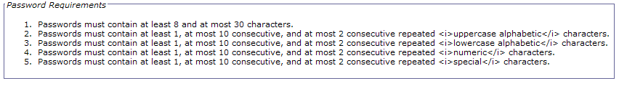
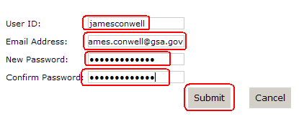
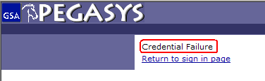

- Once you have successfully updated your password, you will be taken to your default Pegasys home page and your password will be updated. You will also receive the confirmation message stating, “Password changed successfully.” in Pegasys and a confirmation email from PegasysNotification.
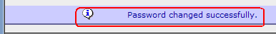

If you are unable to set up your Security Q&A’s or are unable to reset your password, please contact the OCFO Service Desk at ocfoservicedesk@gsa.gov or 1-866-455-6588.

